I suppose everyone at times has the urge to set down some of the experiences and memories that are associated with his life, and so I am yielding to the urge in the hopes that it may prove of some interest to my children when they read it, perhaps long after I have gone. So far my life has been a very happy one, and I would like to express my gratitude; First of all to my Heavenly Father for His goodness to me; second, to my parents for their loving care a happy childhood, and a clean heredity both physical and spiritual; and last, to my faithful loving wife and two children all of whom I love no tongue can tell.

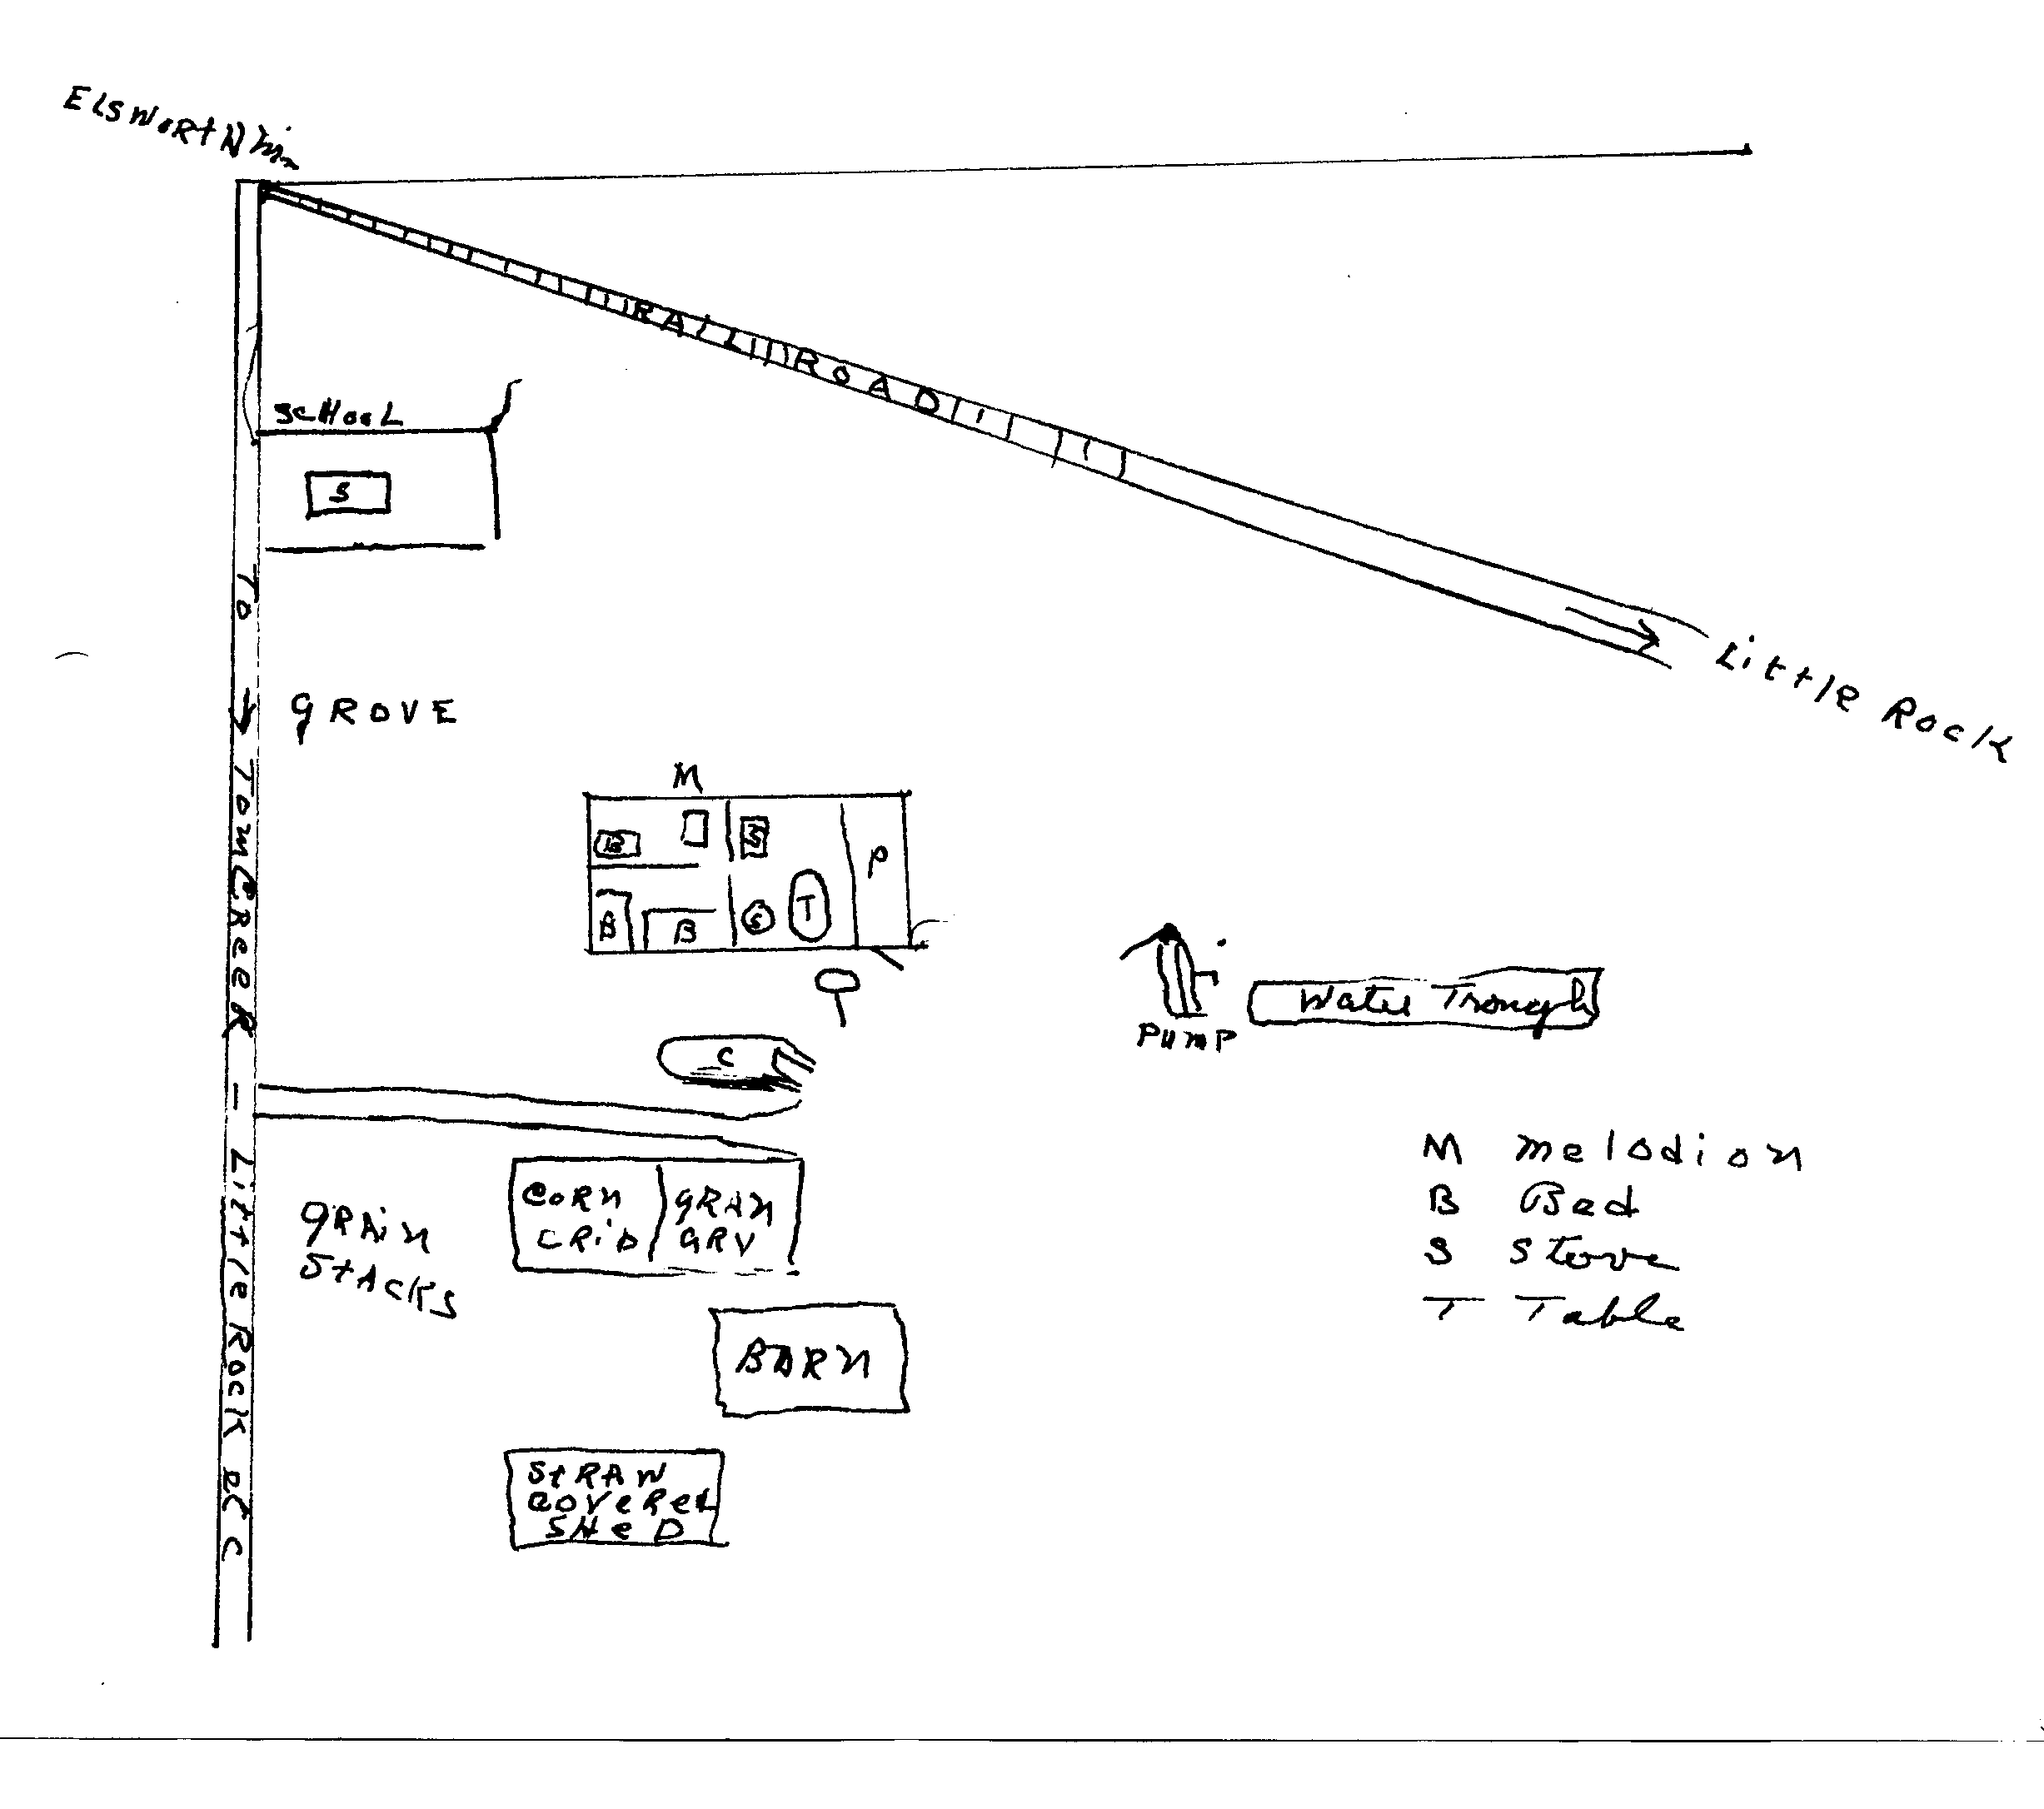
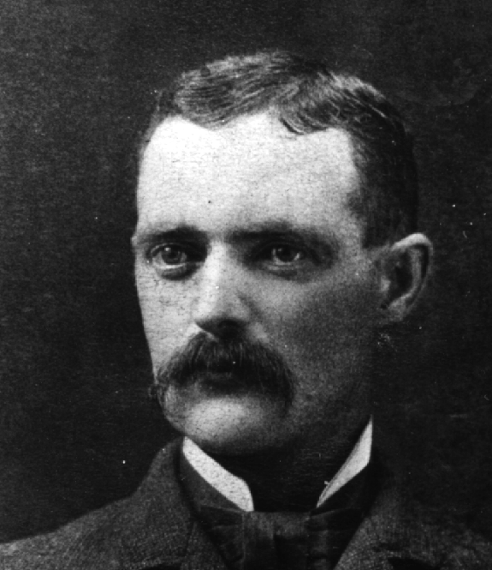
My first hazy memories are of incidents that must have occurred when I was about two or three. I can still remember walking down a board walk with my father who stopped to talk to an old man with long white whiskers. This man took me into his house and showed me quite a large group of canaries. Then to the echoes in childhood memories there is the sound of a donkey braying off to the northwest of our house. This I am sure occurred in Sibley, Iowa where I was born. At the age of three or four we moved from Sibley to a farm six miles northwest of Little Rock, Iowa. I do not remember moving and do not know how old I was when the next recorded events took place. I do remember visiting school before going regularly, and there is an incident which must have taken place when I was quite young which I remember very well. It had to do with gathering eggs. It was our custom when we found a bad one to throw it against the barn to hear it smash. Well this time after gathering them all, I threw them all against the barn and when I reached the house with the empty basket, mother turned me over to Dad to punish. I remember he gave me only one gentle spank. Mother has told me since that she asked me what I was thinking of and that I said I was thinking of twos and fours. Most of my childhood memories cluster about the farm where we lived until I was thirteen.
William Winter 1890

The house we lived in was small and unpainted, but to us children it seemed very nice. Here is a little diagram as I remember it.

It was down by the barn that we loved to make miniature rivers when it rained. My partner and pal in these undertakings was my little sister. Dad called her his little Dove, but during operations such as this her name was John. My river was always named The Daniel Boone, and hers as I remember was called Riverside.

The little Iowa farm of one hundred sixty acres was a place teeming with interest, and farming operations were usually carried on in miniature by John and me. Planting and harvesting with the aid of hoes and imaginary machinery was done in its season but the best time of all was when it came time to thresh. Our threshing machine I remember consisted of a sled with a smooth board at the rear elevated to an angle of about forty-five degrees. With a human engine chugging away at the proper distance and straw sliding over the sled up the board and dropping behind, a beautiful straw pile could be made. Then the machine could be moved to a new setting and all operations repeated.

In the corn crib there was a swing and by placing a saddle in it one could ride to town, and on arrival many good times were had buying supplies to take home. In that same shed there was a corn sheller which we loved to turn usually feeding it cobs instead of corn. I still bear the scar on the tip of my little finger of the left hand where I injured it when I reached in too far for a cob.

The horses on the farm were a source of interest and pleasure. At first we had only three. There was old Fan, a bay horse who had the habit of going to sleep as she walked, and then stumbling but never quite falling down. A sharp crack with the whip or the end of the reins and she would be fine for a while and then it would happen all over again. Old Nell was a beautiful brown horse. Together they made a serviceable team working in the fields as well as taking us in the lumber wagon wherever we wanted to go. We had no other conveyance and so when we went to town, Mother and Dad sat in the spring seat, we kids in behind, and away we would go, the horses usually walking but occasionally trotting for a short distance at a time. When it was cold how good it was to rush in the house and get off our shoes and stockings and mother kindled a fire in the cookstove and boosted us up so we could put our feet on the warming stove. Speaking of stoves I remember our base burner, with its many ising-glass windows glowing as it kept us warm on cold winter days.

Near our house, perhaps a quarter of a mile away there was a railroad. Early memory recalls the glamour of the trains as they rushed past. In fancy I pictured my sweetheart on every train and named her Bessie Alice. Of course, I waved to her whenever the train went by. We kids often walked over to the track and were thrilled to hear the approaching train as we lay with our ear on the track. We were always careful though to retreat to a safe distance when the train came by. One day returning from such a trip I remember I became lost in a cornfield. The corn was higher than my head and I couldn't see. After a little panic I decided to follow a row and can still remember the relief and surprise when I reached a fence and was able to orient myself.

One of the highlights of boyhood was horseback riding. Our third horse was a white mare. Her name was Dell. We rode her bareback and, while we were too small to get on used to wait until she was eating grass, then quickly straddle her head and when she threw her head up slide down onto her back. She was very wise and hard to catch. Sometimes a pan of oats in one hand and the bridle behind our back in the other would do the trick and sometimes the chase was long and fruitless. Once caught she was gentle as a lamb and when we fell off, as we often did., she was careful not to step on us.

Last of all came old Peg, so named because of her peg-legged gait which was due to stiffness and spavins.

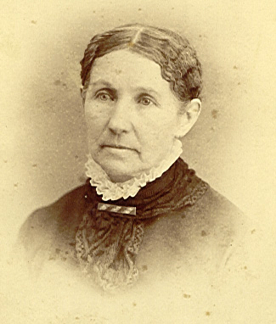
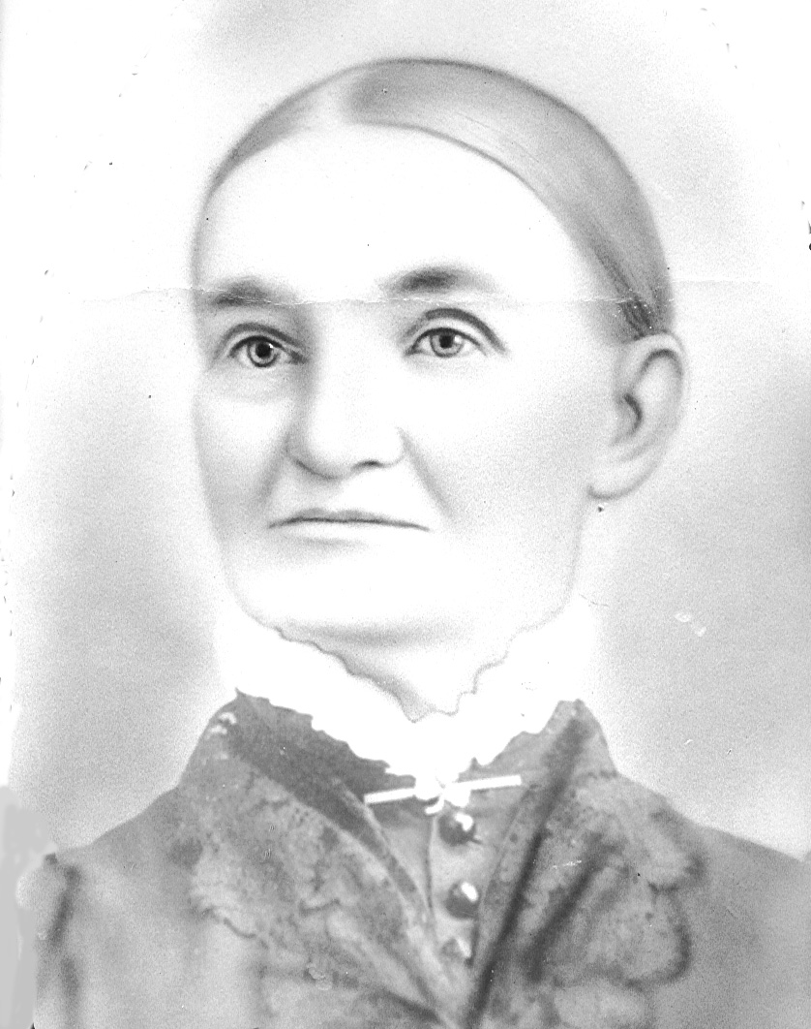
Once or twice a year we went to visit our Uncle Joe who lived on a prosperous farm about five miles south and east of Little Rock. On one such occasion I was allowed to stay a week. While there I got into considerable mischief and among the pranks I remember was the greasing of the grindstone. It squeaked but I applied the grease to the grind-surface of the stone - which didn't help the squeak and did interfere with the efficiency of the machine. Greasing the windmill pump also resulted in getting considerable oil in the watering tank. Uncle Joe was very long suffering and did nothing but gently threaten to use a shingle on me. Anyway when it came time to go home and the folks had come after me I wasn't quite ready to come. Dad, whom I remember as a handsome man with a beautiful brown beard, told me that he had a new pony for me. When we got home there was old Peg. I believe she cost fifteen dollars and was a part of our family until we left the country for southern Iowa when she was sold to a man who promised to give her a new home.
Grandma Rebecca Murray Winter
Grandma Margaret McClelland Wright
Our first cow was named Daisy and was red with white spots. One of her calves was named Bess and they furnished most of the milk for our early childhood. I still remember the tragedy of the day, when because of her advancing age and the pinch of necessity she was sold to the butcher. He came to our farm and slaughtered her there. We kids all went in the house and cried when the time came and the report of the gun outside told us that old Daisy was no more. Then we had another cow, a white one, and still another which was a white roan. The latter was always getting into trouble. Once she climbed up on top of the cattle shed which was roofed with straw and fell through. That same shed made a lovely nesting place for the sparrows and on cold nights they would nestle inside chirping sleepily. On another occasion this same cow, standing on the platform of the well, broke through, falling hind feet first into the well which must have been fifteen or twenty feet deep. After much maneuvering she was extracted with no damage to herself.

One day we had been to visit Uncle Joe's farm and were returning home. It had rained a little. For some reason or other Jim, my oldest brother had elected to stay home. When we got about two miles from home we saw him, coming to meet us on old Dell. His face was as white as a sheet. On reaching us he told us that the lightning had struck the barb wire fence. Lined up along the fence were four of our little herd and a bull that Uncle Joe had loaned us. They were all dead and a total loss except for their hides which my father removed the next day and sold. The carcasses were left and it was a gruesome pleasure of us kids to inspect them and watch the maggots reduce them to skeletons.

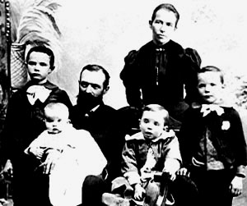
Another experience with maggots resulted from a boyhood prank. I believe it was Jim who tied a tin can to the black calf's tail. In its mad rush to escape the banging thing it collided violently with a barb wire fence cutting its nose quite badly. The wound became infested with maggots and Dad would have to clean it out frequently applying pine tar to the wound. Eventually the wound healed but the cow always had some nasal obstruction as a result.

I remember my Mother in those days as a sweet understanding mother. She had a lovely soprano voice and often would sing as she did her house work. When tired she would sometimes sing "My Soul be on Guard, Ten Thousand Foes Arise.” On Sunday afternoons we would all gather around the old melodeon and sing the good old hymns. Dad sang tenor or bass and the rest of us carried the air. Often too, we would, go for a walk and in the spring pick the prairie flowers: blue bells, butter cups, and wind or May flowers. Very early while looking at a sunset or a lovely view I learned to appreciate the beauties of nature from my Mother.
Jim, Margaret, Dad, myself, Mom, Bill
Winter Family, about 1895

The early years in northern Iowa were full of interest. The country had been settled by people of German extraction and most of the older folks spoke German in their homes. The children with whom I went to school were all German with the exception of one family. I remember the DeBoor family who lived across the railroad track from us. There was Gracie a very disheveled and unattractive girl and two brothers with whom I played. One was Willie and I remember one time he was at our house and we made our favorite soft drink which was made by adding vinegar to a glass of water and then after sweetening it with sugar adding a small amount of soda which made it foam. Willie's comment after tasting it was "smacht fine." Another family were the Virst family. Enos was the oldest and worked like a horse in the field but was mentally retarded and eventually committed suicide. Luther was considerable larger than I and then there was a smaller brother whose name I have forgotten about my size and with whom I used to fight. The bigger brother would take his brother’s part which I thought was very unfair. Their father eventually bought the old Iowa farm for forty eight dollars an acre when we moved away.

Then there was the Gooch family, the only other “American family.” I remember them chiefly for two things; one that the father lost his thumb or finger in the threshing machine he ran, and I was much interested in watching him soak it in hot water, and the other that they gave us a pet badger which we had for a while. He was quite a pet but I have forgotten whether he ran away or was eventually killed. As I look back on it, I think my attitude toward the German children was influenced by my Uncle Joe, who always referred to them very contemptuously as the d------ Dutch.

So when I was twelve it was decided that we should move. Dad took a trip to Southern Iowa to look for land. He and Mother had always remembered New York State with fond memories. Mother, when tired, would sometimes refer to herself as staked out on the prairies. Both remembered the luscious apples of their childhood and the maple sugar. I believe the land agent Dad contacted lived in Winterset, but just how he happened to land where he did, I do not know. Anyway it was a great day when he came back telling of the farm he had bought. It had an apple orchard, and part of it was timbered. The house was two story and had four bedrooms, and so we moved.

The furniture and machinery were packed in one end of a boxcar, and the horses, old Fan and Nell, some cattle and chickens together with the dog and my old cat Petie in the other end. Dad, Jim, and. Bill went together with the car and Mother, Marg and I stayed at Sibley a day or two and then went by passenger train. We arrived in Des Moines in the evening and found a hotel near the depot. There we stayed for the night and there we saw our first electric light. It was burning when we entered the room and Mother was afraid to touch it. I was more ventursome and turned it off and on and was quite proud of myself. The next morning we traveled on to Truro.

It had been a very wet spring and the streets were a sea of mud. No one was there to meet us, so we waded to a little hotel to wait for them to come. I remember there was a piano there and, we tried to get Mother to play it for she was familiar with them, but we could not induce her to do so.

Soon the faithful team appeared pulling the lumber wagon, hub-deep in the mud, and bringing Dad, Jim, and Bill to us. After buying a few supplies we started on the long journey-six miles-home. The roads were awful, and the mud would roll up on the wheels making it necessary to get out every little while and punch out the mud. The hills, which we were not used to, seemed impossible. I remember Mother was quite frightened by them.

Eventually we arrived at our new home and it was a wonderful castle to our youthful eyes. There we were to spend the rest of our youth, and many tender memories are associated with it. There we were to bring in the cows from the pasture and do the chores. There we were to help plow the corn and make the hay and milk the cows. I remember how Dad was always telling us not to work too hard and to take it easy.

I too have memories of the delicious winesap and roman stem apples, the grapes, the black berries, the hazel nuts that grew wild in the pasture, to say nothing of the bountiful supply of black walnuts and hickory nuts.

Soon we were off to school. We attended the Jones school about a mile from where we lived, and we reached it by walking across along the Hannah creek, then across Brown's pasture. I remember three of the teachers. The first was Tommy Hayworth, then Miss Squiers, and Nell Davis followed. There we met the Hagans, the Dodds, the Coopers, and later the Delongs. I remember Nell Davis boarded at our house and had a frequent caller in the person of Niles Jones, whom she eventually married. Oh yes, I must not forget the Beirmas.

Jones school was a typical country school of that day. Perhaps they are the same today but I doubt it. The children started to school at the age of five and walked anywhere from a few rods to two or three miles. The smaller ones were usually accompanied by older siblings or neighbor children. Only in case of a severe storm was any transportation furnished. Classes ran through all of the eight grades and ages from five to eighteen. In the front of the room was a recitation seat where classes came for recitation while the rest pursued their studies. The one room was heated by a big coal stove and it was the duty of the older kids to keep the fire going. In the back of the room stood the old water bucket with a dipper to be used for drinking. One of the prized tasks was to be sent for a new supply of water. Two were excused for this pleasant task: filling it to the brim from the well a quarter of a mile away and bringing it back consumed at least a half hour of time otherwise spent in studying

After about three terms of school it was decided that I should go to Osceola for my last year in grade school. J.W., who had two years in high school at Little Rock was to go also. It was Mother I think who rented a room for us at Miss Osmonds. We did our own cooking, bolstered by supplies sent in from home. Miss Osmond was a maiden lady of uncertain age who was quite good to us. She gave my Mother a slip from an oxalis plant that still blooms in the old home and is still cherished by my sister, Margaret.

It was in the eighth grade that I really got my first taste of the joys of learning. We had a young man as our teacher. His name was L. C. Smith. His enthusiasm really filled my young heart and I reveled in his praise. I have always given him credit for teaching me how to concentrate and really study.

The next year I entered high school. Now I began working for my board. I held several jobs. The first one I remember was as a printers devil for the Osceola Sentinel. It was my job to sweep out and keep the place in order. In my spare time I ran errands and practiced setting type. I never was very fast about it but was proud when I saw what I had set printed in the paper. The editor, J. L. Long, was always kind but very impersonal. I had some good friends among the journeyman printers. Most of them stayed only a little while and many of them went on periodic alcoholic sprees. That year we roomed at Flukes who ran a shoe store.

It was our custom to come home for the weekends leaving for home as soon as school was out and often walking. Osceola was twelve miles from home by road but by cutting across the fields we could cut it down some and usually made it home in about three hours. On Sunday afternoon we would get a ride at least part way back in our top buggy behind old Maud and Charlie. They could really step right along.

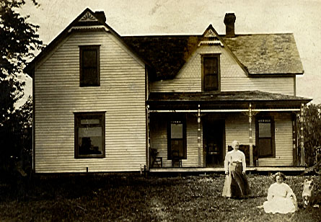
I recall two high school pranks of which I am not too proud. One had to do with my Latin grade. Lester Drennen and I were worried and so one night we went to the high school building and entered through a window, opened the Latin teacher's desk drawer and found the little book in which she kept our daily grades. Carefully we erased the poor ones and raised them to what we wished they might be. I don't know how important the little book was, but our grades were about as usual that month, and as far as we knew we were never discovered. The second escapade was with the same boy. This time We took our class colors in and up into the bell tower and tied them there. The next day the superintendent convened the class and demanded to know who had done it. My pal confessed and had to take them down but I kept mum.
Winterborne August 1912 when I was 13, Maggie and Margaret Winter

There was little or no athletics at high school in our time. We did start a football team of which I was a member, but no games were forthcoming and it soon died. We had no basketball team. In fact I don't know if it was yet invented.

In my sophomore year I was in town alone. J.W. had graduated and was teaching school. That year I worked in a restaurant for my room and board. Here again I swept and scrubbed the place in the early morning, and in the afternoon washed dishes, helped the baker in the bake shop behind the restaurant, and did many things. Here I learned that an egg could be pretty bad and yet could be cooked in certain pastries and not spoil the cake or cookie in which it was used. One of my duties was to dispose of the rats which swarmed in the alley. A big wire trap was set out every night and in the morning would hold a nice quota of squealing rats. The method used was to slip them into the piping hot oven next the roaring fire on the long paddle used in handling the bread pans. In a flash that batch of rats were no more.

The restaurant was run by Mr. and Mrs. Babb, who always were kind to me. During my last year I roomed at their house. Summer vacations were spent at home helping with the farm work. I was really quite a husky kid by that time and was very proud of the fact that I could throw all the other kids my age in a wrestling match. I had a clear soprano voice those days, and often when I went to the milking yard would really let go and sing as I milked. My knowledge of tunes and words was somewhat limited., but all the old hymns and popular songs of that day that I learned had their turn. Old Black Joe, Swanee River, My Old Kentucky Home, Flow Gently Sweet Afton, No Not One, Never Alone, Throw Out the Life Line, were a few of them.

At the end of my sophomore year in high school, I decided to continue my education at Simpson Academy, a Methodist institution located at Indianola, Iowa, about forty or fifty miles from our home. I remember one of my teachers, Miss Sears., who taught Latin called me in when she heard of it and told me how glad she was to know that I was going to try and make something of myself and that she hoped 1 would go on through college. Mrs. Babb secured a job for me in a restaurant so I could earn my board and room. So that fall I was off for the big adventure.

I surely wasn't a very polished specimen those days. I had a shock of dark brown curly hair, and finances didn't allow getting it cut very often. My complexion was bad for I was troubled with acne. One of the deep hurts of that year was that the literary society I wanted to join refused to elect me. Some of my more polished classmates treated me with condescension. Never the less I had a good time. All my spare time, was used working for the college or town folk doing all sorts of things at fifteen cents an hour. One day I was mowing the lawn for the college president and broke his lawn mower. I had idolized the man, but his reaction to the mishap soon reduced him, in my estimation, to his real size. Toward the end of the year my grades were suffering because of lack of time to study, and I suppose weariness when I did have time, and so with much misgiving I gave up my job of dishwashing and waiting tables. Soon after that we had an exam in physics and I did so well that the prof called me in and said, “I don't understand this. You have been doing failing work all quarter, and this is an excellent paper.” I think he thought I had copied someone else’s, but when I explained he was satisfied. My landlady where I roomed was having a wedding at her house that spring and there was much extra work and so I got through the year.

That summer after the corn was plowed, Bill and I went to Spottsville, South Dakota to work in the harvest fields. We got a job with one Frank Ernester. For a while we followed the binder and shocked the wheat and. barley. One hot day he drove out in the field and left us some beer. Neither Bill nor I took any which was quite unusual. All the rest of the hired men did. I still remember Mrs. Ernester. She was so fat that she could walk only with the greatest difficulty and did all her work seated on a chair. The flies were terrible. The artesian water was warm as it bubbled out of the flowing pipe and was very laxative. Soon threshing started, and it was dusty hard work. Bill and I lasted for a while but finally quit and went to town on a load of wheat, the proceeds of which were used to pay us off. I don't remember how much money we brought back, but however much it was we had really earned it.

That fall I returned to Simpson with a little money in my pocket. I still have a picture of the close-clipped hair cut I had. My room-mate persuaded me to go out for football, but I never got very far and soon dropped it. I was very strong but too muscle bound to be very fast. Having taken extra credits my first year, I was able to graduate from the academy and get almost a full year of college credits, thus cutting my high school years to three.

But I am getting ahead. of my story. I believe it was the summer after my first year at Simpson that, intrigued by the stories of huge profits selling books, I decided to have a try at it. The book I was to sell was called Bible Symbols, and its big selling point was that it would interest children. Its plan was to intersperse small pictures in the text of the bible stories. I went to Marysville, Missouri to start operations. The first day I sold one set, but the second and third I didn't sell any. So I returned to my first customer and delivered the set I was using for a sample and went to work on a nearby farm. Now whether this was before or after the South Dakota experience I am not sure. I worked hard all summer for the sum of thirty dollars a month and board. One day the boss went to town and I was supposed to cut weeds with a hand scythe. I didn't get much done, and when the boss came home he bawled me out. I told him I had been sick and wouldn't charge him for that day, and that seemed to satisfy him.

After I stopped working for my board, the cost of food was always a major problem. In order to save I gave up eating breakfast. A meal ticket, good for twenty-one meals, cost three dollars, and by using it for dinner and supper it would last for ten days. I am afraid that the places where I ate didn't make much profit on me.

At the end of my freshman year at Simpson, Dad told me that he would no longer be able to help me with college expenses. I know that he would have liked to, but money was hard to get and always there was interest to pay on the mortgage he had on the farm. That fall I took the teachers’ examination and taught school for a year. My school was the Prairie Grove School, and it was about two miles from home, so I boarded at home walking back and forth each day. I had thirty students ranging in age from eighteen, which was older than I was, to five.
It was the custom for the teacher to go home with those students that invited him and spend the night. This was always an interesting experience and usually a pleasant one, but sometimes not so pleasant. I think I was only a fair teacher, but anyway was offered the job for the next year.

That fall Bill and I were off again, this time to Northern Iowa to work on farms. For a while I worked for one Ben Carpenter and then for Abel Levasseur. The latter had a big beautiful farm near Marion, Iowa. He had two sons about my age who were hard workers. One of our tasks was to shock the corn following the corn binder, and one of the boys and I used to set them up and then run to the next line of bundles for the next shock. This really pleased old Abel. Then for a while I dug tile ditches with a Bohemian by the name of Joe. The ditch was about eighteen inches wide and three feet deep. We got forty cents a rod, and by working hard could make three to four dollars a day. That was hard work but really big money in those days.

Soon it was corn husking time. Both Bill and I hired out to husk by the bushel. We got up early and were usually in the field by just daylight. I have forgotten what we were paid, but know that by hustling one could get sixty bushels picked and shoveled into the crib in a day. We used a hook buckled on over the hand to husk the corn with. The team straddled the row that had already been husked out and, the ears were thrown against a sideboard on the wagon. I mention this, because in these days of mechanical huskers someone might read this who has never seen corn husked in the old way.

I did not get back to school that year until the middle of the year and then I transferred to the University of Iowa for premedic study. Two years of college were required before one could enter medical school in those days, and in a year and a half at Iowa I was ready.

My first years at Iowa are a bit hazy, but I did fairly well in my classes and earned my board waiting tables for a law fraternity. I made some good friends and was active in the Y.M.C.A I spent some time on Gospel teams which went out to surrounding towns for a week to hold Evangelistic meetings and went to Lake Geneva, Wisconsin, for a Y-camp which was a great experience. I was also a member of the Cosmopolitan Club which was made up of those of us who were interested, plus the foreign students. As I recall there were several from India, one or two from Japan, one or two from China and some Filipinos. It was my first experience at meeting foreigners and was quite educational.

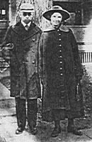
That spring while swimming in the Iowa River, one of my friends got out too far and was drowned. I heard his cry for help and rushed to a boat to go to his aid. The boat was securely chained and fastened with a padlock. Desperately I tried to break the chain with rocks but to no avail. Someone else brought him in but he did not respond to resuscitation. It was my sad duty along with another from the class, to go home with the body and attend the funeral.
Mac & Margaret Winter
I believe it was the next summer that I again decided to be a salesman for the summer and decided to sell aluminum cooking utensils. This turned out well, and I made a nice profit that summer. I think people felt sorry for me. Anyway they were very good to me, and I remember especially Mrs. Joe Blodgette of Central City, Iowa, who treated me like a son.

Soon my second year at Iowa was finished, and I was ready to enter medical school. There were thirty of us young hopefuls, and one of our first experiences was the meeting of our anatomy professor. His name was Prentice, but we commonly called him Prent or old Prent. If he liked you all was well, but how he loved to be sarcastic and make us poor freshmen tremble in our boots. He told us at our first meeting that a third of us would flunk his course and not be able to continue in the study of medicine. This prediction was correct. He always talked through his nose, and walked with a pronounced limp. I never liked him but he did teach me a lot of anatomy, most of which I have forgotten. Fortunately I was able to stay in his good graces and never as I recall got a public calling down as some of my classmen did.

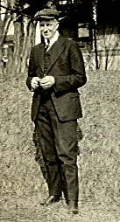
During my premedical days I met one young fellow whom I immediately liked and with whom I roomed for a part of my years at Iowa. His name was Bert Jongewaard. During our second premedic year we roomed in a little shack down near the depot and ate at the depot lunchroom. This suited us fairly well until my roommate’s sister, Maria, inspected the place, and because it was rather dirty and in a poor part of town, advised us to move. We then moved to a little brick house near the anatomy building where we finished our premedic year, and I think our first year in medicine. Our landlady had a very doubtful reputation, which I suspect was justified. We were always being ribbed by our classmates about the place where we lived. It was here that Bert, my roommate, got sick with some sort of a pulmonary infection, which was followed by pleurisy. After being in the hospital a short time he returned home and was not able to finish his year in medicine.
Bert Jongewaard

It was about this time that my finances became exhausted. It looked as if I would have to stop medicine because of lack of finances. I still have somewhere in my possession my old account book which showed a balance of three or four dollars and underneath is written “no prospects for any more”. My Aunt Jenny Wright learned of my predicament. Aunt Jenny was a maiden lady who had
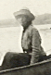
taught school in her younger days, and then for many years kept house for either her brother Joe or Sam. She was a very frugal woman and saved all that she made and lived to a ripe old age with enough to care for her declining years. I can still remember the joy with which I received her letter offering to finance my medical school for the remainder of my course. During the remainder of my medical course I had only to write her for the amount of money I needed, and she would forward it to me. I signed a note for the amount and took out a short-time lifeinsurance policy to cover her in case of my death. With what I could earn I was able to finish my medical school work with a total indebtedness of twelve hundred and seventy five dollars. This is about the amount it takes per year these days.
Aunt Jenny Wright

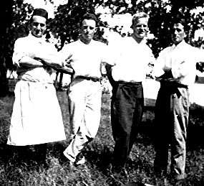
At the end of my sophomore year I was invited to become the camp physician for the Y.M.C.A. camp at Lake Okobojii, Iowa. The camp was named Camp Foster and many groups came to spend a period at the camp all summer. It was with some trepidation that I gathered together all the first aid medicines and instruments I could and then assumed the duties of camp physician. In addition to taking care of the scratches, the diarrheas, the poison ivy's and minor injuries, it was my duty to be a tent leader in all of the boy's camps. I was also supposed. to be on hand for swimming to render first aid in case of any accidents. The only serious accident I remember was a fracture of an elbow in a young boy, and this I promptly took to the doctor in Spirit Lake, who put on a temporary splint. Then I accompanied the boy to Souix City to his home doctor. During the girl's camps I had much more freedom as I did not have to be responsible for a tent group. I remember two or three of the girls were rather sweet on me, and I admired some of them as well. Of course, any romantic tendencies were strictly curbed by rules of the camp, so nothing came of these experiences. The two summers I spent at camp Foster were very happy ones interspersed with fishing in the lake, swimming and boating. The lake abounded with perch which were easily caught, and when I took a boatload of boys out I would fish as well, and we usually came in with a pretty fair catch. There were also bass in the lake and we occasionally caught them as well as bullheads or catfish.
Dr Winter, camp physician, 2nd from left–med school soph

One of my summers, I have forgotten which one, I got the job of stacking straw behind the threshing machine, which toured the country. It was a dusty dirty job and most of the owners preferred to hire it done rather than do it themselves, and consequently I had rather steady work stacking straw behind the threshing machine. I received forty cents an hour for this and worked ten hours a day which was more than the average wage at that time. I got so I could build a beautiful stack of straw and could handle the straw alone as it came from the threshing machine. In the fall I was very proud of the number of beautiful straw stacks dotting the country which I had built.

During my freshman and sophomore years I did fairly well in medical school. As I recall my grades averaged about a B. But upon entering clinical work in my junior and senior years they took a gratifying jump, so that there were a generous supply of A's scattered through the report. I, like every medical student at that time, was uncertain as to what field I would specialize in and considered rather equally medicine and surgery. I was left handed and a bit awkward with my fingers and not handy at tying knots, so after considerable consideration, I decided to specialize in internal medicine. I graduated from the College of Medicine, State University of Iowa in 1917. I remember that my mother and sister came to see me receive my degree. It was a proud moment. For a graduating present they gave me a bathrobe which I preserved for many years but finally discarded, about a year ago.

Following my graduation I took an internship in medicine under Dr. C. P. Howard, a nephew of Dr. William Osler. He was a large man with an English accent, born and raised in Canada. He talked a great deal about Sir William Osler. We used Osler's text in medicine and many quotations did we have from Dr. Osler as quoted by Dr. Howard. We had six interns: Foster and Secoy in Eye Nose, and Throat; Yoder and Morton in Surgery; and myself in Internal Medicine with Gundy who finished a half year later and was part-time intern while finishing his medical school work. Art Gunderson, Gundy as we called him, was a big tall fellow whose folks were wealthy farmers in Northern Iowa. He paid a great deal of his medical school expenses by running a threshing machine each fall, was on a football team or two and is now practicing Internal Medicine in Everett,
Washington. We were all busy people and I of course, felt that I had to work the hardest since I had to take care of a large share of the Internal Medicine cases. Dr. Howard was very good to me and often took me home to his house for dinner and seemed to like my work. Toward the end of the year, World War I was on and appeals were being made for volunteers. Some of the interns considered going but decided to wait until they had finished their internship. We, of course, entered the army immediately after our internship, and Dr. Howard one day said to me, I want you to go to a certain clothing store and pick out a uniform, the nicest one they have, and have them send the bill to me. This, of course was a great lift to a poor intern who didn't know where his next dollar was coming from.

Immediately after finishing our internship we entered the army. Dr. Yoder and I were sent to a medical officers training camp at Fort Riley Kansas, and were there for one month. There we learned to drill and take charge of troops. I shall always remember the cavalry horses they had there. We did a great deal of riding and thoroughly enjoyed these horses. After one month I was transferred to the Lafayette Division at Camp Meade, Maryland and was made Commanding officer of a casual medical detachment. This detachment was used for training medical troops, and as soon as they were trained they were then transferred to other units. After a very little time I was placed in command of Field Hospital 241, and had four or five other officers under me. It was about this time that the influenza epidemic broke in camp and we were activated and sent to a part of the camp where there were empty barracks. Here we set up a hospital and received all flu patients and in a very short time had between fifteen hundred and two thousand patients. All the more seriously sick patients were immediately transferred from our hospital to the base hospital and of course mortality was very high. My chief duties were executive in character. I had to supervise the hospital, see that proper food was ordered, and proper medical care rendered. Often I had to go to the base hospital for medical supplies. I shall never forget one day for some reason I went out to the huge tent which was used as a morgue. It had been impossible to secure caskets because of the huge demand for them and this huge tent was filled with bodies lying side by side down each side of the tent for at least one hundred yards. I traveled in those days in a side car of a motorcycle and my driver was a Negro. This Negro was with me and he took one look and then streaked away as fast as his legs would carry him. I don't believe that I ever saw a Negro as frightened as he was. However, he did return to the motorcycle and drove me back to my hospital after my business at the base was completed.

Our hospital had received overseas orders to be in readiness to sail. We had already sent over some of our officers and men to make arrangements for our landing and camping facilities when news came that the war was over. The first news, however, was false and while we were thirty miles from Baltimore we could hear the noise of the celebration resulting from the premature announcement of the Armistice. When the news really came our feelings were somewhat mixed. We were all disappointed not to have been able to get to France and do active fighting. On the other hand we were glad that the war was over.

Our own morale and the morale of the troops dropped rapidly after the Armistice. It was difficult to get the men to drill and the officers were not as keen as they had been. The only reprimand I remember getting in the Army was during this period. We had the troops out drilling. I turned them over to my first Sergeant, who was an excellent drillmaster, and went to my quarters and began reading a Saturday Evening Post. Old Colonel Sessions was out nosing around, noticed my absence, and came to my quarters and really gave me a dressing down.

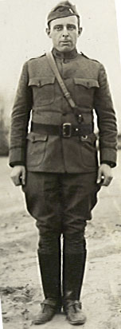During this period at Camp Meade I had opportunity to frequently visit Baltimore. We often went down to the docks and watched the ships come in and on occasion went out on boats for oysters. It was the custom to open them on the boat, add a little salt and eat them raw. I doubt if this was very sanitary but we enjoyed it. In Washington on weekend leaves we frequently took in the sights and on one or two occasions went out to Mount Vernon to view Washington's Tomb and the sights out there. It was during this period that I met Dr. Howard in Baltimore and he asked me to return to Iowa City on my discharge and be his assistant. This I considered very seriously, but I decided against it because of the small amount of money he was able to offer. Before being discharged from the Army, our Field Hospital had accumulated a huge mess fund and each unit was entitled to spend this for whatever entertainment we so desired. The men wished to have a big party and consequently we held such a party. Girls were brought out from Baltimore and the food was lavishly ordered. As I recall the party cost about fifteen hundred dollars.
I always felt rather guilty about this as it seemed to me it would have been better to have returned it to the taxpayer.
1st Lt. Winter U.S. Army

After saying goodbye to my trusty sergeants and packing my things, I left Camp Meade and have never returned. I then went to New York City, where I visited relatives and also visited Walton, New York, which was the birthplace of my Mother. At that time several cousins were living in this vicinity and they took great delight in welcoming me and showing me all of the places I had heard my Mother talk about. After visiting in New York and seeing the sights of New York City, I returned to Iowa, took off my uniform, and began to look around for work.

Dr. C. R. Harkan of Osceola,, Iowa offered me a job at $165 a month and board. This I accepted and for one year did general practice with him. Dr. Harkin was a hard worker and expected his help to work hard also. He turned over many night calls to me, and frequently I was called into the country to see patients. Sometimes the roads were muddy, sometimes they were snowy, and it was hard work. I recall one trip where I was trying to get up a muddy hill, and slid back down three times before I finally negotiated the hill. I delivered quite a good many babies, but one in particular I remember and shall never forget. This was a breech delivery and things seemed to be going very nicely. The hips and body were easily delivered but the after-coming head I could not deliver. As I became increasingly anxious and was putting increasing pressure from above and increasing traction from below, I felt the head collapse under my fingers and then the baby was easily delivered. I found on delivery that the baby was a hydrocephalic and that it could not possibly have lived even had it been born as it had other malformations. On many occasions I assisted in the diagnosis and operation of cases of appendicitis, hernia, etc. In those days operations were not so readily accepted as they are now and it was necessary to persuade the patient to have his appendix removed. Nowadays we sometimes have to talk people out of operations which we consider un-necessary, but in those days the reverse was true.

Dr. Harkan was just starting his surgery and so I always felt that I was of considerable help to him in building up his surgical practice. One day I had a small boy with an intestinal obstruction. Dr. Harkan was away and so I operated upon him myself. I was very concerned about the possibility of having to do an anastomosis and had a Murphy button ready in case this was necessary. However, on opening the abdomen it was found that the bowel was kinked by an adhesion and by freeing this adhesion the obstruction was relieved. The bowel was tremendously dilated and we had considerable difficulty in closing the abdomen, but the patient did very well and made a fine recovery. This I believe, is the only major abdominal operation I have ever performed. I did a few circumcisions, and I believe one or two tonsillectomies while I was at Osceola.

While there I lived at Dr. Harkan's home. He had a delightful wife and two small boys; Dwight and Alden. The boys were a little bit slow about dressing for breakfast, and I used to encourage them by racing them to the breakfast table. Dwight has since become a famous heart surgeon. Alden, during his first year at Harvard Medical School, developed severe multiple sclerosis and has since been confined to his bed almost completely paralyzed, but he still lives.

It was nice to be near the old home, and while I was too busy to go home frequently, I did get out there several times for an overnight stay. Some of the people who knew me when I was in high school became my best patients, and delighted, and still delight, to tell of the time they knew me when I was in high school. However, I decided that there was not too much future in partnership or in working for Dr. Harkan and so decided to enter practice for myself.

It was then that I purchased my first automobile. It was a Ford with a cloth top, small tires, and was started by cranking. One had to be careful in cranking it lest it backfire and break ones wrist. I was very proud to be the owner of a car. I remember the first car I ever saw. It belonged to a Dr. Mitchell at Osceola, and he brought it to town about the time I was a sophomore in high school. It had a chain drive. The hind wheels were much like those of a buggy with small hard rubber tires. The front wheels were a little smaller, and it ran at times and at other times refused to run. The horses which it met on the road or in town were very much frightened and it occasioned more than one runaway.

Anyway here I was ready to start my practice. I chose a small town in southwestern Iowa, which was a mining town and had no doctor. I shudder to think of what my end might have been had I established a practice there. Just as I was about ready to embark, I received a letter from my good friend, Dr. C. P. Howard, in which he stated that he had been thinking about me and had heard that there was a fellowship in Medicine available at the Mayo Clinic, Rochester, Minnesota. He suggested that I investigate it. I did so and in a few days was on the train for Rochester. There I was interviewed by Dr. Wilson, who was a kindly, sympathetic type of man. He asked me about my interests and what reading I did, and other personal questions and then referred me to some of the members of the staff. I met Les Powell, who was a graduate of the University of Iowa in the class behind me and he recommended the setup very highly. So without hesitation I applied for the fellowship. My wages were to be seventy-five dollars a month, and I was to pay all my own expenses. I returned home in high hopes that I would be accepted and shortly thereafter I received a letter stating that I had been accepted and was to start work the first of July. I sold my Ford to a neighbor, Charles Fitzgerald-who drove it for many years-and was soon established in Rochester.

My first service was with Dr. Griffin in the hematology department. The system was for the fellow to see the patient on admission to the section. He made a careful history, complete physical examination, ordered what laboratory studies he needed and made his diagnosis and recommendations. Then he called in a consultant, one of the men on the permanent staff, often the head of the department-who reviewed the history, physical findings, and diagnosis, and confirmed or rejected the diagnosis. Many of the patients were surgical patients and after the medical consultant had seen them we would call in the surgeon by means of putting on his light. It was in this way that I met Dr. Will and Dr. Charlie Mayo, founders of the Clinic.

Dr. Will was a very dignified gray-haired man, who was a keen diagnostician in his own right. I have never before or since met a man who could sense the correct diagnosis so quickly and make proper recommendations. I remember a particularly puzzling case, a young woman with pain in her pelvis in which he was called. He looked over my history a moment, asked the patient a few questions, examined her pelvis and said, "I think this woman has tuberculosis of her tubes and ovaries and I shall advise surgery." I have never known how he arrived at his conclusion, as there was nothing in the history or findings to my mind that suggested a diagnosis of tuberculosis. However, I do know that upon surgical operation the pathological report was identical to that of the diagnosis made by Dr. Will.

Dr. Charlie was of entirely different type. He was slow and easygoing, visited with his patients, and rather tended to accept the diagnosis presented to him. He had many interesting and bizarre theories as to the cause of disease. I remember one of his theories as to the cause of peptic ulcer, and the reason why men had them more frequently than women, was that the man of the house sat down to the dinner first while his woman fussed about getting it on the table. He then further theorized that the man drank his coffee scalding hot while the woman's coffee had a chance to cool off. This in his opinion was the reason why men had ulcers of the stomach more frequently than women. His opinions were not respected so highly as were those of his brother Will, but in the operating room he was a wizard. He was extremely clever with his hands and could do most anything easily and quickly.

An interesting sideline on the two brothers was that they were always praising each other. Dr. Will, particularly was always talking about his brother Charlie and some of his feats in surgery.

The Clinic then was rather a small organization with I should judge about fifty men on the permanent staff and an equal number of fellows. We knew each other pretty well, at least the fellows knew each other, and we had many fine times both in the Clinic and in social ways. Now the Clinic has grown so big that the permanent staff know only a few of the fellows and likewise the fellows themselves do not know each other.

I spent the first year at the Mayo Clinic as an examining doctor in various sections of the Clinic, learned a great deal, and saw, of course many cases of all kinds and varieties. At the end of that time I transferred to the Olmstead Hospital which had been established for research and study of cases in Medicine. It was headed by Dr. L.G. Roundtree. Dr. R.M. Wilder, and Dr. Fitz were also very active, also Dr. Norman Keith. They were studying chiefly hypertension, diabetes mellitus, and allied diseases. When I first started work there there was no insulin as yet discovered and diabetes was a very serious and often fatal disease. It was particularly fatal for children. While I was there news came of the discovery of insulin, and we were of course very anxious to get some. In those days a diabetic diet was high in fat and in the severe cases almost a starvation affair. In fact it was quite a regular practice to give diabetic patients, of the severe type, a day of starvation in order to re-establish their sugar tolerance.

I particularly remember a very severe diabetic child, a little boy of about seven. It was decided that if insulin was received in time we would use it on this boy. However, the boy died before the insulin was received, and so it had to be used on other cases. Dr. Wilder was particularly interested in diabetic cases and was working on the ketogenic ratio, in other words the ratio of fat and the ketogenic portion of protein to carbohydrate. I assisted him in this study, doing a great deal of the calculations of the results obtained in the various experiments and was more than pleased when Dr. Wilder published his paper and was kind enough to add my name to the title. This was the first time I ever saw my name in print in a medical magazine and I still retain some re-prints of the article.

It was about this time that Dr. George E. Brown joined the staff of the Mayo Clinic. He had formerly practiced in Miles City, Montana, and with the outbreak of the war had been associated with the Rockfeller Foundation. He was assigned to my service, and I became his assistant. He of course, was not accustomed to the detailed physical examinations, and detailed histories which were required and it was my good fortune to steer him along until he got on to the ropes. He was quite a brilliant man, full of energy, and wrote extensively after I left the Clinic. He finally died of pneumonia but also had severe hypertension.

After a little more than two years at the Clinic I began to question whether or not I should finish the Fellowship of three years and perhaps stay on at the Clinic as I might have, or go out into the practice of internal medicine. Dr. Brown stated that the Clinic in Miles City where he had worked, was in need of an internist, and he suggested that I take the position for a few years and then if I desired, finish my training. This fitted pretty well into my plans, since I was anxious to get married, was still carrying the debt which I owed to my aunt, and was having a very hard time making ends meet on the seventy-five dollars a month allowed by the Clinic. So in February of 1922, after meeting Dr. J.H. Garberson at Rochester and discussing the matter with him, I decided to come out and look the place over.

The morning I arrived the thermometer registered forty degrees below zero. I stayed at the house of Dr. M. C. Pfunder, who was doing eye, ear, nose, and throat work for the Clinic, and whom I had known slightly when he was at the Clinic during my first year. After dinner at his house, I decided I would take a walk and walked out toward the reform school. I looked over at Signal Butte, which did not look very far away, and thought I might walk out across the fields in that direction. I got through the fence and started out across the field when Dr. Garberson drove up and honked his horn at me, so I returned to the car and he explained to me that it was forty degrees below zero and that Signal Butte was further away than it looked. He then drove me around town and showed me the town and surrounding country. In February it looked pretty barren and rugged to a boy who had been raised in Iowa.

The next morning I made rounds with him at the hospital and interviewed the business manager, Mr. McCarthy, at the Clinic, and also met Miss Flora McDonald who was then doing all of the laboratory and X-ray work for the Clinic. I asked, as a starting salary, five hundred dollars a month. So I returned to Rochester rather undecided thinking that perhaps I would not accept the position. On my return, however, they wrote me saying that while the starting salary would be three hundred fifty dollars, they would hope to raise it as quickly as possible to my figure. After considerable debate I decided to accept the position and agreed to arrive the first of April, 1922.

After a short vacation at home on the farm, and a visit with my sweetheart in Orange City, I departed for Miles City to establish my practice. On the first day or two after arriving I saw patients, and was getting along nicely when Dr. W.W. Andrus, the senior member of the firm, asked me to go out to Angela to deliver a baby which he did not have time to do. I had no car at that time so I rode out to Angela in a truck and found the woman in labor at her ranch home. The labor proceeded very slowly, in fact the woman was making no progress, and so after a reasonable time, which I believe was most of one day, I sent word to Dr. Andrus that I thought he had better come out and deliver the baby by forceps. This he did and soon we were back in town. Dr. Randall and Dr. Andrus did all of the obstetrical work but occasionally when they were out of town I would deliver a baby or two. I recall that I delivered at least one set of twins.

I had little difficulty in fitting into the Clinic. I immediately started doing the fluoroscopic diagnostic work and was soon very busy. Before I knew it September had come and this was the month of my wedding when I was to bring my new bride to Miles City.

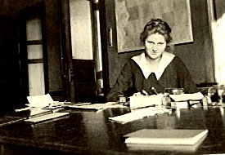
I had first met my wife-to-be, Martha Jongewaard, in Orange City, Iowa. The occasion was a reunion of the group who lived at the Carr House. It was decided to meet at Bert Jongewaard's home in Orange City as this seemed a fairly central location and I believe it was about at the end of my junior year in medicine. There we met Bert's father and mother and of course his charming sisters, and two small brothers.
Martha Jongewaard in County Clerk & Recorder’s office Orange City, Iowa

Father Jongewaard, as I later knew him, was a quiet man with a beard, a great student of the Bible and deeply religious. Mother Jongewaard was a charming woman, a good manager and a fine cook. Willie and Hallie had already gone into the mission field in India and I did not meet them at this time. However, there was Jean, whom I had met at college, and Maria also, but the two younger sisters I had not met, Esther and Martha. I suppose I might have been influenced by my roommate, Bert, who thought his sister, Martha the nicest of all his sisters. Anyway I was much impressed with the beautiful young lady who sang so beautifully and it was not long until I was writing to her regularly and making arrangements to occasionally get to Orange City for a visit.

It was during my internship, I believe, that she was in the hospital a little while for some dental work and possibly a tonsillectomy. I remember I visited her once in my Army uniform and we had some long walks and talks together. I was a little discouraged I remember because she expressed herself as not believing in long engagements and of course since she was planning her nurses training, and I was in the Army, there was little hope for anything but a long engagement. However, the letters continued and after I got out of the Army and started practice in Osceola, I again went to Orange City to visit her. I remember the night when we were sitting together in the hammock, when I rather stumblingly proposed to her, and she accepted me. Her father and mother were away some-where at the time, but about midnight we went into the house and announced our engagement to the assembled sisters, who I believe were suspicious that something was in the wind and were waiting up for us. The next morning I had to return to my practice in Osceola and remember the ride to the little town of Alton about three or four miles from Orange City with my sweetheart by my side. Martha then went on to her nurses training and I to Rochester for further training. After about a year of training, however, Martha developed a furuncle which must have given her a systemic infection, for she developed then a severe pleurisy with effusion and returned home to recuperate. This took, as I remember, about six months. By this time I was getting very anxious to get married and was able to persuade her to give up her training and come to Miles City to be my wife.

The wedding was to have been on September sixth, and Bill and I reported on time. However, Martha's Aunt Jane had died, so the wedding was postponed for two days and our wedding was set for the eighth of September. Bill was to be my best man. I roomed at the house next door to Martha's home and had a dress suit which I had borrowed for the occasion. I remember that afternoon the lights were off for a while, and I was rather nervous, so much so in fact, that I had a great deal of difficulty tying my bow tie, and finally had to get the man who owned the house where I was staying to tie it for me.

We were married in Martha's home before a bower of daisies. The wedding songs were I Bring You Heart's Ease and The Lord Is My Shepherd. Martha looked beautiful in her bridal gown, coming to me very sweetly on her father's arm.

After the wedding and reception Martha and I soon were off taking the train at Alton for Minneapolis. We honeymooned there for about a week, staying at the Andrews Hotel. We saw the Art Gallery, Minnehaha Falls, and all the sights, besides having a delightful time getting really acquainted with each other as husband and wife.

Soon our honeymoon was over and we were on the Milwaukee train for Miles City. I had rented a furnished home at 707 South Center. This was completely furnished with furniture, dishes, and all the necessities, and was a cute little place. I paid fifty dollars a month rent for it at that time.

We were met at the train by the Clinic Staff. They had purchased a very nice reading lamp as a wedding present and escorted us to our new home.

Soon we were settled there and began our life together, which has gone on sweetly for these thirty-one years. I have always been very thankful that God was so good to me as to give me my darling wife, Martha. We lived in the little house very happily for three or four years at which time we bought a house at 619 South Lake Street and moved over there. It was a cute little house. We did considerable remodeling and repainting and bought our own furniture and lived there very happily for many years. I do not recall just how many but I believe about ten.

We had been married five years before our first baby came. We had been hoping for children for some time and were more than happy when we knew we were going to have our little gift from heaven. Martha developed high blood pressure and albumin in her urine during the latter part of the pregnancy and this occasioned considerable concern. She was on a very limited diet for at least a month before the baby came. Esther came out to be with her a short time before the expected time, and Martha was in the hospital for some little time before the labor started. It was a long and difficult labor and forceps were required before the baby was born. Finally on March 12th, 1928, our darling daughter, Peggy, came to be with us. She was very tiny. Her birth weight was five and one half pounds. There was a quite a bad forceps mark on her temple and she still carries a small scar on the temple from this incident.

One of the sweet memories of this period is a picture, which we remember of Esther holding the tiny baby in her arms and rocking her and singing oh so sweetly, Danny Boy.

Not long after the baby was born we received word of the serious illness of Father Jongewaard. He was living at Ames at that time and had a severe pneumonia. Esther returned home to be with him, but of course Martha was unable to travel and in a few days we learned that he had passed away. It was a great sorrow to Martha that she could not attend her father's funeral but the sweet new baby engaged all of her attention. Soon mother and babe were back home again and the new father and mother were anxiously watching over their precious babe.

I remember that we placed the crib in the little room adjoining our bedroom, but every move the baby made one of us was up to investigate and see that all was well. It seems now as if it was no time at all until she was a rollicking baby girl. We had made the long car trip back to Iowa to show her off and soon we knew that we were to have another child.

Again Martha developed high blood pressure and albuminuria, and again she was placed in bed on a very limited diet. This time Mother Jongewaard came out to be with her and help out. Margaret Louise was trundling around in her little kiddy car, and one afternoon they heard an awful crash as she started tumbling down the stairs. Mother Jongewaard rushed to pick her up and found her unhurt, but the shock of the experience was enough to start labor and so Malcolm was born, about a month prematurely. And so on June 8th, 1928, a tiny baby boy came into our life and home.

As I look back over their childhood days and the happy home we had together, it seems all too short. They have been very precious children to us and have never given us any cause for worry or concern.

Now Malcolm is a senior in medicine. He is engaged to be married and soon will be starting a family of his own. Peggy is a missionary in Japan having completed a year of language study and is entering into a rich and happy life in the service of her Lord and Savior.

Mother and I are growing older, but are joyful in the progress that our children have made. One of the sweetest things about our family life has been our Christian Fellowship. We have always had a family altar. We have all met together about the Throne of grace and have felt that all our lives have been God-planned, and that has made us very happy.

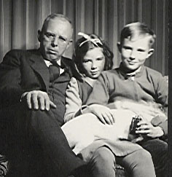
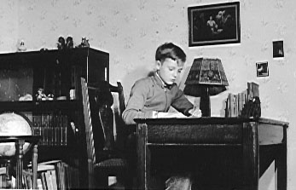
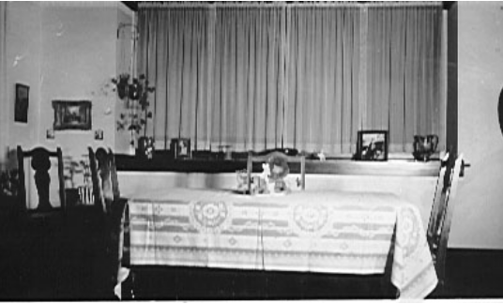About fourteen years ago we moved into our present home at 1917 Main Street. We traded houses with a Mr. and Mrs. Harry Michaels, they taking our smaller house and we the larger one. We did an extensive remodeling and painting job and have been very pleased with our present home. The children were not anxious to move, and I remember we had to promise them a new bicycle so that they could get back to the old haunts easily before they would consent to do so. Peggy wanted to stay with her little friend, Grace Youdan, and not move at all, but adjustments were soon made and we were soon well established in our new home.
Dining room 1917 Main 1938 looking west
Me with my two children & dog Spot
Malcolm studying in his room 1938

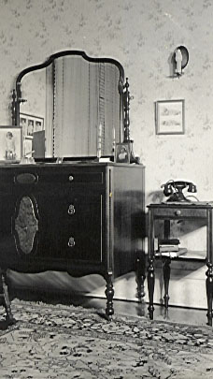
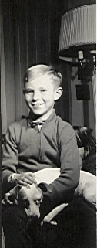
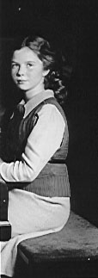
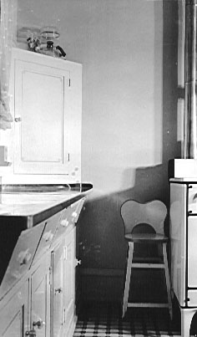
Our bedroom 1917 Main 1938 with phone next to bed
Northwest corner of kitchen 1917 Main 1938
Malcolm & Spot
Peggy at piano

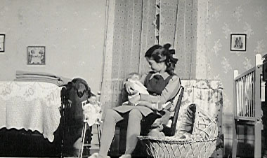

S.W. corner of kitchen

Peggy in her bedroom with her dolls
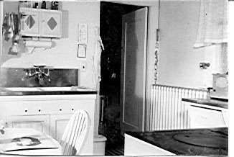

The early days of my practice at the Garberson Clinic were busy ones. The Clinic was first located over what is now the Nash-Ackers Automobile Sales room, and was very cramped. The waiting room was small and the rooms where we saw patients were just cubicles. After a few years it was decided to form a corporation and build a Clinic building. By combining with Mr. George Foster, who owned the drug store on the corner of Seventh and Main, this was accomplished and the Colony Building was built. This was thought to be large enough for all our needs in the distant future, but as of 1953 we are already out-growing it.
S.W. corner of kitchen

Our business manager was Mr. E.S. McCarthy, a very pleasant chap, who as far as we could tell ran the business very efficiently and was liked by patient and staff alike. We were very shocked later in the years of the Clinic to find that he had been gambling and had been taking Clinic funds. Since Dr. Andrus and Dr. Garberson were the owners of the Clinic at that time, we of course had nothing to do about it and Mac, as he was familiarly known was allowed to sell his house and reimburse the Clinic for the funds he had taken. I never would have believed that the accusation was true, except for the fact that he himself admitted it.
Peggy in her room 1917 Main, 1938

It was also at about this time that Dr. Garberson began to have family trouble, which eventually ended in his divorcing his first wife and marrying Miss Helen Coleman who was then a secretary at the Clinic. This, of course, caused a storm of criticism from the town and Mrs. Garberson number one, and Garby would take turns crying on my shoulder.

Dr. W.W. Andrus was a pioneer physician, having been practicing in Miles City for many many years. He was a general practitioner and never, while I knew him, ever cracked a book or looked up anything or made any attempt to keep up with the progress of medicine. His chief asset was a good story. Of these he had a large supply and could sit down at any patient's bedside and soon have him smiling and laughing at the many funny stories he could tell. At about the age of seventy, Dr. Garberson asked him to leave the Clinic and he purchased the share of the Clinic from him. Dr, Andrus was very hurt and began to practice by himself. In caring for a case of erysipelas he contracted a very severe infection in his hand and arm and in those days there were no antibiotics to combat infection with, and thus he died. With all of his faults I always liked Dr. Andrus and felt that when he died I had lost a good friend.

Dr. X. C. Pfunder, who was here when I came, remained for about ten years. His father, who was a pharmacist, had invented a stomach remedy which was known as Pfunder's Stomach Tablet. This was widely advertised and widely used and made the father about a million dollars. He urged his son to enter the company but this the son refused to do, preferring rather to continue his practice in medicine. However, he did induce him to come to Minneapolis and set up an eye, ear, nose, and throat practice there. He died of cancer of the stomach in 1950.

He was replaced by Dr. E.H. Rowen who practiced with the Clinic until about five years ago when he left the Clinic and set up practice for himself in Miles City and helped organize a group in competition with the Clinic.

Dr. R. R. Randall also was a valued member of the Clinic and remained active until almost the age of seventy, when following a coronary heart attack, he retired but still lives in Miles City.

Dr. Elna Howard also joined the Clinic about twelve years ago, and has continued as an active part, practicing obstetrics and pediatrics.

Dr. S. C. Pratt came to the Clinic as an assistant for Dr. Garberson and faithfully assisted him for several years. He then was called into the service, but returned following his term of service in Europe and has remained in the Clinic, doing the surgery, up till this time.

Dr. H. D. Harlowe was hired to replace Dr. Rowen in the eye, ear, nose, and throat department.

Then we were joined by Dr. H. E. Brogan who did general practice and obstetrics.

About a year ago Dr. Warren Randall joined the Clinic after a thorough training in surgery at the Mayo Clinic and a year of practice at a clinic in North Dakota.

Our business manager, Mr. George Fry, also came to the Clinic following McCarthy's resignation and has been associated with the Clinic ever since.

In August 1950, Dr. Garberson passed away. He had had a bad heart for several years, had been urged to stop working, but because of his domestic troubles felt that he could not do so. He did a spleenectomy on the first day of his last illness and then following this was confined to the hospital for a short time.

Upon his death it was necessary, of course, to re-organize the Clinic and a partnership was formed. The partners consisted of myself, Dr. Elna Howard, Dr. S.C. Pratt, Dr. H.D. Harlowe, and Dr. H.E. Brogan. This year Dr. Warren Randall has also joined the partnership and will become a full partner at the end of five years.

The practice of medicine has changed a great deal since I started to practice medicine. One of the most difficult fields in the practice of medicine, when I came here, was the treatment of pneumonia. Patients would come in extremely ill, with high temperature, rapid respiration, and usually pneumococcic pneumonia. They would run high temperatures, usually from seven to ten days when they would have a crisis. The temperature would suddenly fall, and they would recover, providing they had not died before the crisis came. Mortality was very high, and we were always trying new treatments. Finally a pneumonia serum was worked out, and then it became necessary to type the pneumococcus in order to administer the proper serum. Next we heard that they had developed a drug in England called Sulfapyrodine, which was of great value in treating pneumonia. Then followed the sulfa era with various forms of sulfa being tried and discarded for newer and better ones. Then came penicillin and the other antibiotics which are in wide use now.

Pernicious anemia was a uniformly fatal disease, and it was felt that the patient would die in at least the third remission. The only treatment we had in those days was repeated blood transfusions, and this was done repeatedly in many cases. Then came liver extract and Vitamin B12 folic acid, etc.

Insulin was unknown as I have previously reported in this biography. Now the diabetic may have a generous diet and do almost everything that anyone else can do providing he takes his proper dose of insulin.

Hospital rates have steadily increased. When I first came here the rates varied from two and a half to three dollars a day, and five dollars a day was tops for a very special room. Now the cheapest accommodation possible I believe is eight dollars a day and the better rooms around fifteen. When I came here what is now the old hospital had just been renovated and a new wing attached. We felt in those days that it was a very fine hospital. In the past three years, however, a new hospital has been built and the old hospital turned over into an obstetric and geriatric hospital.

And so things change and progress, and the few things that I have mentioned are only a very few of the many important changes in the practice of medicine during the thirty-six years which I have been in practice. As I look back over the years in Miles City, I think of the many fine loyal patients whom I have cared for and many of whom have passed on to their reward.

Our children have grown up. Peggy was first to leave home, going to Wheaton College as a freshman. She had graduated with high honors from our local high school and did well at college and in four years received her Bachelor of Arts Degree. During her years in college she had dedicated her life to her Savior and decided to be a foreign missionary. As further training for this she went to the Biblical Seminary at New York and spent two years there, receiving her Masters Degree in Christian Education. She had by this time joined the Conservative Baptist Church and was appointed as a missionary to Japan. Following about a year and a half of traveling from church to church she was able to raise her support and on March sixteenth, 1952 she sailed for Japan. Mother and I went with her to San Francisco, where I took a post-graduate course in internal medicine while Peggy and Mother visited relatives and friends. While we were there we had a fine time with our California cousins and had planned to see Peggy sail away. However, the freighter on which she sailed was carrying Army supplies and was to leave from an Army pier. Sailing was delayed and so we were unable to wait for the boat and our last glimpse of our darling daughter was as she stood waving at us as our train pulled out for Montana. Now she has been away for a full year, and we are already looking forward to her first furlough four years from now.

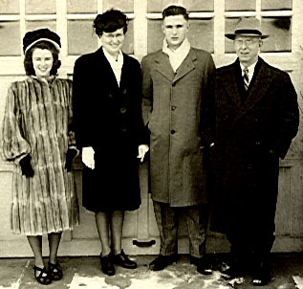
Malcolm was Valedictorian of his high school class, having finished his high school work in three years with the addition of one summer school session. He too went to Wheaton and after four years received his Bachelor of Arts degree and then applied for admission to a medical school. The schools were especially crowded at this time because of many boys who had served in World War II and were using their rights granted them by a grateful country to continue their education at government expense. For a while it looked as though he would not be able to enter medical school, and it was with great joy that we received word that he had been admitted to Northwestern. Now he is a senior medical student at Northwestern and will soon be starting his internship.
Winter family about 1946

While in Chicago he met a fine, lovely, Christian girl, Miss Beth Tate who is taking nurses’ training at a Swedish Covenant Hospital where he externed. So now he is engaged to be married and plans to be married next November. On completion of his internship it will be necessary for him to serve for two years in the armed forces, this service having been deferred in order that he might secure his medical education.

I suppose that one should not close an autobiography without giving due credit to those who have had so much to do with whatever little success I have had in life.

I think first of my mother. She was born in New York State, near Walton,, New York, and her maiden name was Wright Her mother married a widower with older children and I have heard my Mother speak many times very affectionately of her step-sisters. Mother had one other sister, my Aunt Jennie, and three brothers, Sam, Joe, and Malcolm. At an early age her father died from typhoid fever and resultant hemorrhages. Her mother then moved in to Walton, New York and assumed the raising of her little family. There Mother went to grade school and also to the Academy. Only a small percentage of people in those days had more than a common school education. After teaching school a while she decided to come west and there joined her brothers, Joe and Sam, who had already come to Iowa and were farming. Here she kept house for them for a while, and I believe taught a term or two of school.

One day a handsome man stopped at the house. He had come from nearby Sibley to hunt prairie chickens and had a bird dog with him. It developed that William Winter had also been born in New York State in Lavina, a town only about twenty or thirty miles from Walton. A friendship struck up and soon culminated in marriage.

For a time I believe my father did carpenter work and then purchased a butcher shop in Sibley and ran this for a while. It was not too profitable, I believe, so he decided to start farming. By that time he already had his four children; James, William, Malcolm, and Margaret. He purchased a hundred and sixty acre farm in Northern Iowa in Lyon County about six miles northeast of Little Rock, Iowa. He had only a little stock and a huge mortgage on the farm.

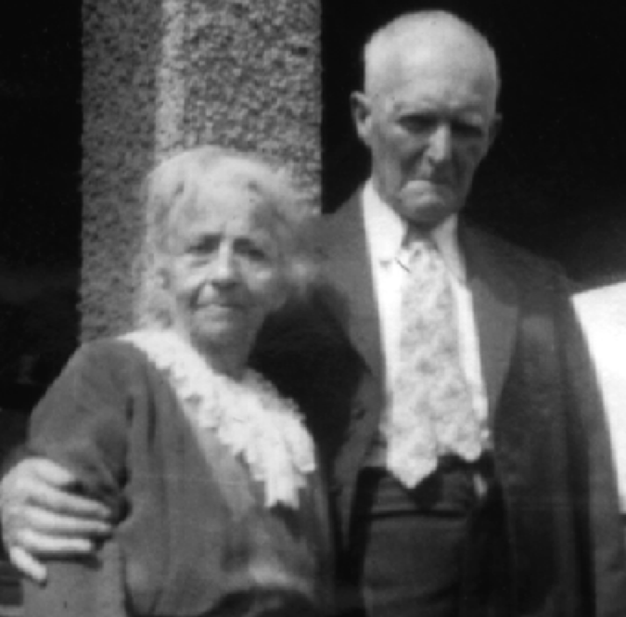It was on this farm that most of my early memories of mother were formed. She was quite a short woman, always rather plump and had a beautiful soprano voice when singing. She had been raised in the city, and farm life was hard for her to adjust to. Sometimes she became very discouraged with her situation and referred to herself as “an old cow staked out on the prairie." Mother was a deeply spiritual woman and taught her family to love God and to live an upright life.

In her younger days she did a great deal of oil painting, in fact taught painting in Sibley, Iowa, when she lived there and had a great eye for beauty. I am sure that what little appreciation I have for the beauties of nature and for beautiful things was instilled into me by my mother. Often when we children quarreled she would say, "When little birds in their nests agree, It’s a shameful sight to see little brothers and sisters fall out and quarrel and fight.
William & Maggie Winter 1938
Wherever she went she started a Sunday School, both in Northern Iowa and also when she later moved to Southern Iowa. Sunday afternoons we always gathered around the little melodeon, and there we sang the sweet old hymns, she with her clear soprano, Dad singing either tenor or bass, and we children with childish voices chiming in on the tune.
Maggie & William Winter

Mother was always very ambitious for her children and it was she, I am sure, who urged me to finish my education. She grew old very gracefully, and was always interested in everything, including world affairs, good literature, and especially in Christianity.

My father was man of about five foot eight, of medium build, always fairly strong, but not excessively so. In my childhood days I remember him as a man with a large brown beard. One day he went to town and had it shaved off, leaving only a mustache. When he came home, we at first did not know him. He was always good to us kids and provided for us to the best of his ability. He was always very calm and rarely scolded us for our misdemeanors, and if he did scold us it was only very mildly. He was always looking out for us and urging us to be careful and not work too hard or get too tired. Through all of his lifetime he did not have very much money and lived a very frugal life. As he grew older he read extensively and would sit by the hour reading the Saturday Evening Post and other periodicals. In his old age he read the Bible through two or three times. He was a dear dad and I loved him very much.
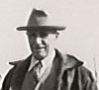
My brother, J. W. or James, was a somewhat mischievous child and loved to tease. I remember one of the early stories I have heard about him when we still lived in Sibley was an episode where he was attempting to comb a neighbor girl's hair with a garden rake. I think Mother had to punish him more than the rest of us children. I remember very well several times when she had to turn him over her knee and use the hair brush on his bottom. On one occasion she used it so hard that the hair brush was broken and this distressed her very much as they were hard to come by. Some of the details of his education and our association through the years are contained in my biography. Now he is a successful veterinarian, practicing in Norwalk, Iowa.
Dr. James Winter

Bill and I were more or less pals through our boyhood. In Northern Iowa we called him Ray, as his second name was Murray, William Murray. He did not like this name and when we moved he requested that his name be changed to Bill, which it has remained. Bill and I in our boyhood went swimming together and were in many adventures together. I have already mentioned the trips we took in our youth to various places to work. Bill always loved farming and elected to stay home and run the farm. I have always felt very grateful to him for furnishing such a wonderful home for Mother and Dad in their declining years. I feel that Bill would have made a success in any field that he might have entered. He always had a very happy nature, was not easily disturbed or worried.
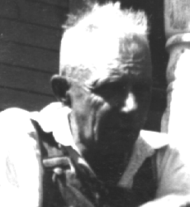
Bill Winter 1950
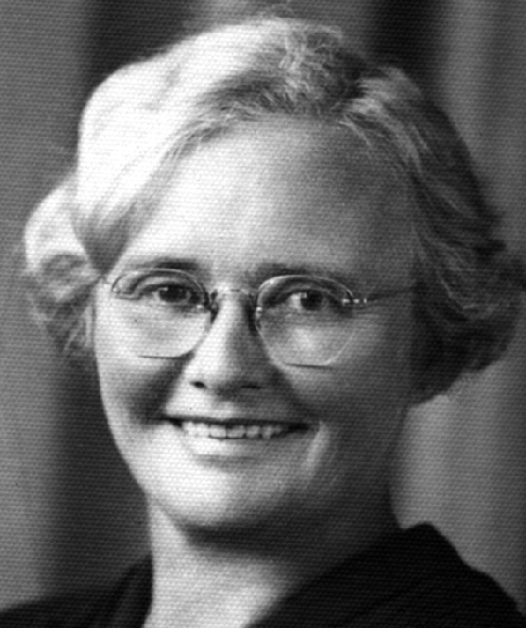
My little sister, Margaret, I first remember as a tiny little towheaded girl in Northern Iowa. Dad used to call her Dovey. She too would frequently join Bill and me in our various undertakings and many of the fine times we had together. After moving to Southern Iowa she too went to Jones School and finished there. She too stayed home and kept the home fires burning. In Mother and Dad's later years she nursed them tenderly and kept them happy and contented. At about the time I was an intern, on my urging, she had decided to take nurses training and entered the University Hospital at Iowa City for this purpose. Everything was going along nicely, but a short time before she was to enter training she had an ulcerated tooth which was extracted by a dentist who was reputed to be not too clean. Anyway she had a lot of trouble with this infection, and when she entered training developed a rheumatic condition of her feet which required quite a little stay in the hospital. Because of the condition of her feet and general health it was decided that it was unwise for her to continue her training. She returned home and has since, as stated before run her end of the farm with efficiency. To her also I owe a great debt of gratitude for the tender care she gave my parents all through their declining years.
Margaret Winter 1950
Bill Winter

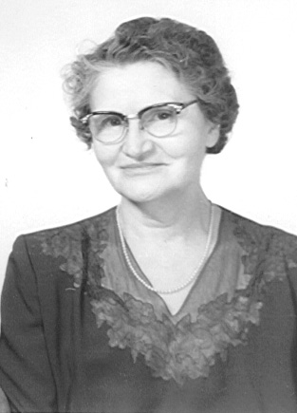
To my wife, Martha, I also owe a great debt of gratitude. We have had a happy wedded life together, and she has been a homemaker in the truest sense. To her, of course, I owe my two lovely children, and they have grown up to be such fine people, children of which any parent could be proud, because of her training. For this I am very grateful.

Our home has been founded on Christ and from the moment we knelt in prayer together after our marriage, until this time, we have felt God's guiding hand. Through the years our family altar has been a precious institution and now we can feel that we and our children are bound together in the Blessed Tie which binds our hearts together in Christian love.
Martha Winter

And so I will bring to a close this little autobiography which covers the sixty-one years of my lifetime. There are many things that I have omitted perhaps that might have been of interest and perhaps some things which are included which are rather uninteresting, but anyway it will perhaps give you some idea of the life history of yours truly.
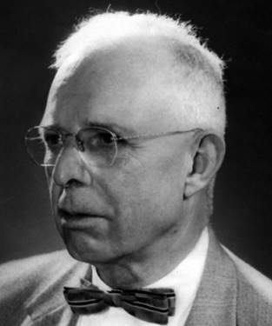
Malcolm Winter Sr. 1964

