Early Memories
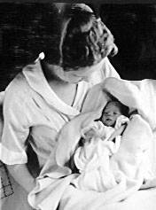
My earliest memories date back to the time I was about 4 years old. I can remember a top - the kind you got spinning by pushing a spiral rod down, raising it up, pushing it down again. I think that must have been a present given to me when my tonsils were taken out.
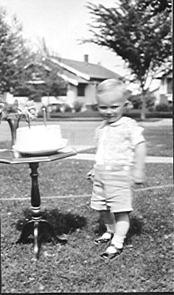
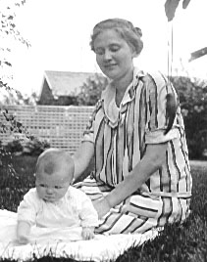
My early childhood was spent in a 2 bedroom house at 619 S. Lake Street. We had a black cat with a white face, named Smutty. Also later a terrier dog named Spot. A big elm grew on the front curb and next to it was a fire hydrant. A little sandbox was located in a nook by the southwest corner of the house. I used to ride up & down the sidewalk on a little 3 wheeled tricycle. One of my good friends was Jimmy Golden who lived 2 doors down on our side of the street. Youdans lived across the street to the south, Inghams across from us on the other side of Lake, Boesphlugs north, next to us - then Goldens. Bergs on the north end of our block. Heckmans 2 doors north from Inghams. There was a vacant lot next to Youdans, and we used to make caves in it. Also carve out little rivers and canals with tunnels underneath.
1st picture
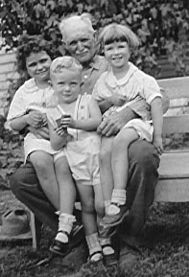
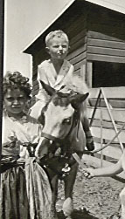
I attended Lincoln School 4 blocks north of us on the other side of Lake Street. When I first started school, I used to write on the blackboard - first with one hand, and then with the other. The teacher didn’t care which hand I used, but she decided I should use one hand exclusively - not both. I can still remember being taken to a room and asked which eye I could see best out of, which ear I could hear best with, and which hand I used for what. My father was left handed, & I remember that I wanted to be like him. Therefore I always indicated “left”. The final part of the test was to have me write my name on the blackboard - first with one hand and then the other. I remember scribbling my name with my right hand and carefully writing it with my left. Conclusion was made that I was left handed, and I was told to do everything with my left hand. Near the end of the 1st grade I started printing everything rather than writing. I came home with D’s in penmanship. By the time I was ready for 7th grade, I was in real trouble. We used to vacation in Iowa every summer, and my folks took me to U. of Iowa at Iowa City. There they gave me an Angle Board Test. A hinged board is set in front of you. You are given a pencil in each hand, blindfolded, and told to place the pencils in notched pattern circles. You trace these a few times and then the patterns are withdrawn, and you are told to draw the notched circles free hand, both at the same time. As you do this, the hinged boards are angled back. You reverse the pattern with your non-dominant hand, and keep drawing it correctly with your dominant hand. That test showed that I was more right handed than the average right handed person. Thus at that point, I had to learn to write right handed. I spent all summer being tutored, and also went to business summer school and learned how to type. My writing 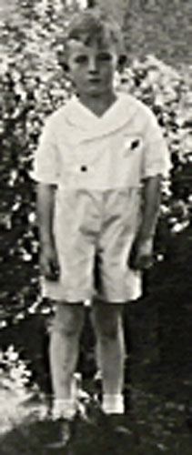improved and was pretty decent, until I had to write copious notes for medical school lectures. It deteriorated then and has been bad ever since.
2nd birthday
Age 3 with cousin Jane, Grampa Winter and Peggy
My grade school memories include piano lessons by an elderly lady with white hair named Mrs. Hatfield. I remember her spending quite a bit of time with me trying to get me to identify different notes as she played them. I was never successful at this and to this day still have trouble knowing if I am on or off key. At home I found practicing for my piano lessons quite onerous, but I stuck out the assigned time.
Age 4 on pony at Uncle Jim’s farm
When I was quite small the folks hired Bella to help care for the house and us children. She was a Scot with dark hair pulled back in a bun - talked with an accent. She fell in love with and married Duncan McKenzie, a rancher from Cohagen, Montana. Her replacement was Eva Kahl, and she stayed with us until after we had moved to Main Street.
Age 6
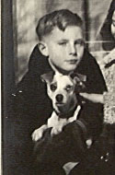
About the time I was in the 6th grade, we moved to 1917 Main Street to a much larger house. The folks traded with the Michals. For the first time I had my own bedroom and didn’t have to sleep with my sister. My dog Spot unfortunately was a car chaser. On much busier Main Street, he had a hay day. However he paid the price by getting run over about a year or so after we moved. My folks were gone at the time to New Mexico to be with my Aunt Maria, & I was devastated. I never wanted to get another pet, but my sister prevailed on getting the folks to get another dog a year or so later. We named him Flash. He was ½ Springer spaniel & ½ cocker spaniel - black with a white spot in the center of his forehead. I taught him to stay in the yard. He was very good about this unless a female dog or a squirrel tempted him to break the rules. He wore harness, and used to pull me on my bike or on roller skates at fairly breakneck speeds.
Spot
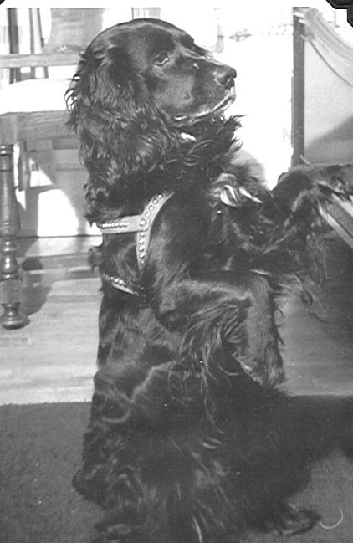
Every summer my parents would travel back to Iowa to see their families. On my mom’s side most of the family along with my grandmother lived in Jefferson, Iowa, and they would usually arrange a Jongewaard family reunion for when we were there. Since Mom had 8 siblings, and usually most of them would be there with their families, these affairs would turn out to be attended by a huge crowd of people. One of my male cousins, was about my age, and he would often coax me into doing things, I didn’t usually do, like going out behind my Uncle Bert’s barn to smoke corn silk.
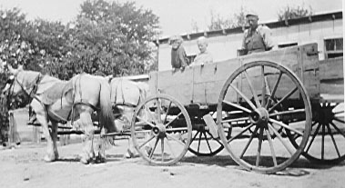
My dad’s family lived on a small farm near Truro, Iowa, 30 miles south of Des Moines. His brother Bill, & sister Margaret had remained single and stayed on the farm - Bill to do the farm work, and Margaret to care for my grandparents. In the early years the farm had a crank party line telephone, but no electricity. The only way to keep things cool was to lower them into an old well hole covered by a little shed with a rope and pulley mechanism. What an improvement it was when my dad bought them one of the early propane refrigerators. Electricity didn’t come in until the late 1940s. Cleaning kerosene lamp chimneys was a task I did fairly regularly. At times the folks would let me stay on the farm for fairly prolonged periods. My uncle Bill had a fine sense of humor. Gambling was forbidden in our family, but Uncle Bill was always betting me milk shakes (bought when we would go to town), that I could or couldn’t do this or that. One time when I was about 7 or 8 we were riding home in the hay wagon and he bet me that I couldn’t pee off the back of the wagon while it was in motion. He won the bet. Later as I grew older I was permitted to help plow the corn, and help in other work. The farm had two teams - 2 mules, and 2 horses. Uncle Bill plowed with the horse team and I with the mules - Joe and Jenny. One time we came home for lunch and I was unhooking the team so that they could be watered and fed over the noon hour. Somehow just after I had them unhitched from the plow, but still in their harnesses, and singletrees, they spooked and started running. I grabbed the reins trying to stop them, but to no avail. They pulled me behind them and one went on one side of the hog house - the other on the other side. The harness got torn to bits. Needless to say, my uncle wasn’t very happy.
Peggy and myself with Uncle Bill by the chicken house
Flash
Farm work also included milking about 5 cows by hand every evening. The barn was always cozy and warm with the sweet smell of hay. You would sit on a little 3 legged stool and squirt milk into a stainless steel bucket. Every so often you would aim a squirt at one of the many cats around the place. They would catch it directly in their mouth. The cow’s tails would frequently swipe across your face if you weren’t careful. After milking the milk would be poured into a hand powered separator. The cream would be saved and often hand churned into butter. The skim milk would be fed to the hogs. Every evening eggs would have to be gathered. Every Monday morning was wash day. The wash machine was gas engine powered and would make a lot of noise. Water would have to be hand pumped from the well outside the kitchen door, heated, and then poured into the wash machine. After everything was washed it would be hung up on the clothesline in the front yard to dry. Also included in a days activities would be fence mending, cleaning animal dung out of the barn into the fertilizer spreader, and then having the horses pull it to the field you wanted to apply it to. It had a whirling spreader mechanism in the back that worked pretty well once it was put in gear. Once a week, the weeks supply of sour cream and eggs would be taken to Truro and sold. In the early days a model T Ford was our means of transportation. Later when Dad purchased a Chrysler, he gave our old Dodge to Uncle Bill. Bill in turn traded the Ford for several gallons of sorghum and a certain amount of cash. Evenings after a hard days work we would sit out on the front porch (which faced south) and watch the fireflies over the front yard. Also frequently would see amazing displays of lightning and thunder.

In highschool I developed several friendships. Bob Lynam, and I had an interest in model railroads. We built a pretty good track layout in our basement. Had a Sears model train with quite a bit of track and 4 electric switches. Bob Mosby and I were interested in chemistry and rockets. We used to make gun powder for fuel. Then we learned to replace potassium nitrate with potassium chlorate. It burned much faster and better. We made our rockets out of cardboard tubes with plaster of Paris nozzles on the end. Problem was that the nozzles didn’t stand the rocket blast heat very well. We had some successes though with some rockets going several hundred feet up in the air.
We also played with manufacturing hydrogen from electrolyzing water. We used to burn the hydrogen as it came out the end of the glass tube we had funneled it into. It used to go pop, pop with a little blue flash of flame. For some reason one time we had a long length of glass tubes connected with rubber tubes & we must not have had all the air out of the system. It blew up and there was glass all over the kitchen.
In highschool chem. lab I learned how to make bakalite by mixing ammonia and formaldehyde - one of the first plastics ever developed. One time mixing the two, I got a horrible whiff of fumes from both. Made my lungs raw for a few days. We also learned how to made nitrogen iodide, by mixing iodine and ammonia. You would get a black precipitate and filter it out of solution by putting the solution through a funnel with filter paper in it. When the precipitate would dry out, it would become very explosive - 4 times more potent than nitroglycerin. Just a small vibration would set it off. Wet the precipitate was nonexplosive. We would put it on the highschool hall floor. When it would dry out and people would walk on it, it would pop under their shoes, and give them a little bit of a surprising jolt, as well as make quite a bit of noise.
We also made silver bromide by mixing silver nitrate with sodium bromide, learned how to mix it with gelatin in the dark, and apply that solution to adding machine paper to make photo emulsion paper. I made some pretty good photo prints - used to carry one of them of my friend Bruce Baker in my wallet.
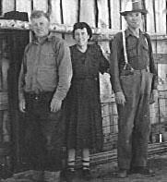
At home, I turned our basement “fruit room” (where canned goods and home canned fruits and vegetables were stored) into a dark room. The folks gave me a Kodak 828 camera. It used roll film the same size as 35 mm, but bigger because there were no cog holes along its sides. You could focus with it and it had f stops from 4.5 to 16. I took lots of pictures with that camera, and learned a lot about the basic principles of photography.

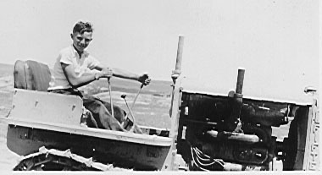
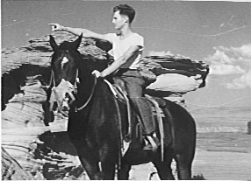
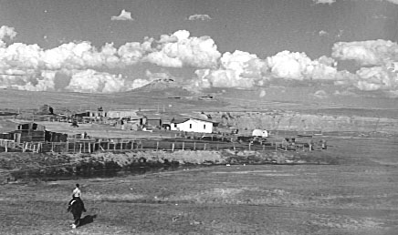
My early highschool summers were spent out on McKenzie’s ranch south of Cohagen. Bella and Duncan, her husband had remained good friends of the family. On their ranch, Johny McKenzie, Duncan’s cousin lived with them, and also a Polish sheepherder named Jimmy. I used to help them fence, put up hay, round up cattle and wild horses. Jimmy had a small Caterpillar tractor used to help make dams. I learned how to run it, and was quite intrigued with what it could do. I remember one time they left me at a dam site miles from the ranch. I was to drive the cat home. However just as the pickup with Jimmy & Duncan was disappearing out of site, the cat ran out of gas. It was after lunch time and I was getting thirsty and hungry. I ran after the pickup as fast as I could and just barely caught it. If I had missed it would have been a long walk. Work attitude on the ranch was low key “If we don’t get it done today, we will do it tomorrow.” That of course didn’t apply to lambing time or roundup time. Back in those days there was still a lot of open range and there were still large herds of wild horses. Ranchers would bring them in to a corral occasionally to pick out horses with their own brands that had wandered off and become part of the herd. Also to find and brand colts to mares with their brands. Several of the riding stock at McKenzies had been purchased at Fort Keogh. They always named all horses born in a given year with names beginning with the same letter. The horse I rode, named Lolo, was huge. His back came level with the top of a car. One time we were rounding up a large herd of wild horses. The stallion leading the herd was a large roan colored horse. In rounding up horses you push them forward, but at a leisurely pace. If you gallop, the herd does also, and often faster than you (those horses don’t have any riders). If you walk the herd outpaces you. Therefore you spend all day trotting, and that gets a bit tiring. As we neared the corral, the lead stallion saw where we were trying to head him and veered off to one side. He was trotting. I was galloping, and still wasn’t even beginning to catch up with him. He was one of the most outstanding horses I have ever seen. He of course got away, but we did get the rest of the herd into the corral. The days of the wild horse herds and open range are long since gone. There are a few of them in the horse reserve in the Pryor Mountains, but no more left on the eastern Montana Plains.
Jimmy’s Cat with me at the controls
Lolo, a delightful horse
Johnie, Bella, & Duncan McKenzie
McKenzie Ranch

I became goal oriented to become a physician when I was in Junior High School. I studied hard in highschool and made good grades - ended up valedictorian of my class. In spite of that the highschool principle called me into his office one time (I think after I had taken an aptitude test) and told me he didn’t think I should try to become a Dr. Having that goal was very helpful, because it made me always try a little harder with efforts paying off by being accepted to medical school at Northwestern University in 1949.
World War II started when I was in 8th grade, and so in highschool I was looking forward to joining the service when I turned 18. I wanted to get as much education behind me as possible before then, and as it turned out I had taken a course in aeronautics as a sophomore taking it during a study hall period. Adding it to the other courses I was taking, I found out that by going to summer school for 2 years with the extra credits from that course, I could graduate at the end of the 2nd summer and thus start college a year early. This is what I did. I took pre-med. in college, and in that field I was deferred from the draft. In medical school, I was also deferred from serving in the Korean war. By the time I finished my training, the draft was over. I felt somewhat obligated though to spend some time in the service and so I joined the airforce for 2 years.

College Years

College years were good training in perseverance - forcing oneself to study long hours and keep up with assignments given. I was assigned to live with 3 other freshmen students off campus in a home with two upstairs bedrooms and bath. Originally we started out 2 to a room, but in short order we made the west bedroom a sleeping room with 2 double tiered bunk beds, and the east room a study room.
For our second year together I rigged up an “interesting” alarm system. I inserted a clock into a wooden face with nails at 15 minute intervals. Wires came from each nail and I could switch whichever nail I wanted to our 4 respective bunks to turn on a little light when someone wanted to get up. For the last person to get up, I had the system hooked up to a home-made electromagnet that would pull a weight off a shelf. It would drop down and jerk the switch to a 110 volt light to which both a radio and a light bulb were plugged into. The whole system was run by a lattern battery, but Colonel Well’s (a retired army colonel whose house we were staying in) was very concerned that the system would spark and cause a fire. I finally persuaded him it was safe. It worked pretty well for the next two years.
Of the four of us in that room, I became very good friends with John Skoglund. He was a business major who came from Rockford, Illinois. He would take me home with him on the short holidays, and introduced me to his mother’s Swedish cooking. After graduation John went back to Rockford and took over his father’s shoe store. When it closed due to changing neighborhood conditions in the 1970s, he went to cook school and became a chef. We have continued to be good friends though the years. Johny was best man at my wedding. My other two room-mates were Jack Swanson and Otis Highbaugh. For most of his college career Jack didn’t know what he wanted to major in. He was very talented - finally ended up earning Ph.D. in education and became a highschool principal. Otis was a talented piano player - ended up being an accountant.
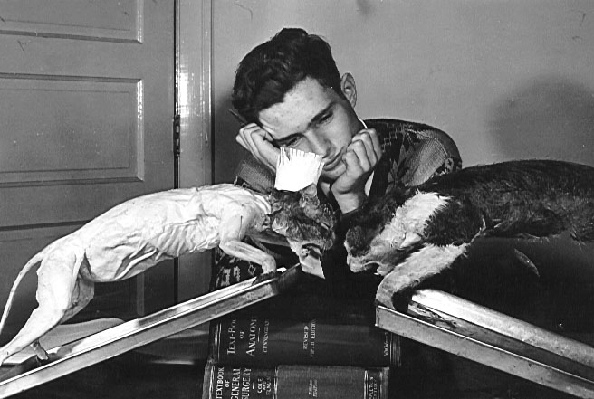
Another student I developed a lasting friendship with was Ron Olson, a pre-seminary student. We used to wrestle for an hour or so about 3 days a week. That was good exercise and a real break from studying in the library. I also played some handball with my room-mate John Skoglund. I went out for track and used to run around the quarter miles wooden track Wheaton College had. Gil Dodds on the athletic faculty at that time had broken the 4 minute mile indoor track record and so was quite famous. I never was able to run fast enough to really get into the sport - even though I enjoyed it. Knowing what I know now - i.e. that I had a fenestrated atrial septal defect, I can understand why I couldn’t run as fast as I wanted. Extracurricular activities also included being in the college concert Band. I learned to play coronet in highschool & continued in college. However I never became a very good player.
Comparative Anatomy
Sundays I always attended Sunday School and Church at the College Church just west of the campus. Sunday afternoon I would always type a letter home. Then if the weather was nice would go for a bike ride. I had a Zenith portable radio. Back in those days portable radios were about the size of a small suitcase with large heavy batteries. I used to put mine in the front basket of my bike & listen to classical music as I rode (something I considered a real luxury at the time.)
Most of the courses I took at Wheaton, were in science subjects. I did take some liberal arts courses, but found them a bit boring. German was taught by a retired missionary. It was a very difficult course for me, but my teacher was so enthusiastic and such a radiant Christian lady, that I devoted a lot of time and effort to it, and ended up enjoying it quite a bit. Sociology didn’t make much sense to me. It wasn’t based on enough facts and so I had a hard time remembering it’s teachings. Embryology was the course that really turned me on in my sophomore year - the one where I felt I learned how to study and how to assimilate knowledge. As I remember it was taught by Dr. Clinton Mack. When I applied to Northwestern Medical School, he wrote a letter highly recommending me, and I feel it was one of the factors that helped in my being accepted.
My room-mate Johny Skoglund was a good swimmer and red-cross swimming instructor. He talked me into learning how to swim during our Junior year. I remember that on a bus going to our swimming class, I got a glimpse of my first TV set. It was in a store window and a large crowd of people were standing outside looking at it.
For my senior year at Wheaton, I roomed at Dr. & Mrs. Fiess’s, a brand new house a few blocks north of the campus. Dr. Fiess was one of my chemistry professors. Chem. lab was in the west end of Blanchard Hall. One of my lab classmates was Leon Wang. He was really smart in remembering facts, but couldn’t reason things out well. I was just the opposite - had to work really hard to remember facts, but could think through problems quite well.
Summers during college and medical school were spent working for the highway department and helping to build both Holy Rosary Hospital and the VA hospital. I worked in the highway paint department and helped paint signs and also do the preliminary marking for painting the center line on the highway. I remember painting a red sign white. We used oil paint back in those days, and about 3 days after I painted it red started seeping through. Not to be outfoxed by a “dumb” piece of wood, I repainted it. However after 12 coats of white paint, and red still coming through I finally gave up. One other vivid memory I have of my highway years is one time we were painting marks for the centerline paint truck to aim at as they painted the highway. Standard operating procedure was for me to stand on the running board with paint bucket & brush in hand and jump off, measure the highway width and paint a mark in the middle about every ¼ mile. In order to speed up the procedure, I was in the habit of jumping off backwards shortly before the truck would stop. One time I did this too early and couldn’t stay on my feet because the truck speed was still to fast. Paint bucket arched up in the air and spilled white paint all over the highway. Needless to say my co-workers kidded me unmercifully about this. We tried to smear gasoline on the white paint to have it blend with the aphsalt, but it didn’t work very well.
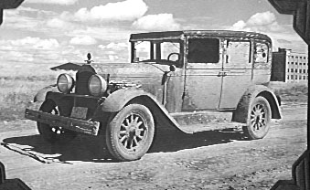
One summer my cousin Bill Johns spent the summer in Miles City and worked on the highway also. Near the end of the summer we took a trip to Glacier National Park and Canada. For transportation in mid-summer we bought ourselves a car – a 1928 Willies Knight. It was famous for it’s “sleeve valve” motor. Instead of having noisy valves, it has a sleeve between the piston and the cylinder which would slide up and down opening the top of the cylinder to admit fuel/air and allow exhaust. This made for a very quiet smooth running motor. Problem is that as things aged, oil would leak between the piston/sleeve/cylinder. When we got the car, it would use a quart of oil about every 50 miles. Before going on our trip, we decided to change transmission oil. We drained it out OK, but in trying to refill the transmission, we poured replacement oil into the clutch housing. On putting the car in gear, it just sat there and didn’t move. We drained the oil out, put it in the right place and with time, the residual oil burned off the clutch plate and the car worked fine.
We headed up to Glacier in late August traveling about 40 miles an hour and putting oil in every 50 miles from a 5 gallon can we carried on the back. When we got to Glacier, our starter gave out, and so to start the car we would either park on a hill, or have somebody give us a push. Since the oil can on the back overhung the bumper, we would have to have them push us backwards. That worked fine. We backpacked in about 6 miles, but it rained heavily and both our sleeping beds got wet (before the days of backpacking tents – we slept under a tarp). Therefore we hiked out in the rain Saturday morning and decided to drive up to Canada. By afternoon we were on a remote highway about 30 miles out of Lethbridge when we our engine quit. We figured “no problem” – we will flag down the next car coming from the opposite direction to give us a push backwards to get it started. This we did, but the car wouldn’t start. The guy pushing us volunteered to pull us all the way into Lethbridge saying that we could do a good turn to the next person in trouble we ran into. We got there around 5:30 and all the garages were closed, but a filling station with a garage let us work on our car. We found out that the problem was in the distributor. A fiber plate that fit against a cam to open and close the points had broken. Here we were 600 miles from home in an old car on a weekend with no way to get replacement parts. We decided to fashion our own using a brass tube from a fuel pump to make a rivet to hold it in place. It worked – although our timing was off and the engine didn’t run very smoothly, but it allowed us to “limp” back home at about 30 miles an hour. The irony of the whole story is that when we were cleaning out the car to sell it, we found a complete new set of points in a pocket on the inside of the back door. I have forgotten what we sold the car for, but if we still had it today, it would be worth a mint as a vintage car.
1928 Willies Knight mudded up in Canada

Girlfriends

High-school
Bobby Lew Davis: older sister of one of my friends - Louie Davis. She was about a year older than me. I don’t believe I ever dated her, but we spent a lot of time talking together in chem lab in high-school.
JoAnn Lewis: younger sister of one of my good high-school friends, Paul Lewis. I was attracted to JoAnn and we dated a few times, but she didn’t reciprocate the “vibes” and so the relationship dropped at that.
Joyce Treat: One of my high-school class mates - adopted into the Cook family. She was a pretty girl, and quite talented - eventually ended up marrying one of our class “no goods” - Tommy Jacobson. Tommy had a drinking problem and I think Joyce felt sorry for him. The marriage as expected didn’t last very long - was associated with lots of heart-break and I expect ruined Joyce’s chance to make something of herself. I don’t think I ever dated Joyce, but I would have liked to. Her sister Margaret Cook was also attractive, and the two were a couple of the most popular girls in our class.

College
Mildred Groendyke: my one fairly serious college romance during my sophomore year at Wheaton. Mildred was year older than I, and we shared the same value systems. She liked me a lot. Our relationship was always “platonic”, but got to the place where I visited her family one spring vacation. I think the relationship didn’t progress mainly because I wasn’t quite as physically attracted to her as I would like to have been. Besides that I was beavering to get into medical school and couldn’t allow time for a really serious relationship. She couldn’t afford to return to Wheaton her Junior year. We wrote to each-other for a year or two, but then the relationship ended. She ended up marrying and becoming a overseas missionary
Alice: believe Alice was about a year behind me. I dated her quite a few times my junior or senior year. She was physically strongly attracted to me, & I to her, but intellectually we were on somewhat different planes. Besides, by that time I was never dating the same girl twice in a row (every other date was OK) in order to keep myself from getting serious before medical school.
Sally McCutchen: the most popular girl in our college class. I used to sit in chapel and dream of dating her. Actually one time I got up enough nerve to ask her for a date and she accepted. We had a good time. However in “social graces” I was out of my class, and so didn’t feel I had much chance of anything progressing further.

Medical School
Ethel: a girl I met at Moody church during evening social hours. Our chemistries jelled together nicely, and I took her on a number of dates. She came from a blue collar Chicago family, and was getting a little vocational education post high-school. Her “social graces” left a bit to be desired and the differences in our educational backgrounds was great. For those reasons, and also because in my junior year I moved to Swedish Covenant Hospital in the north part of Chicago to be an extern, our relationship cooled. Of interest in 1997 a Miles City resident visiting Disneyland in Florida, was talking to one of the seasonal workers down there and found out he was retired and from Chicago. The worker hearing he was from Miles City, asked him if he knew me, and told him that his wife and I used to go together and that she had wanted to stop in Miles City when they were traveling through the area, but that he had discouraged the idea.
Madges’s friend: Madge Hazzelet was a student nurse from St. Luke’s Hospital dating my cousin Bill Johns (he was a year ahead of me in medical school). She lined up her friend as a blind date. She was a girl whose father ran a filling station in the south part of Chicago. She was a dark haired beauty, and we dated a number of times. However the chemistry was wrong.
Swedish Covenant Student Nurses: As an extern at Swedish Covenant during my Junior and Senior years at medical school, I (with 5 other Northwestern medical student externs the 1st year and 7 the 2nd) ate in the same dinning room as the student nurses. We had our own table, but were exposed to all these young vibrant girls and had a chance to date many of them if we wished. We really didn’t have much time since medical school required tremendous amounts of time studying, and then working as an extern took daytime and sleep time also. I was still avoiding any serious relationships because of these time demands, but I did date quite a few of the student nurses on weekends when I wasn’t on call - still on the routine of never dating the same one twice in a row. The one girl I was fairly strongly physically attracted to, was going steady with a pre-seminary college student. I would spend some time talking to her when we were on ER call together, but never dated her. The others were nice, but none of them caused more than passing interest.
Beth Tate: Near the end of my Junior year I noticed a pretty brunet girl in the dinning room and decided that I should try to get to know her. I had a date for the next Sunday with a girl I had gone out with several times, but she called to cancel because she had a bad cold. That evening when I went to night kitchen to prepare next day’s lunch, Beth was sitting there eating before going on night duty in the nursery. I screwed up my nerve, introduced myself, and asked her for a date that Sunday night. She accepted. I will never forget that date. Of all the girls I had ever dated, here was my “dream” girl. She was a beautiful extroverted competent dedicated happy humble gentle interesting brown haired Swedish/Irish girl, who shared most of the same interests I had. I fell head over heels in love. My resolve to never date the same girl twice went out the window. The week after our first date, she was transferred to Children’s Memorial Hospital for training in pediatric nursing. When she got back to Swedish Covenant I had to spend 3 mo. on a surgical clerkship at Passavent Hospital, and when I got back from there, Beth was transferred to Cook County Hospital for training in psychiatric and infectious disease. Thus if we hadn’t had that first date, we would have missed eachother.

Medical School

A number of medical schools in the 40s used a pyramid system of admission - you had to stay above a certain rank in your class in order to stay in school. Northwestern did everything possible to keep students in school once they were accepted. You had to work and study hard, but teachers were there to help you anyway they could. Freshman year was mostly basic science - Human Anatomy, Biochemistry, Embryology, Physiology etc. with a little Physical Diagnosis thrown in. Clinical professors at Northwestern were almost all practicing physicians who taught at the medical school part time. Those who taught basic science were usually full time professors - some of them doing a little research on the side. Northwestern was located in Evanston, Illinois north of Chicago, but the medical school, law school and dental school were located together in Chicago on North Lake Shore drive, on the lake front just north of downtown. Medical students lived in Abbot Hall, a high-rise dormitory. There were about 5 medical fraternities - one in their own frat house - the others each occupying a floor of Abbot Hall. In addition the Hall had it’s own dinning room, and in the basement, some real nice hand ball courts. I lived on the Phi Chi frat floor. We were assigned two to a room. Each floor had a lounge with a little side room. In that room was a TV set with about a 12” black and white tube. In 1949 TV was just starting and we considered that quite a luxury to have a set available to watch. My room-mate was Frank Rundle, a fellow Montana student who had lived in Miles City. I don’t remember too much about my Freshman year, except that almost all my time was spent either going to classes in the Ward Building, where the medical school was housed, or studying in my room at Abbot Hall. I did take time out to play handball. Also we would spend some time walking up and down the lakefront when the weather was nice.
Sundays, I would always write a letter home - would walk about 1½ miles to Moody Church for their morning service, and would often also attend their evening service. I was able to make average grades - found Bacteriology to be my most difficult course. In Anatomy, each 4 students were assigned a cadaver. Our class had 5 girls (out of 70 students), and two of them were assigned to the cadaver I had. He was a somewhat emaciated elderly man. We carefully dissected him from head to toe.
Our Embryology class was taught by Professor Aery. He was in his late 60s and had become famous for the work he had done in Embryology research, and also as a teacher. He was excellent and taught us a lot.
At the beginning our sophomore year in medical school, we for the first time were exposed to patient care. The long years of didactic study of scientific subjects suddenly changed to having to deal and be responsible for people. Being the son of a physician, I had been exposed to medicine as an observer for many years. That had really not prepared me for the change from learning to doing. After investing 5 years studying, here I was finally doing. I found I enjoyed this a lot. Some of my classmates did not. They ended up going into radiology, pathology, or industrial medicine where they could still be involved only in the academic side of the science.
My room-mate Frank Rundle worked weekends during our sophomore year at Cook County jail. One weekend to see what it was like, I spent the weekend there with him. During the middle of the night a fellow came in who had been stabbed in the abdomen. We both checked him over and decided that he needed to be operated on. We called the staff man on call and told him about the case. He told us just to watch it. We objected, but did what he said. By the next morning the patient had a ridged distended abdomen and shortly thereafter died of peritonitis.
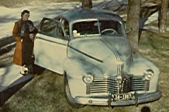
At the start of my Junior year at Northwestern, I had a chance to become and extern at Swedish Covenant Hospital on the north side of Chicago. That meant I had to purchase a car so that I could commute back and forth to school. I bought a second hand Pontiac two door with a small rear seat. It had a conventional heater in the front, and also and under the seat heater for the back. It served me very well for the rest of my medical school career including driving back to Miles City for summer vacations. I took very good care of it changing it’s oil and greasing it regularly. It’s dash was fading and so I painted it a bright brown. It gave me very little trouble, except for one time driving back to Northwestern from Cook County, it’s tie rod came loose. One front wheel went one direction and the other the opposite direction. Fortunately I was able to stop before loosing all steering control and crashing. I used to get from Northwestern to Cook County by driving through the catacombs. They were a series of underground roads running next to the Chicago River, mainly used by delivery trucks to deliver goods to down town skyscrapers. Taking that route saved a lot of time in getting between the two institutions. When I graduated from Northwestern, I was given a new car by my folks as a graduation present. I sold my old Pontiac to my friend Gene Brasseur - a year behind me - also working at Swedish Covenant as an extern. The one needed service to that automobile that I should have been doing but never did was greasing it’s front wheel bearings. Shortly after Gene bought the car, they gave out and cost him quite a bundle to replace.
My first car – the one that allowed Beth and myself to really get to know eachother. It had 2 heaters, one in front and one under the front seat. We painted the dash brown
Working at Swedish Covenant was quite an experience. The camaraderie with my fellow externs was great. We lived in a house 1 block south of the hospital - two to a room - would eat all our meals at the hospital, and had access to it’s night kitchen to fix lunches for when we were at school. We used to make some pretty unique sandwiches - slices of meat, cheese, mayonnaise, peanut butter, and whatever else was available between two slices of bread wrapped in wax paper, and then taped shut with adhesive tape. One sandwich was more than enough to be a good lunch. We were given room and board, and paid $30 a month for being on call every 3rd night our first year when there were 6 of us, and every 4th night our second year when there were 8 of us. The guy on first call would handle the emergency room and the one on second call would work up any surgical cases scheduled for the next day, and also be available for backup in the ER. Swedish Covenant ER was about the 2nd or 3rd busiest in the whole city of Chicago at that time. We quickly became experts in handling minor problems and suturing all sorts of minors cuts etc. We would be able to call a staff man for anything we felt we didn’t know how to handle. When on first call you stayed in the hospital and were usually up a good portion of the night. It was a rigorous experience, but a good one where we all learned a lot.
A couple of ER cases stand out in my mind. One was a child brought in with a 5” axle from a toy truck stuck almost all the way into it’s skull. That case was immediately taken to surgery where the neurosurgeons removed it. As far as I know the child did OK, but I didn’t get any long term follow up. Another was a lady brought in after an auto accident complaining of pain in her right knee. I x-rayed the knee, when I should have x-rayed the hip. It was what was broken. I learned a lot about refereed pain from that case. Early at about 5 AM one Sunday morning, I was called to the ER for a young man brought in after being hit by a car while he was waiting at a streetcar stop. It turned out he was DOA (dead on arrival). The case was significant though in that later the man’s father came to see me. He felt I was very significant since I was the last person to have seen his son. He was an auto dealer from suburban Chicago, and told me that if I ever needed a new car, he wanted to me to have one at cost. When the folks gave me a new car for graduation, we contacted him and he was true to his word. We bought a beautiful 4 door 6 cylinder gray Dodge with a dark blue top with overdrive. That was the car I took on my honeymoon, and it stood us in good stead through internship, fellowship, and airforce. Finally sold it after we settled here in Miles City.
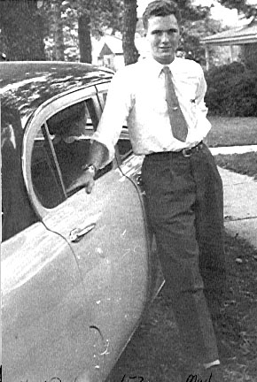
The only clerkship I had where I had to live in the hospital was my surgical one at Passevant right next to the Medical School. I was assigned the hand surgery service, and so spent hours assisting on time consuming exacting hand surgery cases. It was interesting, but didn’t make me very enthusiastic about surgery.
My new 1953 Dodge
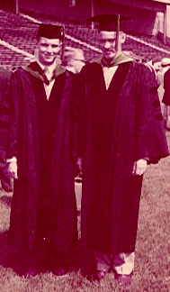
During my OB clerkship, I spent two weeks at Chicago Maternity Center near Cook County in a slum district. It wasn’t safe to be on the streets in that area. A stabbing murder took place right outside its front door during the two weeks I was there. Medical students were set up in teams of two. The first week you would watch and the second week you would be in charge. We would go to the patient’s homes and deliver their babies. We had little black bags and would wear white intern uniforms. We would stay at the patient’s house for the duration of the labor. Most deliveries were multiparous ladies. If they got into trouble we had the option of calling and having them transported to Cook County Hospital. We were called all over the poorer areas of Chicago, and were exposed to all sorts of people and living conditions. In our white uniforms with our little black bags, people knew who we were and it was rare that any of us were accosted or robbed. We would get to where we were going on the streetcar or bus. Living conditions we were exposed to were often very deplorable. Our standard operating procedure was to take newspapers and cover the bed with them, clean the lady up the best we could, and then have her lay on the “clean” newspaper covered bed to have her delivery. I watched 5 or 6 deliveries that first week. The second week I delivered about 6 or 7 babies, all of them without any complications. One of the black babies I delivered was named after me. The social instruction received living in those homes for the 6-8 hours we would be with the ladies during their labor period was as valuable as learning how to deliver babies. I think I delivered 2 more babies during my internship at Iowa Methodist. That is the extent of my OB training.
Medschool graduation with roommate Ethan Vanbenschoten

Internship

One of my Swedish Covenant house-mates, David Baridon, came from Iowa. He persuaded my room-mate Ethan VanBenschoten, and I to apply for a rotating internship at Iowa Methodist Hospital in Des Moines. All three of us were accepted, and started there after graduation from Medical School July 1st 1953. We rotated through all the primary specialties. The program was well run, and allowed me to pick the specialty I felt would be most interesting. I was attracted to OB, but after spending several nights being up all night and then having to work the next day, I decided that was not for me. General surgery was also interesting and the physicians I was under urged me to consider going into it. The Pediatric department at Methodist, run by Dr. Hill, was quite famous, and I enjoyed my stay there. Internal Medicine interested me the most however, and a couple of staff men I was under had trained at Mayo’s and advised me to apply there for an internal medicine fellowship. This I did, and with a good word from them, was accepted.
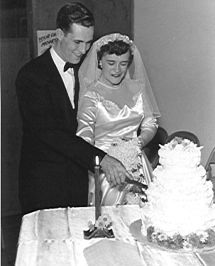
My time in Iowa went quickly. That fall I married Beth Tate. We had become engaged in medical school, but the logistics of getting married didn’t work out until Nov. We had a two week honeymoon in the Smoky Mountains of Tennessee. I came back to Iowa Methodist with the flue, and so everybody kidded me on how much marriage was agreeing with me. I moved from living in the top floor of the hospital to a little one room apartment a couple miles north of the hospital. Beth worked as a nurse, so we would have off call nights at home together, but would also get to see each other for short time periods at work.
I had a number of relatives living close to DesMoines, and so on occasional weekends we would get down to see them. I remember when going for weekends on my Uncle Bill and Aunt Margaret’s farm near Truro, south of DesMoines, we would rob the hospital ice machine, arrive on the farm Friday evening in time for me to help milk the cows and for Beth to help gather the eggs. I would set the hand powered separator for the thickest cream it would make. Beth would bring in the eggs. We would make ice-cream from the fresh cream and eggs in a hand driven ice-cream maker, and would be eating it 2 hours after its ingredients had been in the cow or chicken. It sure was good, but I am sure by today’s standards was extremely high in saturated fat and cholesterol.
Nov 4, 1953 wedding
We also spent some time in Winterset, Iowa where my Uncle John F. Veltman was a general practitioner. We could get to his house anytime during the night, and it would be all lit up with people still up ready to welcome us and make a bed for us to sleep in.

Mayo’s

Being accepted for training at one of the world’s finest medical centers was quite an honor. Beth and I found an apartment next to the fairgrounds. We could go outside on our balcony and see over the fairground fence to watch the weekend auto races. I remember I wanted to look my best when I presented myself to start seeing patients at the clinic. Therefore I went to a downtown barber to get a haircut. The whole time he was cutting my hair, he was griping about people who gave themselves their own haircuts. He gave me the worst haircut I ever had in my life. That evening, Beth bought a home barber outfit at the local drug store and did her best to rectify the terrible cut I had had. She has been cutting my hair ever since.
My training at Mayo’s was unique in that we spent much of our time seeing outpatients at the clinic. We were assigned a patient to see - would work up the problem, and order whatever lab tests we felt indicated. At that point a staff man would take over - review and critique our work, and follow-up with the patient. We would be able to review the final outcome and learn whether we had approached the problem correctly. This type of training gave us many skills in learning how to handle patients, as well as learning about their diseases.
About half our services were hospital ones - 3 months at a time, usually being on call and sleeping in the hospital every 3rd or 4th night. We were busy, but unlike the residencies many of my friends were in where they were on duty 16 hours a day, we were given time enough to study about the various problems we were seeing. Since Mayo’s was a referral center, we saw more than our share of rare and complicated ones.
One of the services I was on was in Basic Sciences. I opted to finish a study started earlier studying the amount of atherosclerosis in female hearts. Coronary arteries were dissected and sectioned every few millimeters of their length. % narrowing from atherosclerotic plaqueing was measured and recorded. I did the same thing for cerebral arteries and wrote an article which was accepted for publication in Circulation on the Correlation of Degree of Cerebral and Coronary Atherosclerosis in Women. That was also accepted as a thesis towards earning a Master’s Degree in Internal Medicine.
After finishing my fellowship, while waiting to join the air force, I stayed on at the clinic for a couple of months seeing outpatients.

Air Force

When I joined the service, they were so short of internists, that they skipped the 6 weeks orientation course, we were supposed to have at Gunther Airforce Base in Alabama. I was assigned directly to Ellsworth Air Force Base in South Dakota. I had to be taught all the rules of military etiquette, including what uniforms to wear, how to salute, etc. as I started my job of being Chief of Medicine. I was a lowly captain, and the job description called for rank of Lt. Colonel. Of interest, the entire two years I was in the airforce, I didn’t stand one inspection, and I didn’t ever own a summer dress uniform.
The second year at Ellsworth, I was appointed Chief of Professional Services - in addition to continuing my job as Chief of Medicine. I learned a lot, in that I had to rate each physician as to job performance. Physicians are a good example of the adage “You can lead a horse to water, but you can’t make him drink.” You could require a physician to report to this duty or that, but you could never force him to think, draw conclusions, or practice the art of medicine. That was something he had the choice of doing or not doing. Fortunately most physicians are in the profession because they are compulsive dedicated people. By and large the men I worked with did their jobs well, and were a pleasure to be around.
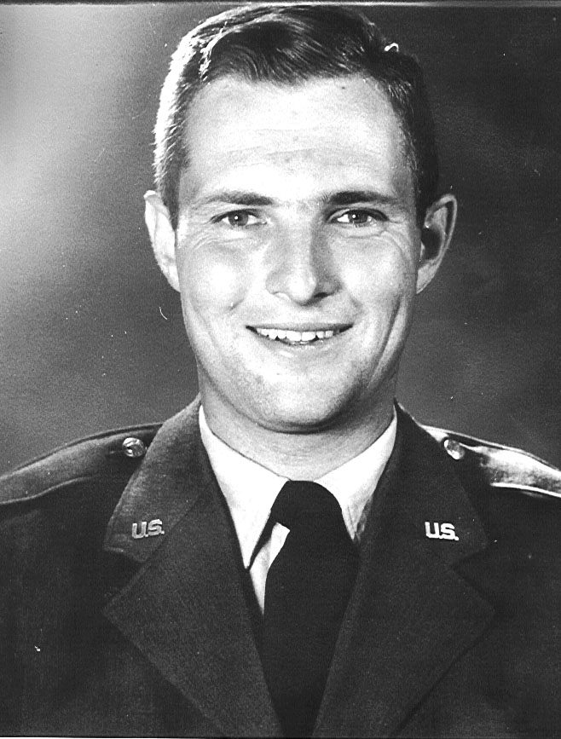
During our time at Ellsworth, the Suez Canal Crisis occurred. That was
downplayed to the press, but to us was blown up as a dangerous problem that might lead to all out war. We physicians were confined to the base hospital and not allowed to go home (even though our housing was on base.) Because of danger that our B52 base would be a target for Russian missiles, I had Beth and the children take off for the Black Hills. Bruce was a newborn baby still on Beth’s breast. Her milk supply dried up, but the place she was staying at had experience with that type of thing - got Bruce on a bottle. The crisis didn’t last long and as soon as Beth knew everything was safe, her milk supply came back.
Airforce days were pleasant ones, in that the rigors of fellowship study were over, and I was able to start practicing what I had learned. I was respected for what I knew. Work hours were great. I was on call every 3rd or 4th night and weekend. Days not on call ended about 5 PM. Weekends off were completely free. We took advantage of that by spending a lot of time in the Black Hills camping and fishing. The base recreation center would check out tents and camping supplies free. We would rent a fishing boat and motor for $1.50/day - take off with it on the top of the car, and find the most remote lake we could. Sgt. Box, the hospital lab supervisor, always knew where the fish were biting the best, and which lakes and streams had been recently stocked. Right after Bruce was born, we spent about 5 days at one of the most remote and highest lakes in the Hills. Bruce’s baby carriage could be detached from it’s wheels, and we would put it in the boat & the five of us (Beth, myself, Malcolm, Scott, & Bruce) would spend the day on the lake pulling in nice size trout. Boy were they good freshly roasted over the fire.
When our two years were up, the Airforce wanted us to stay in, and we were tempted to. They offered us a tour over in England, and that would have been interesting. However we knew staying in the service would mean moving every few years till retirement, and both of us wanted to get our roots down and stay in one place. We looked around at several possible spots to live. Miles City needed an internist at the time, and moving back would mean we would be close to family and what I had known all my life as home.

Miles City

When we came here there were no decent houses to buy or rent. In the airforce we lived in a two story apartment without a basement. That meant there were no steps to get into the house. We became very fond of that, and when we came here we decided to gamble that we would like it here and build a house to be ready close to the time we would arrive. We were pretty unkowlegable about house size, but we knew we wanted a house with 3 bedrooms, a study, a family room, a living room, dinning room, kitchen, and two baths. We also had seen several houses built into the side of a hill with ability to walk into the top story without climbing steps, and then having the basement level with the back yard - again without steps. We went down to Midland Lumber Co. They had a number of house plans that we looked at. We found one that satisfied the above criteria, and decided that it was what we wanted to build. The problem we ran into is that we were going to build an average size/price house. Our plans turned out to cover 2,400 sq. ft. per floor - a lot bigger and more expensive than we naive amateur house builders were thinking about. We decided to downsize, and make each room smaller, but our contractor, a highschool friend, talked us out of that by saying that a smaller house would have just as many doors, windows, light fixtures, utilities etc. and would cost almost as much. We then went looking for lots and found one on the west end of the new golf course on a “hill” - i.e. the west side of the slough (the old Tongue River bed that used to run through Miles City). That part of town was quite run down at the time with old small houses on it. Also it was a long way from schools, the hospital, and the clinic. About that time the Catholic Church decided to sell a lot they had bought years before as a site to build a church on. It was located in the Miles Reserve 1 block from grade and highschools, 3 blocks from the hospital, and 8 blocks from the clinic downtown. The only problem was that the lot was flat. The price was right and the advantage of closeness won out over being on a “hill”. We adapted the house plans by making the basement walls a foot higher than usual. That permitted us to make slots in the front wall of the basement to hold the joists, thus allowing us to have a front & east side entrances to our house even with the entrance walks. The back and west sides of the house were built conventionally allowing them to have basement windows. We used all the dirt excavated from the basement to slope the front lawn up so that it would be even with the east and south sides of the basement. We had to get special permission from FHA (Federal Housing Authority) to be allowed to do this. I do not think it had ever been done before (or since for that matter). I am told that they would not allow it today. To me it was and is still a good idea. It permits our house to be wheelchair accessible and is extremely convenient. It also allows us to have a full basement. The joist slots have 1” air space on each side of them so that the joists never get wet and will never rot.
Our contractor, Bryce Richards, built our house for $11/square foot with the basement, front room and bedroom carpeting, built in refrigerator and stove tossed in free. Our lot 125x125 feet cost $2,400. We paid $30,000 for the house - about $6,000 down and the rest on a 5½% FHA loan. We moved here in August 1959, and our house, which had been started in April, was finished by September. I will never forget the thrill of moving into such a “castle” with so much room.
Our first project was to seed the yard with grass. Actually we dug up several truckloads of old Tongue river bed dirt to put on top of the basement fill. Then we spread commercial fertilizer - then oats, and finally grass seed. The oats came up and shaded the fragile grass seed until it took. That winter the oats died off and the next spring we had a beautiful lawn. The next project was to go out to the pine hills and dig up juniper trees. We planted them as a hedge along the front of our property. About 4/5ths of them grew. We replaced the ones that didn’t make it the next spring. Our driveway was gravel, and our basement was an empty shell.
Through the years with our children’s help we have added a lot to our house - a shop, a darkroom, 3 bedrooms, a bath, a store-room, and a game room in the basement. Upstairs when we could afford it we added central air-conditioning, a 2 car garage, and a greenhouse. Later we added a front room fireplace, a 2nd greenhouse with a hot tub and sauna, and a sunroom. Still later we remodeled the basement into a 2 bedroom apartment with kitchen and front room, and it’s own entrance. In 1992 we added a screened/windowed in back porch. In the 90s we also made our house reasonably smart with motorized window quilts on the windows, and with X10 digital computerized controls to run most electronic functions. We have piped our hi fi to almost every room in the house, and have remote infra-red controls in our bedroom to control all hi fi functions. We also saved our old thermostat when we got our new air conditioning thermostat. We put them in parallel with remote control relay from our bedroom and the kitchen to put the old thermostat into or out of the circuit. Thus we can with the flip of a switch control our house temperature at any two settings we choose. Before going to sleep at night we flip it to 65 and on awakening in the morning to 72. By the time we get out of bed after having our morning wakeup coffee perked by our X10 timed coffee maker, our house is toasty warm. The summer of 1995 we replaced all the windows with argon, thermopaine E glass windows & added 1/2” Styrofoam insulation & new siding.
All four of our children grew up in Miles City, and the memories we have of the times we spent together are very precious. We tried to reserve 3 or 4 hours Sunday afternoons for family activities. We took quite a few afternoon hikes, and back-country 4-wheel driving expeditions in our International Scout and later our GMC Jimmy. Every summer we would set aside 10 to 14 days for a mountain vacation. When the kids were young we would park a trailer near a good fishing stream. As they grew older we went on some fantastic back packing trips.
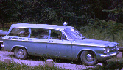
1961: We had purchased a Corvair station wagon. We inserted a plywood board behind the front seat so that Beth and I could stretch out in the back. Malcolm slept under the board in the foot space in front of the back seat. Scott slept crosswise in the front seat, and Bruce slept between Beth on myself. We took our first really big trip driving down (via Albuquerque to visit cousin Bill Johns) to California where we visited the Dierenfield family, and had our first exposure to Disneyland. It was a great trip, and our little car with it’s rear mounted air cooled engine slept us all every night on the road very well. Later that summer our neighbor J.P Johnson flew Beth and I up to Canada in his private plane. Beth visited old friends in Prince Albert. J.P. and I went fishing on Lac Laronge. We caught some really big Lake trout, Northern, and Walleye Pike. Had our own Indian guide and a couple of boats. (J.P. was fearful of getting caught out on the Lake if a motor failed or something happened to a boat).
1961 Corvair Station Wagon
1962: Susan had been born. We rented a trailer from friends, and spent time in the Black Hills at our old air force camping haunts.
1963: We flew to California via Phoenix to visit Ben.
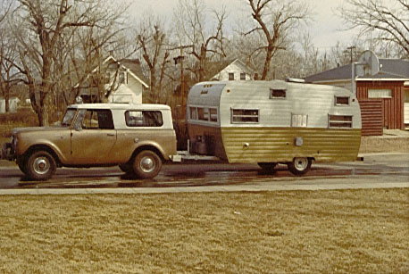
1965: We traded our Corvair for a beautiful red Pontiac Station wagon and again rented a trailer. We drove to Portland, Dad coming with us to attend a Federal Aviation Examiners seminar. From there he traveled back to Miles City. And we traveled down to West Coast to California. Got the car and trailer stuck in beach sand in Oregon, but enjoyed the beautiful coast line scenery. Susan got her first exposure to Disneyland.
1968 Scout and our 1st trailer
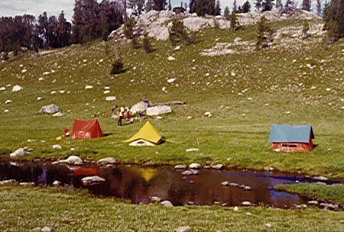
1966: The family took a camping trip to Four Mile Creek along the Boulder River sleeping out under tarps near our car. We also backpacked into Blue Lake in the Crazy Mountains. Beth traveled to Ireland with her folks.
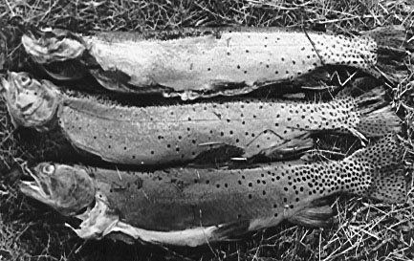
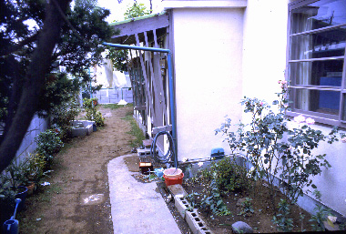
1971: Mal was 16 & Susan 9. We along with our friends the Hoskinsons and their four, spent 10 days hiking 55 miles in the Beartooth Wilderness going in and coming out along the east fork of the Main Boulder River visiting about 6 different lakes. The kids all did well and we had a wonderful time. At Pentad and Favonious Lakes we all learned how to fish with our hands. They are crystal clear high mountain lakes with small meadow streams with undercut banks feeding them. You can see the trout swimming in the lake, and if you are patient see them swim upstream. If you crawl on your belly to the edge of the stream and slowly place your hand in, you can feel the fish resting under the undercut bank. You hand doesn’t spook the fish as long as you move slowly. You simply suddenly grab the fish to catch it. None of us believed you could fish this way, but we all did.
One of our campsites on our 55 miles back packing trip
1972: We visited Hoskinsons in Hawaii, and after a week left the kids there while Beth and I visited my sister and her husband Hiroshi in Japan. That was our first overseas trip. We visited Beth’s nursing school roommate. She took us out to dinner and spent a whole month’s salary on the meal. She had been General MacAurthur’s translator, and after nurses training in the States, taught American nursing standards to her Japanese colleagues. A few years after our visit she died of liver cancer. We also visited the home of a junior college student that had stayed with us while going to school in the States. Her father, an architect, had a beautiful home below Mount Fuji and they really rolled out the red carpet for us. We learned about Japanese Tea ceremonies and also how to sleep on futons and enjoy ofuro hot baths. It amazed us how few traffic accidents there were with no side walks and with buildings coming right up to intersections corners. They used convex mirrors on each intersection, so you could tell if a car was coming from the side street. Coming back home, we picked the kids up in Hawaii, but Mal stayed there for an extra month. Later that summer, He, Tom Adams, and the Hoskinson kids tried to climb Granite Peak, but got directions confused on ended up on another peak.
Peggy & Hiroshi’s house in the old Tachicowa area of Tokyo
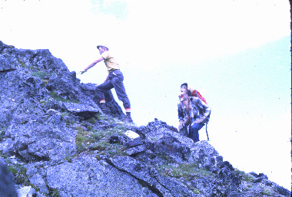
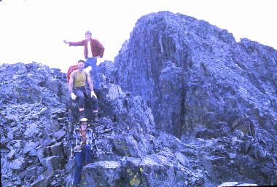
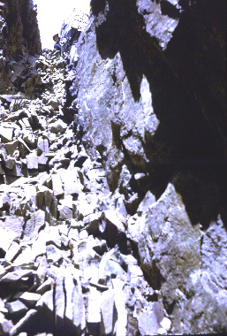
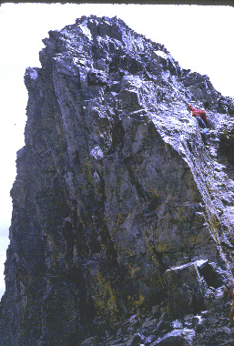
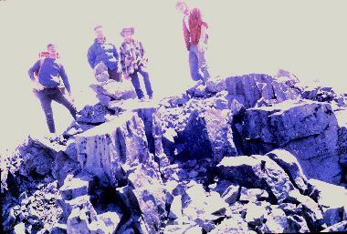
1973: We backpacked into Blue Lake with the Hoskinsons. Us boys climbed Crazy Peak, our first really high mountain – over 11,000 feet high. We had to shiny up a
early part of climb chute we had to traverse to get to top Crazy Peak On top

chimney chute to get to the top. It was quite an adventure. The view from the top was terrific.
Later in the summer our family along with Jay and Van Skoglund hiked from Cook City to East Rosebud. Each night you have a new lake to camp by. Scenery is the most spectacular or any trip we ever took. At one of the lakes (Medicine Lake) 1,000 feet above Dewey Lake where we were camping, we caught big cut throat trout every time we threw our hook in – the best fishing I have ever experienced.
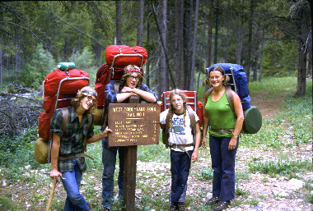
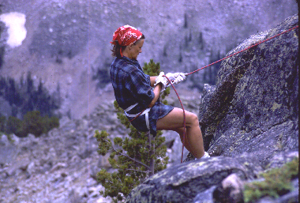
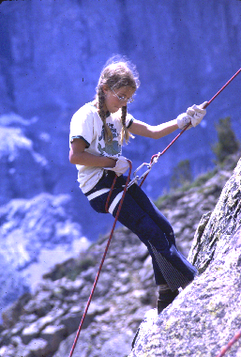
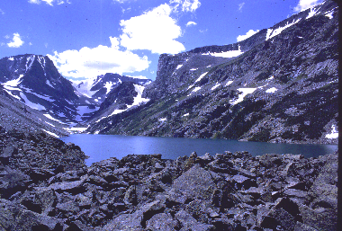
1974: Beth and I started the year with an early spring hike into Gertrude Lake. It was still frozen over with 5 ft snow drifts in the area.
Later in the summer with Mal, Bruce, and Sue we had a fantastic hike on a loop

Start of loop hike Beth repelling Susan repelling

trail southwest of Red Lodge into Keyser Brown, Black Canyon Lake, Rock Lakes, Lost Lake, & September Morn Lake. We also learned how to repel & climbed Silver Run Mountain. Saw a lot of mountain goats on that hike.

Granit Peak Climb
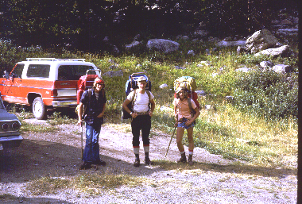
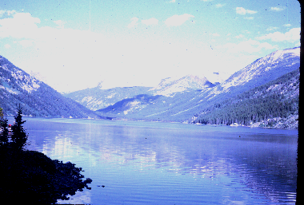
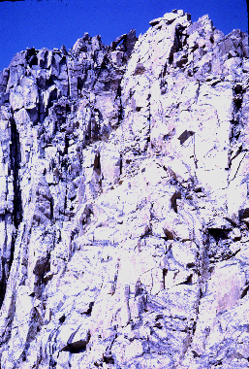
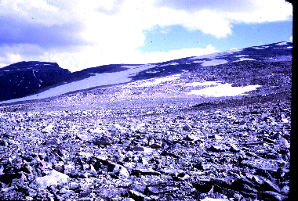
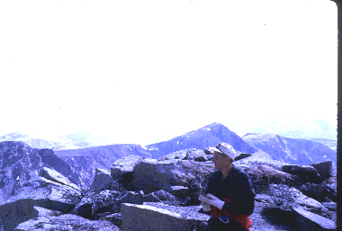
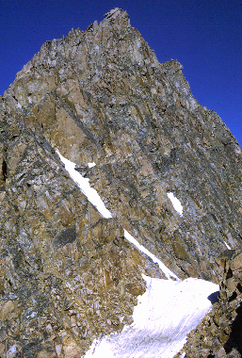
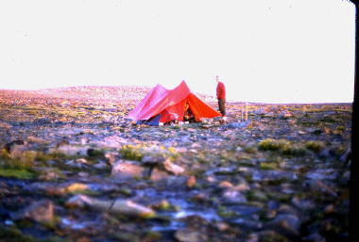
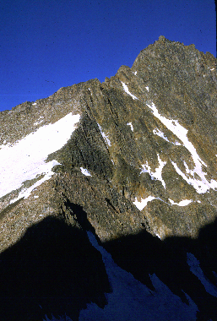
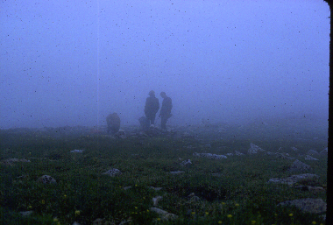
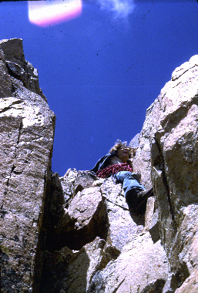
Near the end of summer, the boys, Tom Adams, and I hiked to the top of Granite Peak, Montana’s highest mountain 12,750 feet. Whether you make it to the top or not is largely determined by the weather. You have to cross one snow bridge, but otherwise you can do the climb without ropes. There are a couple of places where you are going straight up and have to be boosted up about 10 feet of sheer rock face – a little scary when you look straight down below you. We made it to the top about 2 PM after spending a night camped out at base camp on the high plateau. The day was clear and the view outstanding. I felt it a real accomplishment for a 46 year old.
Chute we had to climb near the top

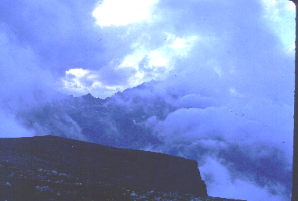
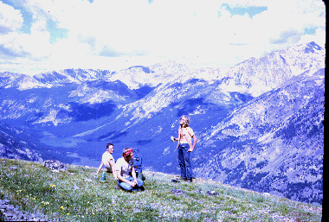
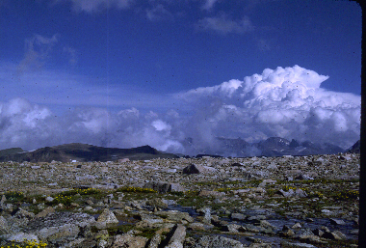
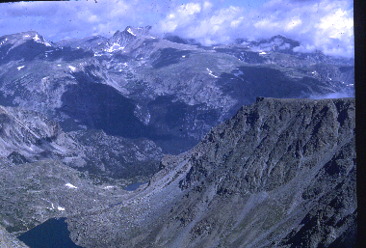
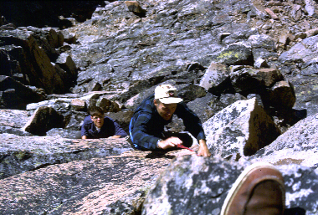
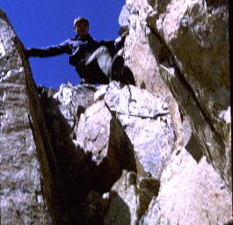
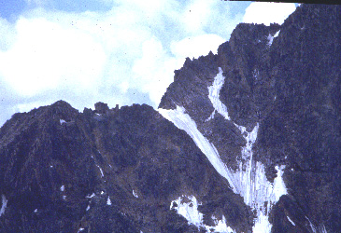
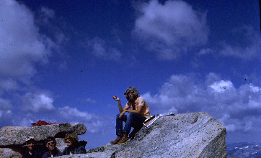

Mal on top of Granite Peak
Granit Peak Summit

Chute near top
Snowbridge you have to cross to get to top of Granit Peak
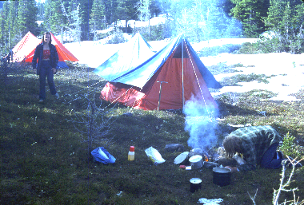
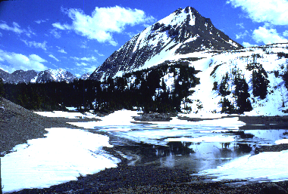
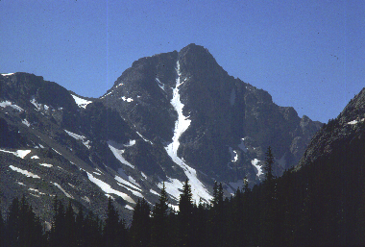
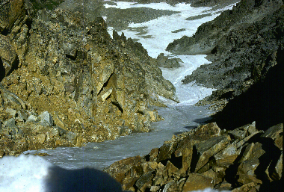
1975: I had a postgraduate medical seminar to attend in Banff, Alberta. Afterwards on July 3 we embarked on a week long hike in Kanninaskus National Park south of Banff to Three Island Lake on the border of Alberta & British Columbia. We easily forded a stream on our route. Even in July, ½ the lake was covered with ice. From our camp you had an immense view east out over the Canadian planes. One night huge cumulous clouds developed, and when it got dark they were below us out over the plains with lots of thunder and lightening. Sky above us was crystal clear. When we got back to Calgary, we asked, and sure enough they had had one doozy of a thunder storm that night. Getting back to Calgary turned out to be a problem. When we came to cross the stream we had easily forded a week earlier, it was a raging torrent, impossible to wade across. It fed into a huge lake, and it would have taken us 3 days to hike around it. We had only 1 days food supply left. Our son Bruce (very nimble on his feet) came to our rescue. He spotted a large tree that had fallen across the stream, was able to walk back and forth across it a number of times ferrying our back packs, and finally steadying us as we gingerly “tight rope walked” across it. We all made it without falling in.
Our Three Island Lake campsite
Three Island Lake on border between British Columbia & Alberta
Looking down “tale”
Whitetale Mountain
Later in the summer we climbed Whitetale Peak, a very pretty mountain above September Morn Lake in the Beartooths. I got good pictures of it “tale”
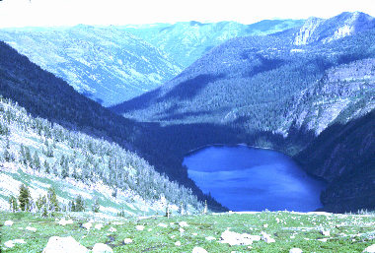
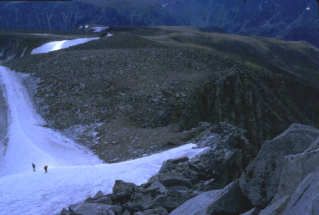
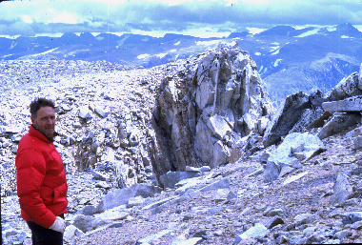
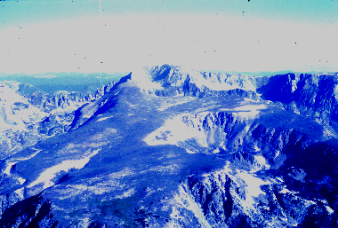
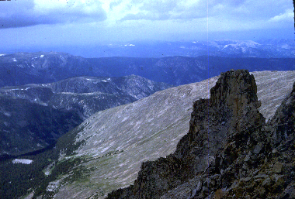
1976: We hiked into the Bob Marshall Wilderness just south of Glacier National
Park to Sunburst Lake. Later that summer the boys and I climbed Mount Wood, Montana’s 2nd highest mountain.

Glacier on south face Mount Wood On top of Mount Wood View from top of Mountain

Still later we started construction of our “cave”. Our friends the Stevensons had bought a couple of lots in the Pine Hills Ranchetts 12 miles east of Miles City.
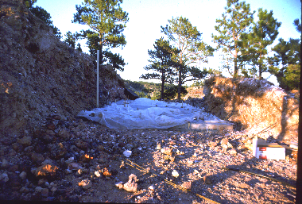
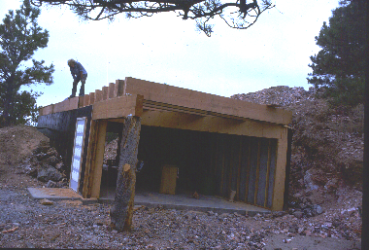
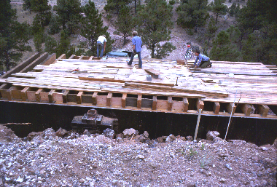
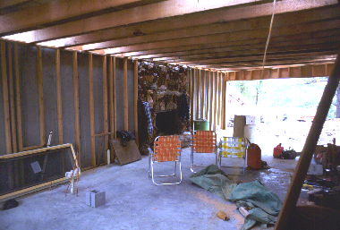
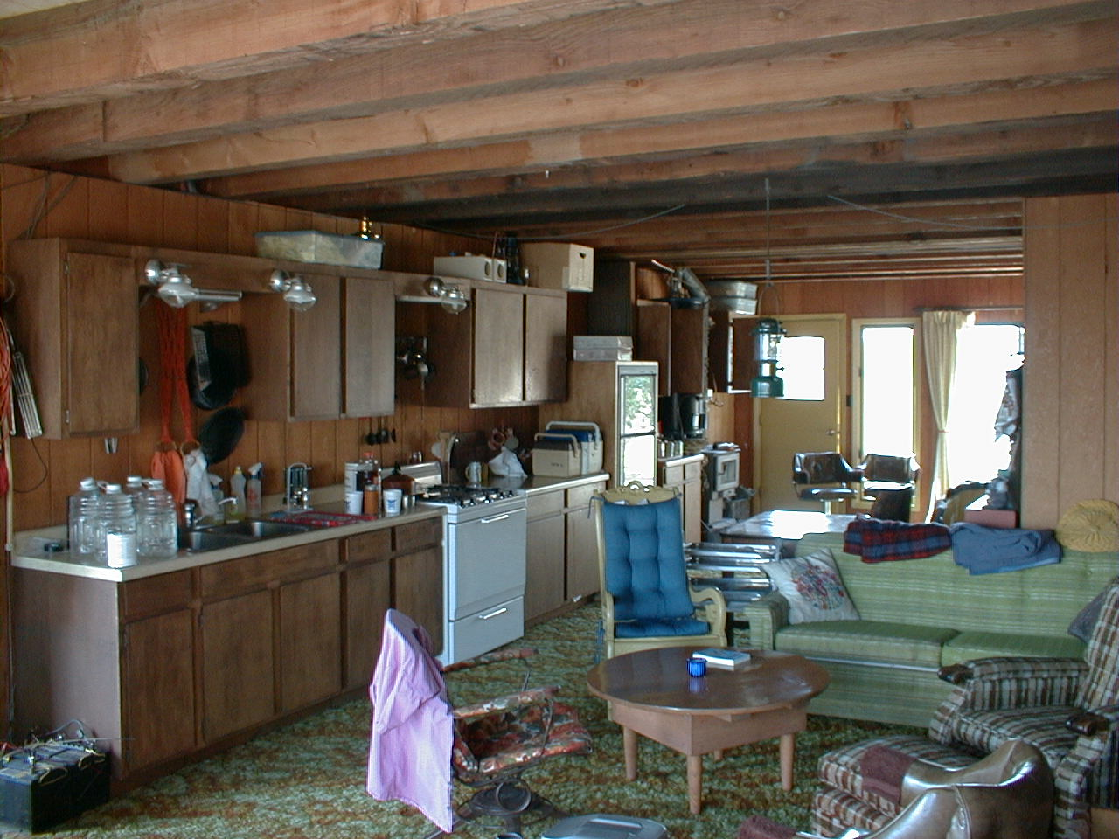
They had built an A-frame cabin on one of them, and given the other to their boys.
One evening we were having supper out there with them, and the Stevenson boys motioned to Beth that they wanted to show her something. They took her over to their lot and asked her if she wanted to buy it. They wanted to use the proceeds to buy a couple of horses. Beth has just inherited some money from Duncan McKenzie’s estate, and so she was interested. Our kids chirped in and said “Ma we will build you a summer home.” It ended up that Beth bought the lot, somewhat to Dale Stevenson’s dismay. She decided she wanted her cabin not in the spot designed for it, but up on the ridge of a hill. We decided to build it underground in the hill. One Saturday we went out and started to dig out where we were going to put it. Of course the ground was rocky and we got nowhere. Our friend Tom Hardesty, who had bulldozed all the Ranchett roads, ended up bringing over his big D6 Caterpillar and bulldozing a 18 foot wide trench crosswise in the ridge of the hill. We poured a concrete slab floor in this, and then built 8 foot concrete walls along the edges. From Wyoming we obtained 11”x17”x17 foot timber beams, and placed these crosswise over the top at 1 foot intervals. On top of them went 2x6 planks, and on top of them 5/8ths inch exterior grade plywood. We painted that with epoxy paint, and covered it with 4 layers of 4 mil black plastic. Sand and gravel covered that, and then Tom bulldozed dirt back over the top. We filled in the ends with sliding glass doors, placed a large fireplace in the north wall, a wood stove near the west end on the south side, erected 2x4 insulated wood covered walls along the sides, carpeted the floor, put in plumbing, electric wiring, propane and 12 volt lighting as well as 110 volt outlets. The fireplace is made out of native rock, all of which Beth picked out and carried up the hill from where it had landed after being bulldozed out of the trench. She has an interesting story to tell about the cave roof. Ashland area lumber mill was supposed to supply the beams, but defaulted. Randall Lumber was able to procure them from Wyoming, and transported them up to their lumber yard. They weren’t supposed to haul them out to us, but the let Beth “steal” their big diesel 16 gear truck. She learned how to drive it going out to the cave – even manipulated a couple of big hills without stalling it. Once there our boys and 3 of our big strapping friends unloaded it. Trick was to get the first beam crosswise over the cement walls. Once that was accomplished all the other beams could slide over the first one to get to the other side. They boys got the job done by early afternoon on the hot day. Everyone was thirsty and drinking pop. Beth’s can had been open for a while, and it turned out a couple of yellow jackets were inside enjoying a “sugar” fix. Beth managed to swallow both into her mouth and they bit her throat on the way down. She knew she was in potential trouble from swelling that could obstruct her breathing – was smart enough to instruct Mal on how to do a tracheotomy if necessary. Fortunately all that happened was that her throat got really sore. She drove the empty truck into town and called me at work. As soon as she heard my voice, she broke down crying. All's well that ends well and the kids got most of the cave construction done just in time to go off to college. We sent Bruce off on the bus with his toothbrush for his freshman year – marked contrast to Mal whom we had delivered in person. Mal followed several days later after we had the sliding glass doors installed and took Bruce’s gear.
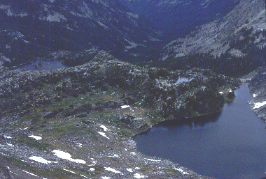
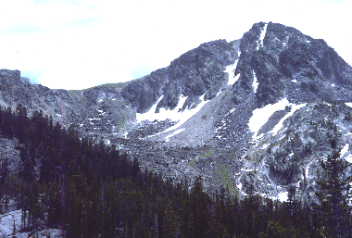
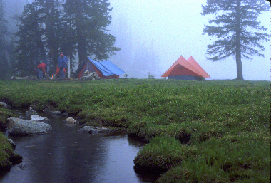
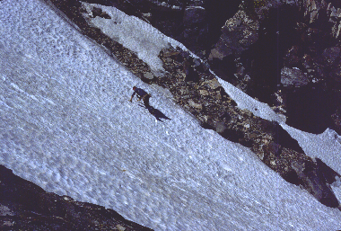
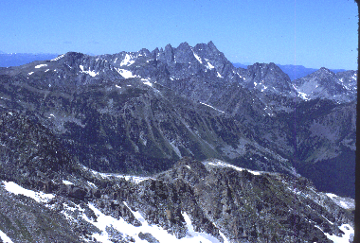
1977: We hiked along the West Boulder into Kaufman Lake and then over the mountains east to Four Mile Creek. The last night on the trail by Lake, we encountered a ferocious thunder and lightening storm, were a bit afraid we might be
Kaufman Lake Campsite Boulder Mountain Tom Adams snow climbing Needles from top B. Mtn.
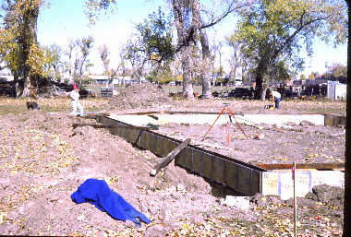
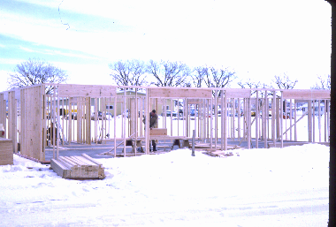
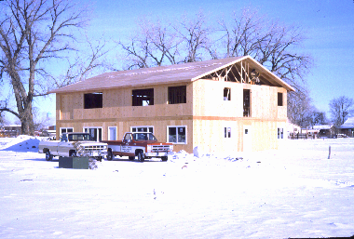
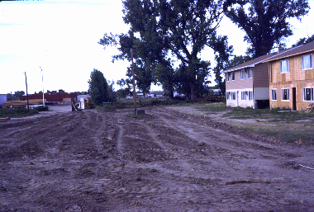
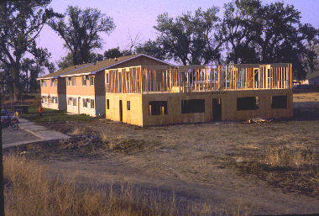
hit by lightening. The mountain ridges above us were. That night my lower back started hurting and going into spasms. The next day with the help of codeine I was able to hike out with the kids carrying my backpack. They said I was a very pleasant person to be worth, ranting about a number of topics that didn’t make much sense to them. Once out I rode down to Big Timber on a board in the back of a truck. Eventually my back recovered.
Foundation 1st Apart. Framing 1st Apart. 1st Apart. Nearly finished Street development 3rd Apart. framed in
That same year we started building our apartments. A few years earlier, a 10 acre lot had come up for sale. Bill Hoskinson inviegled me one noon hour to go with him to bid on it. There were 4 of us there, and it ended up each of us got 2 ½ acres. We decided to build seven 4 bedroom apartments – ended up building 2 the first year and a 3rd the following year. We added a 4 unit garage 15 years later. In general they
have been a good investment for us, but retrospectively if we had invested the same amount of money in the stock market, but would have done better.
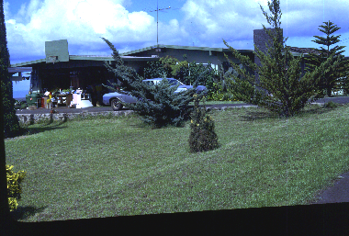
1978: The entire family were into cross country skiing. Beth and I also had
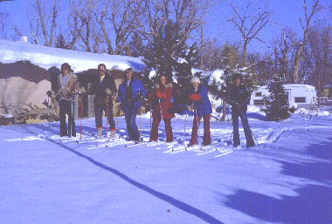
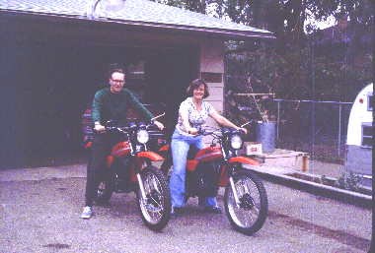
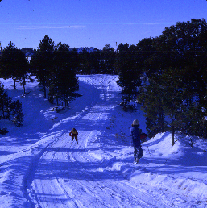
purchased and were riding a couple of Yamaha dirt bikes.

For our summer vacation, we wanted to hike in a different area, and so picked the Cabinet Mountains in far northwest Montana. They aren’t very high, but that is the
lowest base elevation of anyplace in the state, and so you have to hike up 5 to 7 thousand feet. They get a lot of rain, and so scenery is beautiful. On the last night of our hike in we were just
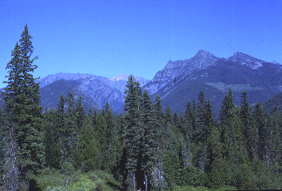
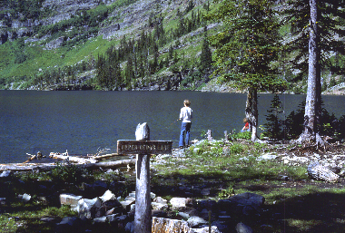
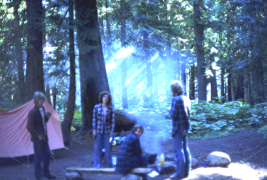
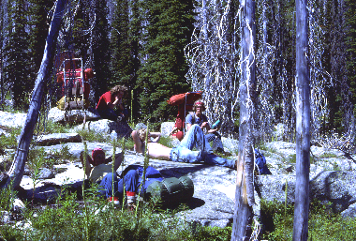
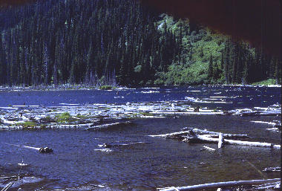
setting up camp in a lush high mountain meadow right at sunset, when a huge
Cabinet Mountains Upper Cedar Lake Granite Falls campsite Bushwhacking from Sky Lake Klatawa Lake commercial jet barely cleared the top of the mountain just east of us. It was so low and close, that we could see people sitting in their seats, by its windows. We all thought it was going to crash, and were preparing to put on our packs to go to the crash site. However it disappeared from view, and when we hiked out and asked about it nobody knew anything about it. The area we were in was not near a commercial airline route. Why it was there, and what it was doing so low, will ever remain a mystery.
On September 15th Mal and Kim were married out at our cave. Shortly thereafter Mal started Medical School. In early fall we visited them in their Seattle apartment
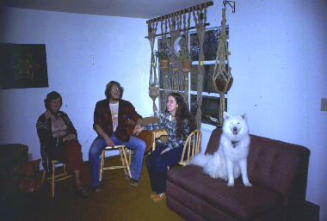
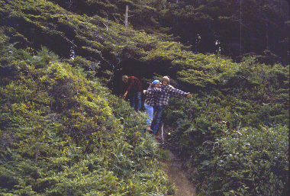
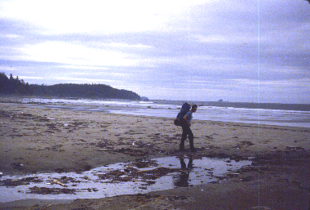
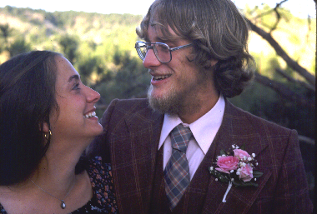
Mal & Kim’s wedding Mal & Kim’s med. school apt. Olympic Peninsula
and also went backpacking on the Olympic Peninsula.
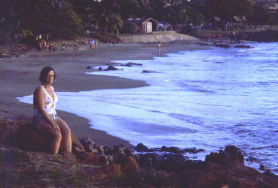
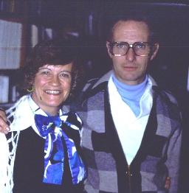
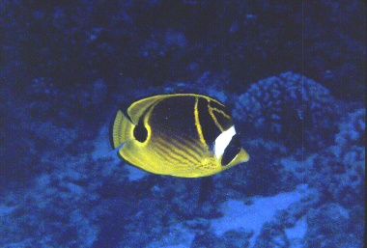

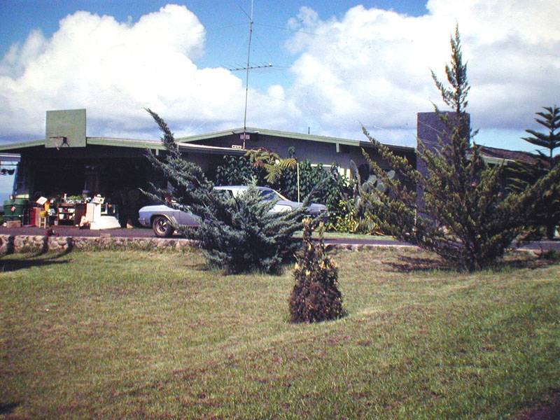
November 4th was our 25th wedding anniversary. We celebrated it in Hawaii with
25th wedding anniv. Hoskinson’s house Beth on exclusive beach scuba fish picture lantana flowers
our friends the Hoskinsons.
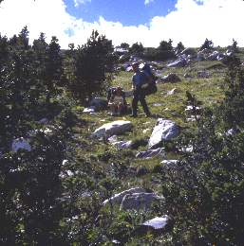
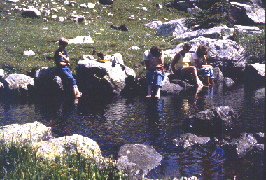
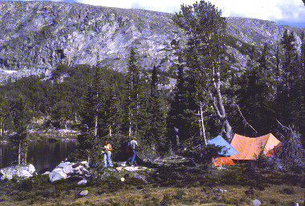
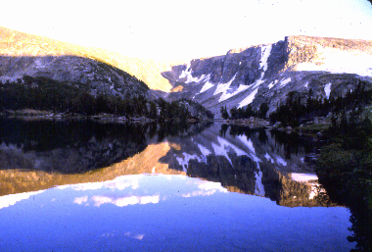
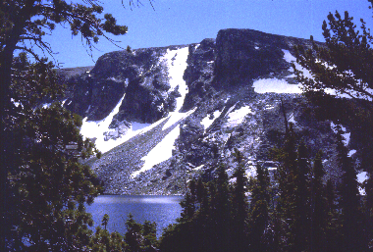
1979: The most challenging hike we ever took was into Lightening Lake in the Beartooths. On that trip we had nephew Tim and friend Tom Adams with us. Lightening Lake is famous because it has Golden trout. It is very difficult to get to though. You can try and climb up into it from the west fork of the Stillwater river, but there is no trail and so that is very difficult. Or you can go in on the east fork of the Main Boulder and hike over to it- a long arduous trip over a couple of high mountain passes. That is the way we went. Laurie Helvig, Bruce’s fiancée drove us to your tail head, and then after a wonderful time by the lake with some side trips to other lakes, we hiked down into the Stillwater drainage and out to meet Laurie at the West fork of the Stillwater trail head. I was 55 years old at the time and considered that hike quite an accomplishment. Brian learned what hiking was all about on that trip. We had a beautiful campsite by the lake – didn’t catch any Golden trout there but did in the next lake over. On coming out we learned that Laurie had had an accident with our Jimmy going about 70 feet down a steep embankment when she slid on some loose
gravel. That vehicle was damaged some, but she escaped without any injury.
1980: Bruce and Laurie were married July 26 outdoors next to her home at Nye.
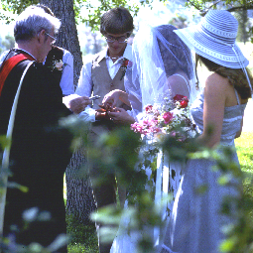
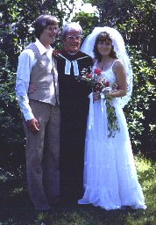
For part of their honeymoon, they went backpacking with us to Lake of the Woods nearby in the Absorkee Mountains. Shortly thereafter the Helvig home became the Stillwater Platinum Mine. Laurie’s folks had to build a new house about a mile away.

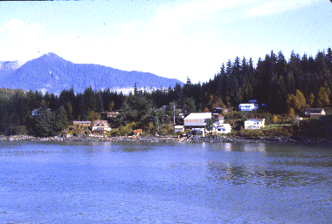
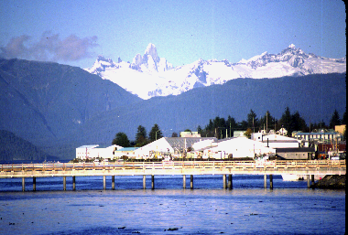
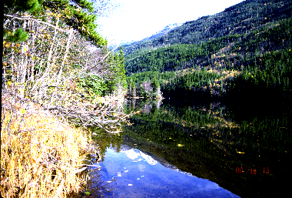
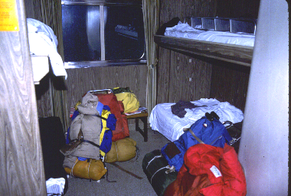
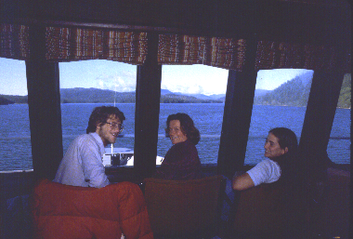
That fall Mal was able to get two weeks off from school in late September. We all took the ferry through the inland waterway . .
Wrangel St. Petersburg Our view from the boat Our cabin Lower Dewey Lake
along the Canadian Coast to Skagway. Scenery as seen from the ferry boat was very beautiful. At Skagway we backpacked in to a mountain lake. It was cool enough to freeze at night, but in spite of this we had a good time. A single engine plane flew us back to Juneau. It had to make three attempts before it was able to land. We learned a little bit about what Alaskan bush flying is all about. One nice thing about that trip, is that all the mosquitoes were gone.
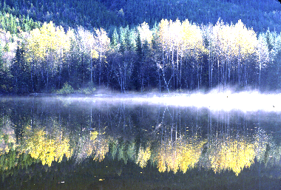
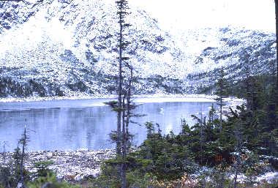
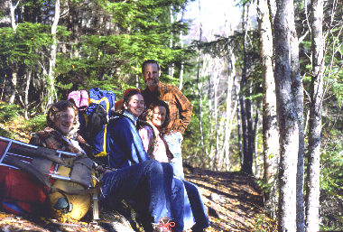
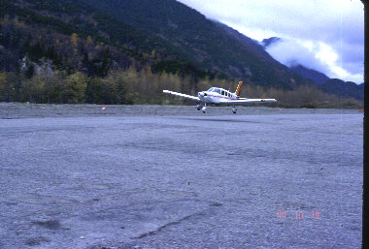
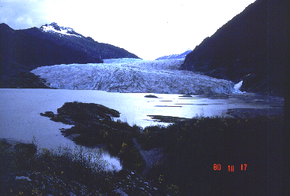
Lower Dewey next morning Upper Dewey Lake Mal, Kim, Beth, Malcolm Plane we flew back in Mendenhall Glacier
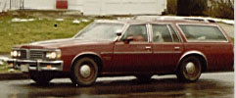
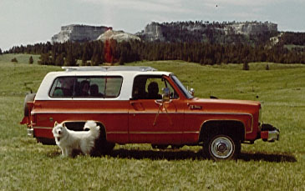
1981: We added a hot tub room to our house. Vehicles we were driving that year were a Pontiac Stationwagon and a GMC Jimmy
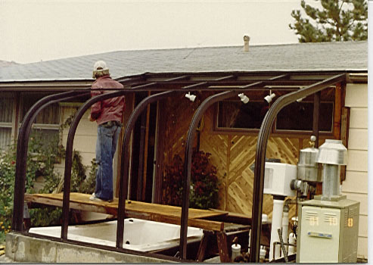
1973 Jimmy with Kim’s dog Tashia
Hot tub greenhouse addition
Pontiac Station wagon
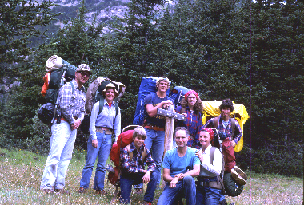
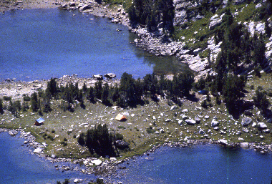
Our backpacking trip included our pastor Bob Starburg with wife Jewell and son Ben, daughter Sue, and nephews Paul Kitamura and Brian Tate. We hiked into
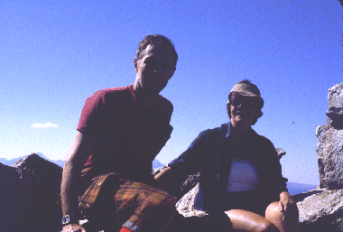
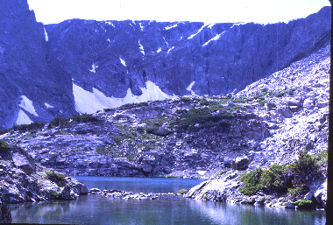
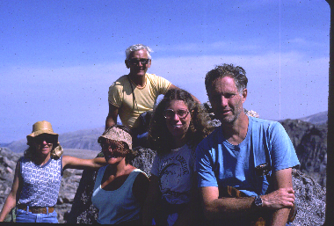
Entire crew at start of hike Mary’s Lake Myself & Beth atop Gross Mtn. Dude Lake Atop Sylvan Mtn.
Mary’s Lake, Dude Lake, and climbed 11,056 foot Gross Mountain and 11,943 foot Sylvan Mountain.
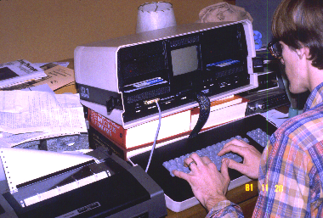
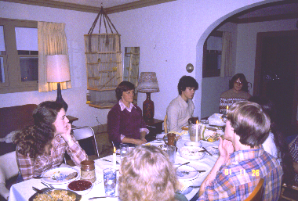
Thanksgiving was spent in Rochester. Bruce had just acquired an Osborn portable computer. Mal was a Fellow in Internal Medicine at the Mayo Clinic and had just purchased a new home.

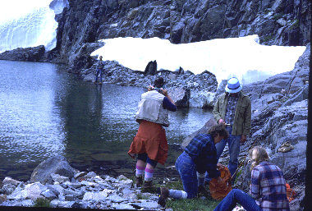
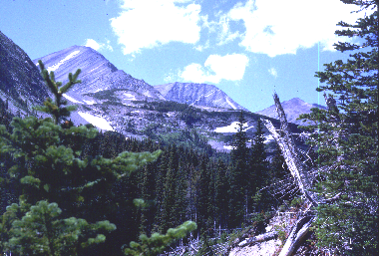
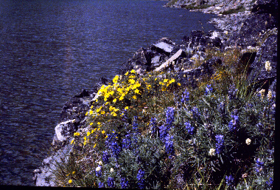
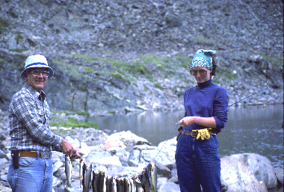
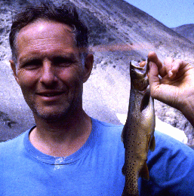
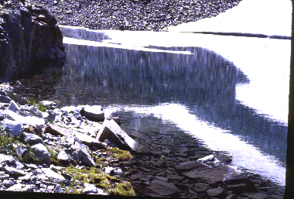
1982: We hiked into Crazy Lake with our Thanksgiving/Mal & Kims Bruce/Osborn computer
Crazy Mountains Crazy Lake camp Crazy Lake 1st day’s catch Mal & fish Lost Lake

friends, Susan Mattacks & boyfriend, Bob & Jewel Starburg, and Susan Winter.

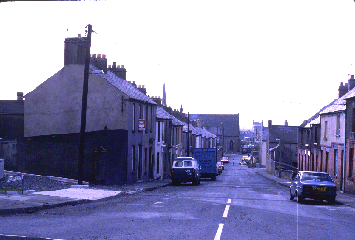
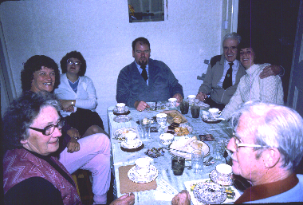
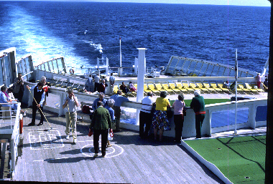
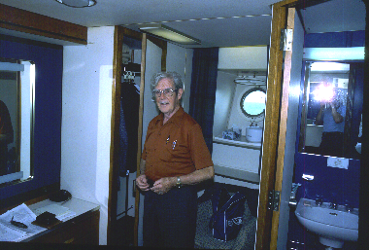
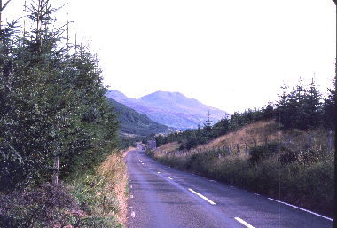
1983: Susan flew with us to England. We rented a car, stayed at farmhouse bed Scotland near Loc Ness Newtonards, Tate’s home Tate family Dad Tate in QE2 cabin QE2 deck
and breakfast places, and toured England and Scotland. Then we flew to Ireland and
visited Beth’s uncle, aunt, and cousin. Dad Tate was there and we all came home on the Queen Elizabeth II. Our first ocean voyage was on rough seas, but we all had a good time.
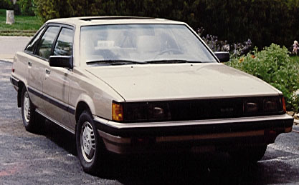
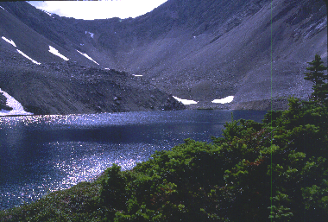
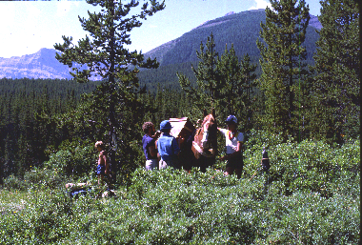
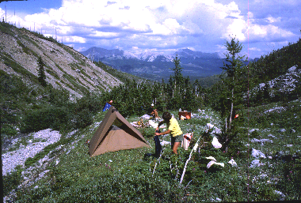
1984: In April we revisited Hawaii. That summer the Stock Growers celebrated their centennial in Miles City. In August we took our last
Our new 1984 Toyota Camry with sunroof
Camp below McPhail Lake Our packhorse Blaze Loomis Lake
back-packing trip. We went with Canadian friends
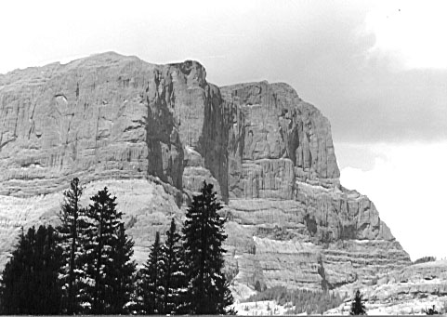
Susan Mattocks and Eon Hyslop and took along a pack horse to help carry our packs. Our trip was to McPhail Lake in the Highwood Mountain area of Kennanascus National Park, and all went well until the last day 6 miles from our trail head when we lost our horse. We had to carry all our gear out and go back to Calgary with an empty horse trailer. Turned out the horse had broken hobble and wandered up to our previous camp site. There some other horseback riders found him and brought him home.
1985: On our 55 mile back packing trip in 1971 while crossing Columbine pass we had a view south that showed us Pilot and Index Peaks in Wyoming, and Cut-Off Mountain in southern Montana. It was a peak that had a huge cliff on it’s east side & that was what was visible from Columbine. I always wanted to climb it and so in July 1985 with friends Tom and Linda Adams, we made an attempt. We approached it from the south, and would have made it except for a
Cutoff Mountain
notch on it’s slopes that had cliff drop-offs and made further climbing untenable. Although defeated in our quest, we had a good time trying.
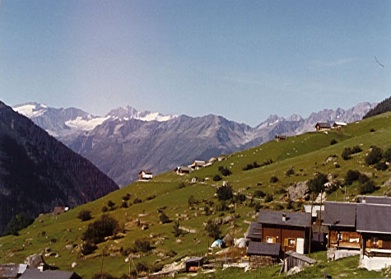
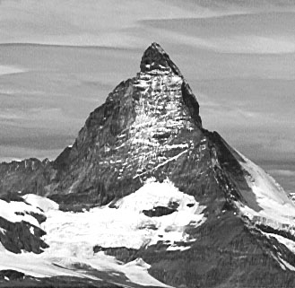
In September, Beth, Sue, and I traveled to Germany, Switzerland, and Austria. I had always dreamed of spending a day mountain climbing in the Swiss Alps, and that dream
The Matterhorn
View on our day hike out of Bisten
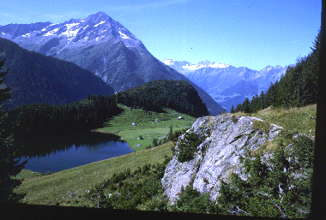
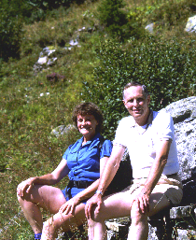
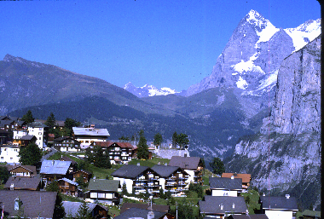
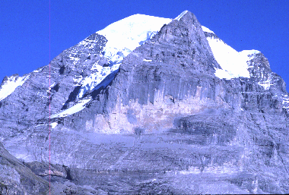
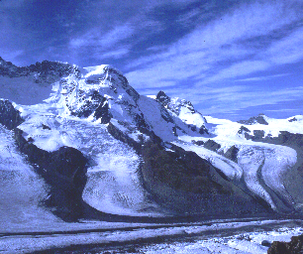
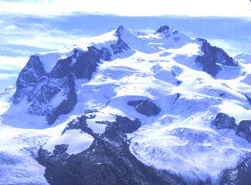
finally came true. We stayed at a Hotel in the .
Amsteg Hike Mal & Beth Murren Eiger 13025 ft Breithorn Jungfrau 13642 ft Rosa 15217 ft.
eastern part of Switzerland, and the owner had been in the Swiss army. He told us where to go, and we had one day spent hiking in the high mountains – a really memorable experience. To get up to altitude, we took a local cable car (they have
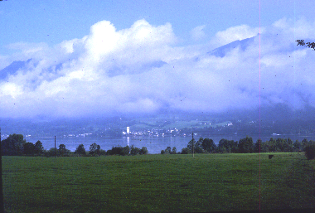
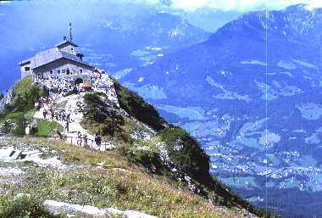
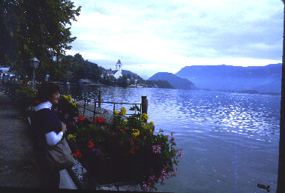them all over) used to carry people, stock, supplies etc. Valleys in the alps are only about 500 feet above sea-level. Mountains go up to over 13,000 feet. Our cable car took us up to about 8,000 feet. The day was beautiful. Signs told us what we thought were distances to various places. It turned out they told us times. Therefore we found ourselves late in the afternoon a long ways from our trail head. We were hiking down a single lane mountain road and a car came . . Two views of Wolfgang Lake in Austria Hitler’s Eagles Nest
along it. We got the idea that if another car came, Susan would put out her thumb and try to hitch a ride for us. That happened – a Swiss cattle herder complete with leather breeches picked us up – had a tape player in his car playing Swiss polkas. We bounded down the mountain side at breakneck speed until we met another car. Only thing to do was back up about a mile to a place where the road was wide enough. This
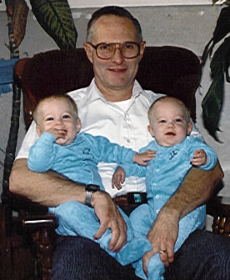
we did at about 30 miles an hour. Then a short time later had to do it again. We got down to the cable car in time to get home before dark, tired, but content. The next day we were able to see the Matterhorn – also a emotional experience. Still later absorbed the beauty of Austria, stayed by an Austrian lake, and visited Hitler’s Eagles Nest.
In October our first grandchildren, Nick and Zack, were born to Bruce and Laurie in Rochester, Minnesota.
1986: We had a Tate family reunion at Cielo in Warner Springs, California.
Our first grandchildren Nick & Zack Winter
1987: Was an eventful year.
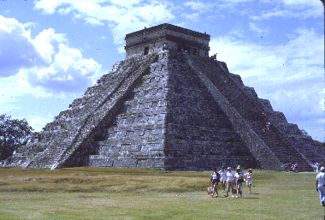
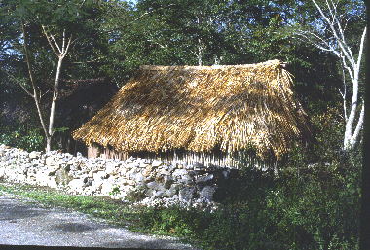
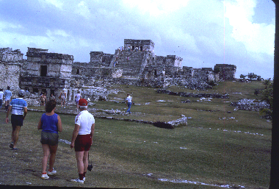
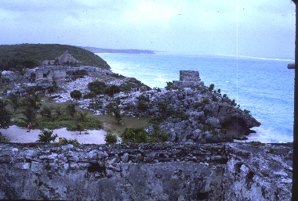
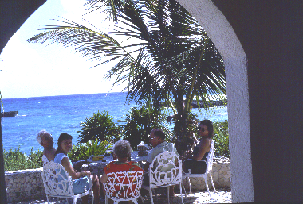
In February we flew to Cancoon with Starburgs and Opps, & spent a week at a remote beach house right on the ocean.
Cancoon Villa Tallum Ruins Native Hut Chichen Itza
We swam every day and also took some day trips to Mian ruins.

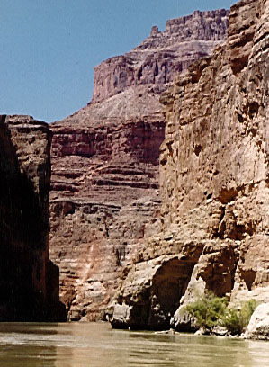
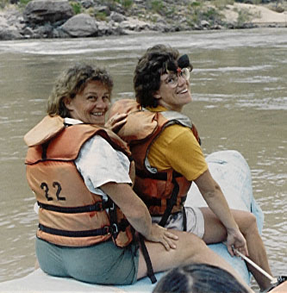
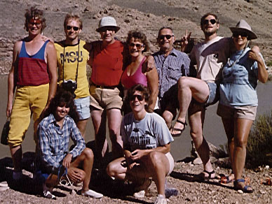
In August we floated the Grand Canyon with Mal, Kim, Scott, Darcy, Susan, a college friend of Mal’s, Dell, and Kim’s Dad, Doug Hennefent. 40 of us floated on two large rubber rafts. All our meals were fixed for
Scott, Del, Malcolm, Beth, Doug, Mal, Kim
Darcy Susan
Beth & Susan on the horn of the raft
Grand Canyon
us, and we ate like kings. Each night we would sleep out on a sandy beach. Going over the rapids was exciting. The largest one - had a 36 ft. drop. After a week we were helicoptered out back to civilization.
Beth and I had never seen the oranges and reds of fall colors in north-eastern United States. Mal finished his Hematology/Oncology fellowship at the Mayo Clinic, and graciously volunteered to spend thee months in Miles City, taking over my practice so that we could take a three month trip around the periphery of the United States. We purchased an Alpenlite 5th wheel trailer and a GMC S15 truck to pull it, and took off in late September on one of the greatest adventures of our lives.
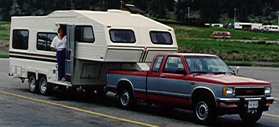
Along the way we saw 30 or so friends – stayed in only one house overnight (because the people would have been offended if we hadn’t) – really enjoyed our trailer. We visited friends at Ellsworth Airforce Base outside of Rapid City, South Dakota (where we had been stationed when we were in the airforce), and got to see a B1 bomber. We did a lot of genealogy research in New York, finding gravestones for Thomas Winter and his wife Isabella Turbull in the Bovina, New York Cemetery. We also visited the farm he
1987 GMC S15 truck pulling our new Alpenlite trailer
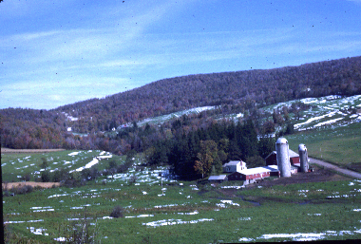
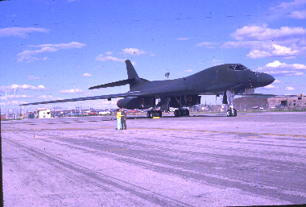
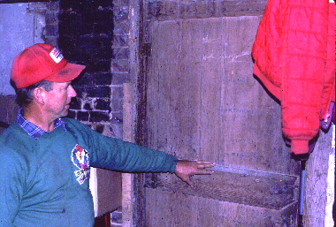
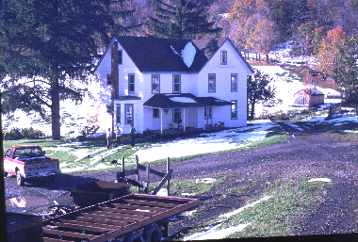
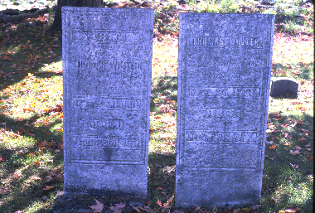
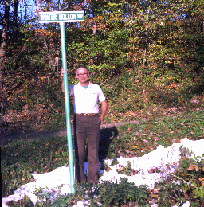

had homesteaded in what is now called Winter Hollow. In the basement of the house he built is a door with T Winter stenciled on it. His brother, Robert Winter’s house is a ½ mile north, and has a corner stone saying it was built in 1887. That was on the farm we believe our great, great, great, great grandfather John Winter homesteaded. Robert bought it from him. From New York, we traveled to New England, and hit it at the height of the fall colors. In Boston, we visited some historic landmarks including Concord Bridge, and Nathaniel Hawthorn’s House of Seven Gables. We visited Washington D.C. In Florida we saw Epicot Center and Cyprus Gardens. In New
Orleans we visited the French Quarter. And in Baton Rouge, Louisiana we became reacquainted with Dave Wall, one of our close airforce friends. He purchased Huey Long’s house for $1, and cut it in half, transported it to his lot several miles away, and
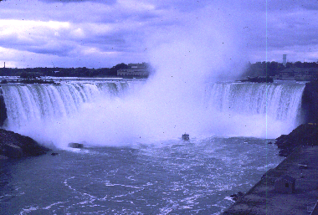
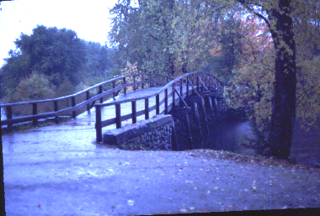
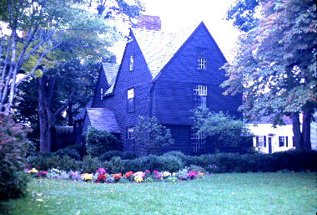
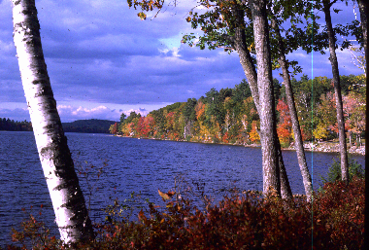
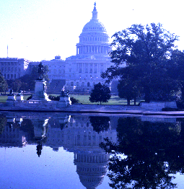
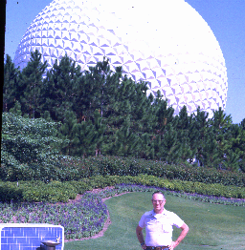
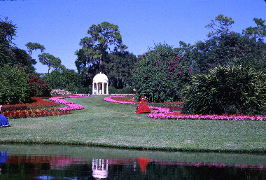
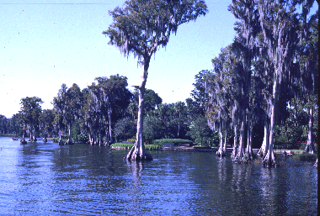
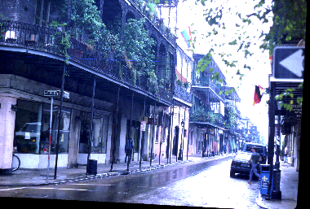
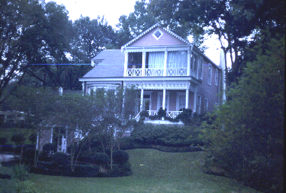
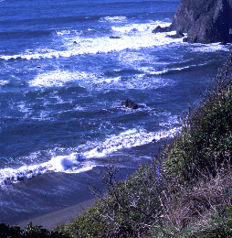
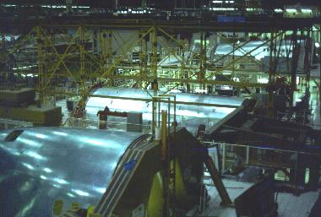
Fall colors in Maine Niagara Falls Concord Bridge House of 7 Gables Capitol Epicot Center
Cyprus Gardens Cyprus Trees French Quarter Huey Long’s house Oregon Coast Boeing factory
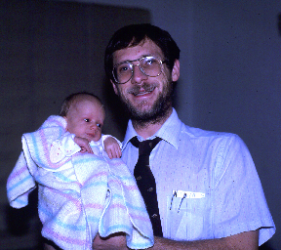
reassembled it. We visited friends and relatives in Texas, New Mexico, and California in November. By December we were in Oregon, and were able to arrive back home a couple of weeks later. December 17th our 3rd grandson was born to Malcolm & Kim.

Malcolm & Luke

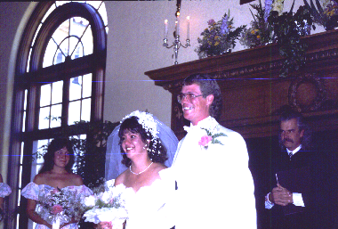
1988: Scott married Darcy Skates August 26th at Gallatin Gateway (old
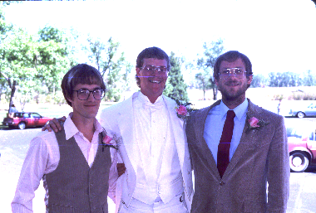
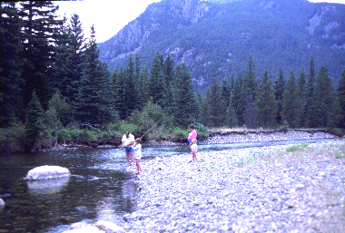
Yellowstone Park Milwaukee Train Station) southwest of Bozeman. Jim and Dawn
Scott & Darcy Bruce, Scott, & Malcolm Tate family fishing on Boulder
Tate with children Peter & Victoria visited us from Ireland. We introduced them to Boulder River camping.
1990: Susan was married to Brad Page June 3 in Wibaux Park here in Miles City. Brad’s family and friends came from Australia. Sue and I arrived Cinderella like in a horse drawn carriage at the Park and after the wedding the reception was held at the Town and Country Club. Susan even hit a few golf balls in her wedding dress.
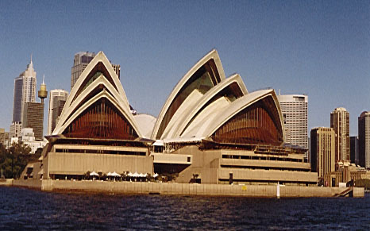
1991: We took our first trip to Australia – nonstop on a specially modified 747 out of Los Angeles. They put bigger motors on it so that it could carry enough fuel. When you take off, even the tail fin is full of fuel. I had always thought of Australia as about like the United States, but with opposite seasons. Turns out it is a lot more tropical, and mostly desert, with only a 200 miles strip along it’s east coast lush and green. It’s northern border (equivalent to the southern border of the U.S. is about the same latitude as South Carolina. Its southern border is the latitude of northern Columbia South America.
Opera House Sydney

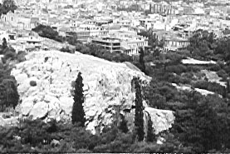
1992: Charles and Rachel persuaded us to go on a Footsteps of Paul trip which they led. We visited Greece, Turkey, and a number of islands off the coast of Greece. Seeing the cities Paul had visited during his lifetime was a moving experience. We also visited Peramum, Turkey, and saw where Luke had had his medical training.
Mars Hill, Athens, Greece from where Paul preached his famous sermon

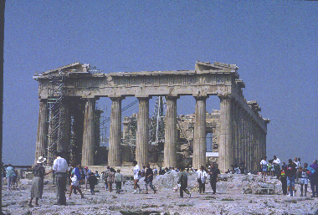
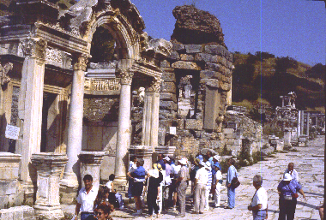
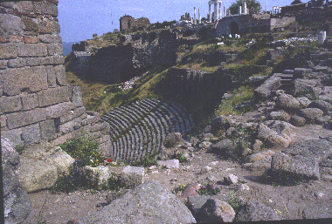
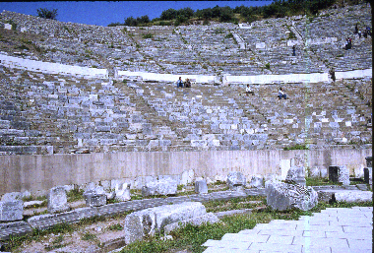
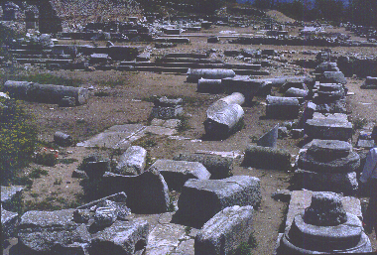
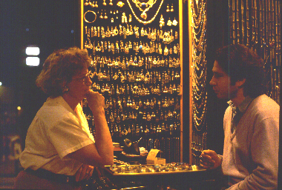
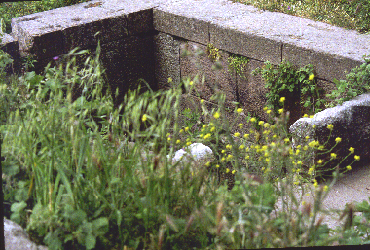
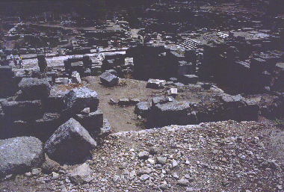 Acropolis, Athens Pergama, Turkey Ephesus, Turkey Ephesus Arena Philipi, Turkey

Corinth, Greece Istanbul, Turkey Med Exam room, Pergama
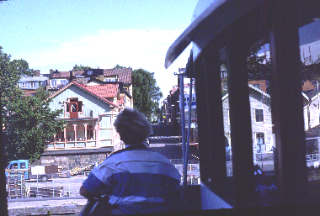
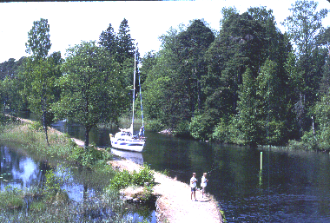
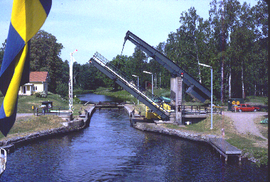
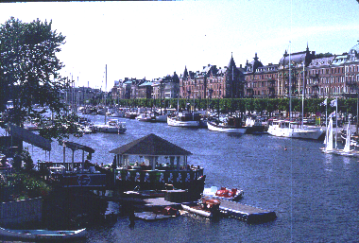
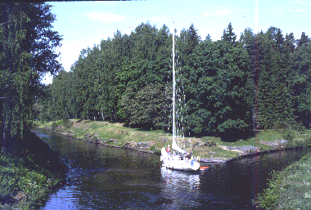
Trollhatten family street Gotta Canal Godnogen locks Norkvarn lock Stockholm canal

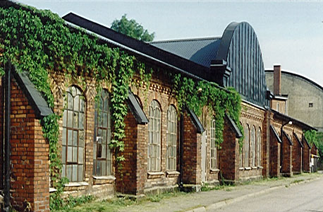
Then we briefly stopped in Ireland on our way to Sweden. There we visited Trollhatten, where Beth’s family came from, and then embarked on a trip through the Gotta Canal. It took us from the west coast of Sweden to the east coast through many locks and a lot of beautiful scenery. The trip through the beautiful countryside at about 15 mph was one we will never forget. Days were about 20 hours long.
Trollhatten Ironworks where Beth’s Great Grandfather Svenson worked

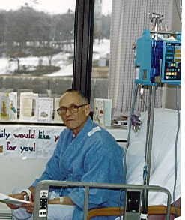
1995: In January I underwent cardiac surgery at the Mayo Clinic, having an atrial septal defect closed, and also having the Maze procedure done on my atrium to surgically terminate chronic atrial fibrillation.
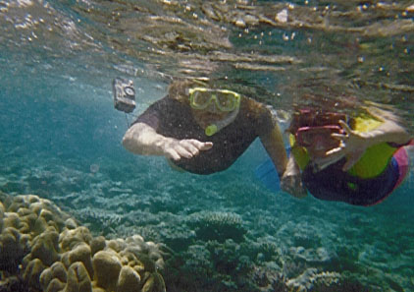
In April, Bruce, Laurie, and family traveled with us to Australia, where the Pages took us on a trip to the Great Barrier Reef on the northeast Australia Coast. We had a wonderful time – saw all three types of tropical rain forest, snorkeled the reef, and went deep sea fishing. Swimming every day in warm tropical water was a real delight.
My hospital room in Rochester several days postop.
We also revisted Umina, where Sue and Brad live north of Sydney.
Brad & Sue snorkeling over the Great Barrier Reef, northeast Australia

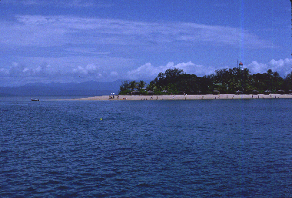
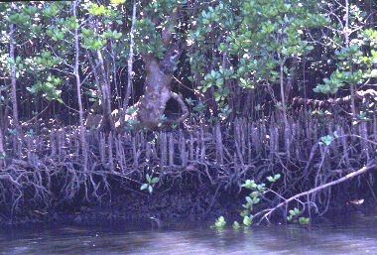
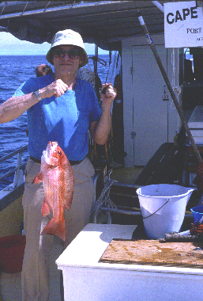
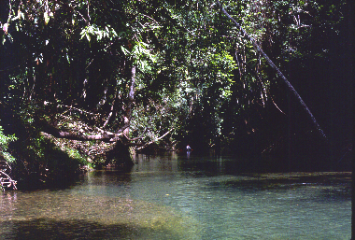
Great Barrier Reef Rain forest mangroves Rain forest river fish

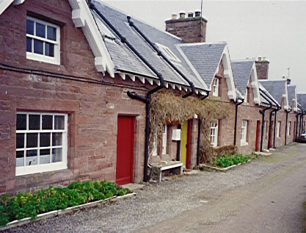
1996: We traveled to Northern England, and the south of Scotland in a genealogy search for Winter family roots. We found Mosstower, the tenant farm in southern Scotland, where our John Winter Jr., son of our great, great, great, grandfather John Winter, worked and lived. We have a letter from Thomas, one of his sons written to his grandfather John Winter Sr. after he had moved to Bovina, New York to live with two other sons (Robert, our great, great grandfather Thomas Winter), and one of his daughters Margaret. We also visited Beth’s cousin, Jim Tate and his family.
Mosstower tenant farm workers quarters where Tomas Winter and his father John Winter Jr. lived
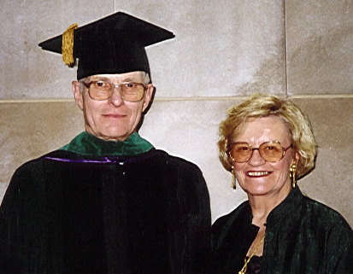
1997: In March I was awarded the honor of being inducted to Fellowship in the American College of Physicians at their annual meeting in Philadelphia.

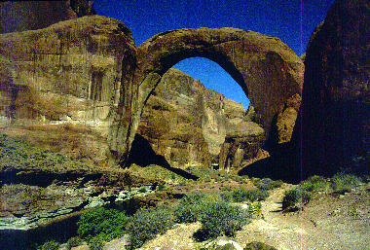
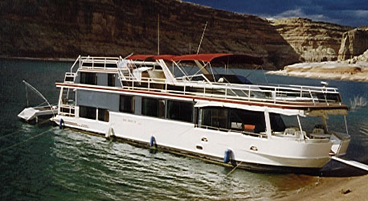
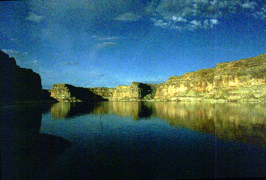
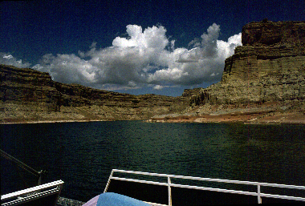
In August Frisbies invited us to go on a Lake Powel cruise on their house boat.
Frisbie’s houseboat on Lake Powell
Lake Powel Natural Bridge
Jim and I went to high-school together and have been friends for a long time. Charles and Rachel befriended them also when Frisbies attended their church in NewPort Beach, and were invited also. We had a fantastically good time.
1998: We trailer camped with Malcolm and family at White Sands State Park in Idaho in June. In July we spent a weekend at Teddy Roosevelt National Park in Medora, and in September we did genealogy stuff in Iowa, and visited Bruce in Rochester. October took us to Lewiston, and November to Australia for Shianna’s birth. We were home for Christmas to enjoy a visit from Bruce and Laurie.
1999: In February with Bob and Sandy Short, we visited a former patient I had cared for in the ER, who asked us to stay in his guest condominium in Miami Beach, Florida for a week. We had a wonderful time, and also visited Epicot Center and Cape Canaveral. In May we visited Farragut State Park in Idaho with Mal & family, and also took in my 50th Wheaton Class reunion. In June we bought a new Ford Crew Cab ¾ ton truck to pull out Alpenlight 5th wheel trailer. In August we vacationed in Bodego Bay California with Susan, Annie Tate, Katrina Iserman, and Susan Mattocks – also attended nephew Brian Tate’s wedding by Flathead Lake in Montana. Then in October with Bruce we pulled our trailer back to New York to pick up more genealogical information about the Winter family. We were able to see the inside of Great, Great Grandfather Thomas Winter’s house with his name stamped on a basement door. He used to ship vegetables to New York City, and stamp his name on the crates. Our final trip of the year was to Belgrade to spend Christmas with Scott and Darcy.
2000: In February we visited our friends, the Hoskinsons, on Maui in Hawaii – also visited the main Island. I retired from my medical practice the end of June at the age of 72 – had a wonderful retirement party attended by many of my patients, and most of my colleagues. Also the entire family was there. In August we visited the Peace Gardens in Canada
2001: In Jan we visited California, stopping at Bryce & Zion Canyon National Parks on our way home. In August we enjoyed an Idaho camping trip with Malcolm and family, and then in September visited Wind Cave National Park in South Dakota.
In November we were finally able to take a 3 month trip to Australia. We had our own “granny pad” to stay in at Susan’s, by taking the roof off their garage and building a 2nd story – then putting the roof back on again. We had a fantastic visit, which included a 3 week car trip around Tasmania, a beautiful island 500 miles south of Australia. Unfortunately near the end of our stay, we learned that my sister Peggy Kitamura had cancer of the pancreas. She died just before we arrived back in the States the end of January.
2002: In July Susan and girls came to the States, and we had a wonderful (but late) surprise celebration of Beth’s May 18th 70th birthday, with the entire family coming – first at the cave, and then later traveling to Red Lodge.
In September Beth and I visited Butchart and Minter Gardens in British Columbia, and
2003: In March we visited Malcolm and family in northern Italy and southern France. Malcolm took a year off practice – spent a lot of quality time with his adolescent kids in Europe.

Miles City Medical Experiences

When I came to Miles City in 1959 the Garberson Clinic occupied most of the Colony Building on the northeast corner of Main & 7th. Foster Drug was on the first floor front of the building. The clinic business office was located just behind the drug store, with Dr. Nansel’s dental office in the north part of 1st floor. A wide marble U-shaped stairway led up to offices on 2nd floor. On the landing two-thirds of the way up was a huge Elk Head, an animal that had been shot by Dr. Garberson. The east side of the 2nd floor south wing had 6 rooms. The north 2 rooms were my Dad’s. The next 2 were Larry Campodonico’s and the last 2 were mine. Each room served as both a consultation room and an examining room. The final room next to mine was the clinic library, rimmed with mahogany floor to ceiling bookcases, filled with some current and many very old (some dating to the 1890's) leather bound volumes of medical texts. The west side of the south wing contained EENT offices facing Main Street, then Xray, then lab, then a waiting room. Surgeons and Dr. Howard had their offices in the north wing. The x-ray had a huge rotor that would rotate by 4 ball posts to covert AC to high voltage DC current and it made a lot of brilliant blue sparks when it was going. Brud Foster, the building owner, had installed a hydraulic elevator, because it was really difficult for some elderly patients to climb the stairs.
Office calls were $3. House calls were $5. Night calls, I believe, were $10. The Clinic took care of all County patients for $250/mo., paid as a retainer to the County Physician, Dr. Winter, Sr. We also provided all professional services to Milwaukee Railroad employees through the Milwaukee Hospital Association at a contract fee of $1,000/mo. Which, incidentally, did not change from 1956 until the railroad left Miles City about 1968.
My starting salary was $1,000/mo., with contractual incremental raises over a four year period to $1600/mo, after which full partnership was granted, with a share in profits. The partnership had the power to accelerate the process and I was made a full partner after one year and the payment by me of $4500 to buy into the partnership. That amount was determined and the contractual arrangements set after the death of Dr. Garberson, who, prior to 1951, was the sole owner of the clinic, employing all of the physicians. When he died, he left the clinic assets equally to his long time employed physicians and his business manager. They, in turn, determined to avoid the indenture of physicians that they had endured for as long as 30 years, included all of the physicians then employed by the clinic.
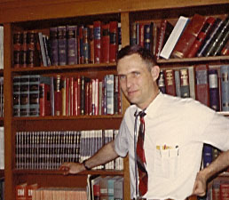
After I became a full partner, earnings based on a percentage of profits made after all expenses were tabulated each month, were distributed equally to all partners. An attempt was made to equalize the work-load and, even though the majority of the physicians were qualified in a specialty, a unique environment in a small town in the 1930's, all of the physicians broadened their fields to include most of the general medicine. We all would stay at work until all the patients were seen. Office hours were from 10:30 to 12:00 and 2:00 to 5:00, but we usually didn't get out until nearly 6:00. Appointments were made by the clinic receptionist for all of the doctors except the Ob-Gyn-Pediatrician, who worked long hours and saw more patients than anyone else. Patients who were not scheduled for a specific physician on a regular schedule were given a “pink slip” and would sit in the waiting room until someone finished his regular schedule. Then those patients would be seen in order until everyone had been cared for. Noon hours were usually taken up by making house calls. Thus workday started at 8 at the hospital and ended by 6:30 or 7:00 at the hospital. Often there would be a house call or two to make after supper. We averaged 1 or 2 night calls a week - usually housecalls. We worked Mon. through Fri. & Sat. morning, plus rounds twice daily at the hospital 7 days/week. A couple years after coming here we started taking 1 weekday afternoon a week off. That was really great. It was not an easy decision. There was much discussion at a long meeting before some of the older physicians agreed that patients would still receive adequate services.
Clinic library
Larry Campodonico’s and my relationship started out pretty competitive the first few years I was here. As time passed though we became stalwart friends. We got into the habit of taking a 15 minute coffee break every morning, the only break we would really have from push push push to keep from getting too far behind on our schedules. Through the years we discussed a lot of patient problems at those breaks, as well as other subjects varying from theological, to political, to philosophical. Now that Larry is gone, I really miss those breaks. The professional and personal relationships developed over a career lifetime are really the core issues when one looks back to measure success or failure. One wonders if those opportunities even exist outside the borders of medical practice in a rural setting like Miles City.
Several years after coming here, some of the clinic partners recognized two facts; that some of the physicians were working much harder than others for the same compensation and that lack of incentive was constraining growth in every area. Beginning in 1961, they started pushing to change earnings distribution formula to a percentage of production. There were many long and heated meetings, resulting in the resignation of one surgeon who joined the small group of independent physicians in town. In 1962, a graduated income, based on production after all expenses (shared equally irrespective of production) was implemented. Within one year, individual incomes, which had stagnated at about $23,000 per year, grew to an average of $33,000 per year and rose every year after that.
Miles City had a Red Light District for many years. The police department had an informal agreement with the madams, that once a week each of their girls would be examined by a physician. The clinic was given the contract to do this and so each of us internists got to know all of these girls pretty well. Each week they would come in for a gonococcal smear and a pelvic exam. In those days gc cultures had not yet been developed. When their smears were positive, we would treat them and forbid their working until a repeat smear was negative. We would occasionally pick up early syphilis also, by smear of a chancre or by an monthly VDRL test. What was interesting to me was the wide variety of personalities the girls had. Some were gruff and raw. Some were very petite and gentle. A few were married and would take off for a week or two every couple months to go back and spend with their families. They lived by a very strict code i.e. off the street before 5 each evening. When I would see them downtown during the day and try to say “Hi” to them, they wouldn’t even blink an eye at me or recognize me in any way. They were the best-dressed women in town and were recognized by that fact by other women. A local women's clothier, who, for those years, had a remarkable inventory of up-scale fashions, opened his store at night to cater to the "girls". It is certain that a large part of his long successful career derived from that business. During the 1940's and 1950's, the complex containing the brothels had a reputedly marvelous Chinese chef. During the evenings, when the "girls" were working, the town's leading citizens, including the physicians, took their wives and guests to the brothels for catered meals. The acceptance of the houses in Miles City was repaid by the generosity of the madams, who openly supported charitable and civic activities. One long-standing madam who died in Miles City, left her estate for the benefit of deprived children and for purchase of eyeglasses and hearing aids for the poor. Her money was administered by her good friend, a local longtime minister. This era of tolerance and western hospitality ended in 1967 when the county attorney finally closed the brothels. Personally I felt that was the morally right thing for him to do. However I could see the police department’s reasoning, that under their agreement, prostitution was controlled and health risks were minimized to some extent. Once the houses were closed, it still went on, but in an uncontrolled fashion and with much more abuse potential to the girls practicing it.
House calls were time consuming and often led to scheduling an office appointment or to hospitalization. At night they were often to relieve nausea, pain, or to treat an acute problem, that nowadays would be seen in the emergency room. They did help you get to know your patients though, in that you would get to see the inside of their homes and that would give you tremendous insight into the type of people they were. Many of our patients in the 1960's died at home and death calls were a very important service. It was years before patients would accept a funeral director's decision that death had occurred. Also you got to know Miles City streets pretty well. Finding houses in the middle of the night was difficult, but a spotlight on the car helped. Unpaved streets, poorly placed mailboxes, ruts and unplowed snow were frequent and seasonal hazards.
Several housecalls stand out in my memory.
One was to the home of an elderly couple. He had bronchitis and probably could have come to the clinic, but wanted to be seen at home. When I walked in their house to see him, there was his wife, completely bald. When out in public she always wore a wig. I made a diagnosis, on the spot, of myxedema, treated her husband, but also got her to come in for a PBI (protein bound Iodine) test. It confirmed the diagnosis. She was started on thyroid hormone and over the next 6 months grew the most beautiful head of black hair you ever saw.
Another was to the Red Light District. A customer had a heart attack at the moment of his climax and died on the spot. I simply confirmed that he was dead. The girl he was with though was really shook.
Another came about because of a phone call to the clinic. I was to call back, which I did, only to receive no answer. I don’t know why, but something prompted me to stop by their house on my way home. They had been overcome by Carbon Monoxide poisoning. Both survived, but probably wouldn’t have, if I hadn’t made that call.
In the 60s cardiac monitors and defibrillators came into use. The first monitors we had at the hospital were little 5” round display tubes. That was before CCUs and ICUs. I remember one of the first patients I defibrillated - not even my patient. I was walking by his room one morning making rounds when I heard the alarm go off, rushed in his room and found him unconscious in V fib. I believe in those days we only had AC defibrillators. He responded to a couple shocks and CPR, recovered and has done well ever since. Also I remember a case at the clinic. We didn’t have a monitor there, but we did have a direct write EKG and a defibrillator. He went into V fib while we were doing his EKG. We shocked him and cardioverted him, then called the ambulance to take him to the hospital. I accompanied him. The ambulance driver was so shook that when he went to turn the siren on, instead of pulling that switch, he pulled the hood unlatch switch. The hood came up, but we were in such a hurry that he stuck his head out the window and drove the ambulance all the way to the hospital with the hood up. That patient survived about a year and then succumbed to a heart attack.
Over the years, special units evolved in Miles City as they did everywhere, from our first cardiac unit with three beds and one monitor, to the present ICU-CCU with five beds and state of the art monitors, central monitoring and specially trained staffs; from 30 day stays for MI patients who lay flat in bed while we treated their complications with digitalis, quinidine and thiazide diuretics, to 6 day stays for patients who are ambulated promptly after treatment with a vast and changing armamentarium of diagnostic tools and therapeutic modalities.
Shortly after I came to the clinic, we replaced our x ray unit with a brand new state of the art General Electric unit. It had much more power and an excellent flouro unit. Although there had been a radiologist in Miles City for sometime, he left in 1956, leaving the clinic without coverage. After he left to 1961, one of the surgeons who had had experience in fluoroscopy did the clinic fluoros. In the airforce, I had worked with a couple of Rapid City Radiologists and learned how to do fluoroscopy. Therefore, I inherited that job at the clinic and did the Upper GI and Colon x-rays for a while. Although we have had several radiologists since then, we have never been without radiologist coverage. For many years, we had a primitive X-ray therapy unit at the clinic, which was used primarily for acne treatments, but was nearly unused by 1960. Because radiotherapy was in its infancy, it had been as effective as anything in the state, even in Billings. It was donated to the hospital when we made room for our new unit, but cobalt's advent made therapy impractical and too sophisticated for this area and except for radium implants for cervical cancer and uterine cancer, radiation therapy was all done in Billings. Since the cancer treatment center was established here in about 1990, much of the therapy is again done locally.
For many years, the clinic kept a supply of radium seeds which were used in the treatment of uterine and cervical cancer. They were kept in a lead container in the basement of the Foster Drug Store. When controls became more stringent, a change had to be considered, but nothing was done until the drug store was robbed. Among the loot was the container of radium. Fearful for the thief, the danger was broadcast. Ultimately, the thief (a drug store employee) confessed that he had dumped the container in the city dump when he knew what it was. A search found the radium and it was immediately given to the hospital.
In the late 60s we were bulging at the seams. Dr. Hoskinson had joined our Ob-gyn dept. and we needed more room. About that time the Dybas were trying to develop a shopping center. They had Tempo dept. store and Buttrey’s supermarket lined up to come in. Key Drug would come in only if we as a clinic agreed to move out there also. We had been talking for at least a year about alternatives, including the remodeling of the clinic building. As always, there was resistance to change. The drug store was unwilling to sell the building and only feeble attempts to upgrade the building were offered. Certainly, the physicians were unwilling to spend money on a building they couldn't own, and they recognized that downtown parking problems and restricted growth potential were serious problems. Therefore we negotiated a terrific deal for the piece of land we needed. We were given the land at no cost. Five of us obtained a small business loan and invested some of our own money to build a new building. That was no small achievement. Our partnership agreement, which was one typewritten page, specified that any one partner could veto any proposal that affected the clinic. One of the original partners vetoed everything that was proposed. Only by forming a separate partnership could we build a new building. Erdman Associates designed it for us and they did a pretty good job, except they didn’t make the nursing stations, or the halls big enough. We moved in 1968 and only a few short years later had to build another wing in order to accommodate more doctors. Those of us who built the building formed a real-estate partnership and leased it to the clinic partnership at a fair rental. About 20 years ago, as the clinic anticipated growth and after one of the partners had left, we realized that eventually the clinic would be owned by widows of the original owners, a potential source of real trouble. Because we needed to expand, the owners of the building proposed to refinance the building, add on the necessary wing and give the building to the partnership, providing perpetual ownership to the clinic physicians. That policy nearly backfired, when a surgeon who had been with the clinic for less than two years left and demanded his share of the equity. That was negotiated away, because basically he was fair, but we took steps to prevent that from happening again.
In 1966, the physicians established a maximum Keogh plan. For ten years, through that long period of drought in the stock market, there was little gain. Several times in the early 1970s, we looked at incorporation, but consultants advised against it, for reasons which were subsequently proved to be spurious at best. Again there was resistance from the older partners. In 1976, after bringing in John Mutschler Associates from Minneapolis, we were finally convinced of the value of incorporation and it was accomplished. We established, at that time, a defined benefit pension plan and a defined contribution profit sharing plan for the clinic employees under our clinic manager's supervision. It was a very successful and profitable change.
In 1972, our business manager, after 54 years, retired and was replaced by a personable, capable young man. For many years the clinic did well, with the vagaries inherent in a small group of physicians with multiple needs and opinions. The fact that there was a nucleus of dedicated career members held the group together and assured its survival. In the early 70s we became involved in all sorts of administrative activities, including an HMO feasibility study and a Rural Health Initiative, which later led to our involvement in a clinic satellite program. Several of us worked with Nurse Practitioner and Physician Assistant training programs and we employed physician extenders in the clinic. In the early 1980s we got involved in trying to run a satellite clinic at Colstrip. We thought the future of rural medicine depended on expansion of our market share, especially with the increasing concentration of secondary care in the larger centers. The experiment took up a lot of our administrator’s time and was very frustrating to all of us. Also we were computerizing our billing services and the learning curve on computers was something else again, also very frustrating and time consuming for our administrator. In addition to these responsibilities, he oversaw retirement investments of clinic employees.
By 1982, there were rumblings from several partners about the clinic management style, particularly with regard to distribution of income. At that time, all expenses were deducted before a production formula was applied. Because there was a wide disparity in production among the various specialties, the contribution to overhead was skewed and although it was intended to be that way to help lower earning specialties, it needed to be adjusted, because of the widening spread in incomes that we had not experienced before. Unfortunately, because we had not anticipated and dealt with the problem earlier, negotiations with the unhappy physicians came to naught and the blame for the situation centered on the manager. He was already stressed by satellite and computer problems and could not deal with the allegations of incompetence, indeed, even of dishonesty and he resigned in 1984.
Because of the increased work load, the clinic had hired an assistant manager, who took over the reins. It didn't take long to realize he did not have the skills necessary to manage the clinic. There had been some discussion among physicians about the future of the clinic and of health care. Negotiations were begun in 1985 with the Presentation Health System, the parent of Holy Rosary Hospital, offering to sell the assets of the clinic to the hospital. The goals of integrated services, more efficient and cost effective care, and decreased competition with it’s attendant duplication were powerful incentives for the hospital. The clinic physicians were happy to be freed of administrative duties and in 1986 the Garberson Clinic became part of the Presentation Health System, managed through a for-profit subsidiary corporation owned by Holy Rosary Hospital. The buy-sell agreement preserved the production distribution formula affected by the medical CPI, but free of any accounts receivable effect. The purchase price was amortized over 15 years at 9% interest. When the income formula was established, it included a consideration of the payment, but was still comparable to industry standards of the time. There was a penalty clause tied to length of service and leaving the clinic, but not to disability or retirement.
Under hospital management, the clinic didn’t do very well. The hospital made the mistake of assuming that clinic management was the same as hospital management, something the whole industry has had to unlearn. In 1988, the clinic hired Medical Group Management to analyze our operation and to obtain a manager for us. After that, although there continued to be problems as the Hospital management learned the differences in clinic administration, the agreement worked well for a period of time. Then the hospital board developed a new health center in the South of town, encompassing a new hospital, with integrated clinic and nursing home (replacing the old County Nursing Home 5 miles East of town). We moved into the new building in 1995. Within a year the Hospital was in financial trouble, and sought to solve things by canceling all our contracts. We had the option of signing a new contract, going into practice independently, or quitting. At that point the Billings Clinic offered to hire us if we wished. Five of us ( Drs. Vadheim, Stickney, Robinson, Shiotoni, and myself) took them up on their offer. We all have been extremely happy with the arrangement. The rest of our colleagues either went into independent practice or signed new contracts with the hospital. In early 1997 I had to give up the hospital part of my practice because of my health problems. My colleagues graciously agreed to admit those of my patients that needed hospitalization, and the arrangement has worked out very well. I thought my clinic practice would attenuate considerably, but it really hasn’t. I am as busy as I have ever been. Nights with very few night calls, no ER calls, and weekends off have been great. I miss the challenge of hospital practice, but in a way not having to worry about critically ill patients is a relief.
Since I have been in Miles City, the practice of medicine has changed tremendously. The number and quality of laboratory tests that we can now order has expanded in a mind boggling way. Our X-ray department obtained cathode ray flouro units. Then came radioisotope scanning, then ultrasound, then a Cat scanner, then a dedicated mammography unit, and finally a MRI scanner. Recently these units have all been updated to remain state of the art. We added an ICU/CCU on 5th floor in the 60s and then replaced it with a better more modern one on 6th floor in the 70s. The new hospital has an state of the art ICU with updated equipment. For a small town, I think we have been a bit unique in that we have offered much more primary specialty care with good updated equipment most towns our size would not have. This has been due to physician and hospital cooperation and foresight.

Personal Medical History

My birth was a month premature & I weighed only 4½ lbs. I had quite a few ear infections, and ate the age of 3½ I had a circumcision and tonsillectomy at the same time. My earliest childhood memory was that of receiving a spinning top after the operation. My general health was good, but in the 40’s I developed hayfever and was started on desensitization shots. The in 41 one time when dad was at a medical meeting, I caught the flue and was in the hospital 3 days. I remember I really enjoyed the nurses taking care of me. In medical school studying for final exams, I developed Herpes Zoster on the right side of my chest – was kind of uncomfortable studying, even with Rx with codeine. Around 1960 I had my first bout with sciatica. Then in 1970 a routine EKG demonstrated a left bundle branch block. This was worked up at the U. of Minn. and I had a coronary arteriogram which was normal. By 1978 I was starting to have symptoms of hyperprostatism, and a cysto showed chronic posterior urethritis with inflammatory polyps. In 83 I was off work for a while with backache, and that problem continued to interfere with life style whenever I would try to do much lifting. In 1988 a lumbar spine MRI showed desiccated lumbar disks plus a large herniated disc fragment extending right superiority from the L3-4 disk space causing moderately sever spinal stenosis.
In 89 I had my first bout of paroxysmal atrial fibrillation. Also later that year I had a TUR on a short prostatic urethra, completely occluded by lateral lobe hypertrophy. I continued to have occasional bouts of atrial fib. My first echocardiogram showed an ejection fraction of 65% with a left atrial diameter of 3.9cm.
While seeing a patient in the ICU in the middle of the night in Jan. 92 I experienced the first of several episodes of left sided paresthesias, starting in the hand. These were diagnosed as migraine equivalents after a head MRI was normal. That same year a repeat echocardiogram showed an atrial septal aneurysm. EF was 60%.
In the spring of 1994 I developed an allergy to quinidine that I was taking to keep my heart from fibrillating. I dropped my hemoglobin 2 Gms because of hemolysis and also dropped my platelet count to about 100,000. I itched for about 6 months. I was switched over to digitoxin and diltiazem and stayed in sinus rhythm for a while, but with time flipped into chronic atrial fib. My exercise tolerance dropped and I started having problems retaining some fluid and having to take occasional lasix. I had been reading about a new operation the Maze procedure developed at Washington University in St Louis to surgically make it impossible to fibrillate by making a series of incisions in both atria so that the 4 or 5 circular re-entry circuits that cause atrial fibrillation, would not have enough area to occur. (Electrical impulses can’t cross surgical scars). Since my heart rate was being well controlled by medication, and I was on coumidin to protect from atrial clots, I was advised in Billings to live with my problem. I called up one of Bruce’s friends, an electrophysiologist at Mayo’s in Rochester and asked him if I would be a candidate for the procedure. He thought I would be, and so in late December we ended up spending Christmas with Bruce and Laurie, so I could be evaluated at the clinic.
The studies were done in early January, and showed atrial size was up to 4.5 cm., EF 63%., and my atrial aneurysm was actually an atrial septal defect. I had probably had that all of my life. To start with the shunt was from left the right, but as my heart started to get into trouble, my pulmonary artery pressure was starting to go up and I was reversing my shunt and becoming hypoxic with O2 sats running around 91%. I needed to have that fixed and at the same time the Maze procedure could be done. As a matter of fact, one of the incisions with the Maze was right in the middle of the atrial septum, and so that could be made and the defect closed by simply sewing it back together again. At surgery the defect turned out to be a fenestrated one, about the size of a nickel. I was in the operating room for about 6 hours and on bypass for a good 4 hours. Everything went well and my recovery was uneventful except for a small stitch abscess at the bottom of my sternum occurring about a week after getting home. O2 sats returned to normal and exercise tolerance markedly improved with much less fatigue. Postop echo EF was 55%, and 3 mo. later 51%. However by December of 1995, it had dropped to 25-30%. In February 1996 I think I had adult whooping cough, 2 week prodrome, 2 weeks of severe cough with whooping, 4 weeks subsiding cough with swallowing difficulties. Another echo in April at Mayos also showed an EF of only 26%, but EF on a Muga scan was 38%. Monopril dosage was increased, beta blocker therapy with metopranol maintained, coumidin and lanoxin started. On a follow-up Muga in August EF was 55%. In June of 97 when carvedilol became available I switched to it. I did pretty well until spring of 98 when I started having to take bumex for fluid retention, and experiencing quite a bit or orthostatic dizziness. A Mayo Clinic echo EF was 35-40%. There was a short blip on Reuter’s News Service about Trental being used in South Africa to lower levels of Tumor necrosis factor in patients with cardiomyopathies. Over 6 mo. it increased their EF 10% & cut TNF levels 60%. I started on it, have much less orthostatic dizziness, less fatigue and have been able to get of diuretics.
In August 98 I started having more dizziness. A Holter showed 4-5 second pauses, and so that evening a temporary pacemaker was inserted and the next day a permanent Medtronic Kappa bichamber pacemaker that determines rate by measuring both muscular activity and respiratory rate. The atrial lead could not be placed in an atrial appendage (I am missing both of mine.) and so a screw in lead was inserted in an area of the atrium where it could sense p waves and also stimulate contracture if no p waves are present. I was found to have atrial fibrillation (inspite of my Maze procedure and so had to be cardioverted before the permanent pacemaker was inserted. It so far is working well, sensing atrial beats and pacing ventricular beats. It had a “mode switch” which automatically changed it from DDDR to VVVI if necessary. I was started on pronestyl, but could not tolerate it and so was switched to amioderone.
In May 99 a prostate nodule was discovered. PSA was upper normal at 3.92, but free PSA was 9.4% and prostate biopsy showed a Gleason’s grade 7 prostate cancer. In June I had prostate brachiotherapy with Iodine127 implants with no complications.
In August 99 because of very mild pulmonary dysfunction, and a steady paced rhythm, amioderone was discontinued. I did well but in March of 01 shortly before a planned trip to Australia, O2 sat was low 92% at rest, 88% walking, and chest x-ray showed multiple infiltrates. These were diagnosed as most likely from bronchiolitis obliterans with organizing pneumonia. After a Mayo Clinic visit, plan was to watch and see what happened – do a throacoscopic lung biopsy later if symptoms didn’t improve. Rachel Dierenfield, Beth’s sister, was dying from multiple myeloma, and so we traveled to California. There the condition became worse, requiring a quick trip home, and a decision to start cortisone without the biopsy. Fortunately response to this was excellent. I was able to wean off and stop it in July.

Religion & Philosophy

I had devoutly Christian parents and so was brought up believing in Christianity.
My father was always my role model. He was humble about his beliefs, voiced them in a reasonable realistic way, and with one exception (his addiction to smoking) was what I considered a perfect example of living a Christian life. When he started to smoke of course, it wasn’t considered to be bad. By the time I was in college however, we were learning about the problems it caused, and he genuinely wanted to quit. My mother had been markedly opposed to smoking for years. When I was accepted to medical school, he vowed to quit, as a way of thanking God for allowing me to be accepted. However his addiction was so strong, that he started sneaking smokes without ever letting my mother know that he had restarted. However most people in town knew, because they would see him smoking in the car. I know he felt bad about this, and to me it is just an example of how powerful an addiction to nicotine can be. My Dad was a strong person with a powerful desire, medically, emotionally, religiously to quit - & yet he couldn’t. He was active in church leadership and in the choir - had a good tenor voice. For years he was on the school board and for most of those years he was its chairman. Also he was an active Kiwanis member. He liked to fish. He did quite a bit of yard work. He was a voracious reader. He worked 60-70 hour weeks most of his life, was an intelligent respected physician who kept himself current in this field. In spite of that he had a lot of time for both his children. Our welfare was important to him, and he did many things to help us get jobs, study, be good students, with consciences telling us to do what was right & honest rather than what was expedient. Since his life was an example for this, we were both helped to resist some of the temptations that happen to all of us as we grow up.
My mother was a very devout Christian, who spent hours of time regularly in personal, family, and church devotions. She was concerned for the rest of us, and that spilled over in her becoming emotionally upset, when our actions or beliefs didn’t coincide with hers. She had the fortitude to voice her opinions, but also would feel so badly when she felt we were Biblically wrong, that she would cry and become depressed & have “tired” spells severe enough to decrease her ability to function. That of course pressured the rest of us to try and comply with her wishes, even though we honestly didn’t always agree. In high-school and college, that caused little problem for me because most of the things she believed in (evils of dancing, working on Sunday, drinking alcohol, etc.) I either agreed with or at least didn’t disagree with enough to make a big difference. However once I married and needed to comply with wife and children wishes vs. my mother’s that was a different problem. She had no insight into her “passive aggressive” behavior and so we all “lived with it”. I give both Beth and my children a lot of credit for handing it as well as they did. Mother to her friends and to me had many saintly attributes because of her devotion to her faith. She spent hours with me helping me to study and apply myself & was a strong support for helping me feel I had done my best and that that was all that was expected of me. Growing up, she was always there when I needed her. She wasn’t athletically inclined, but since Peggy and I wanted to learn to ride horseback, she screwed up her resolve and got involved with us. She also tried her best to learn how to drive a car, but never quite mastered the art.
I could always talk to both my parents - didn’t feel I needed to keep any secrets from either of them. I always considered myself to be just “average”, but because of my parents, always “tried a little harder” and thus made considerably more of myself than I would have otherwise. This was done without being pressured by either one of them - was done because they were both interested in me and I wanted to please them.
One of the many principles drilled into me from early childhood was that of remaining abstinent from drinking any alcoholic beverages. That was one of the teachings of the early Methodist church and strongly believed in by both my parents and also their parents and families. I accepted this, but as I grew older and learned that some fellow Christians (for example Lutherans & their pastors) saw nothing wrong with moderate drinking, I sought help from the Bible. I learned that Jesus himself drank wine. It’s true that back in His day water supplies were impure and fermenting of juices was one way of assuring a non-infectious fluid supply. However if drinking alcohol was always evil, I am sure that Jesus would have not set the example He did. As I got into studying medicine, I learned that 7% (plus/minus a percentage point) of people world wide become alcoholics once they start drinking. Alcoholism is one of the major social problems of our time, being responsible for family breakups, job loss, poor health, and even death in a huge percentage of people affected by the problem. Not only that, in our mobile society, drunk driving is responsible for >50% of all automobile accidents deaths and injuries. With these statistics in mind and with the knowledge that although we know the tendency to alcoholism is probably inherited, we have no way of predicting which people are going to fall prey to the disease, I have continued to have strong feelings that the best way to avoid the problem is to never drink and therefore never expose oneself to the risk. I decided that there are no Biblical guidelines for this, but that ethics and morality would strongly suggest it. Now the problem is becoming even more complicated in that we are learning that 2 drinks a day are probably beneficial in that they raise HDL cholesterol levels and protect against heart attacks. More that 2 drinks a day though are considered harmful, causing all sorts of cardiac myopathies and other problems. Nonfermented grape juice is supposed to have the same benefit, and so maybe my reasoning about not taking the risk in the first place is still valid.
About 7th grade I started questioning Christianity’s reality - started to learn about the scientific method of proving things, and was certain that Biblical Christianity would withstand any challenge. Later I decided that there was no way to prove one’s faith.
In college during a week of revival services I made a definite commitment to my faith in Jesus Christ. - also commitment that the girl I would fall in love with would be a devout Christian. When I met and fell in love with Beth, I knew that she was the girl God had ordained for me. Our marriage has proven that over and over.
To me my Christian faith is a gift from God and is a support system for living my life in a way that gives me peace and contentment, keeps me humble, and allows me to feel that mistakes and errors are forgiven and forgotten by my Creator because of the Sacrifice His Son made on the cross. Since Forces of Evil exist in this world, I have an explanation for the numerous problems and sometimes disasters I see around me. I also have faith that God has answers and that “all things work together for good”, even though I as an imperfect individual often have difficulty understanding them. God is an Omnipotent Being who I can communicate with through prayer, and that is a great comfort. Also my only duties to Him are to try hard to please Him & to do what is right and honest in my daily life. I am not forced to earn “brownie points” with God. I simply try to please Him because of His love for me and my love for Him. I feel that my soul is that part of me that has understanding. The part of me that makes judgments is that part of my soul that weighs and determines things that come before me and determines decisions that I make about everything in life. My conscience is the monitor of my soul - judging me and pronouncing verdicts on all that I say, do, or think. My soul will live forever.
When we first had children, my concepts of “bringing them up in the way they should go” were pretty simplistic. Teaching them Christian concepts seemed pretty clear cut when they were young, but as they grew up things became more complex as they started to think for themselves and challenge concepts the same way I did when I was in my teens.
One of the goals that was pretty important for me was to have Malcolm go to a Christian college, with Wheaton, my old Alma Mater, being the place I would have chosen. Malcolm had other ideas & wanted to go to Montana State. I’ll never forget his final decision, voiced to me while we were discussing the subject in the shop downstairs. By then he had started to define his theological ideas. Whether they would have been modified, had he gone to Wheaton or not, I will never know.
Scott, who had more difficulty in school than his siblings, was never a candidate for going to college. His group of friends were into behaviors that neither Beth or I approved of and peer pressure, plus I think some rebellion against pressures to fit into the mold I wanted him to fit into, resulted in activities I had never expected would ever occur.
Bruce, by the time he was ready to go to college, was interested in engineering and didn’t feel that Wheaton would offer him what he wanted. Besides his brother was at Bozeman, and so the precedent for where to go had already been pretty well set. In college Bruce took some philosophy courses, and I will always remember one day in our livingroom when he was reading a book, challenging conservative Christianity. If I understood him correctly, he agreed with the book more than with the conservative Biblical interpretation of Christianity.
Susan did end up going to a Christian college - one of our American Baptist colleges in Sioux Falls, S. Dak. She learned a lot about her faith, but also was introduced into some “hard facts of life” in that her college president, one of the role models I believe she admired a lot, was in the process of going through a divorce.
My belief is that salvation is a God given gift to anyone who accepts Jesus Christ. Right and wrong are black/white absolutes, but since in this life we “see through a glass darkly”, we have difficulty defining truth properly. The Bible tells us there is a Heaven and also a Hell, & I believe this literally. This has made it a bit difficult for me to quiz my children on their actual beliefs. If my concepts are true then their acceptance of “born again” Christianity is the most important decision of their lives. I truly believe each of them has made this decision, but none of them are active in church life. Bruce and Laurie have not exposed their twins to Sunday School or vacation Bible school. Mal & Kim do have their kids go to some vacation Bible school & church functions, but not regularly. Beth’s philosophy (& I fully agree with it) is that those close to you should never be pressured into doing anything from feelings of duty, guilt, or trying to please you. Besides, one’s belief system is very personal & is between them and their God. Any influence we have on it is more by example of our own life in their eyes. Both of us have tried to be good examples, but of course retrospectively in my own case, there are many occasions when I feel I have fallen short.

Churches
Beth, being the daughter of a Presbyterian minister, grew up Presbyterian. I grew up Methodist. When I was in college, my folks switched their membership to being Conservative Baptist because they felt the Methodists were becoming too liberal. In College I joined The College Church, an independent conservative church right across the street from the campus - partly because I liked the minister - Evan Welsh. At medical school I went fairly regularly to Moody Church because it was within walking distance of Abbott Hall where I lived. In Des Moines, Iowa, I can’t remember the church we went to. In Rochester we became interested in and charter members of an Evangelical Free Church. Both of us liked its theological stand on many topics. After we left Rochester, we joined the Free Church in Rapid City. On coming back to Miles City, we visited a number of churches, but finally settled on the 1st Baptist church and have been there ever since. Both of us were Sunday School teachers for many years, Beth for highschool students and then for 5th and 6th graders, and myself for the adult class. Beth has been in choir - frequently as it’s director. Although I can’t sing very well, she has gotten me involved also. I have been active in deacons, and trustees, and the past 10 years or so have acted as church moderator.

Children

Malcolm:
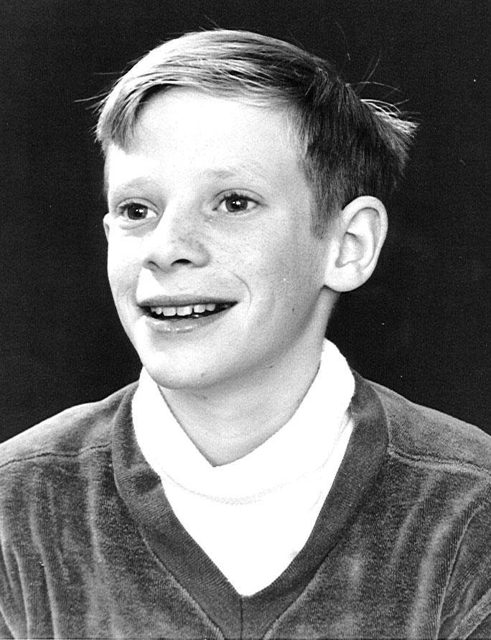
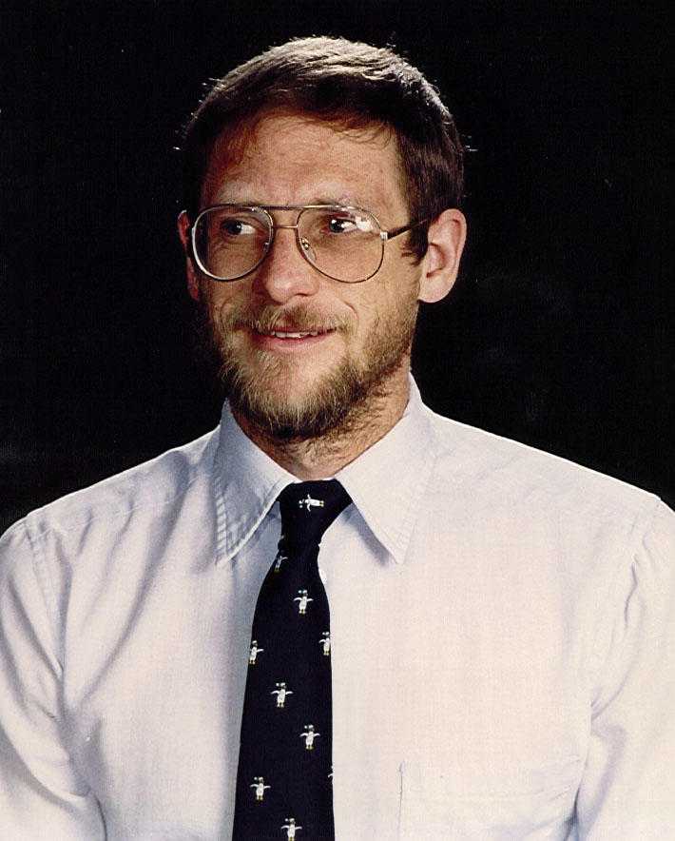
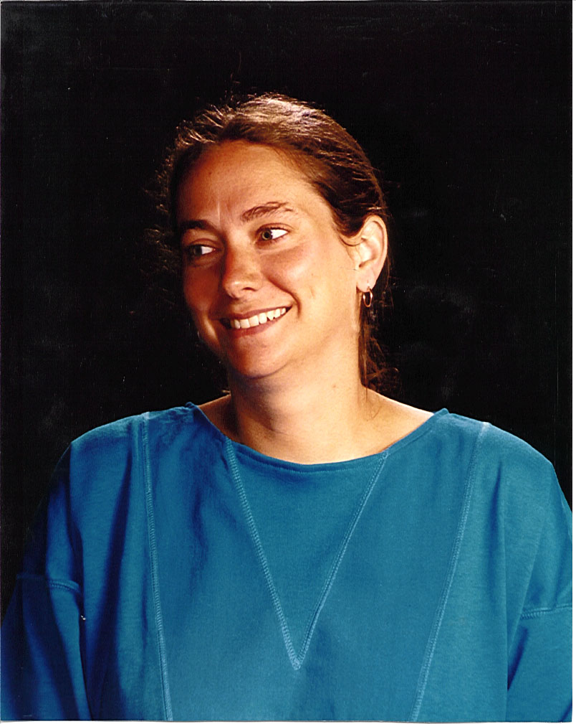
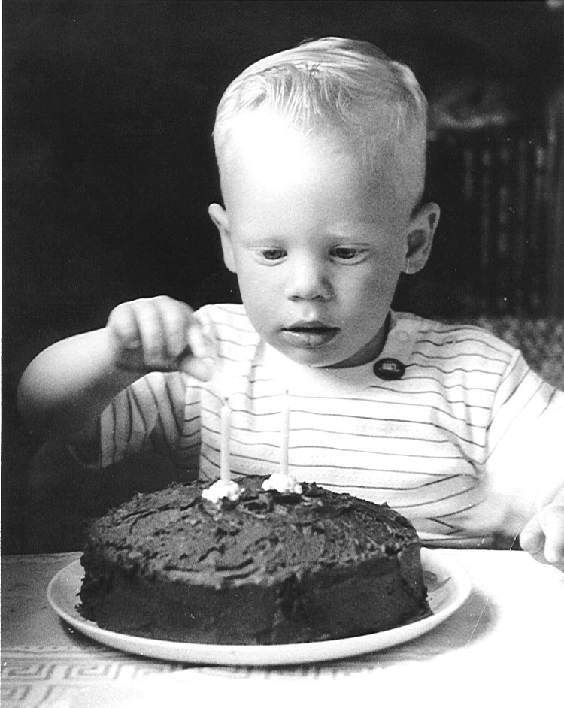Our first born delivered at St. Mary’s Hospital in Rochester, Minnesota 11 months after I started my fellowship in internal medicine at the Mayo Clinic. Beth had been working as a clinic section nurse in urology. After Malcolm’s birth she devoted her time to being a full time mother with less support from her husband than she should have had, because I was devoting every spare moment I had to getting through my training. Malcolm was a well behaved baby. Early in life he learned to defend himself from his older peers by biting them. We didn’t approve of this, and so it lasted for only a short period of time. By the time we left Rochester, he was an active little tike, and actively assisted

Malcolm age 2 Malcolm about age 12 Malcolm age 32 Kim Winter age 31
us in many of our hobbies, including fishing and camping. He did well in grade school. By the time he was in high-school he was interested in all sorts of things, including model rockets, photography, model hot air balloons, raising a calf, hiking, and backpacking. He always had a group of friends helping him. Sometimes that included his brothers.
Model rockets were just starting to be commercialized when Mal got into them. He fired his first ones from our front yard after Beth had asked the police for their permission. They didn’t know what they were and so gave their blessing. However one, at the last moment before blastoff, tilted to one side and on blastoff headed for the postman delivering mail next door. He, an army veteran, hit the deck in a hurry, scattering mail every whichway. After that he fired most of them from more remote locations.
The boys also got into making hot air balloons from plastic dry-cleaning bags. They would blow them full of warm air with the shop vac - then place a candle or lamp in their bottom opening and launch them from our yard. The wind would determine the direction they went. Many of the launches were at night, and the balloons looked like UFO’s. A time or two notices went out over the police band radio that unidentified flying objects were in our area. After launch, the boys would chase after the balloon. One time when the balloon went south, little Susan chased after her brothers. Of course she couldn’t keep up and so was soon lost. She identified herself to a perfect stranger as “Sue” and being Miles City is a small town, she was delivered safely home.
By the time he was in highschool Malcolm was showing signs of being very bright. He and his friend Brad Jones both scored above the 99th percentile in national scholastic aptitude test before college. Thus when he went to Bozeman, part of his tuition was paid for by a scholastic scholarship. There as expected, he did well. He applied to several medical schools - was accepted into the WAMI program at MSU, his alma mater, going to his first year of medical school there and then the last three years in Seattle. He had several girlfriends. The one he ended up marrying gave him a tough time at first. He traveled back to Minneapolis to court her, and finally persuaded her their relationship should become serious. They were married after his first year of medical school. After medical school Malcolm was accepted for an internal medicine residency at the Mayo Clinic, my alma mater. As he rotated through the various subspecialty services, Hematology was the one where he related to the staff men best. It also appealed to his inquisitive nature and he decided that was what he wanted to subspecialize in. He finished a 2 year fellowship and then was able to by taking one additional year in Oncology to have the qualifications to be double boarded in both. He passed his boards without difficulty.
After finishing his training, he and Kim decided to take 6 months off. Out of the goodness of his heart, he spent 3 of those months in Miles City filling in for me while Beth and I took a 3 month journey around the periphery of the United States in our 5th wheel trailer. He thus was the 3rd Winter physician in Miles City, and some patients went to see him simply to be able to say they had been examined by all three generations. Of course everybody wanted Malcolm to stay on in Miles City, but if he had he would have had to practice some general internal medicine and practice his specialties part time. Billings Clinic wanted him to come there, but they were in desperate need of a hematologist and couldn’t wait till he finished his 3 months in Miles City. He ended up deciding on Lewiston, Idaho, both because he liked the town and area, but also because he liked the oncologist who wanted him to come there. He and Kim were able to buy an older house near the hospital and remodel it to their liking. At first he practiced in a multispecialty clinic, but with time he and his partner Mike decided to go on their own. They were able to purchase a medical building just a block from Mal’s house. They expanded it and took in a 3rd oncologist partner. Malcolm had a huge practice, and was well liked by all of his colleagues and patients. He was chief of staff of his hospital, and also involved with a committee on how best to integrate managed care into their system when it comes to Lewiston. In 2002 for several reasons, he resigned from practice in Lewiston, and took over a year off in order to spend quality time with his kids. They spent nearly a year living in various spots in Europe, home schooling the kids, and learning a little French. In Oct 2003 Mal will be moving to Bremerton, Washington where he will be restarting practice – will be partner with 4 other oncologists. That will give him less time on call than in Lewiston.

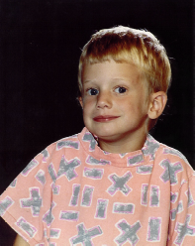
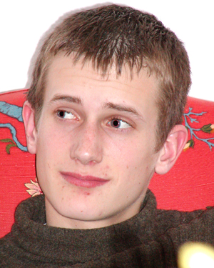
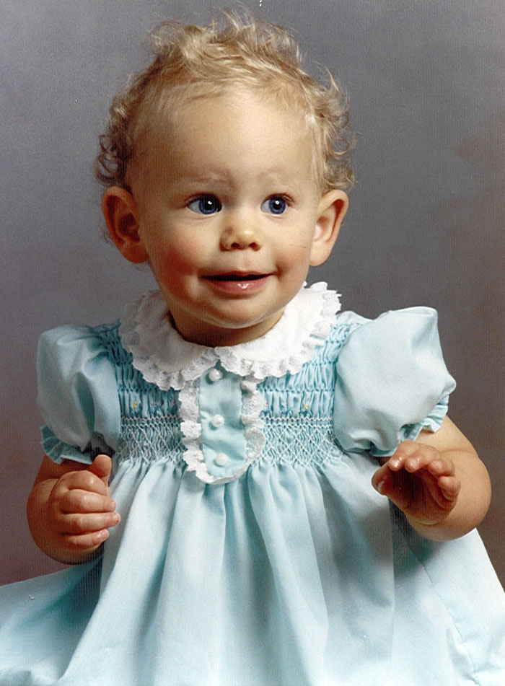
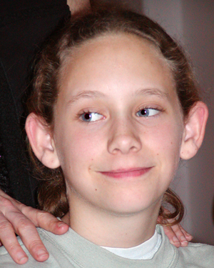
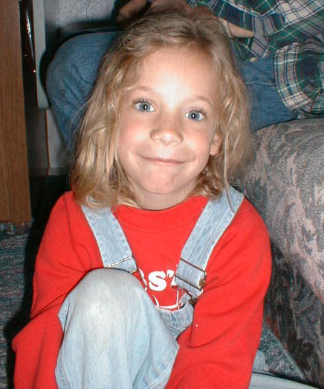
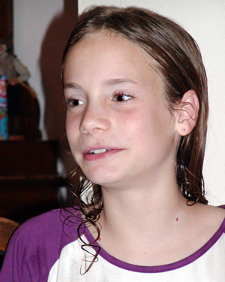

Luke age 8 Luke age 15 Cassie age 3 Cassie age 12 McKenzie age 5 McKenzie age 10

Malcolm and Kim have given us 3 lovely grandchildren - Luke, Cassandra, and McKenzie. All three are bright lovable kids.

Scott
I have always considered Scott to be the friendliest of our 4 children. As a baby he was easy to take care of. One time while we were in the airforce he ran a high fever and had a febrile convulsion. Whether that was a factor in why he had a more difficult time in school than our other children, I will never know. Fairly early in grade school, he was diagnosed as having dyslexia. Paula Rome in Rochester worked with him and also taught Beth many of the newly emerging techniques for dealing with the problem. Because of this and the many hours Beth spent with him, he was able to graduate from high school. Living with two very bright, and one average sibling wouldn’t have been easy for most kids with his problem, but he did and got along with everybody very well. I tried to be involved with tutoring in math and science, but retrospectively, I feel I didn’t do very well. Also tried to get Scott involved in various projects that I was doing. For various reasons that didn’t work very well either.
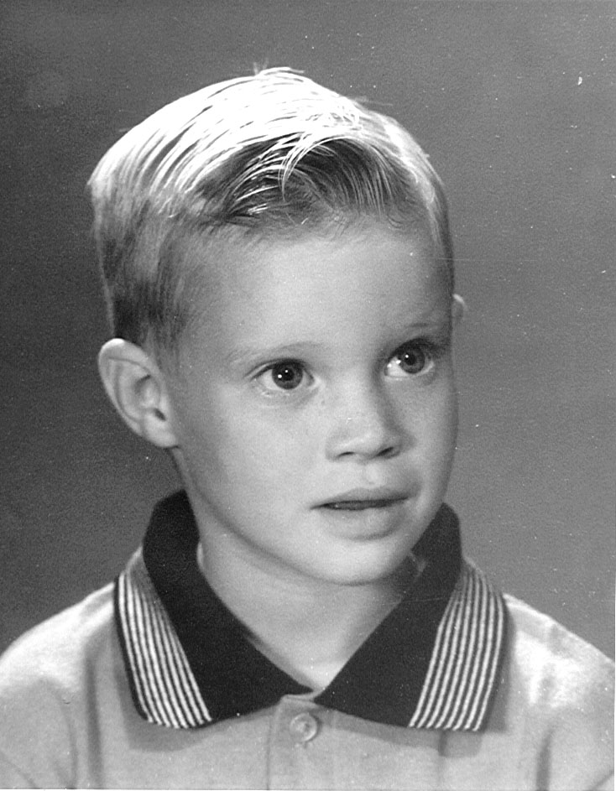
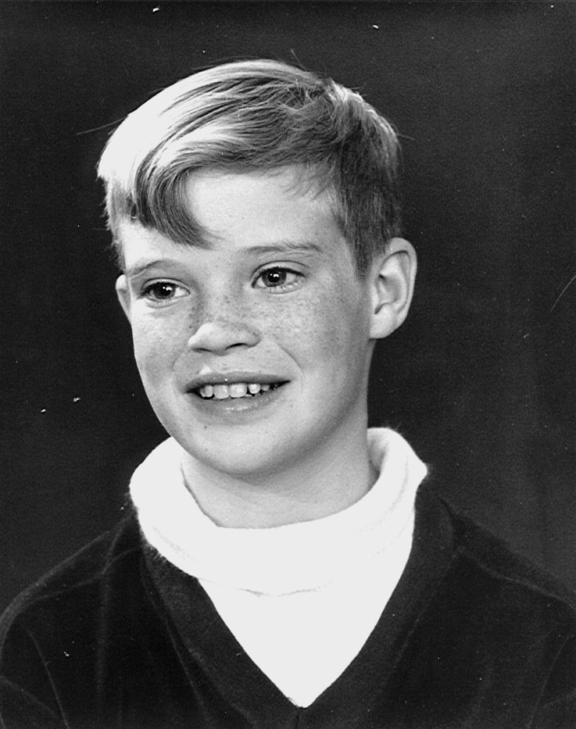
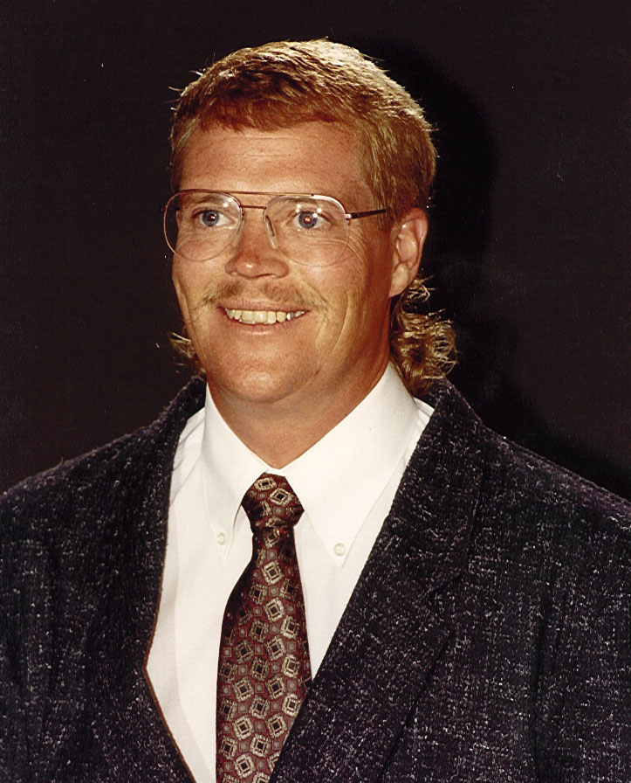
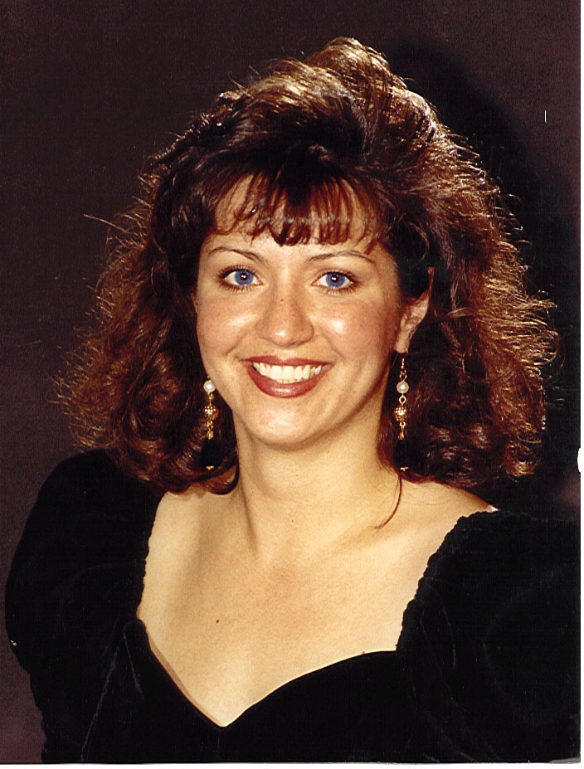
After high school, Scott had various jobs, including some as a carpenter. One time the motorcycle he was riding was hit by a car, and he dislocated one of his metacarpal bones. This was
Scott about age 4 Scott about age 12 Scott age 36 Darcy Winter age 30
reduced by a hand specialist orthopedist in Billings, but interfered with his being a carpenter. He worked various places in Miles City, and then moved to Bozeman where he got a job working in a garage and running their wrecker. That entailed quite a few night calls. In 1988 he married Darcy Skates and about a year or two later they moved to Missoula, Scott to enroll in chef school and Darcy in surgical tech school. Once graduated Scott worked for a Missoula restaurant and Darcy got a job as surgical scrub tech. After about the year they moved to Billings. Scott worked at Jakes a gourmet restaurant. That job was supposed to have a lot of potential for advancement, but didn’t. About that time Malcolm got the idea of purchasing a restaurant outside of Lewiston, just across the river in Asoton, Washington, and have Scott manage it with the eventual goal of owning it. This was a very altruistic venture on Mal’s part, but it turned out to be fraught with lots of problems. The restaurant should have done as well or better than it had under it’s previous owners, but for a multitude of reasons didn’t & ended up being a financial millstone around Malcolm’s & Kim’s necks - finally closing the summer of 1995.
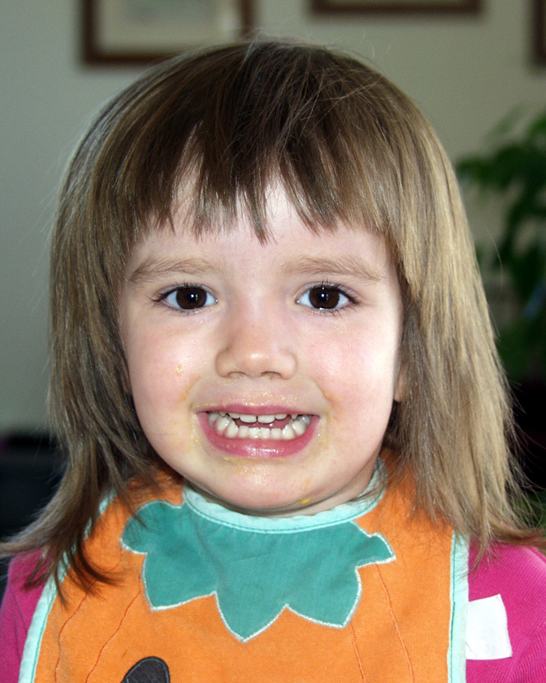
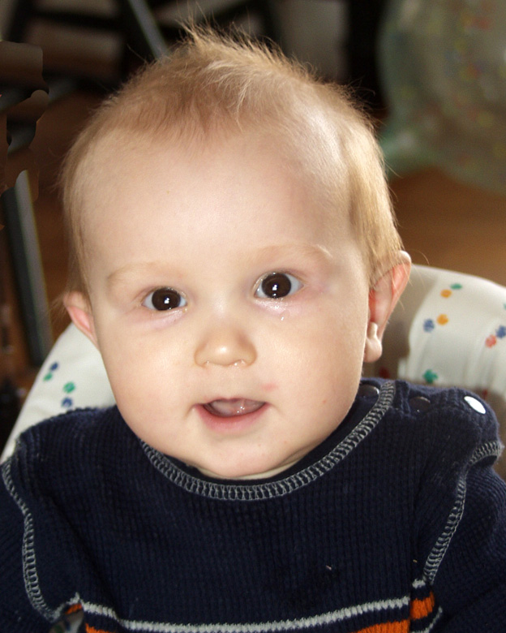
Scott and Darcy have moved back to Bozeman, where he first got an assistant manager’s job at Frontier Pies restaurant, then a chef’s job at the Holiday Inn. Because those jobs entailed working evenings and weekends, he switched to working in Zig’s Hardware store to have daytime hours. In 2002 he moved to an even better job at Crescent Electric where he was able to have all of his weekends off also. Darcy worked for an insurance company, later switching to working as a dental assistant – utilizing her surgical scrub tech training. Now she is still in the dental office but is bookkeeper. Scott and Darcy purchased a house between Bozeman and Belgrade, redid their yard, and later added onto the house. It looks at this point that Bozeman will probably be their permanent home. They have two children Madison born Mar 2000, and Michael born August 2002.

Madison 2003 Michael 2003

Bruce
Bruce was born at Ellsworth Airforce Base hospital near Rapid City, South Dakota. We took him camping with us when he was 2 weeks old. When we moved to Miles City, he had to learn what a big house was all about. When Susan came, we put her in one bedroom with Malcolm, Scott, and Bruce in the other. I built some custom made red wooden bunk beds so that all three boys would fit in the same room. The third bunk bed was suspended from the ceiling. When the kids got a little older Scott and Mal moved to their own rooms downstairs, & Bruce stayed in the one upstairs. By that time he was involved in electronics and made himself a special 3 double switch box that encoded how to access his room. He let his mom know that code, but nobody else. That precipitated the era of “bugging”. He and his brothers bugged their sister’s room. Unknown to them was the fact that she was a good learner, and also later bugged their rooms. Beth and I found the wires after all the kids had left home and we were redoing the built-in dresser in Bruce’s room.

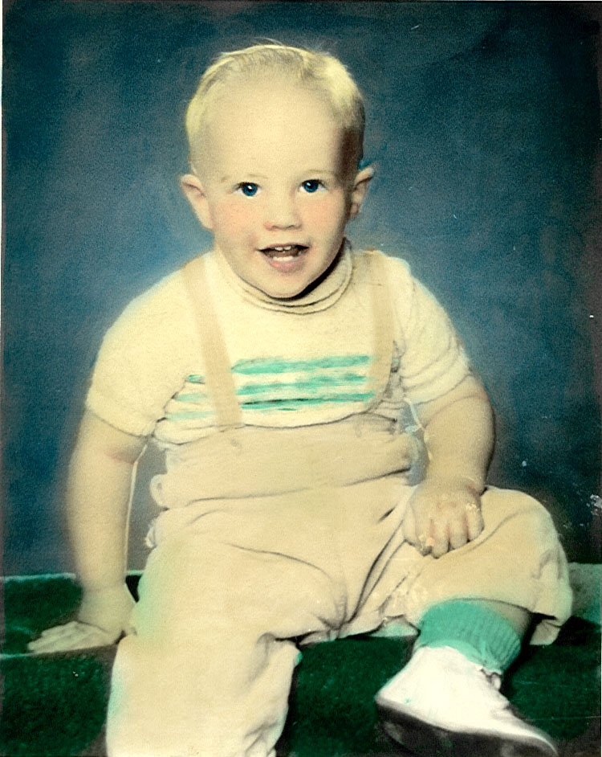
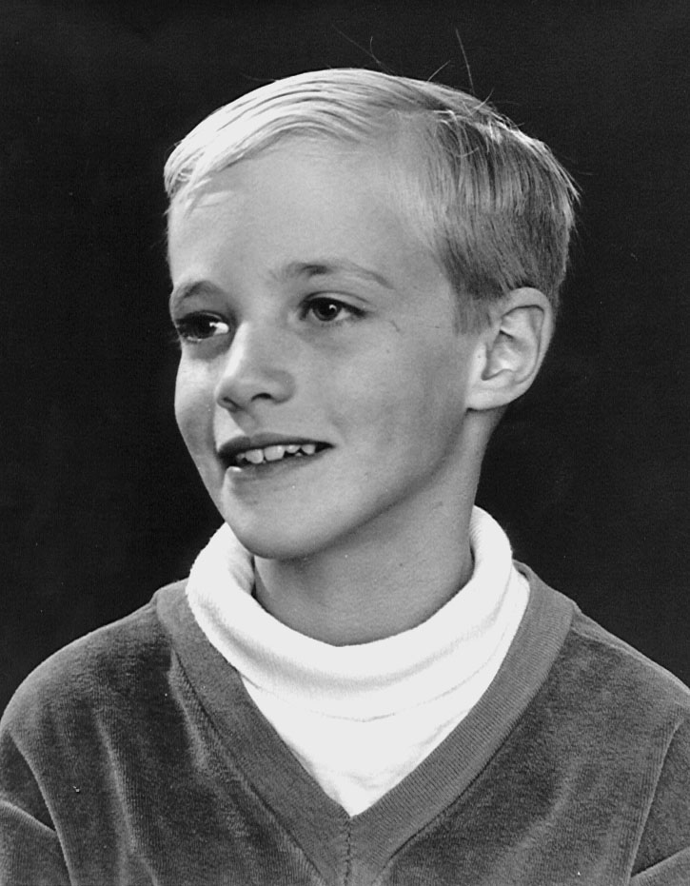
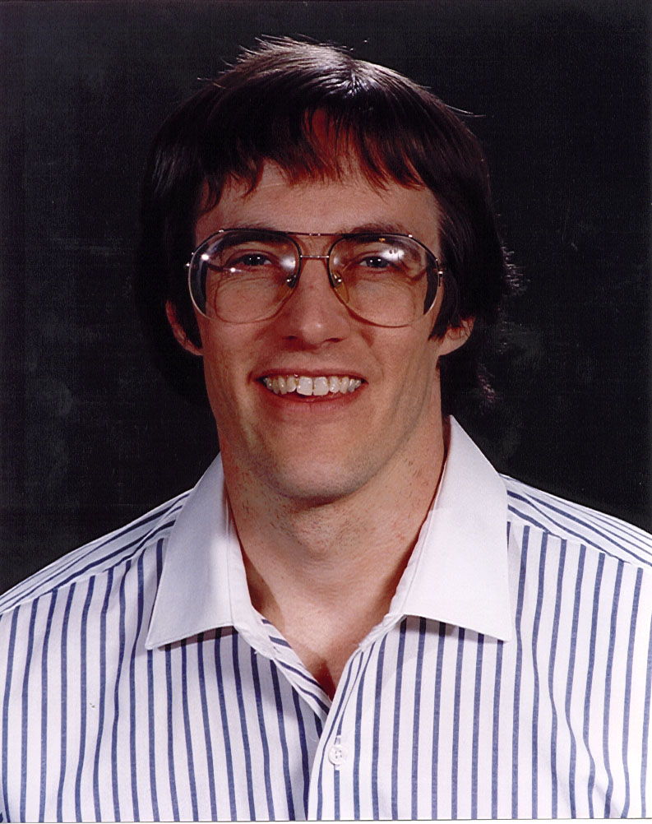
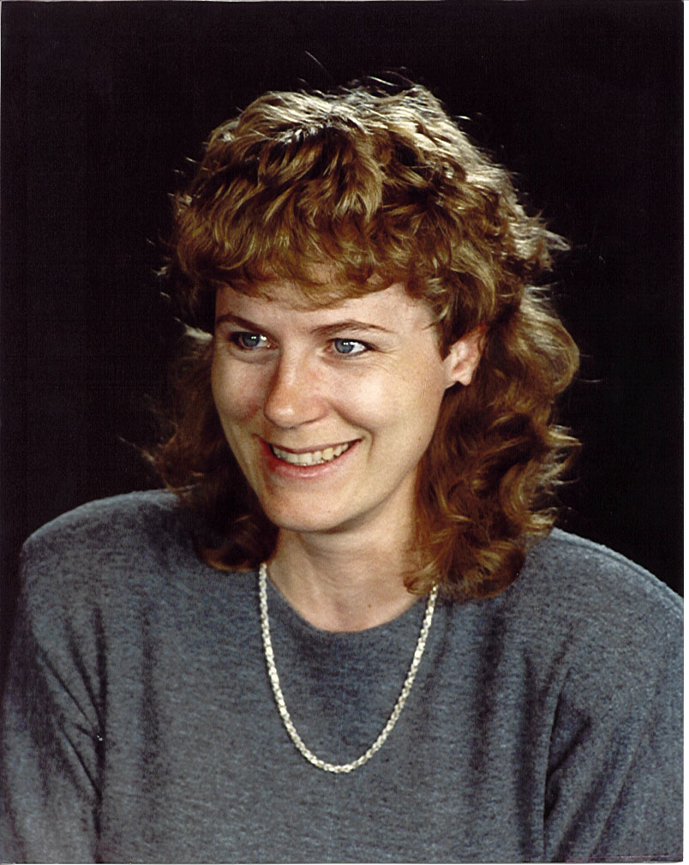
Bruce was known for his tenacity. Tom Adams would frequently let all three boys attack him, and

Bruce about age 5 Bruce about age 12 Bruce age 37 Laruie age 36
then shake them off. He could do that with Mal & Scott, but not with Bruce, who would hang on no matter what. Malcolm and Bruce got along most of the time, but like all brothers, they occasionally had their fights. One time Beth came home and caught them going at it. Since Bruce was smaller, she tried to separate them only to have Malcolm ask her “Mom how can we ever get to know each-other unless you let us fight?” How is a mother supposed to respond to that sort of question?
One time when Beth had to leave the boys at home because she was required to present herself for jury duty, the two brothers went a little too far teasing their younger brother, and he got really mad - grabbed a baseball bat and came after them. They hurried into their bathroom and locked the door. When Beth got home, Bruce was in the process of bashing in the door with the baseball bat. Scott and Mal were cowering behind the shower curtain in the bathtub. That bashed in part of the door has been covered with a display sticker, but to this day remains reminding us of the incident.
Bruce confided in us most of the time, but one time in high school, cut his leg on the table saw in the high-school shop. He came home telling us he had fallen off his bike, and it wasn’t until years later we finally learned the truth. Also, Bruce was our one child that fainted fairly easily. One time he cut himself, and came into the bathroom to wash the blood off - feinted and hit his head against the sheetrock wall leaving a large dent.
In highschool, Bruce excelled in most of his subjects. They let him take advanced calculus, and that fit into his model rocket hobby. By that time, you could buy expendable model rocket motors that would specify how long they would burn and also how much thrust they had. He built himself a model rocket launcher and then by using his calculus he’d figure the angle to point the launcher at and the distance the rocket would fire. Since the rockets would go a mile or so over rough terrain out at the cave we had to figure out a way to compare calculated distance to actual air distance flown. We got the idea that if we blew a note on my coronet - had it transmitted over CB radio to the landing site & then measured the time it took for that actual sound to traverse the distance, we could roughly figure it out by dividing the time it took into the speed of sound at that altitude. The night we were going to try this, we were having the civil engineer that had figured out how strong our roof timbers at the cave had to be to support the earth that would be over them (450 lb./sq.ft.), out there for supper. He got so excited that he drove all the way into town and brought out his laser distance measuring equipment. We had the distance the rocket flew measured to within centimeters & in fact it was real close to what Bruce had calculated.
Photography was another hobby, both Bruce and Mal got into - partly I suppose because it was an interest of mine. They took it a step further & got into making color prints. They also did quite a bit of developing at the high-school photo-lab - helping to make pictures for the high-school annual.
Bruce pal-ed around with about 4 good friends, Billy Able, Jim Burkholz, Colin Cole, and Tom Rhoads. They were over at our house a lot, because it was the center of a lot of their projects. However they did a lot of hiking in the hills around Miles City, and also took some backpacking trips into the mountains.
Near the end of highschool, Bill Woodcock, one of our good friends developed a small camera mount for aerial mapping. He needed and intervolmeter for it. Mapping cameras at that time were all large and heavy & the intervolometers made for them were too. Bruce designed a transistor model from scratch, ordered the transistors and liquid crystal displays he needed for it and photoetched the circuit boards himself down in our basement. The units worked perfectly. Bruce turned his design & instrument in to the science fair at high-school and won first prize in the whole state of Montana on it. Bill’s mapping mounts were also a great success - were patented and have been sold all over the world. Now of course they have been upgraded so that they use global positioning satellite data to shoot & time their pictures. Bruce’s transistorized cards have been replaced with chips.
In college, Bruce like his brother Malcolm, excelled in what he did. In fact when he graduated, the University of Wisconsin in Madison offered him a Bacon scholarship to get his Masters degree. Not only was his tuition paid, but he received a monthly stipend. He got his degree in Biomedical Engineering and for his thesis wrote a paper on Grounding Circuits in Biological Amplifiers. I thought that was a very simple subject, but after reading his thesis found it indeed a very complex one.
During his senior year at Bozeman, Bruce fell in love with Laurie Hjelvik. They were married shortly after graduation & have had twin sons, Nick & Zack. Like their parents, these boys are extraordinarily inquisitive and involved in many projects and hobbies.
When it came time to look for a job, Bruce applied to several companies - GE, Hewlett Packard, Ohio Oxygen etc. He visited Malcolm in Rochester and stopped by IBM to see what they had to offer. They had a job for him, which he accepted even though it was not related to Biomedical Engineering. A year or so later, the Mayo Clinic called Bruce’s Prof. in Madison asking if he could recommend a good biomedical engineer. They were told that the best one was already in their town working for IBM. They offered Bruce a job, but by that time he was so engrossed in his work at IBM that he turned them down. He has become and expert in chip timing. Electrical impulses going through chips have to arrive at certain set points at the correct time to interact with other impulses & how to make them do this, is an art as well as a science. He also got into the field of chip mapping - i.e. how to map and old chip and then change the map to make a new chip (as opposed to making the new chip from scratch). Bruce was quickly advanced to working as a consultant engineer helping write computer programs to solve the problems other engineers were running into. One of the problems he helped solve was that of checking chips to make sure that they were doing their complete job accurately. At IBM chips had gotten so big that even the biggest computer could not check them without subdividing them. That worked OK for new chips, but for remapped ones didn’t
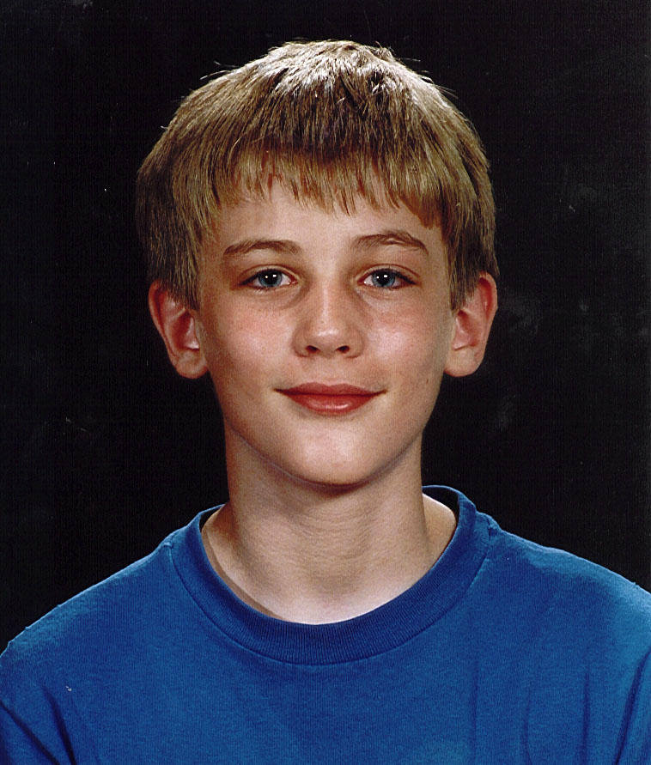
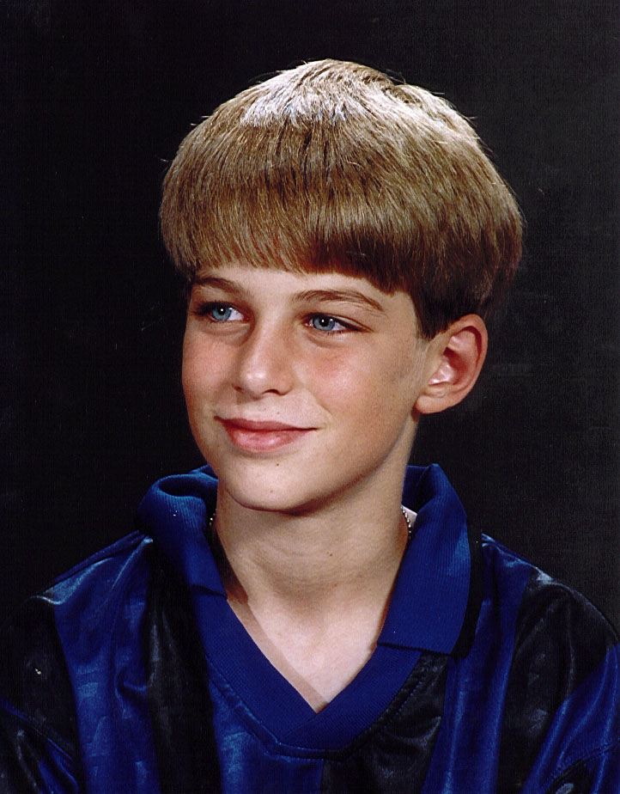
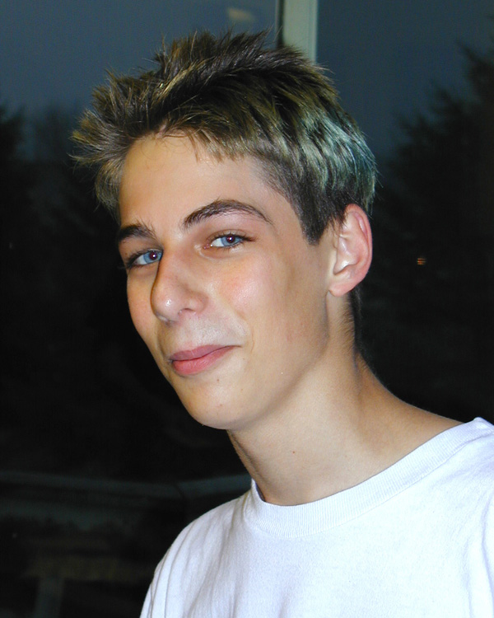
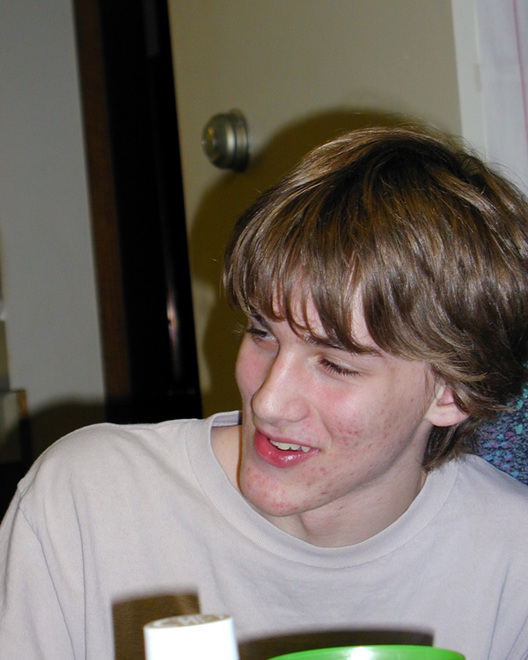

Nick Winter age 11 Zack Winter age 11 Nick Winter age 14 Zack Winter age 14
work at all. Bruce figured out a program that would do it very well. I am told that if Intel had had this program to check their Pentium chip, before they started manufacturing it, they would not have made the mistake they made, and would have saved themselves millions of dollars.
Laurie has a number of interests including painting, poetry and fiction writing. She has had several books published, and received a number of rewards for her work. Bruce, now a senior engineer at IBM continues to implement chip design – recently completed work on a chip that will allow IBM to make the world’s biggest, fastest supercomputer. It will study how DNA folds itself.

Susan
For a girl to be born into a family of three older brothers must be an interesting experience. We found out girls are quite a bit different than boys in the way they act and grow. Susan had her three brothers wound around her little finger. They were all very kind and considerate of her. She would tag along with them on a lot of the things they did, and at an early age got involved in more activities than most girls her age.
Susan had many friends, but I believe her closest girlfriend growing up was Joselyn Perkins who lived a block away and went the same church we did. They would be best of friends one day and not speaking to each other the next.
Susan went to Sioux Fall’s college in Sioux Falls South Dakota and earned a degree as an educator. She had to take a lot of education courses, but also a lot of psychology courses so that she would be qualified to work with emotionally disturbed children, and be able to teach them as well as council them.
In school she had several boy friends - ended up in one fairly serious relationship with a pre-med student. She terminated the relationship, because she felt he wasn’t growing emotionally in the way she thought he should be.
After graduation, she got at job at Deaconess Home in Helena, Montana. It took her less than two years to burn out on that job - partly because it was emotionally stressful working with severely emotionally disturbed adolescents, but also because of the way the place was run. For a group of psychologists, who should be aware of the stresses associated with upsetting circadian rhythms, her supervisors were down right “dumb”. They made everybody work one PM shift/week, one night shift, and 3 day shifts. Of course nobody slept well - they all got tired, and most including Susan quit with in a year or two.
Susan was smart enough to take a break and seek employment totally unrelated to her previous job - i.e. she ended up being a summer time forest ranger at Rocky Mountain National Park. There she did well - also got involved in taking EMT courses at the local hospital. She met lots of foreign
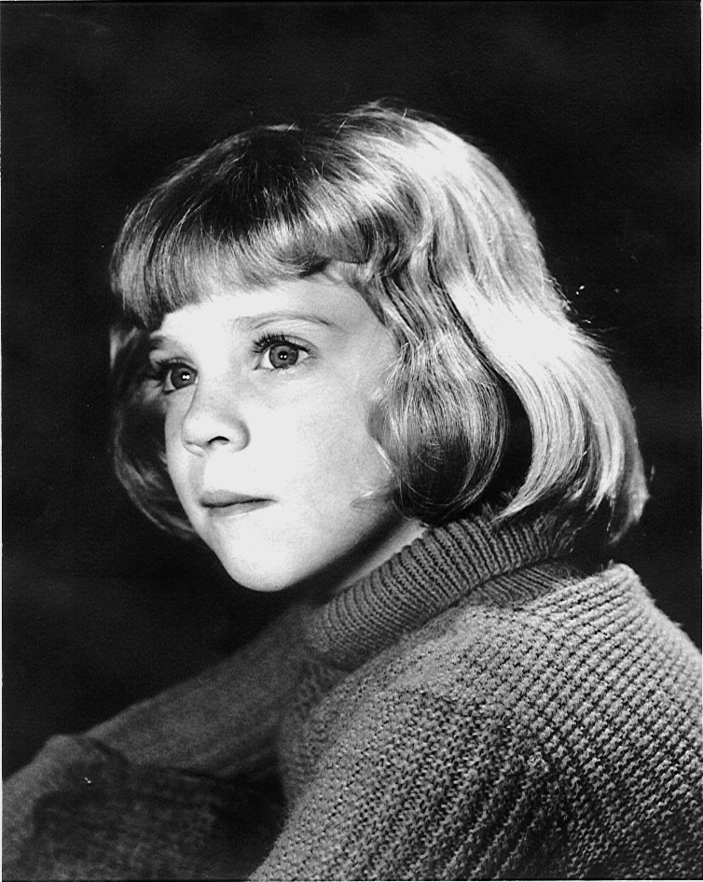
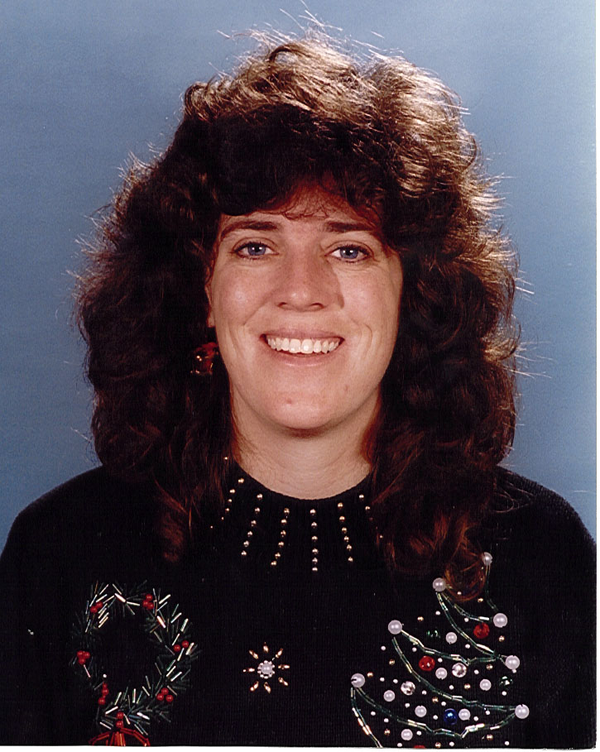
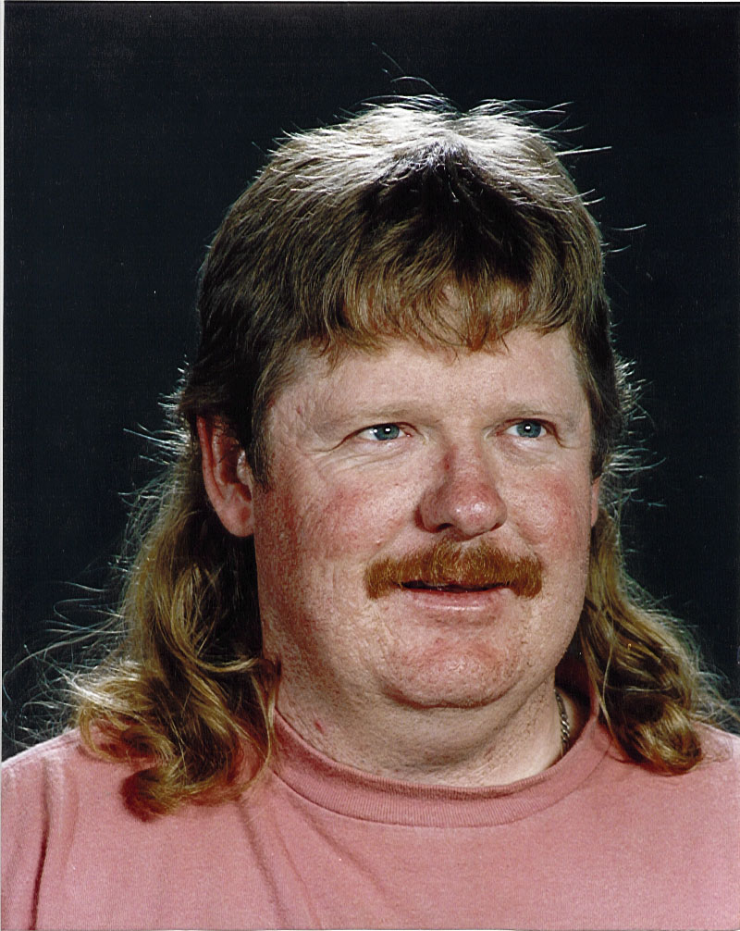
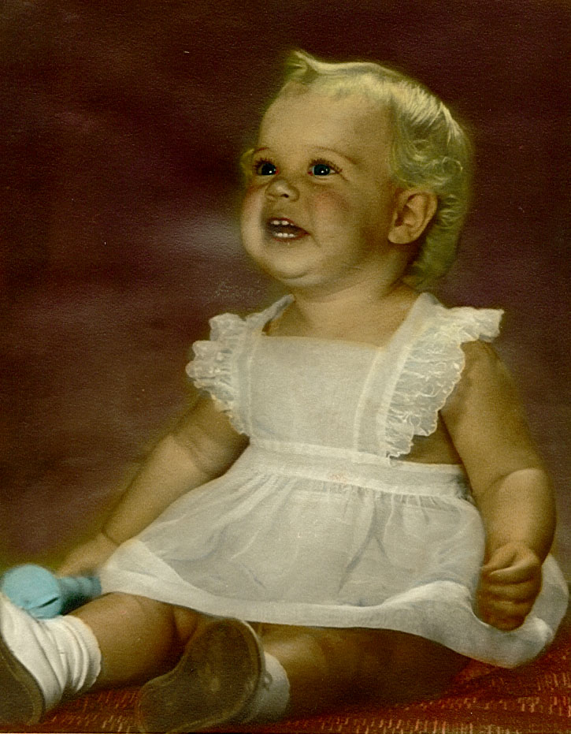
Susan 1963 age 2 Susan about age 5 Susan age 33 Brad Page age 34
visitors in the Park, and one of them, a boy from New Zealand invited her over. She and one of her friends, Emmy Hirabayashi, decided to take him up on his offer and take an overseas trip visiting Hawaii, New Zealand, and Australia. When in Hawaii, visiting our friends, the Hoskinsons, she and Emmy were looking for a famous blow hole on the southwest coast of Maui, and asked two boys where it might be. They told her they did not know because they were from Australia. One of them, Brad Page, on finding out about the upcoming visit to Australia, asked them to stop by for a visit to his folks place in Sidney where he lived. They took him up on his offer and one thing led to another, with Brad and Susan falling love and marrying about a year later. That of course has changed Beth and my lives quite a bit, because we now visit Australia with some regularity. We visited our new
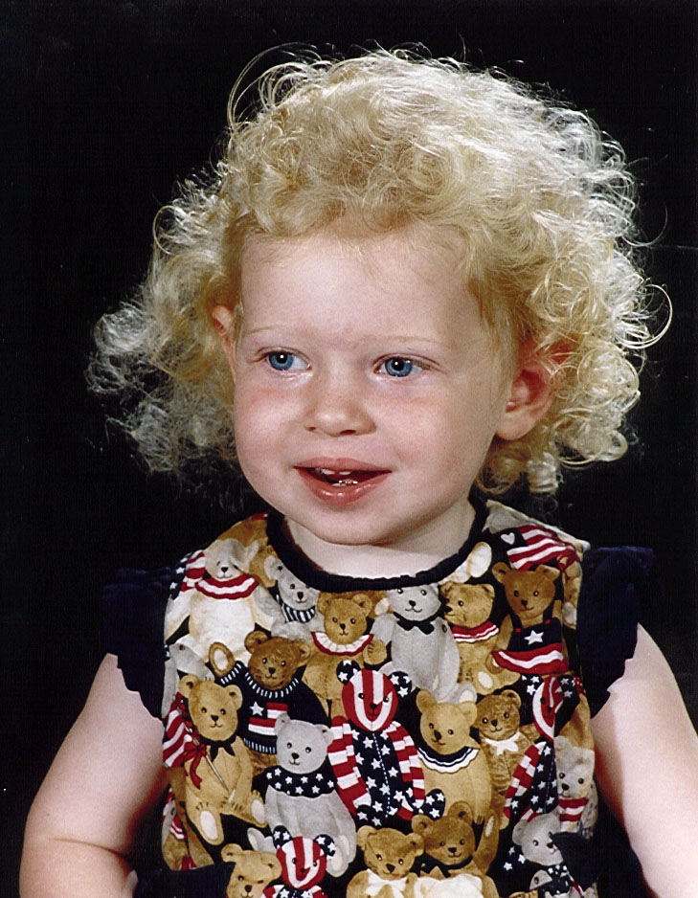
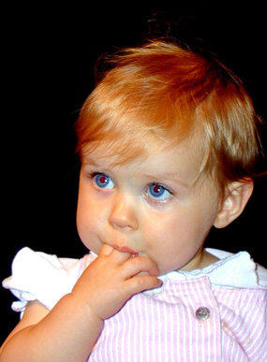
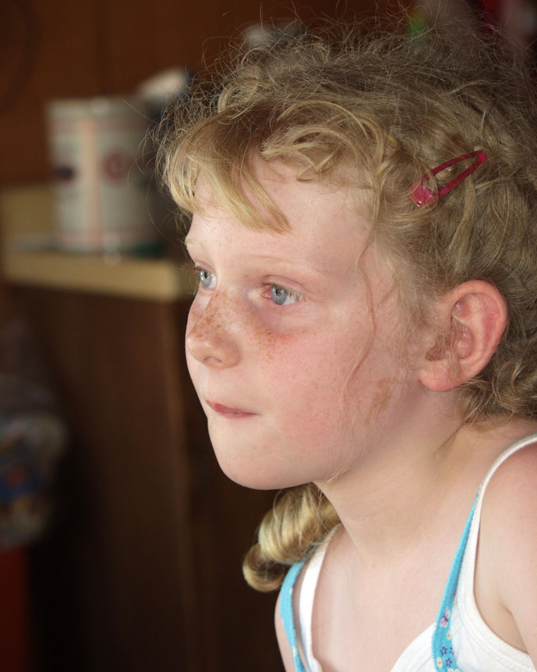
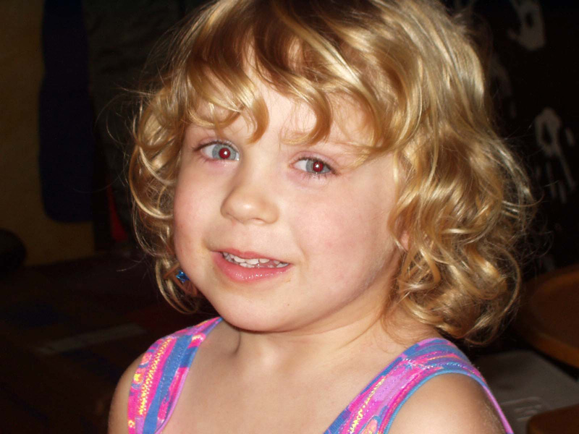

Mikaylie age 2 Shianna age 1 Mikaylie age 6 Shianna age 3

grand-daughter Mikalie Beth born Sep. 9th 1995, and have also taken trips in Dec 1998 for Shianna’s birth, and a 3 mo trip Nov, Dec, & Jan 2002-3.

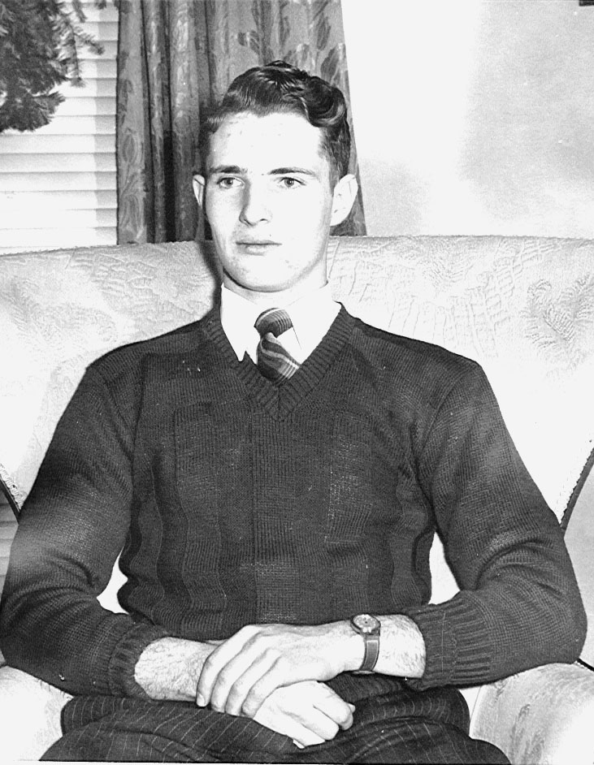
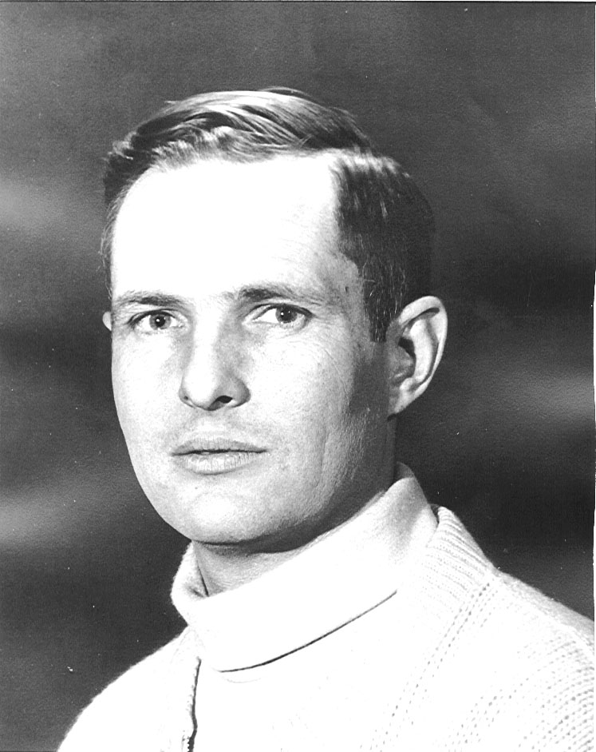
To complete this biography here are some pictures of Beth and myself taken over the years.
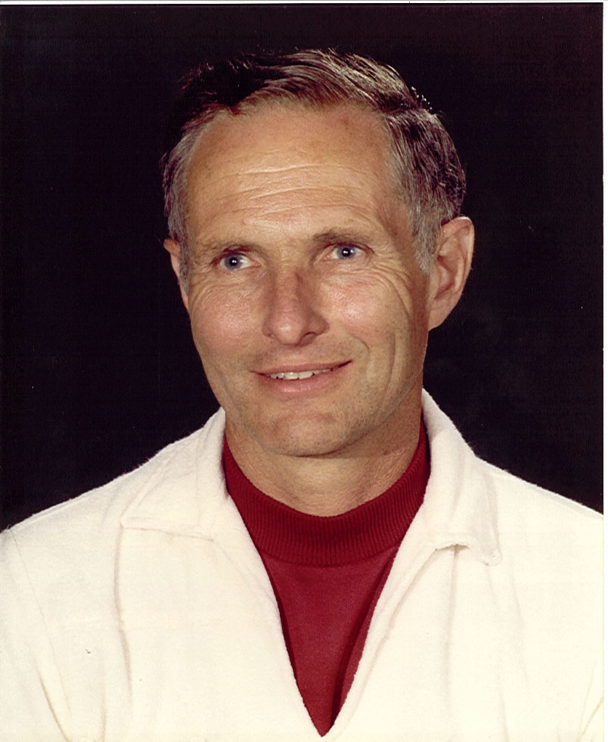
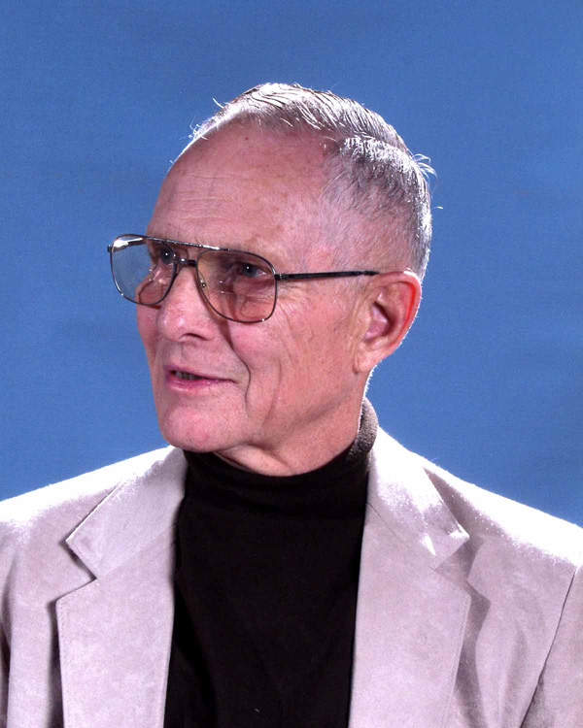

Age 17 1945 Age 43 1971 Age 53 1981 age 73 2002

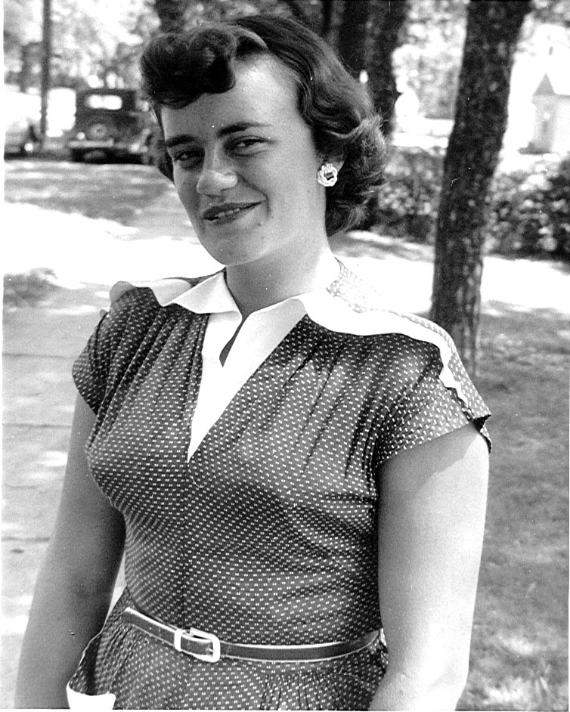
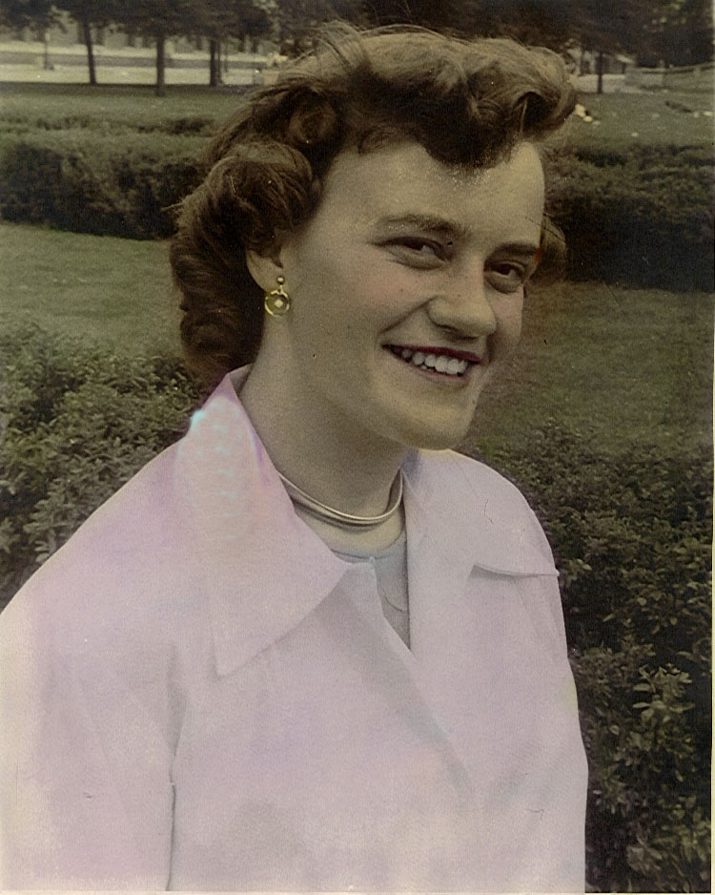
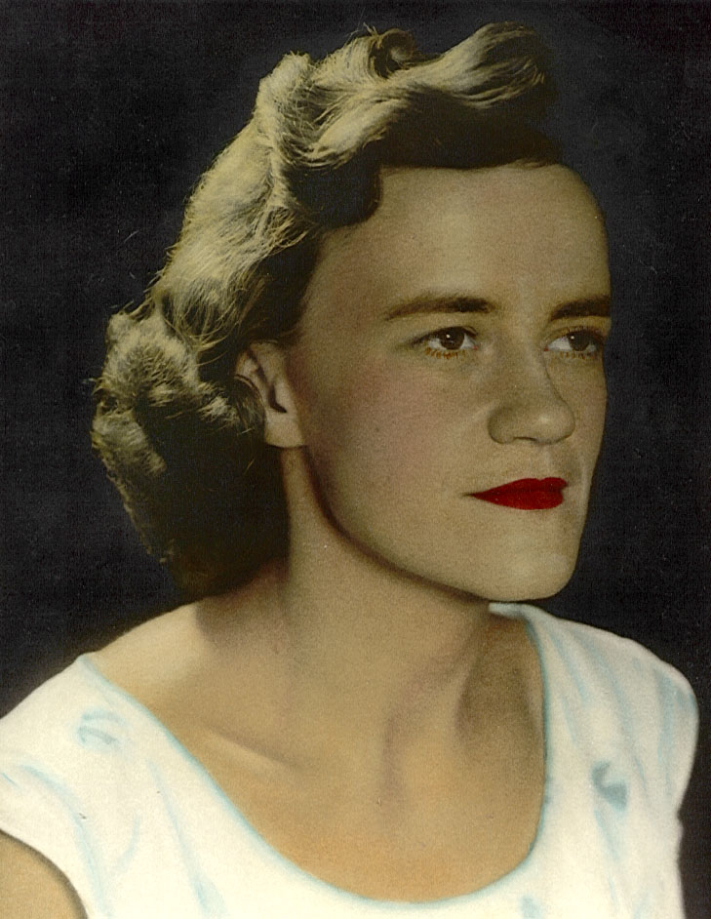
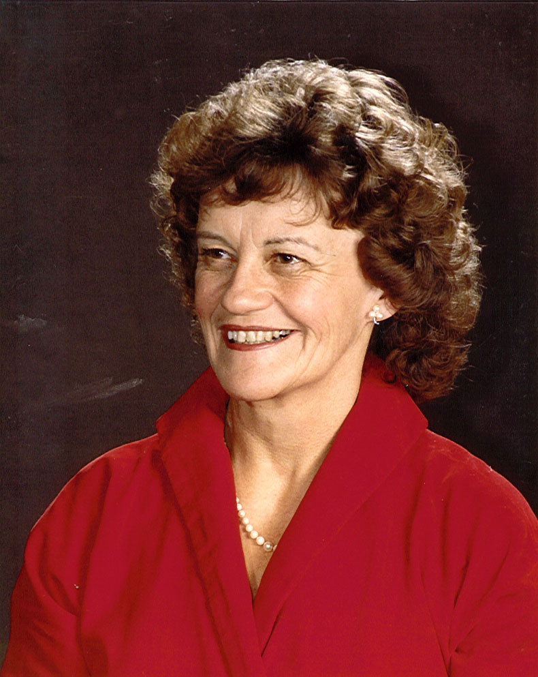
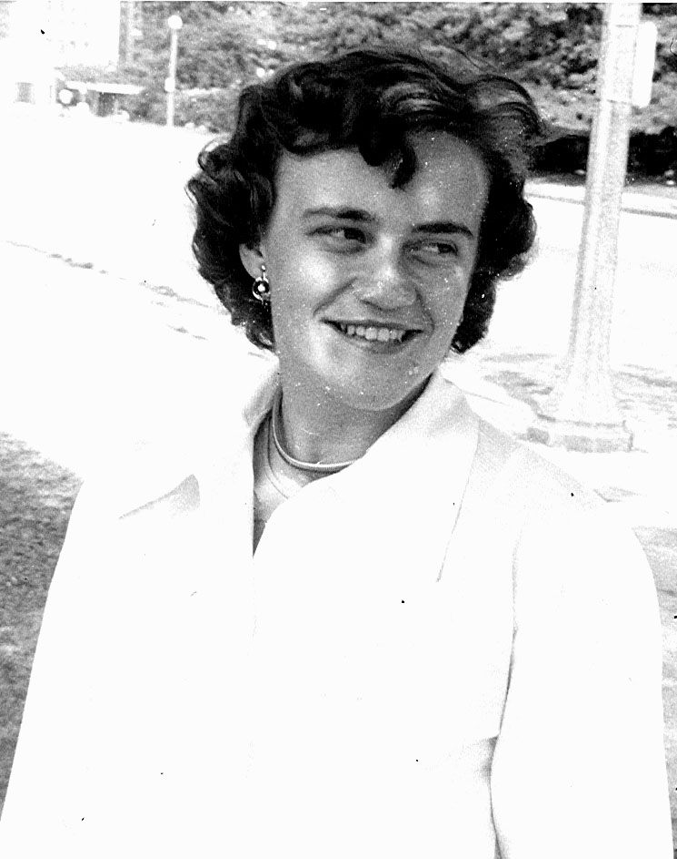
Age 20 1953 Age 20 1953 Age 31 1964 Age 35 1965 Age 54 1987

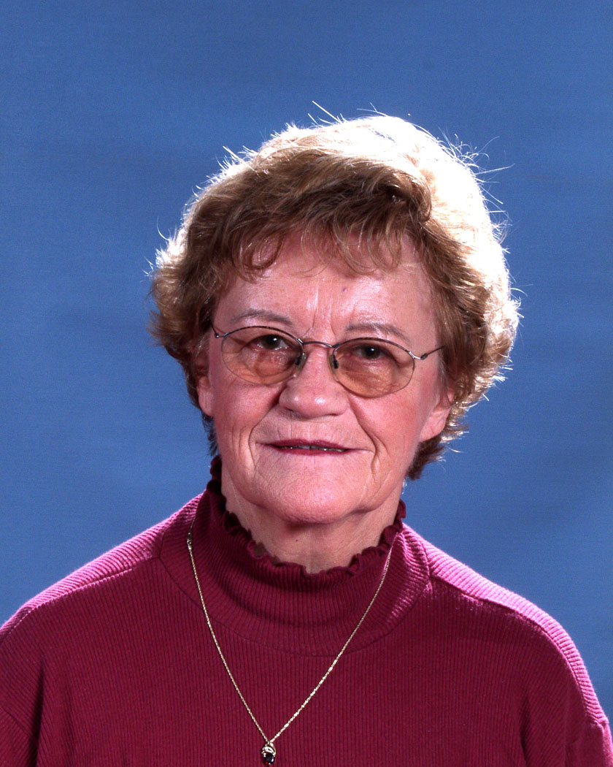

Age 69 2002

Also I would like to insert a couple of very meaningful comments made to me by those whose opinions I greatly value.

Malcolm’s letter to his Dad on his 70th birthday 6/7/98

Dad,
I wanted to use your recent milestone as an opportunity to write down some thoughts. I know I don’t write enough especially when compared to your many appreciated, but unrequited e-mails. Actually I write a lot, just not to the right places. What with progress notes, consult letters, insurance appeals, memos to the IPA membership, lobbying letters to congress, and notes of condolence to families, medicine has been more of a literary career than I at first imagined. I’m often reminded of your comments about grandfather’s elegant records, and I strive to emulate that.
I’ve had a privileged life, and I owe much of that to you either directly or through inspiration. In your quiet, gentle way you helped mom raise me more by example than dictate. You live what you believe. In addition to or perhaps as an extension of your deep religious convictions, there’s your devotion to family, your desire for lifelong learning, your successful career as a highly regarded physician, your generosity, your commitment to clear and logical thinking, and your unique independence that has made for a successful and interesting life. These are qualities to aspire to, and I hope are reflected in my own choices.
There are countless actions that seem small in themselves, but when weaved into a childhood, they make a comfortable, protective coat to go out into the world with. I remember the time you built me an electronic experiment board, your reading aloud after dinner long before it was fashionable, Sunday afternoon excursions, going to Foster’s for electroplating supplies, early morning tennis, camping, building bedrooms, taking me on rounds and impromptu lectures on pathophysiology. These are the threads of a life well lived.
Then once you demonstrated how to live a good life, you had the confidence to step back so I could pursue my own visions. It must be harrowing for a parent when his child starts to explore the world both urban and wilderness with not only physical dangers, but the risk of failure and exposure to beliefs you might object to. With few exceptions you were tolerant and respectful of my choices, false starts, and ideas. Among the more tangible examples, I appreciated the opportunity to build caves with Craig Bundy, build an obviously doomed submarine with Brad Jones, stay extra in Hawaii with Scott Hoskinson, and venture into the mountains with Bruce. I imagine that both of you allowed some of these things only after some discussions and with some trepidation.
Finally, I want to thank you for always being honest, reliable, and consistent. I never had to spend a lot of effort trying to second guess or worry about off the wall reactions, and I knew you’d always be there. Your sense of purpose toward family, career, and beliefs has always been a solid foundation. I look forward to many more years.
Love,

Malcolm

Billings Clinic Assessment May 1997

Reference physicians: Vadheim, Grierson, Stickney, Degnan, Vermillion, Gaddy
Strengths:
* Ethical, thoughtful, thorough
* An excellent physician
* Consultations have always been appropriate
* Follow-up care after consultation is very good.
* Thorough and complete work-ups
* Bright, articulate, well read, one of the most intelligent physicians I've ever met. Seldom, if
ever makes a bad medical decision.
* Certainly a tribute to the clinic, the medical profession, and humanity.
* Clinical acumen
* Keeps up well
* Commitment to Miles City and the practice
Areas For Improvement:
* None noted
Other Comments:
* Have worked with him for more than 25 years and respect him for his judgment
* We all as physicians would do well to emulate some of Dr. Winter's qualifies.
* I feel honored to have known him and worked with him for the last 20 years.
* He carries many years of service to his patients and the area.

