Chapter 1
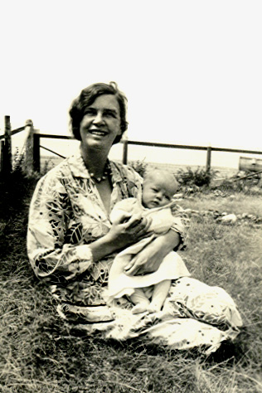
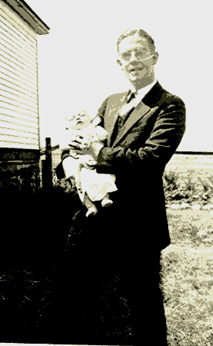
This document is written by Beth in person - although the early years of my life are all word of mouth and of course a bit biased and editorialized. It will be as true as possible as my thoughts go from my mind and memory (which we hope is stable and as accurate as possible) to the paper on which this is printed. The date of my birth was May 18, 1932 - sometime in the wee hours of the morning. My parents, Hulda and Bill Tate and my sister Rachel, were living in Herschel, Saskatchewan at the time but there was no hospital. In the middle of the night when my mother went into birthing labor my dad called a lady who was to come over to watch Rachel while he took Mother to the hospital in Rosetown, Sask. When he got home from the hospital, after I came screaming and kicking into this world, he found the baby sitter had gone back to sleep. My poor sister was all alone, but she slept through the whole drama. She states it has affected her all of her life, but we all know better. Rosetown is 21 miles from Herschel by car, and there was a railroad running through the towns. I took my family there a few years ago. They had no idea my beginning was in such a remote area. The memories I have of my first three years are from looking at photos in which my mother was always dressed with beauty and dignity. When I took my family back some ladies visited with me, and they said my mother was too beautiful for the prairies.
Rev Tate with new baby daughter
I will give you a little history about my parents. My Father came from Newtonards, Ireland, which is towards the ocean from Belfast, Ireland. He studied to be an engineer when he graduated from grammar school, and he was also a golden glove lightweight boxer. In college he had a spiritual call to become a minister along with some of his college friends. He chose to go to bible school in USA - to Moody Bible Institute in Chicago, Illinois. His emigration papers were not in order, so when he landed by ship, he was thrown in jail in the same cell with a drug addict who was going through withdrawals. If there had been another ship going back to Ireland, he would have been on it. He was soon released and was then on his way to Chicago. About the same time after my mother graduated from high school in Muskegon, she went to Moody Bible Institute. They both had planned to go to the mission field in Africa, but the Second World War stopped most of their plans. Dad had his first church in Buffalo, New York where my sister Rachel was born. During this time the US and Britain were not on very good terms, and the USA demanded that British citizens declare their intent to either become an American or return to British soil. Canada was the closest for my father, so he and mother packed up their home and Rachel and went to a United Church of Canada in Saskatchewan. My poor parents were both city people, so they were at a loss what to do out on the prairies. There is a funny story about my father and his first parish assignment. He was given a horse, and he was sent south to his church. They found him two days later in Montana still looking for his church!! He was a very accomplished rider, because his father raised quarter horses in Ireland. That is probably what saved his life. Much later in his life when I brought home the “light of my life” (who was from Montana) my father exploded and in his Irish accent he said, “ Ach!, no girlie, you will not be about to marry anyone from Montana!!” There will be more about that story later in my ramblings.
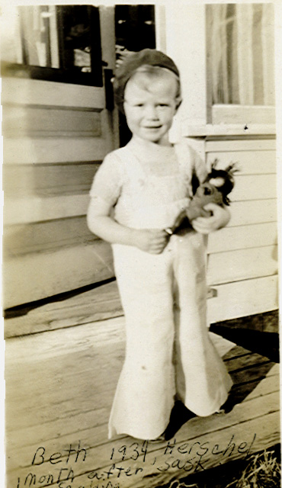
We shall return to Herschel, where I have my first memory of my life when I was three years old. It was rather traumatic, so I imagine that is why it is in my memory bank. My sister Rachel and I were playing in the kitchen, and my mother had just taken the wash water off of the stove to wash the weekly cloths. I accidentally fell backwards into it. I do not remember that part of it which is probably blocked, but what I do remember is the hospital. We had to go to the Rosetown hospital. After speaking to the doctor on the phone the decision was to take me on the freight train. It was in the middle of winter, so they took a door off of the house and put me on my tummy with a tent rigged over me. When the train came to town, it stopped and they put me in the freight car with my dad and a friend. We went to Rosetown 21 miles away. In the hospital they rigged a tent over my bed and I lay on my tummy. The way they kept me warm was to have light bulbs in the tent. Someone stayed with me at all times, and they had to mainly feed me liquids, which were given through a teapot (seeing straws were not yet in use). Amazingly I didn’t get infection in my burns, because antibiotics had not yet been developed. There were some scars, and it was a bit embarrassing as I grew up. Whenever I wore a swimsuit people would ask what those white spots were. They did tan so I spent a lot of time getting a tan, which we now know is not good for the skin.
Beth in Herschel 1 mo after scalding
Our next move was to Outlook, Saskatchewan. I was between 4 and 5 as I remember. Wow! We were in a big city of around 800 people. Outlook was beside the South Saskatchewan River, which is a large body of water. We spent a lot of time picnicking, swimming, and camping by the river. My father had a church on the other side of the river, but in the winter there would be too much snow to drive, and everyone would put their cars up on blocks, drain them, and leave them until spring. The only way over to his church would be to walk the railroad tracks, traversing the huge rail bridge over the river. Then one of his parishioners would meet him in a horse a buggy and take him to church. If we were really brave, we could go with him, but that meant walking the bridge, and hoping you could get across or to one of the side wickets where you could wait until the train went by. I did not do that very often. It was too scary. I do remember running away one winter day, and I told my parents I was catching the train and going to Michigan to my grandparents and aunt and uncle. They let me go because they knew this same family with the horse a buggy were coming to see the folks. They met me and acted like it was all my idea and brought me back home to get permission to take me to their farm for a few days. I was wrapped up in the buffalo robe and went merrily on my way without a clue as to what I was running away from home for!!
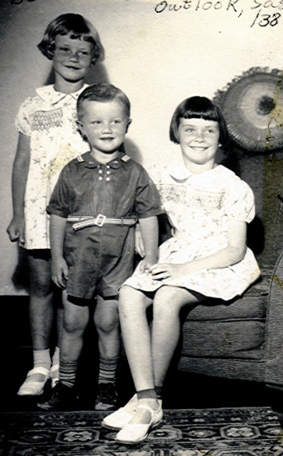
While we were in Outlook, I started to sing with the Royal Canadian Mounted Police. I don’t know how that got started, but they hung out at our home a lot. It was about the time Shirley Temple was so popular. I had blonde curly hair, so they would put me on their shoulders and have me sing along with them. Anyone who knows me, knows I am not very shy, (so I have been told). I was a bit of a ham and stole the show. In December we were putting on a Christmas program and it was a big deal. My brother Ben decided to make his presence known the very night of the concert. They took me to see him to try and help me understand why mother could not be there. When I saw him in the bassinet I tried to tip it over. So much for a nice sister! He tells me he has been in therapy all of his life because of it. All teasing aside, Ben and I were and are good friends, and we did manage to get into a lot of trouble in our growing up years. I am sure it was all of his doing!!
One of my memories of Outlook was wanting to be with my sister and her friends. I was the “little tag along sis” and was tolerated, but knew I was not wanted. So I would do anything they wanted. One game was to crawl on hands and knees and let the older kids ride on your back like a horse would. Well needless to say my arm buckled at one time and I was in a sling with a sprained arm. Another time was when we went sledding and they wanted to know what the hill was like. But this time we had our younger brother Ben, so he was the scapegoat. We sent him down, and of course he found the rocks and hit his head. There were many others episodes, all about growing up. We had lots of fond memories as well as the not so fond. Our doctor had a great big St. Bernard dog that loved to lick and slobber your face. The doctor did use him to find people that would get lost in the snow, and he did carry a little whisky barrel around his neck.
Beth, Ben, Rachel
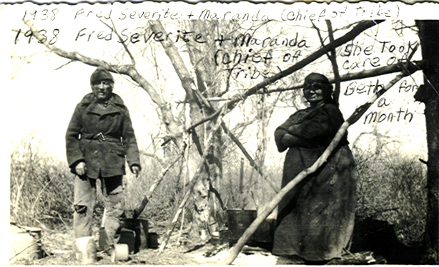
One of the most colorful persons we knew was an Indian chief by the name of Merranda. She was very large - I would say close to 300 pounds. She had a buckboard for going around the reservation, but when she walked you could never hear her coming. She would wear her moccasins and sometimes she would carry me, when I got tired. It would be so rhythmic and soothing I would fall asleep. She took care of me for a week while my sister was taken to a hospital in Saskatoon by our parents. This was before our brother came along. I think I still have those soothing feelings when I am on a ship or in an airplane it rocks me to sleep. The biggest thrill was to ride with her on the buckboard. She always loved to take us because it would cause such a stir when we would arrive in a camp with the chief.
The minister’s family always had a parsonage, provided by the church, to move into. You never knew what you were going to live in, and I honestly don’t know how our mother survived. She was raised in the Swedish tradition, where the mother did all the cooking and would not eat with the family. She would serve the family and eat after. Mother did not follow this tradition, but she really didn’t know how to cook and had to learn as she went along. Our home in Outlook was to us really big and wonderful. It had a back stair case which I imagine at one time was for a maid, but for us kids it was lots of fun to play hide and seek with two stair cases. It was also the spot we were put when we were disciplined, - not so great! I always thought if I got enough momentum at the top I could fly down them but fortunately I didn’t try it.
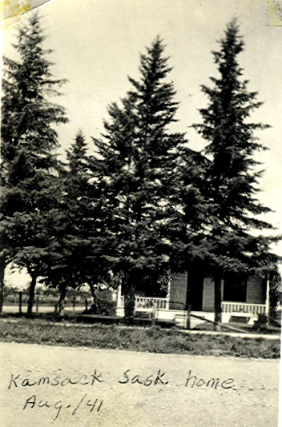
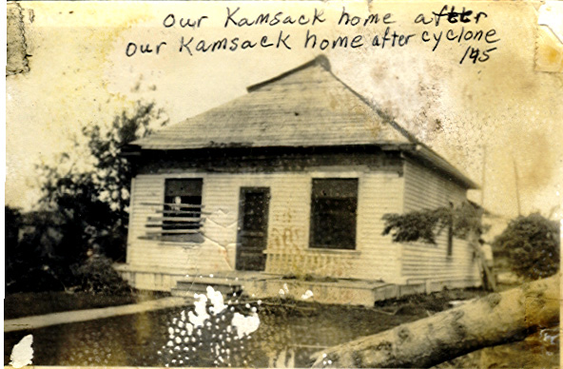
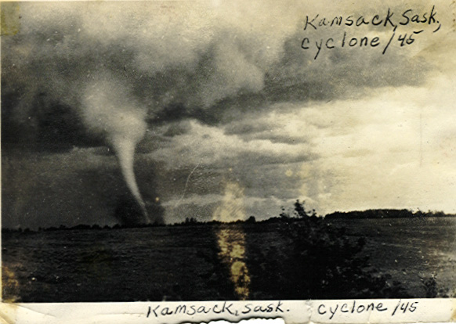
Our next move was to Kamsack, Saskatchewan, which was the one all three of us remember with fond memories. It is on the eastern edge of the province and north east of Yorkton. If you look at a map you will note that there are mostly forest and lakes northeast of Kamsack. Madge Lake is where we spent most of our summer months. We had a much smaller house but a very big yard surrounded with big spruce trees. The town was also on the edge of an Indian reservation. We spent time with the missionaries there, but not like we did with Meranda and so our interests changed. Most of the people in town had cabins at Madge Lake, and we could rent one and spend the time at the lake. It was great because most of the town was there. The month of July Dad would take us out and get us settled, and then he would come back to town to do his church work. The month of August would be his vacation so he would be at the lake with us. We had a gathering of other ministers and families from smaller communities, and they would all be there at the same time so there was lots of fun and games. As we got closer to being teens, we of course looked for our own friends and just checked into home for meals. We were always told to be home by dark. Of course in the summer it didn’t get dark until midnight, and I took advantage of that so the rules were changed. We were all good swimmers but there were guardian angles over us. I would be out in boats and canoes without any life jackets. I don’t think there were any. We would swim way out in the lake or off of islands. In some places they were not able to read the depth of the water it was so deep. Once my brother and I went on an adventure and rowed our boat about five miles over to the next beach. We got caught in a storm so we could not return with boat. We walked back and had to confess. The next day we went back with Dad to retrieve the boat.
We had to grow most of our fresh foods, because we did not have good refrigeration. It was mostly iceboxes. We had a huge garden, and of course it was up to us kids to keep it weeded and picked. We loved to pick peas, because they were so good but mother watched us like a hawk. The parents decided they could get more done if they came to town by themselves and left us at the lake. I think we pulled that off real well. One time when they were in town a huge storm struck the lake. We bolted ourselves into our cabin and hid under the furniture. It sounded like a big train going down the road. When it was all over we had a hard time getting out because of all the trees down, but we did manage to get out and go to one of the other cabins of our friends. I am not sure when the folks got back, but it was sometime the next day or so. They were frantic. They had been in the town and a tornado hit. They could not get to us, and we didn’t know what had happened. At the lake it tore up a long swath of huge trees, and you can see the damage to this day.

All the beautiful trees around our home in town were gone, and the roof of our house was twisted. If we had been in town, the wall and window would have hit my sister and I. The huge brick church was twisted on its foundation. It was very unusual and a surprise for that part of the country. They still talk about it. There were many summer romances at the lake - some good and some bad, but as I said I had a guardian angle, and I learned many good lessons. The lake had an island called Heron Island and all the herons nested there. It was a great sight watching these gangly birds build their nests in the trees and then fly back and forth feeding their young. I took my family back many years later, and they are still nesting there. I also took my husband to one of my favorite spots as a child, where I would watch the beavers and bears. Sure enough the big beaver house was still there, and they were still at work. What a treat! Another funny story when we went back was when we went out in the canoe and Mal, my husband and I were out in the middle of the lake. I got this very frightened feeling, and said we must go back to shore. It was a beautiful calm morning. He looked at me very quizzically and said why. I asked myself the same question. Then I realized my mother was still influencing me so much that I was not enjoying it, so we went back.
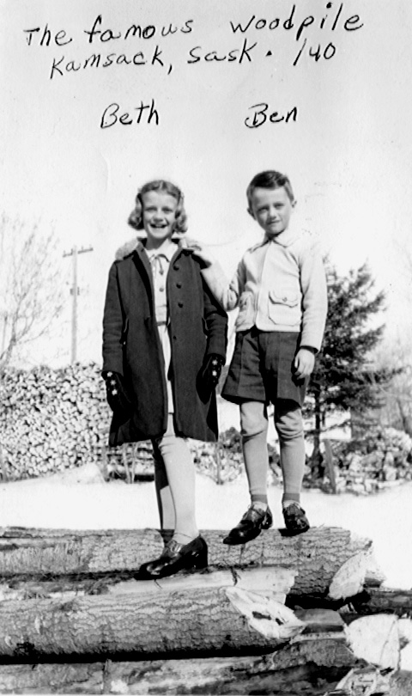
The winters were very long and cold. The first snow came in Sept. and the last snow-bank would be a puddle on my birthday mid May. We had a lot of fun in the winter, because it was so much of our life. We would play fox and the geese a lot. You make a big wagon wheel in the snow. Some one is it, and they would chase the others around the wheel or down the spokes. If you could not get out of the wheel, then you were it. Mom would also have a big tub of snow melting in the kitchen for wash water and we would build roads and houses and play with it until it would melt. Sleigh rides occured almost every weekend. One of the farmers would come to town with a flat bed drawn by horses, and we would jump on usually with our ice-skates, go for a ride, and then skate on a pond. The other game we would play really wasn’t allowed. Sometimes you would get caught, but we called it “hookie bobbing”. That is when a big sleigh would go by usually carrying trees. You would stand on the side of the road with our little sleigh, and once they were passed we would hook our sleigh on one of the trees and jump on. You could go a long way, unless someone saw and told the driver. If your sleigh swung out too far, he could see you. It was dangerous, and most people would yell and let the driver know, but my brother and I could usually go about three blocks before we were caught. We did it a lot in the country, but there it was legal. I often got a ride downtown doing it with my feet, which was a little hard on the boots.
All the houses were heated by coal or wood. We would get a huge pile of logs which then would have to be cut and thrown through a trap door into the basement. It was the kids job to throw the wood while Dad piled it in the basement. We were to yell when we threw but sometimes forgot and Dad was not a happy camper.
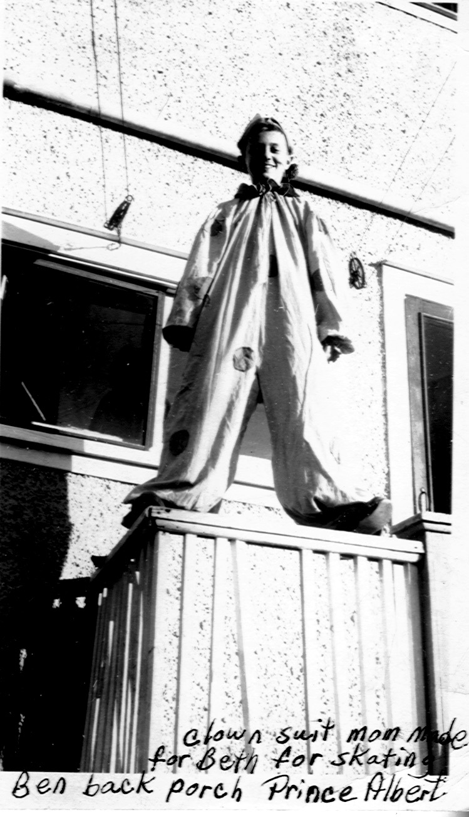
Kamsack is where I really got turned on to ice-skating. Dad couldn’t skate, but when I had my first pair of skates, I bugged him enough that he finally took me skating. He took me out to the middle of the rink and left me there. There was only one thing for me to do, and that was to skate back to the side. Then I held onto the side and went round and round. I was hooked. One of the rules in our house was we had to stay in our good clothes on Sunday, stay reasonably clean, and spend the day reading or visiting. I had a girlfriend whose father was an excellent skater and gave lessons. I could not afford them. The only day he could help me was Sunday. I would tell my folks I was going to visit Shirley, would have my skates, and a change of clothes stashed at her house. I would spend the day at the rink. I learned to dance on skates and do many of the other forms. It was great, but I could not share it with the family. One Saturday they had a carnival on ice, and I wanted to compete. I told the folks. They laughed, and said I couldn’t skate well enough. I told them I could, but I would be a clown. Finally my mother gave in and helped me make a clown outfit. Then I used one of her silk stockings as a mask, and I went to compete. I won first prize and got a silver dollar. I will never forget that night. I wanted to skate fancy which I could do, but I had to be a clown. I remember crying behind my mask the whole time everyone was laughing at me. I think it was at that time I decided that I had to create my own destiny. If I wanted to do something, I had to do it on my own. The family didn’t come because Saturday night was always getting ready for Sunday church activities. They heard about it and were very surprised I skated that well. I will never know if they knew how I had learned.
The next step in the saga of my life was to find a way I could start to earn money, so I would not be dependent on anyone. At the age of ten I started going from store to store to see if they would hire me. You can only guess I was ushered back out, but everyone was kind. I went into the bakery and applied. While I was there the gypsies, who were passing through, came into the shop. I was visiting with them, and the owner was trying to keep an eye on his produce, because they were notorious for taking things from stores. He observed how condescending they were to me, and how delighted they were to converse with me as well as admire my blond curly hair. After they left, he said he would like to hire me to wait on customers. He stated he didn’t feel safe sending me home alone after work, so he sent me home with his two Irish setter dogs, one on each side. If anyone tried to stop me and talk, the dogs would get a low growl in their throats. You can only guess - no one interfered with my going home. The interesting part of this was the dogs would not leave my side until I was through the door and in the house. Then they would turn around and go home. The whole idea really worked. In fact the gypsies wanted to be sure I didn’t cut myself short and get into trouble. The other customers were equally concerned and, if anything, the store made money when I was behind the counter. For me it was a great learning experience related to the fact I learned to measure and weigh produce as well as count change and deal with cash. The down side was I had to sweep the floors, and that is difficult when you are dealing with flour.
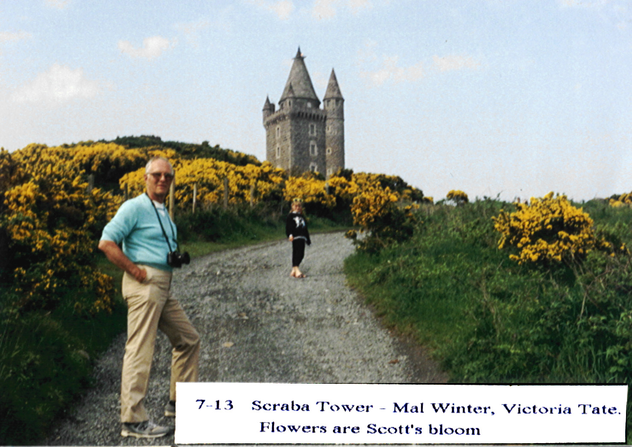
Another memory that stands out in my mind is the war. Canada was a voluntary enlistment. When a cable came to announce that a service person was killed or missing it usually came to Dad, and he would have to go to the families. You could always tell when he was on this mission, because his heart was heavy. One time stands out for me. I was playing marbles with a bunch of boys and I had the best “steely”. This is a steel marble that you could use to take another marble out of the circle. In a way it was a form of gambling, because you got to keep the marbles you knocked out. Everyone would put a certain amount in and then you would try to get as many as you could. The fair way to play is to give the marbles back, but that wasn’t the way we were playing. Dad happened to come by with his message of sorrow. He stopped and looked at me and said, “Are you playing fair my wee girl?” I took one look at his face, and guilt was written all over my face. Needless to say everyone got their marbles back.
Our next move was to Prince Albert, Saskatchewan. Dad was making a career change. He was going into the radio ministry. This was an extremely hard move for all of us. Rachel, Ben, and I made our best friends at Kamsack. I had my first real boyfriend, but I can’t even remember his name. I do remember he was an excellent skater, and I think that is why I liked him. We all begged Dad not to move but I think the war weighed heavy on him, and his own family in Ireland suffered. They were allies with England and they built the war ships. Unfortunately the south of Ireland was neutral, and they didn’t have a black-out code, so at night the German and Japanese could easily target the Belfast harbor where the ships were made, and they would bomb the harbor. One day my grandmother realized that a house along the ocean was sending Morse code across the Irish Sea to Scotland. She realized it was letting someone know on that coast, and then they relayed it to Germany when to bomb the harbor. All the men were away to war or working on ships. She decided if the walls of Jerico could be brought down, they could bring the house down. She got all of the women of Newtonards together with their pots and pans and anything that would make noise. They silently surrounded the house, and at a signal began to make loud noise. The residents ran for their lives, jumped in a boat, and took off. I wish I had met my grandparents, but that was not to be. The stories about them are wonderful. When my Dad and his two brothers were small, a “plague” hit Newtonards. My grandparents pitched a tent out of town on a hill called Scrabba Hill and put their boys in it. They then went back to town and took care of the sick and dyeing. Dad does not remember how long they were there, but he thought it was months. The parents brought them food everyday and checked on them. They all lived without getting sick. Scrabba Hill has a stone watchtower built on it. I don’t know how old it was, but you can see the ocean from it, and I imagine it was built for that purpose. During the war it was used for another purpose. It would be the landmark for the enemy to find, and then they would zero in on the Belfast harbor to bomb. My husband’s retired nurse was an army nurse during the war. She remembers taking a joy ride with an American pilot flying over Scrabba Tower to see how many enemy planes they could shoot down. It is wonderful how lives and stories intertwine.
We moved to Prince Albert, and this was really different. Dad did not have a church, so we didn’t have a ready-made family. We had a house on the hill, and Dad had two fifteen minute programs a week. One was Wednesday evening and the other Sunday evening. The biggest thrill for us kids was to be able to go there with him and watch. The other thing I really got into was hockey games. During the time I was growing up the ice was frozen from the temperature and not artificial, so you had to dress warm. I have fond memories of walking down the hill in a wonderful snowstorm to a hockey game. The northern lights would be dancing across the sky in full color. At Christmas time one of the neighbors would line up a sled (or dray as we would call them) and horses. We would go around the neighborhood picking up friends, and we would have a great sled party. We would have fun pushing each other off into a snow bank, and then we would have to run to catch up. Across the street from our home was a big house that had been turned into a Bible School. The students were trained to go to the mission field from this institution. I don’t know if that meant we were an outpost or what, but anyway they befriended the three of us, had us over for meals and allowed us to look through their telescope. We had some great times. One lady in particular befriended me. She asked me what I wanted to be and I said a nurse. She said that she was one, and she would pray that I would be able to go to her nursing school. I asked her where that was and she said Chicago. I couldn’t even pronounce it let alone know anything about it, and I will tell you more later.
There were two interesting groups of people I forgot to tell you about in Kamsack. The first were the Dukhobors. They were the Russians who escaped the Czar's rule and moved to Canada for freedom of religion. They lived in communes, but the government insisted their children go to the regular schools. Some of my best friends lived in these communes. They were extremely intelligent, and when I would walk home with them I could not go in. My friends would tell me they would have to go in and peel a hundred pounds of potatoes or get bread ready to rise. They all had their jobs to do for the corporate family. The older generation was very suspicious of the government school system. There were a couple of times they tried to burn down the schools, and we would have to meet in temporary schools until they restored the old ones. Saturday downtown was the big day to go shopping and everyone was there. The Dukhobor women would wear long dark coats, always had their arms folded, and wore babushkas on their heads. The men and women loved sunflower seeds. They had the uncanny ability to put a handful in their mouths and shell them, while they talked in Russian. Then at one time they would all turn their heads and spit the shells out. The trick was to time your passing them on the sidewalk after they had just spit. Otherwise you were shelled. In the winter the snow would get so high on Main Street that they would plow it to the middle. We loved to walk Main Street because that is how teens drug Main. We would do it on top of the snow bank so we could see everyone. Saturday morning I used to sell Victory Bonds at the post office to help pay for the war. I was told I could charm a snake into buying one, and it did seem I was very successful.
The other ethnic group of people were the Czechoslovakians. They also lived in their own communities, usually out of town. Dad often served them as a minister, because they would not always have one. He would take communion out to them. One
time he was running late, so he prepared the glasses for the next church down the road. We drove off. At some point we hit a pothole, and we were both wearing the grape juice!! The Czech people really knew how to eat. They would serve twelve course meals I am sure. We would start with porridge and end up with dessert. It was great.
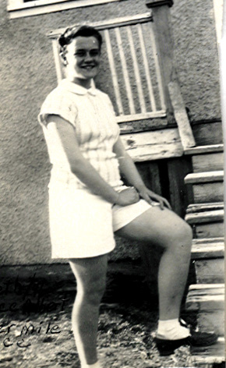
It is time to get back to Prince Albert and school. We were so far north, that most of the school year we would go to school in the dark and come home in the dark. We would have to wear long underwear to school. Of course you would take it off in the bathroom as soon as you got to school. The other trick was to keep you face from freezing. We would wear scarves over our forehead and hats. Then we would make a dint in our mitten to put our nose in. We would have to check with our walking partner to make sure we were not freezing our faces. There was no transportation in those days.
We had a wood and coal furnace. The register was in the hall upstairs. We would all get dressed over the register to keep warm. During the winter Dad would visit his outposts that he had reached by radio. He would go in snowmobiles, which would be driven by a pilot. They were not like today’s snowmobiles. They were like a small one room house with a potbelly stove in the middle to keep it warm. It would have a big window in the front and a steering wheel, which would control the skies that the house was on. There would be a table and chairs inside and benches. An airplane engine powered the snowmobile and the propeller was on the back outside. They could really travel, but you would have to be careful of the propeller. There were many accidents with people being killed or cut up.
Beth in running cloths & shoes
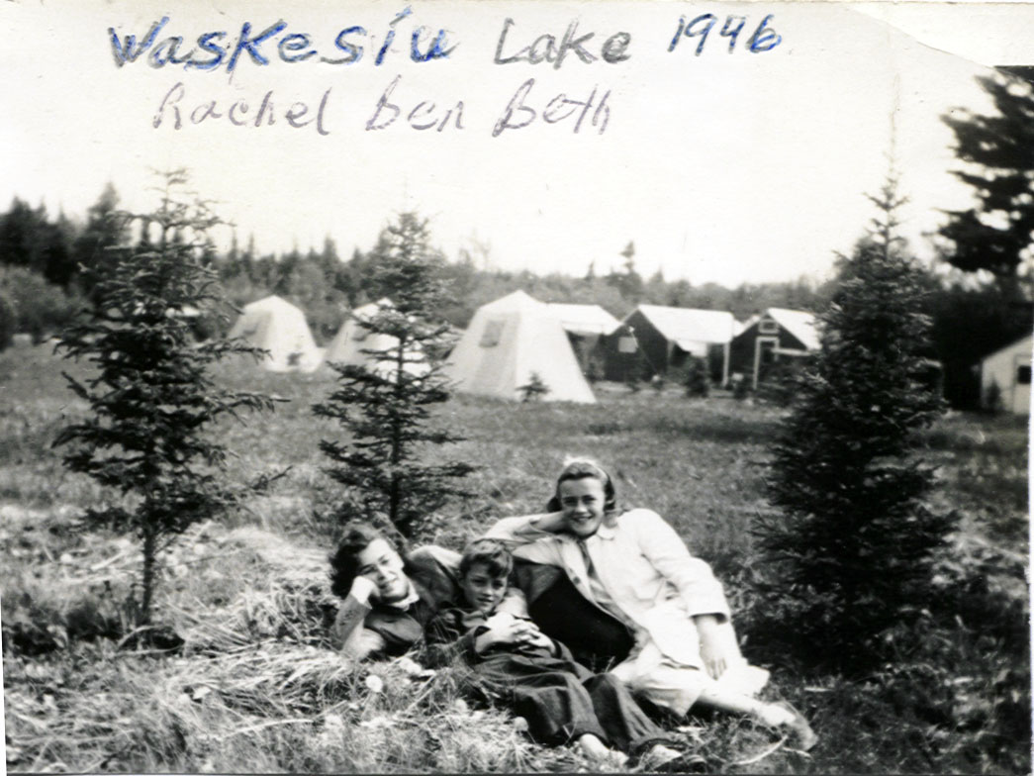
In the spring at school I really got into the sport of running. I loved being the last on relay teams, especially if we were behind because I could sprint to catch up and win. I hated the starter block, so that would get me into trouble with sprints. Rachel had a good friend that was a mile runner for school. I idealized Doris and followed her around like a puppy. She also had a cute brother by the name of Jack. I finally asked her if I could run with her, and she said that would be fine. We didn’t have good running shoes, and the track was packed dirt. As I improved I realized I could pass Doris. Soon I was running five-minute miles. The school and powers out of school were really looking at me to be the future mile runner, but then we moved again - more about that later. Doris’s brother had a good friend by the name of Bill, and I really liked him also. So I dated both of them without the other one knowing. That worked for a while, but then fell apart.
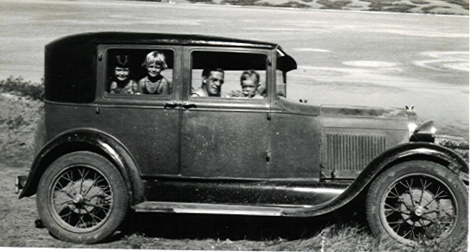
Dad took a trip to learn more about radio broadcasting, and I think he also went to Ireland at the same time. He was gone for quite awhile, and Mom took over. We were great for picnics, but it was often raining. We would venture out anyway hoping it would clear up. When Dad was with us we would usually go to Lake Waskesiu, which is eighty miles north of Prince Albert. It was a gravel mud road, and we were in a model B Ford. We would have to crank it before we started, and then hope and pray we could stay on the road. Even though we got wet and muddy, we always had a wonderful time. When Mom was alone we begged to go to lake, so finally she would get a neighbor to come over and crank the car. Off we would go to a lake much closer. We would have a wonderful day, and then when it was time to go home mother would go into the woods and find a trapper or someone to come and crank the car. Then we would come home again.
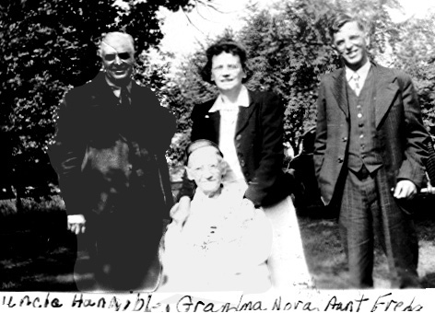
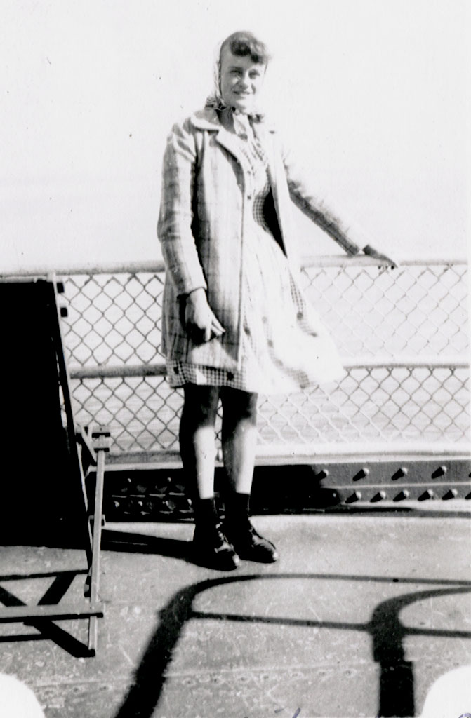
I have a few more tales to tell from our Canada days, which I almost forgot. We took some long car trips to Muskegon, Michigan to see my mother’s family. That was quite a trip seeing we were driving model B and D Fords. I think I have that correctly. We would have the cage on the running board for storage. The church people would make care packages for us, and off we would go. Mother was the pilot. We often got lost to start with, because the roads in northern Canada were often under repair or washed out. Most of them were dirt and gravel. Once we got over them we were clear sailing, except everyone would pass us. If we got up to forty miles an hour, we would whoop it up. I remember one of the surprises in the care packages was bubble gum. We loved it until one of our bubbles would break. Dad thought it was a blow out, so we had to stop chewing it in the car.
Uncle Hannible, Grandma Nora, Aunt Freda, Uncle Ray
Rachel, Beth, Dad, Ben
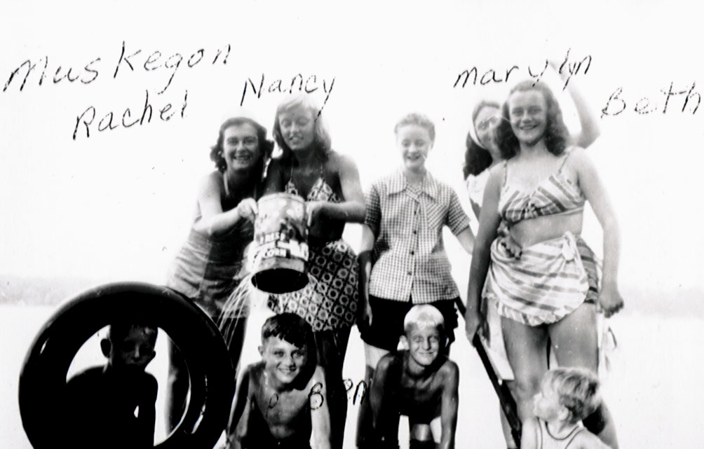
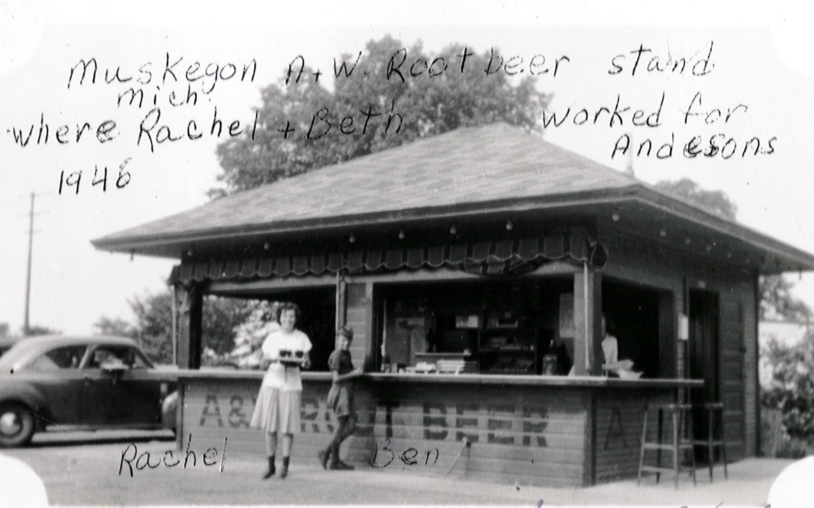
We would drive to Milwaukee, Wisconsin to catch the boat across to Michigan. We often got there in the middle of the night, so we would sleep in the car, then load car and all when the big car ferry would dock. The folks would have a room but the three of us would roam the ship. We would land north of Muskegon and drive to the Carlson family home which was small but wonderful. Grandma was a small lady and only spoke Swedish. Every time I would be near her she would pat my head and say “little flicka” which would be girl, I think, in Swedish. Uncle Hannibal and Aunt Freda lived with grandma. Uncle Hannibal was a big kind man who loved us dearly. He never married but was loved and respected by all. Aunt Freda had TB when she was a teen-ager and was in a hospital (or sanitarium as it was called) most of her young life, so she never married. She was a partial invalid but was a wonderful artist. She made cards and flannel-graph pictures to earn some money. President and Mrs. Eisenhower had her make most of their greeting cards. They were always bright colors and had the troll art look. We understand there are some of them in the Eisenhower estate, but we have not seen them. She would sign them down in the lower right hand corner F Carlson. When I worked in Saugatuck I was able to visit Muskegon a few times. When we used to visit Muskegon as kids we had some really good friends that we hung out with. They were the children of our mothers’ friend and they were our ages. Rachel and I also worked at the A&W stand and met a lot of fun friends there. Sometimes it would get hectic and it was not well lit so it would be hard to find the cars to take the orders to. We had some friends that sang in a quartet and they would sometimes come to the stand and sing which helped everyones’ spirits.
Ferry croosing to Milwaukee
Ben
The other situation I wanted to mention about Prince Albert was my running. I became quite good. When the family was moving to Chicago, they were approached about leaving me in Canada, so I could train for the Olympic team. The folks said, no that I needed to be with them. At the time I was angry but it was a good decision.
Dad accepted a job in Chicago after he had attended a class their. Mom and Dad had talked about it a lot, and we were all ready to go onto higher education. The opportunity was not in northern Saskatchewan, so they thought it wise to move where colleges were more available.
Rachel at A&W stand

Chapter 2
Our move to Chicago entailed a lot of details. My father and I were the only ones in the family who were not American citizens. My mother and Rachel were born in America, and my brother Ben could take the citizenship of either parent, because he was a minor. I had turned sixteen, so Dad and I had to take the train to Saskatoon the capital of Saskatchewan and apply for entrance to the United States. When we finally moved, we went by train, but at the border Customs came through and checked our passports. There happened to be a stow-a-way on the train, and they found her. There was a lot of screaming as they got her off of the train.
Our porter was a black man. He was the first black person I had ever seen. He was delightful and realized that us kids had never seen a black person so he was great with us.
We arrived in Downers Grove, Illinois, a suburb of Chicago about thirty miles east of the Loop. At that time suburbs were just coming into existence. The little towns used to be rural farmland, and they were just beginning to grow and be homes for families commuting out of the city. The commuter train was the main form of transportation.
We arrived and were met by a lovely family by the name of Taylor. They were the core members of the Fairview Ave. Presbyterian Church, where Dad was to be the minister. The house, or parsonage as it is called, was almost bigger than the church. It was an old farmhouse with lots of space but not a bit of furniture. We carried our mattresses that first night from the Taylor’s house. I am sure we were quite a sight. This was in November. That is winter in Canada, so we were in our long coats, boots, mittens, hats and carrying our mattresses on our heads. The minister before Dad had run off with all of the church money so we came to a very desolate situation. The next day food and furniture started to arrive from the entire congregation, so in time we were well situated.
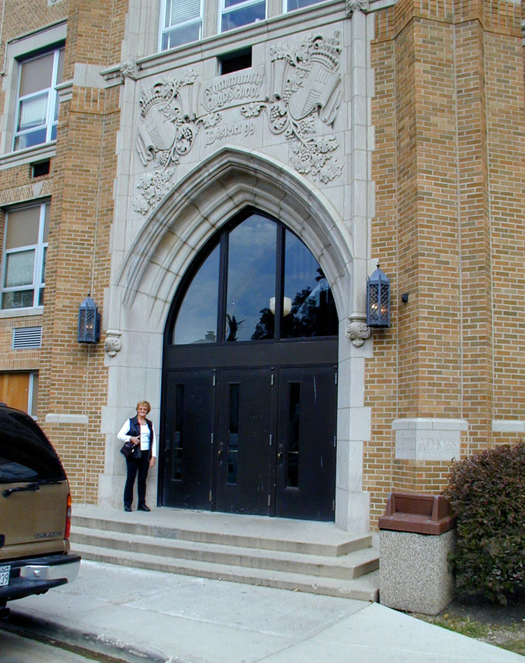
School was the next thing to tackle for Ben and I. Rachel had graduated so she was looking at a job and then college next semester. I was a sophomore in High School. Of course, the only clothes I had, made me look like a refugee--and this was one stylish suburban school. I really stood out, and in the office the secretary said to me “You can’t dress like that!!”
I asked her what I was to do; they were the only clothes I had. She gave me a disdainful look and then started to show me around school. By the time I entered my first class I was an emotional wreck. The teacher thought he would help me out and introduced me and asked me to read the poem they were reading. I love poetry so that seemed easy enough, except I had this strong Canadian accent. The whole class went up in gales of laughter, and I had no idea why. That was all sorted out, and some of the kids took me under their wing. They ended up being my best friends.
My next class was mathematics and the only class open was geometry. This happened to be taught by the football coach and the only students in the class were the players and I. I didn’t have a clue about football. They didn’t play it in Canada, and it was before TV. Most of his problem-solving situations were the plays of the next game. I learned a different approach to mathematics as well as football. One thing this class did for me was to make me popular with all of the girls because I had direct contact with the football team.
Downers Grove High School
Being a preacher’s kid in Canada isolated you except on Sunday. Not many of the kids hung out with you at school, but they were nice to you on Sunday. I vowed no one would know what my Dad did. It didn’t take long for them to find out because some were in our church. It didn’t make a bit of difference, which was wonderful to find out.
I loved high school. There was so much to do in choir and drama as well as different clubs, so I was busy. I had a great gang of girl friends, and we spent weekends sleeping over at different homes and going to dances and movies as a group. Dancing was a no no in the preacher’s house but I just went to sleep-overs and would go with the gang.
In my Dad’s church choir was a man ten years my senior, a businessman in Chicago. He was quite taken with me as a little sister and one practice he asked if I would like to go for a motorcycle ride after church on Sunday. I asked my parents and Dad talked with James and asked what it was all about. James said he rode the weekends with a gang of Harley Davidson motorcycle riders. They all had professional jobs and girlfriends or wives. They had been looking for a mascot and they would like me to be it. One of them would leave their lady friend at home and I would ride in place of her. My Dad said that would be fine--if they all came to church first. The next Sunday the front row was full of leather riders and their bikes were parked outside. That caused a real buzz.
The riders really took me under their arm. They would know what my schedule was at school, and if they thought I might be in any conflict or having any trouble they were there to check me out after school. Sometimes I would ride home with them and other times we would just visit.
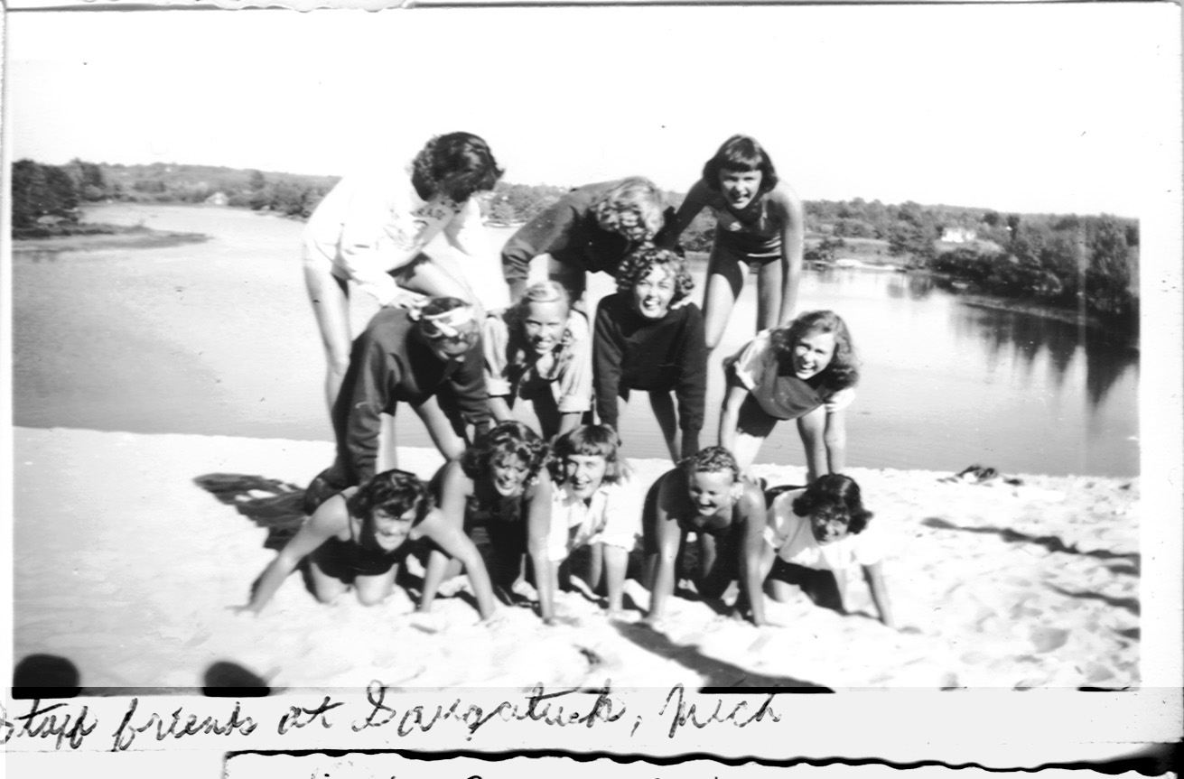
One incident, which stands out in my mind, followed the school play. I was part of the back stage crew and they had a party after the last performance. I mentioned this to James at choir practice and he said sometimes they get kind of wild and I said, “Oh no, this is at one of the kid’s homes.” He asked me the name and address and we let it drop. When I went to the party with some other kids I noticed there were no adults there. The party started and within the hour the lights went out and it was a fight to get to the door and get out. I was really frightened--being a kid from the country--but once I was outside I saw that there were two of my friends on the Harleys and they took me home safe and sound. They didn’t say a word but one guy had a tear-stained jacket and they let me off at home with a hug and a tap on the head. Who said there are no guardian angels!
That first summer I went to church camp at Saugatuck, Michigan. When I was there I got to know the staff and asked them if there would be a job for me. I was able to work as a waitress so I stayed on at camp and worked and lived with the staff. At first I was really homesick and I called home and said I wanted to come home. Dad told me to wait a week and he would come and get me. A week passed and he called and asked if he should come. My response was “Why!!” I have used this a lot when people have asked me what to do about someone who is homesick.
My first real boyfriend came with his family to stay at family camp. His name was Jack. I was very busy working and his parents had a real close watch on him, but we did have time down by the lake to sit and watch the water and the moon. The following year I went back and became the store manager, who fixed ice cream and sandwiches and candy. I was only seventeen but I was hard on my peers. The store had been in the red and I turned it around and did not allow anyone credit. They had to have cash. In short order it was making money.
I remember one of the sales men coming in and wanting a hot breakfast because the camp food was just for the campers. We didn’t have any way to cook but it gave me an idea and I got an electric plate that had two elements and I was ready. I had bacon and eggs and hamburger in the refrigerator and my first customer came in and wanted two eggs easy over. All of a sudden I realized I didn’t know how to cook so I made a deal. You cook and show me and it will be a free meal. He did that and showed me how to do hamburgers and french fries. We were in business.
One of our campers was from Grand Rapids, Mich. They had lots of tall good looking Dutch men. Some of my waitress friends and I got to know some of them, and they said, “Come to Grand Rapids and we will show you a good time.”
Our next day off we decided to do that. None of us had much money. I decided we could hitch hike, which we did. We spent the day at an amusement park with our Dutch friends, and when it was time to come home we talked them into bringing us home, which was over a hundred miles. We gave them many promises that we would write and come back but that was the end of it and another fun experience.
I guess the biggest adventure we did was take a boat trip back to Chicago. Again we had the same day off. When I say we - it was three girls I hung out with. We all worked at camp. We went swimming and sunning in Lake Michigan. While we were swimming this beautiful yacht came by and asked if we would like to take a ride. Of course we agreed and they lowered the ladder and we got in. They then told us they were going back to Chicago and we were a captive audience so to speak. Well once more we had a guardian angel. I informed them we were all under the age of eighteen. They were very nice and fed us and we were let off at the dock on Canal Street in Chicago.
I asked for some money to call home, which they gave, and poor Dad had another call. He said, “Where are you?” I told him and I also asked him to bring some cover up shirts for the three of us. He dutifully came, gave us some clothes, and drove us back to Saugatuck. I was the senior advisor at the dorm, so we had no trouble getting in and Dad went back home.
The other memorable experience that happened at Saugatuck was a dance. In the town itself they had a wonderful pavilion with a live band and of course we snuck out and went to the dance. How could you not go with the music coming across the lake? It was a live big band. We always had someone to dance with, and then we would sneak back to the dorm. One night when I was closing the store and group of kids came over from Penele Knook, an inner city camp that we provided for. They said at the store they had an ROTC high school group of kids at the camp, and they needed some dancing partners. I went to the dorm, got my friends, and off we went. My partner was a superb dancer, and we were all over the floor.
I didn’t realize at the time the Chicago Tribune was doing a story on the inner city kids. They took many pictures, which I thought were just of the camp. turned out they were headline news in the paper. My folks were introduced to my expertise in dance. That didn’t come out until much later when brother Ben wanted to go to a dance. Dad said, “Why don’t you ask your sister?” At that point he brought out the headline article. Oh well! Someone had to be a pioneer.

Chapter 3

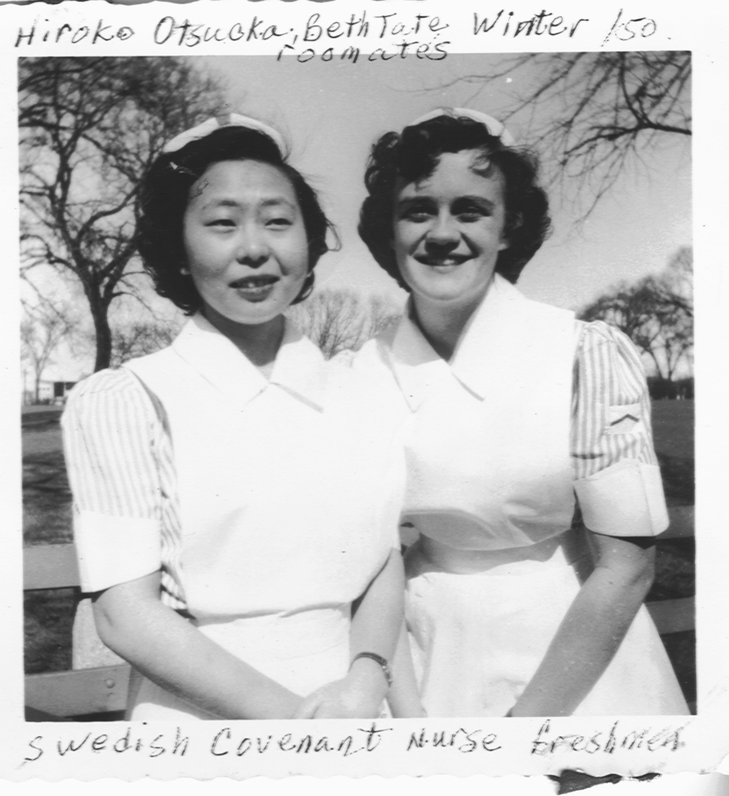
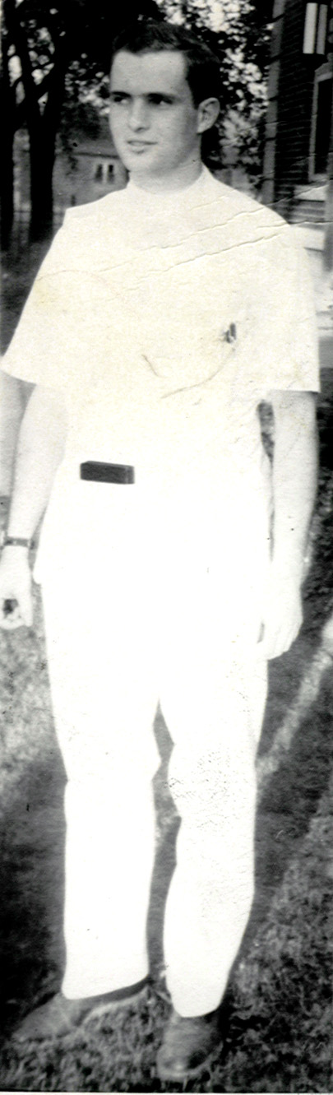
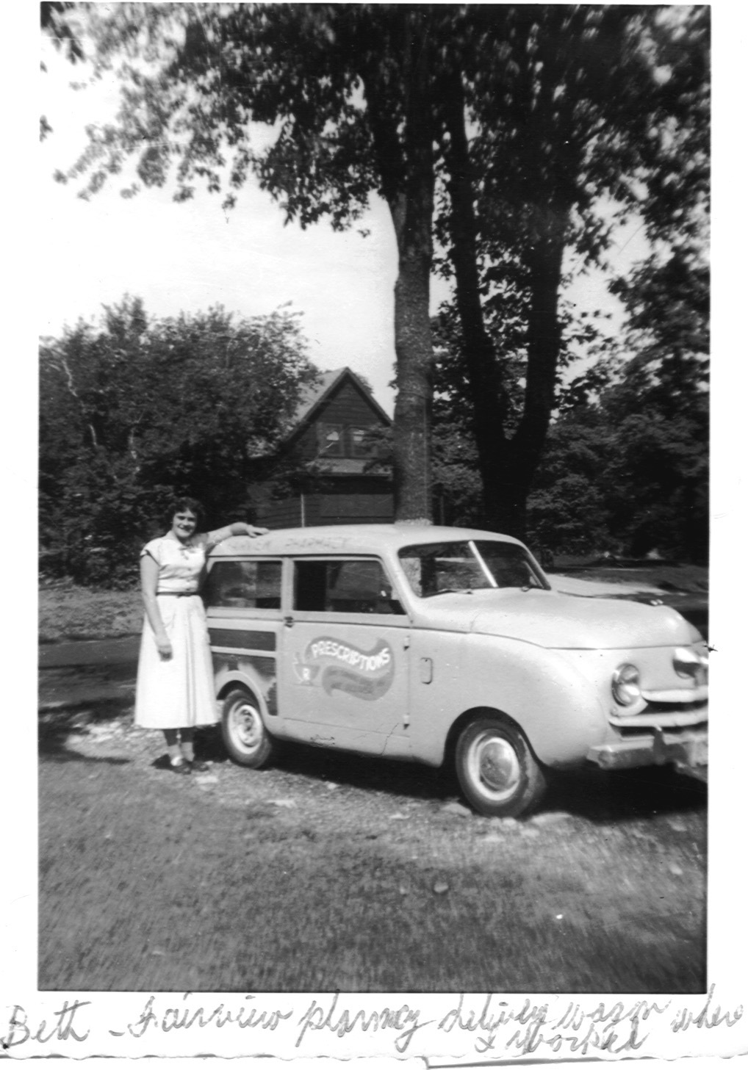
Now back to Chicago and the continuation of my life. It was time to look for a nursing school, where I could follow my dream when I graduated. I had worked the last two summers at Pippenger’s Drug Store. I delivered orders, counted pills, waited on people, decorated windows, and did many other jobs. It was good money, and I had earned most of my tuition. I visited many of the programs and was accepted into all of them. Then I remembered Swedish Covenant, which the missionary lady in Prince Albert had told me about. When I went to visit, I fell in love with the place. It was small enough and offered a great program. My biggest problem was a serious boyfriend. He was a telephone repairman and went to our church. Bob Jensen was a big man and kind. He wanted to build me a house in the suburbs and settle down. It sounded real good at the time but once again my parents pointed out my dream. They said, “Try nursing for three months and then see what you feel.” Well you know the rest of the story. I was hooked on nursing. My roommate was Hero Otsuka from Japan. She had been General McCarthy’s interpreter in Japan and had met some American nurses who were teaching a Bible Study to students. They encouraged her to go to nursing, and they would finance her. Hero and I had a great time learning our nursing subjects. It was doubly hard for Hero, because of the language barrier. We would name all of the objects in our room to be part of our anatomy studies. Every time we used the sink we would have to name the bone structure we had given it. I dated a lot on weekends with different young men my classmates knew. Most of my classmates had boyfriends who would come to see them. They would bring along a buddy and I would be their “blind date” so to speak. I got tired of this, but it was a free meal and a movie. I announced to Hero I was through with men, and she laughed at me. About the same time I was working nights in the nursery, and I would go over to night kitchen to have supper and fix a snack for night shift. I had heard about the medical students the hospital had been hiring to cover their emergency room as well as do the history and physicals on patients admitted to the hospital. These men had been dating the student nurses and some were already going “steady”. I had heard about this one in particular who had dated a lot of my classmates. I was on the list I was told. I made the smart remark that we lived at the end of the hall, and he was working his way down the hall. One evening in night kitchen this very handsome medical student walked in and I was in the process of setting up a practical joke that would get the next person wet if they tried to open the container on the table. He very nicely assisted me in the project. I thought he couldn’t be all-bad. Anyway my life was about to be turned upside down, and I didn’t know it. He asked if I was busy Sunday evening, and could I go to church with him. I told him I had to be back in time for work but I would be glad to go with him. Well meet the man in my life Malcolm Winter who has been top of the list for me from then on. I was not aware of it right off but I really liked him. We had so much in common. We loved the out of doors, flying kites, and playing chess, liked classical music and on and on. I came home and told Hero. She groaned and said here we go again. I told her it wasn’t serious. I had my life planned, and further more I had five blind dates lined up.
Beth & Pippenger's delivery wagon
Hero & Beth
Malcolm Winter
I was also singing in a trio, which went to different churches and sang as well as preached. One of our group did chalk talks while we sang. Chalk Talks were a way of telling a story on flannel or paper with colored chalk. The picture was actually created while the trio sang. We were booked for months and trying to fit that into our studies and work was a job. We had an agent who was a very rich single man in his late forties. He was involved in the seminary close to our hospital, and it was connected to the Evangelical Free Church. One day he said he was picking us up for a picnic. True to form he picked us up in his limo. We drove north and west of Chicago to a beautiful estate. We had our picnic, and he asked what we thought of the place becoming the future spot for the Seminary. We all thought it was wonderful. From what I understand that was his family estate. He gave it to the church for their seminary and now it is a wonderful campus called Trinity Seminary. Mal and I started dating. The trio was breaking up anyway, because the artist and the alto were graduating and leaving. Our benevolent agent Mr. Johnston never forgave me for not going out with one of his seminary students.
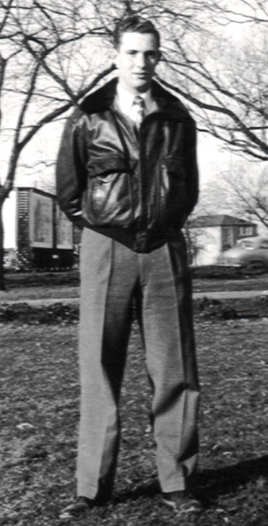
By now it was pretty obvious to me that my heart belonged to a wonderful man by the name of Mal Winter. I tried to fulfill the blind date duty. I made it through two and bagged the rest. Whenever Mal was called out at night to the ER, I would always be called at my workstation. Soon I would hear him walking down the hall to see me. He was also really good at stalling the utility elevator in the hospital to work in a kiss or two on our way on or off duty. A short time after we started to date we were sent to different hospitals for training, so if we had not met then we probably would have missed each other. As you have read in Mal’s history he had a deal with himself that he wouldn’t date the same girl more than twice in a row. He lost his bet with the rest of his buddies. I had to go with him and twelve other medical students to pay the debt of any ice cream they wanted at Charmets on Michigan Ave. in Chicago. I was a bit embarrassed but it was worth it because I had a great guy. Bob Jensen showed up at the hospital home from leave in the air force. I had told him our relationship was over, but I think he wanted to see if the uniform would change my mind. I was surprised. I took him to meet Mal who was playing tennis, and that was the end of my relationship with Bob.
Mal Winter
A few incidents stand out in my mind during my nurses training which I would like to share. We had two orderlies (college boys who would help at the hospital) who were pranksters. One time they brought me a chocolate milk shake, but it was really barium from X-ray. Fortunately I was able to tell after the first sip. Another time I had a death on my duty at night, and I needed help getting the body to the morgue. I called for help and one of them came. I took another nurse, and we went to the morgue with the body. The orderly pulled out the storage cooler tray that we put the bodies while waiting for the funeral home to come and get them. As he pulled it out there was a body on it and it started to sit up. It was covered with a sheet so you couldn’t tell who it was. I started to scream and run down the hall. Of course my scream went up every air vent and woke the whole hospital up. My nurse companion fainted on the floor. As you can guess it was the other orderly on the slab. I always think of what would have happened if his buddy had forgotten which slab, or we hadn’t gone down when we were supposed to. Scary huh!! You can well imagine they were disciplined. I understand they both became preachers! Another story happened as we came off of evening duty two hours late because it had been so busy. It was 1AM when we got over to the dorm, and then we realized we had to get up at six for chapel the next morning. We rebelled, went into the library, took out the encyclopedias, and substituted them for the hymnals in the chapel. The next morning in chapel was a disaster because the dean of our nursing school was leading the service, and she always picked out hymns we didn’t know. So the pianist and the leader were the only ones participating. The whole school was campused until someone would tell who did it. No one would, and this went on for a couple of weeks. By then we were all in bad humor. One of the doctors who lectured us asked me what was wrong, and I told him. He was furious, because he excused us from his lectures if we worked nights. He went to the powers that be, and from then on chapel was not mandatory. When we worked days, we all loved to go. If we got off of nights on time we would be there also. When we went back for our ten-year reunion the Dean of Nursing happened to pass us culprits, who had switched the books, and as she passed, she said sweetly “have you sung from encyclopedias lately?” That was the first we realized she found out who did it. One last story happened when I was at Cook County Hospital in Chicago. I was working in the contagious disease department. We had had a serious polio outbreak. I was in the unit with iron lungs and the swinging beds. I had at least ten lungs and three beds, when an electric storm knocked out the electricity to the hospital. I was alone on duty at the time, and I had to decide whom I would hand pump and save. It seemed like a lifetime, but I am sure it was seconds. I chose a sixteen-year-old girl who was feisty and physically strong. When I pulled down on the pump it would press her rib cage and push the air out and she would yell, “don’t save me I want to die”. The hospital had a back up generator and electricity came on to my unit. Also staff from all over came to help. The end of the story happened years latter. I was watching Donahue one day and he was interviewing the lady who had designed the wheel chair to be worked by the breath of the person in it. I was shocked because her story matched mine. I am sure it was the same person. When I tried to call, they said it was taped, and they didn’t pass messages on. There are many other stories, but there is lots left in my life so we will move on.
Mal and I continued to date and talk to each other on the phone every evening. He was at Passivent hospital, while I was at Cook County. He did start at Cook County, as I was finishing. He would bring us lunch sandwiches he had fixed at Swedish Covenant the night before. They were triple layered and sometimes quadrupled. Who knows what was inside, but they were good. If the weather was good we often ate it outside in front of the hospital under the statue of Louise Pasture. We often called it “Louise’s pasture” because they never mowed the lawn. Mal went home for Christmas. I was still at Cook County. I knew we had been serious enough in our relationship that I had better make up my mind if I wanted to spend the rest of my life with this man I loved. I had already been accepted at King Hospital in Hawaii as a surgical nurse and I had all my life planned. The night before Mal came back I wrestled with the issue and prayed about it and was up most of the night. When I picked Mal up at the train he had an engagement ring for me and of course I accepted it. We then drove out to Downers Grove, so Mal could ask my Dad for my hand in marriage. When my Dad saw the ring he said to Mal “it is a little late to be asking isn’t it laddie.” We then went to celebrate by going to a live radio broadcast, which was called “Songs in the Night”. It was done by George Beverly Shay who later became Billy Graham’s soloist. One day when I was getting report at Cook County Psychiatric department, we heard from the day room where our patients were a statement “Miss Tate’s engaged, Miss Tate’s engaged”. We all knew it was our large male manic who was a Houdini, who could escape from anywhere so we thought we better go check. He had stacked all the tables up, and he was on top waving the keys to the psyche Unit. We all grabbed to see if we had our keys and we did. He had taken them off of one of the staff earlier. Seeing he was announcing my engagement I talked him down, and asked him to give me the keys, or I would be in trouble. He very nicely complied, which we were grateful for, because we had some very serious offenders on our ward, one being the milkman slayer who had killed a dozen people hitch hiking from Chicago west.

Chaper 4
Mal & I both graduated in June. I still continued at Swedish Covenant until September. Mal went for his internship to Des Moines Iowa Methodist hospital. We wanted to get married when I graduated, but my folks had my sister Rachel’s wedding that summer and did not have the money. They said if I could pay for my own they were OK with it. I worked at the hospital for three months and with the help of some generous people, I was able to get married. One of my patients was a wonderful Jewish man by the name of Mr. Goldblats. He asked me about my engagement ring, and I told him the story. He told me he owned a big store with a wedding department. The dresses used for modeling were never sold. If I would pay him $25, so he could say it was sold, I could have my pick of the styles that had been shown. I went to the store and bought a beautiful satin with a full-length train for 25 dollars. It was wonderful and it still is. Our daughter Susan wore it for her wedding. It only gets more beautiful.
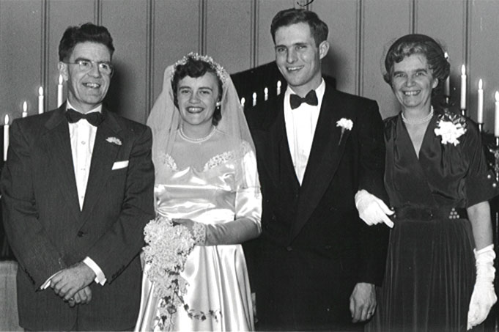
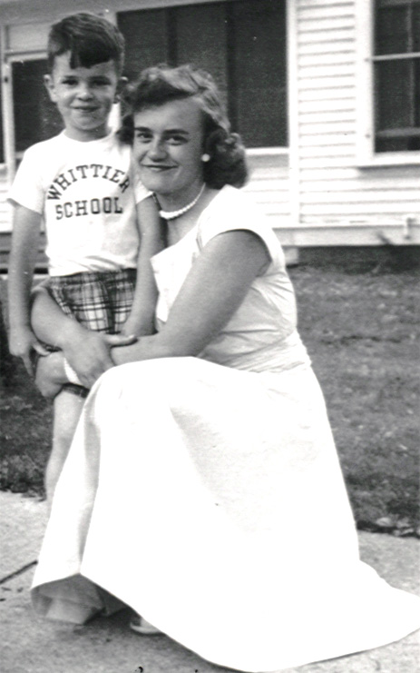
One very important event I forgot to mention was the sixth member of our family. The first Christmas after we moved from Canada the folks announced we were going to have a new sibling in our family. We could hardly believe it but were excited about it. Six months later we welcomed Timothy Tate into our family. He was such a beautiful baby. The hospital would not allow Ben to see mom or the baby because he was too young. That was not a problem for me. I snuck him up the back staircase, and he got to see Mom and Tim. Tim was loved by all of my classmates in nursing. They still ask about him. I would often bring my classmates home for a weekend, so they could get away from school. I would like to come home Saturday afternoons, so I could watch Ben play football. They won the state championship, when he was on the team.
Tim & Beth
Our wedding happened November 4th. We had it on a Friday afternoon because our church was small, and we had to invite the whole congregation and also my school of nursing. We thought if we had it on a weekday it would keep the crowd down, but not so. They all took off from work, so we had a huge wedding. I still don’t know how we fit everyone in, but it was a wonderful celebration. The summer before we were married I went to Miles City to meet Mal’s family and friends. Mal could not come, so I was on my own. The whole town welcomed me and so did the country people. Mal planned our honeymoon, and we had a wonderful time. We went to the Smoky Mountains. We had a great cabin, but one night he decided we were going to camp out. I had never done it and wondered what had I gotten myself into. I don’t think I slept a wink. Every time I opened my eyes I was sure there was an animal looking me in the face. Returning home from the honeymoon we ran out of gas, because we had helped a trucker who needed a ride back to a town. This should have been a warning to me also because we have run out of gas a few times since then with the famous statement “we have enough gas to get to the next town Bethie!!” We called my Dad on a Saturday morning and his statement to us was “girlie you are married now”, but being a loving father he came to the rescue. You can believe Mal was reminded of this for many years. My Father gave us a hard time one Sunday, when we came into church late. Mal had picked me up after I got off of nights, and we went to Downers. We walked in about five minutes late and I think it was the first time Mal had met my parents. My Dad announced from the pulpit that they would start the service as soon as his daughter and the young gentleman with her would sit down. Mal still came back for more!!
Dad Tate, Beth, Mal, Mom Tate
We moved to DesMoines after our honeymoon. Mal had rented an apartment for us. It was just two rooms with a “Murphy bed” which folded up in the wall and a closet bathroom. We were both working, so we didn’t need much. Anytime we had off we would go to Mal’s aunts and uncles. We would love to go to the farm where Aunt Margaret and Uncle Bill lived. They would both have fun teasing me, because I was a city gal. I told them I was raised in the north woods, but they always managed to catch me acting like a city slicker without much knowledge of farming. We always knew the lights would be on at the Veltman home, which was Mal’s mother’s sister. Her husband was a doctor. We would arrive at two AM sometimes, and the lights and coffee were always on. There was always a bed open for us. One night we were especially late, and it was when satin sheets had just come on the market. We both jumped into the twin beds from opposite sides and slid right off into the middle floor with great noise and lots of laughter, but that was not unusual for that home. I had a hard time remembering I was Mrs. Winter now and not Miss. Tate. When I would answer the phone at work I would say Miss Tate RN speaking. Very often it was Mal and he would correct me. I had a wonderful black lady who was my aid. She made my new job a happy one. We were making beds one morning for a patient going home the next day. She was a young lady and lots of fun, so we decided to short sheet her bed. In the evening she started to bleed and Mal was on duty. He asked her to get into bed, and of course she couldn’t get between the sheets. She started to laugh. He couldn’t understand what it was all about, and she told him about this prankster nurse. He recognized the description and soon found out the name. I got an interesting phone call later. He gave me a hard time, but no damage was done. The first Christmas away from home Mal was on call. I wasn’t sure what to do because he had to stay at the hospital Christmas Eve. We had a patient on our floor that was dying of cancer. She had a young family of three children and a wonderful husband. She wanted to go home so bad for Christmas, but needed medication and care. I offered to go home with her and take care of her. It was so sad and so wonderful. I watched her eat popcorn, which I knew would make her extremely ill, and yet she and the family had such a good time. She and I were up most of the night because of pain and sickness but she was content that she shared it with her family. She died New Years day. Mal’s Aunt Jean who was a doctor was a delightful person. She had this huge black straw hat, that we all called her wedding hat, because it went to all of the nieces and nephews weddings. I still have the hat and treasure it. One day she came sweeping into our apartment and looked in every closet and finally stood in the middle of the room with her hands on her hips and said, “Where is the bedroom”. We of course pulled it out of the wall.

Chaapter 5
Our move to Rochester was an exciting one, because Mal was going into a fellowship residency that he had worked so hard for and dreamed of. My sister Rachel and her husband Charles lived in the small town of Chatfield near Rochester, and they rented an apartment for us. It was so much fun being near them. We spent lots of good times together. Our apartment was across the street from the stock car races, so we would take our chairs out on the fire escape and watch the races. I got a job at the clinic as a float nurse for wherever they needed me. We both were working long hours, so we tried to get an apartment closer to the clinic. It was a walk in basement, but it was nice to be able to walk home. I also started to get my US citizenship. I had to go to night class for six months and had to have lived in one place for three years. This was the first time that had happened. It was so interesting, because I was in class with people who had escaped the revolution in Hungary. They didn’t believe the teacher. When he talked about democracy, they said that is what they thought they had. We also had Koreans who had gone through the turmoil in their country. It was a wonderful learning experience. When we got our citizenship it was a real thrill watching them cry and hug. I tried to apply for my citizenship when we went for our marriage license. The courthouse said, “That went out after the war. You can’t get it from your husband.” I turned to poor Mal, and said well I guess we won’t get married. The clerk was in shock, but of course Mal knew me by then and nothing surprised him.
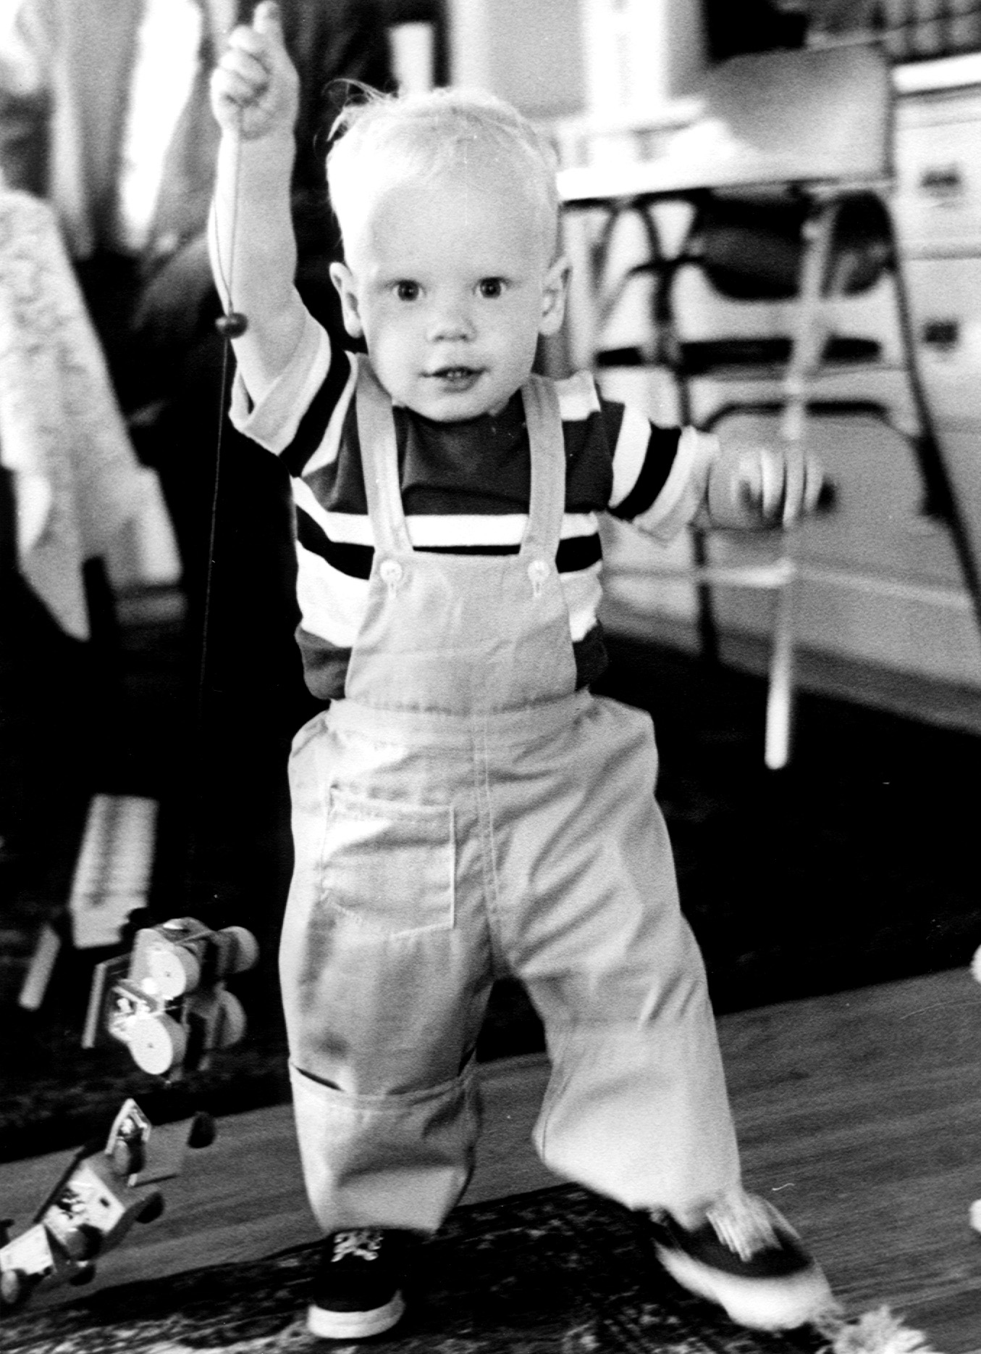
Our son Malcolm arrived on the scene near the end of our first year at Mayo’s. We were so excited when we realized I was pregnant. We decided to announce it at a dinner party we had for our friends. Of course they all knew it already. It was written all over our faces. I had been taking an accounting course at the Jr. College and of course the final exam came the week after Malcolm was born. The teacher said she would baby sit while I took the exam, and she did. When we knew we were pregnant we applied for housing provided for fellows with families. These were Quonset houses, and you had a Quonset for a house and a half one for a garage. We got one shortly after Mal was born, and it was so great. The fellows were so busy and we were all so broke and shared the same life style. It was so much fun being with other mothers and sharing baby-sitting. There were three of us who knew it would be good to get away for part of a day. Once a month we would get a baby sitter, and the three of us would dress up and go out for lunch. We were always hatching up ideas, when we got together. We thought it would be wonderful to see if we could have a tour of the Mayo farm and home. It was finally arranged. Afterward we met with Mrs. Mayo for a few minutes. We shared with her that she was a piece of history and wouldn't it be wonderful if others could share. We said it could be a good money raiser for a cause. She was just living in a part of the complex so it would not put her out. It was never done while we were still there, but it has developed since. I hope we had a part in planting the seed. Our neighbor Elaine Lundston was so good for me. She was older and knew what to expect with children. She helped me with Malcolm a lot. She called him Billy to keep the Malcolm’s straight. I just watched a document of the Quonset houses and Elaine was in the picture and I think our Malcolm was in the wading pool. It sure looked like him, and he lived at her house most of the time.
Son Malcolm
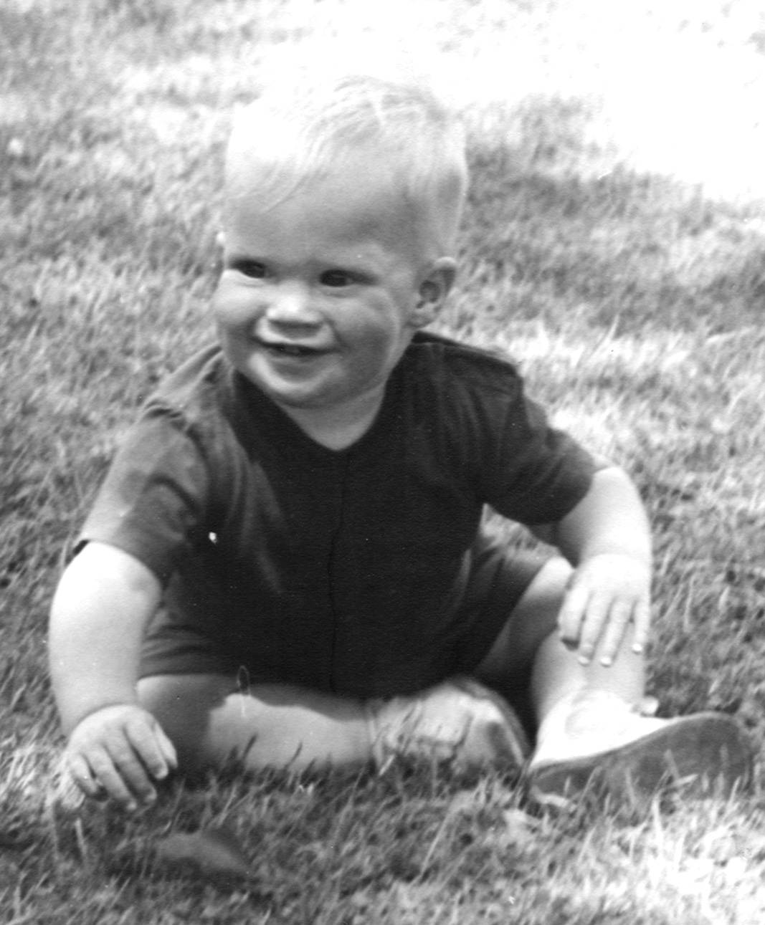
When I went for my six-week check up after Malcolm was born they informed me I was pregnant. We were in shock, because I was nursing Malcolm, and I didn’t think you could get pregnant. There are exceptions to the rule, and we were one. Nine months later we welcomed Scott into our family. We of course needed two cribs. It was like having twins, but one was mobile. Our church family was such help with the children. Mal was working hard on his research paper and spent a lot of time in the lab. Some experienced mom’s in our church would help me with my two boys and would often come over and take one or both to give me a break. Malcolm and Scott had a lot of fun together especially early in the morning. In their cribs there would be gales of laughter coming out of the bedroom, and we would find crib contents all over the room or in the other crib. Malcolm loved to push Scott in the stroller, but one of us was close by. One of my vivid memories was at a lake we would go swimming in. We had a couple of cars full of moms and babes and we went on a picnic to the lake. I was nine months pregnant. As we were unloading the car Malcolm took off and ran down the boat dock. He was too far ahead to catch. I was screaming and running into the lake trying to get to the end of the dock before he did. He jumped off but a man had heard my screams and was waiting at the end to catch him. As I came out of the water drenched and crying, my OB doctor happened to be there. He said with a twinkle in his eye “didn’t I tell you not to go swimming.” We had a wonderful time in Rochester and have long lasting friends that we shared our lives with.
Son Scott

Chaapter 6
Our next move was to the Air Force. Mal had been deferred from active duty while he was in medical school, so he felt he needed to pay back his duty. It so happened he was assigned to Ellsworth Air force base in Rapid City, South Dakota. They were so short of medical officers that they sent him directly without basic training. We arrived on base without uniform not knowing how to salute or who to salute. It was quite comical and interesting for a while. We lived in officers housing. It happened to be most of our neighbors where B52 plane crews. They would be gone for months at a time. Their wives would stop house keeping the minute they left and would clean up the day before they came home. The rest of the time they would be at my house drinking coffee, while I did my housework. They amazed me. When they would move in, they would be settled the day they unloaded. They said they learned that, because of the many moves they had to make. One of my neighbors was a pro golfer from England. She would take me out front on the lawn, when the kids were napping and teach me how to swing and use the clubs. One day the air force police were patrolling, and I had just hit a practice ball. It went into the cab of their truck. They were immediately out and writing me a ticket. They loved to catch officers or their wives. I explained it was a practice ball, and they said you couldn’t hit one that hard. They found it in the truck, but I still had to go before the judge. He was impressed and wanted to meet my teacher. From then on she earned quite a bit of money teaching. We used to spend weekends camping in the Black Hills, which was wonderful. We could rent all the equipment from the base including a boat a motor for one dollar.
Bruce came to join our family while we were at the base. We had a lot of single
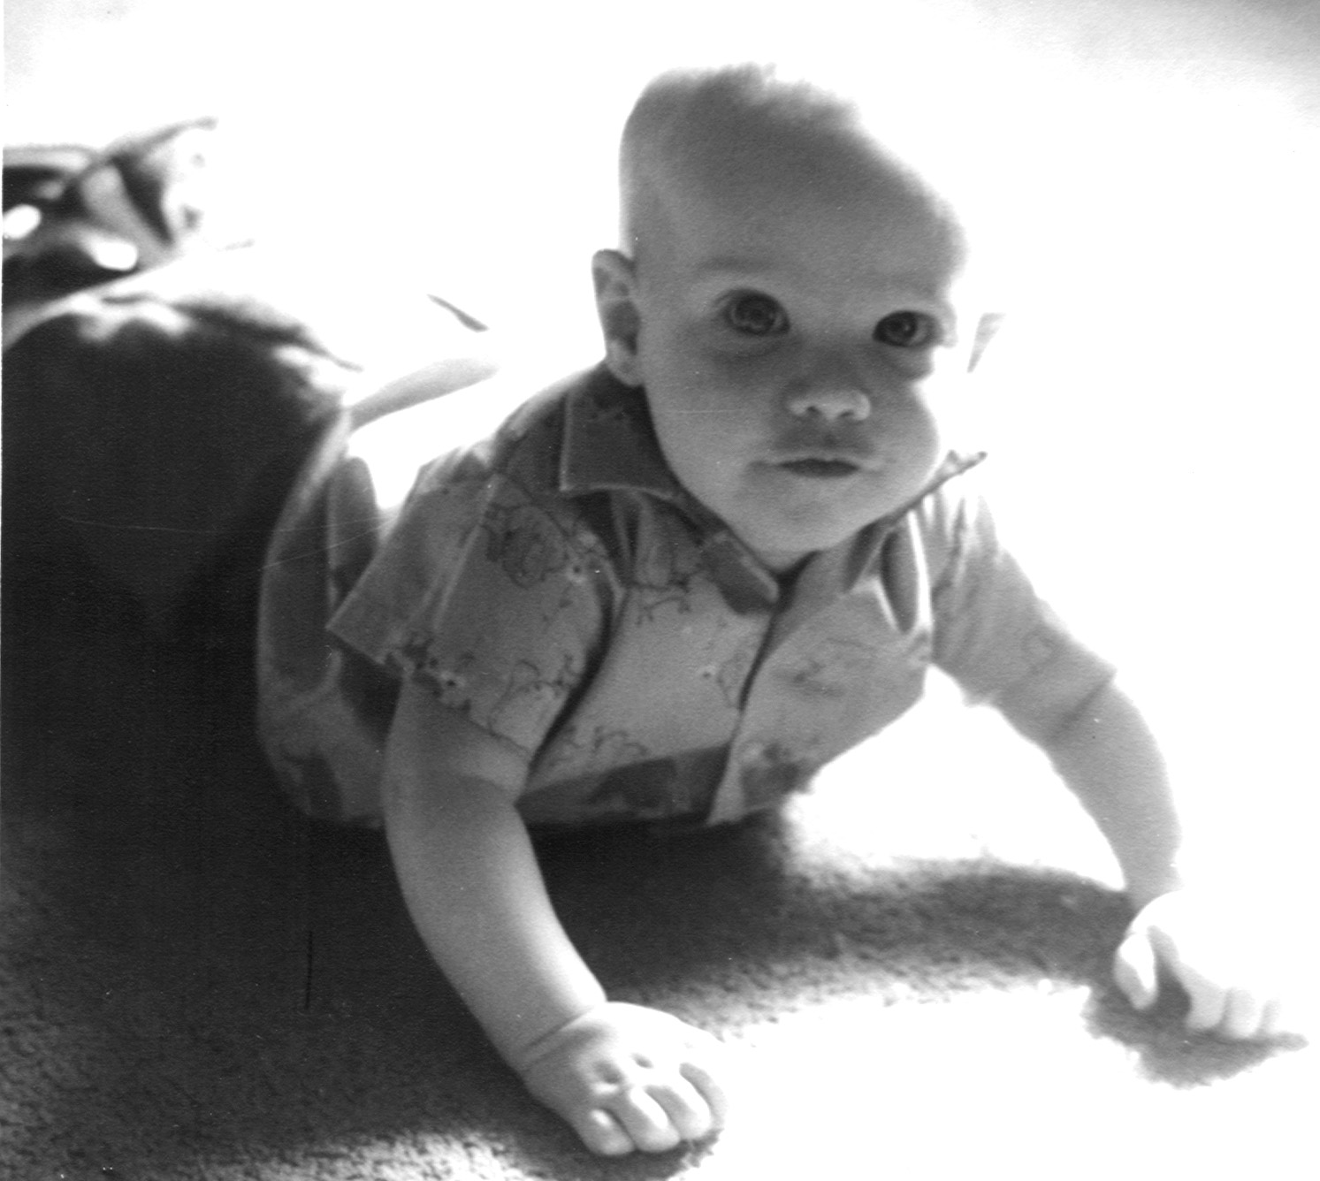
Service-men friends, and they were all excited about my pregnancy. One day when I was near my due date, Scott became sick with a high fever. I called the base looking for Mal and they said they would find him. Our friends thought I was in labor. They rushed over when they couldn’t find Mal and practically carried me out of the house. I finally got them to listen and they went back in and helped me with Scott. Bruce was born shortly after. Within a week we took the three boys and went camping. We would put life jackets on the boys, then life jackets around the buggy, and we would get in the boat and go fishing. We had lots of fun. All I had to do was take care of our new Bruce.
While we were in the Air force the Suez Canal crises happened. Being we were a nuclear base and had the B52 bombers and the atomic bomb, we were put on high alert. They kept Mal on base and put up barbed wire all around. We had made arrangements that if we ever had crises the boys and I would head for a cabin run by and elderly couple in the Black Hills. Mal would follow when he could. He called us from the base and said to go to the cabin. Fortunately my parents were visiting. They helped me with the children, and we went to the mountains. I had no idea if Mal was on his way in a bomber or where he was. I was nursing Bruce who was only a month old. Because I was so worried my milk dried up. The couple who ran the cabins were old homesteaders. She took Bruce and told me to get some rest. She was amazing! We never heard from Bruce for 24 hours. My folks and I could take care of Malcolm and Scott and keep each other company. Mal finally showed up. After lots of tears I got myself under control, and my milk came back. That lady had put together a formula she said she had used often when she would help deliveries when they homesteaded. We went home to Miles City the next weekend and mentioned the crises and everyone said “what crises?” It makes me shudder how often our world and country must get into these kinds of crises and we never know about it, scary!
Son Bruce

Chapter 7
Mal was offered a job at the Garberson Clinic in Miles City, when he got out of the service. We spent many weekends traveling between Rapid City and Miles City in our four door Dodge. We didn’t have any laws to buckle kids in. We would make a bed in the back, and put the three boys back there. They would play, fight and sleep. We had some scary weather, and the Air force would not take that as an excuse. If you didn’t report to duty you were AWOL. That caused us to take some chances during the winter but we made it. On our trips home we house hunted, but there was nothing to rent. We didn’t want to buy until we were sure this is what we wanted to do. A lot came up for sale, which was an excellent central location. We just wanted the back half. The front half was bought by two people who had businesses on Main Street and wanted the street parking. We went together and bought it. Then we looked for plans for a house. We were very ignorant and didn’t understand size. We just liked the floor plan. As they were pouring the foundation the cement man told me he had not ever poured one this big except for a church. We went to our contractor and he said the cost is not in the size as much as it is in doors and windows. We went with it, and we have truly been grateful for all of the space. Our home has been a haven for many, and because it is big we have not felt the impact. We have been blessed by many people from many walks of life who have lived under our roof or passed through during our lifetime. I could tell you many stories. They may come up as I ramble on. Anyway we built the house while we were in the Air force. Thank goodness for good honest contractor, because we were not around. I guess it was a gathering place with lots of verbal help from the curb. Our contractor knew what we wanted, and he did it. It was not quite ready for us when we moved, so we lived with Mal’s parents for a month. That gave me time to pick colors and carpet. We moved in before the carpet was laid. It felt so good, except for Bruce who kept loosing me. He was used to having me close in our air force housing, so he would get lost in the house. He would sit down and cry until he was rescued. He also had just learned to walk while we were on the base. They had a continuous wind, which he was used to leaning into. When he walked in Miles City he would fall over. He had to learn to walk all over again. As you all know Bruce, he persevered!
We settled into our new home taking care of three active boys. We had a neighborhood of kids, which was great for playmates. The mothers finally realized the kids were working each house for treats, so we set up a schedule that would provide the treats for the week. Mal and I became active members of the 1st Baptist church after we visited the churches of Miles City. We chose this church because of the program they had for the youth. We soon were sponsors of the high school youth group. We would have the meetings in our home, so we could let our own kids do what they wanted to do. The group grew quickly, and we had many wonderful encounters with youth. We found that we were getting kids from other church youth groups and this was causing trouble for families. We finally changed our program and started a Young Life group. We met in different homes. It wasn’t long before we were having around 50 kids attending. We had it in the evening during the week.
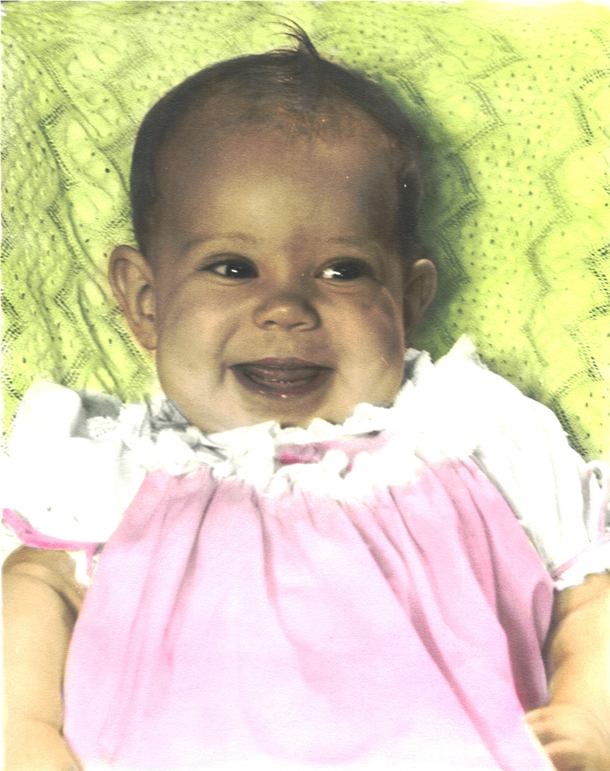
I was dealing with a stomach problem which we thought was an ulcer but soon we realized it was morning sickness and our family was going to be enlarged to four children. The youth were all excited about it and we had fun sharing the whole experience with them. Our wonderful daughter Susan arrived on the scene Sunday around noon. I decided I would skip church because my labor seemed to become active. Mal finally came home and got me to the hospital about 11:30. My physician just made it in time giving me a hard time saying he had to wash the manure off of his hands, which he had been putting on his garden. When they said we had a girl we could hardly believe it. Our youth were waiting at the hospital and when they heard they went up and down Main Street honking and yelling it was a girl. Everyone who heard knew whom they were talking about so there was a lot of excitement that day and it was fun for us to have them share. The boys thought Susan was the most wonderful thing to ever happen and wanted me to set her in her carrier, where they were playing. As she became more mobile we would hear them say “mom come get Susan she is messing up our toys”. They were real good about including her and she thought she was one of the gang. One evening when she was around three the boys had launched a hot air balloon and then they went chasing it. We went to look for Susan and she had obviously taken off with them. They did not realize it and before long they got ahead and she was alone down be the golf course. We were frantic but a man found her and asked her who she was and through tears she said “Susie” and he knew who she was. Thank goodness for small safe towns. We kept a closer watch on her after that and she realized she needed to be a little more careful.
We spent many Sunday afternoon going on adventures. We would either lunch first or take a picnic and then we would load up on our four wheel and go off into the country. Sometimes we would be exploring or shooting off rockets or gathering rocks or getting stuck. Getting stuck happened many times and I would be the one to try and put the brakes on but the boys would goad their dad to drive up that cliff or down that gully or ford that stream. We spent many an afternoon digging out, but fun was had by all.
daughter Susan
My dearest girlfriend started as one of our youth who had moved from Okalahoma with her mother, brother, and step dad. Susan Mattocks and I developed a close friendship over the years as we shared our lives. We have a lot of the same interests and we share everything in our lives and totally trust each other. She lost her brother in the Vietnam War and her father in Word War II. Daughter Susan has joined us in our close friendship, as she has grown older. It is so wonderful to have relationships that are long lasting. We play well together and I remember one trip up the coast of Oregon. Susan Mattocks and I would send Sue Winter in to get our motel reservations and after about three times daughter Sue wised up that she was our gopher and went on strike. We told her that it was her initiation and now she is our equal. It makes my heart glad that our daughter has a close friend who will be there after we are gone.
All of our children have become dear friends as time passes. I also have a wonderful friendship with my siblings. Rachel lives in Warner Springs CA. She and Charles are retired and spend most of their time traveling and seeing the world. They have two young adult children Tim and Elizabeth and another son Paul who died from cancer. Brother Ben and his wife Marilyn live in San Francisco. Ben works mostly in medical management business. He has two daughters Erika and Linda. Tim and Susan live in Bozeman MT. It is wonderful having them close. Tim is in private practice as a physiologist. They have a daughter Abbey who is the age of our grandkids spends lots of time with us. Their son Brian is married and a very successful engineer.
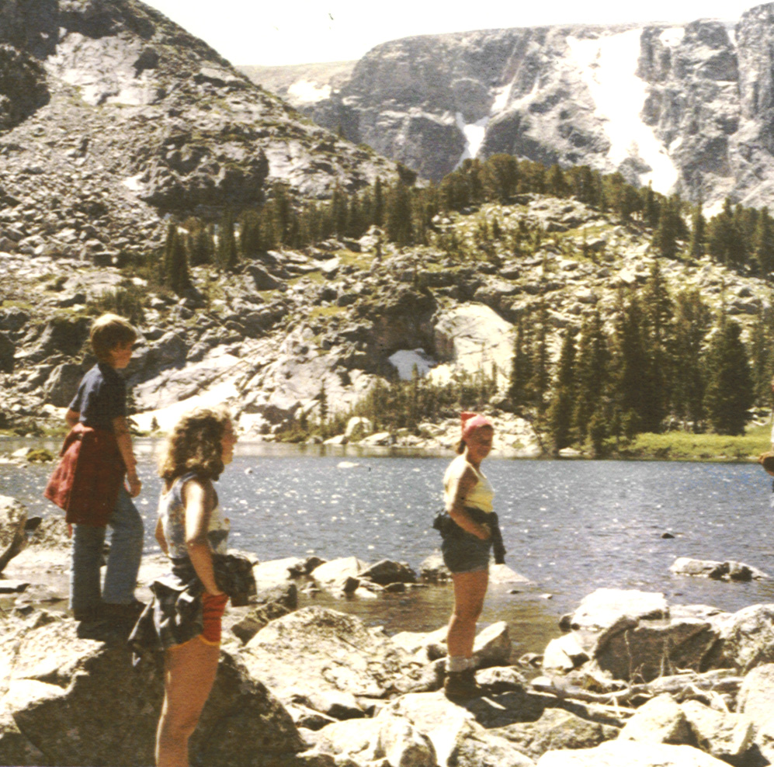
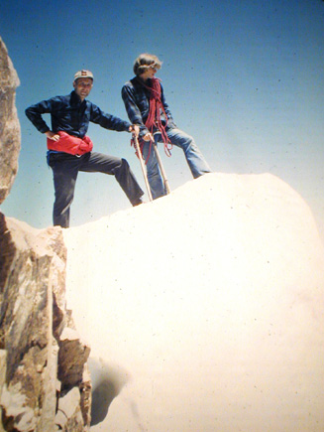
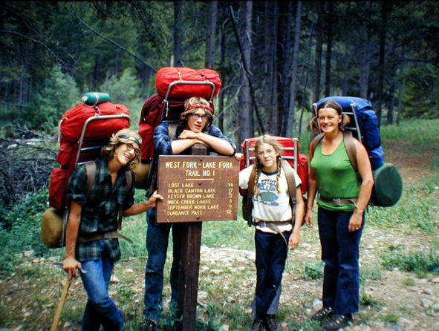
I have deviated from my story so I will return to Miles City. As our kids grew we continued to be busy with them. Most of our vacations were spent camping in the mountains. When they were small we had a trailer, which we would pull to a remote area usually in the Bear Tooth Mountains. We would camp and then take day hiking trips into the higher mountains. As the kids got older and stronger we put packs on their backs, and we would pack in for five to ten days into wonderful high mountain lakes. One of traditions that have come out of our back packing days is the creation of “gorp”. This is a mixture of nuts, raisons, M&M’s, and pine nuts. Everyone would have their own bag and this would be the energy supply as you backpacked. We continue to make it and give it as gifts at Christmas especially for the hospital and clinic staff. Each year we say it is the last but then we end up making it and giving it to some very happy people. When we first started to back pack there were no dehydrated foods available, so we did our own and also made jerki. Our camps were usually beside a beautiful lake in which we would fish for trout. When we were moving from one place to another we would camp by streams. We never had any trouble with wild life. They respected us and we them. We did not carry fresh food so they were not attracted to our camp. If we kept fish it was either in the cold water or in a snow bank and we never lost any to animals. We would always make snow cones with Kool-Aid and the snow from the mountains. Another favorite past time would be sliding down a snow bank, standing up, and using your booted feet as runners. Sometimes you really went fast and you had to be sure of the landing before you started or you could crash into rocks. Before I leave the back packing adventure I will have to tell you the famous Beth lecture. I first gave it to myself when we started to back pack, and then I have used it every time we have a new packer with us. It usually happens the first or second day, when the trail is rough, and you are tired, and it is hot, and you have blisters, and you are wondering why am I doing this. Enters Beth and I usually took the person off to the side with me but everyone else in the pack would go “Oh!oh!time for a Beth lecture.” All I would do is give them the facts that there is no one to rescue them, and if they want to do this they have to carry their load. I also told them I would take them back at that point, but I made it clear I did not want to do that. I would then tell them it would get better once they acclimated, and we got the blisters treated. But the decision had to be theirs and we would give them fifteen minutes to make a decision and let us know. I never had anyone turn back and that was the turning point from a grumpy person to a determined person. I won’t say happy person but they always came through, and on about the third day they were doing great. The only time this didn’t work was when we took Susan and Lisa, our other back packing friends daughter, with us when they were only four. They were smart and went to their Dad’s and asked if they would carry their packs, which they did. Gert, the other mom, and I rolled our eyes and said “soft touch”.
Brian, Susan,Beth Lightening Lake
Bruce,Malcolm,Susan,Beth Kaiser Brown trail
Mal, & Malcolm Granit peak MT
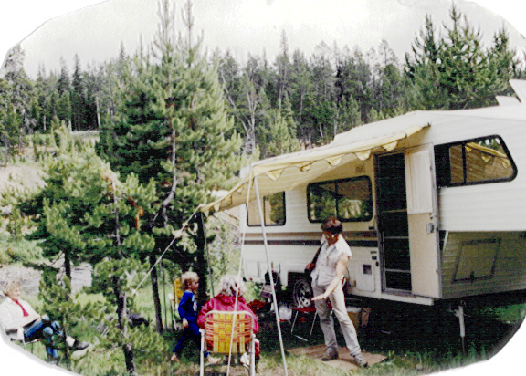
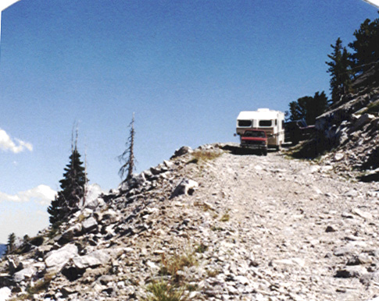
The natural process of life with the kids growing up and leaving home changed our process of vacation. Mal and I went back to trailer travel. We could pull the trailer to remote areas that people could hardly get to with their trucks let alone pull a trailer. Mal was a genius in parking and maneuvering the trailer. Our happiest times would be way back in the mountains with the trailer as base camp, and the kids would have their own tents. We would go on day excursions with the truck and our lawn chairs tied in the truck bed. Of course the adventurous hearts of the guys would get us into some tight squeezes. One such time we were following a trail, which was made by a caterpillar tractor. We came to the end, and we were overlooking a cliff with no way to turn around and a sheer drop of thousands of feet in front. Mal made us bail out. We tied the winch to a large tree and he gunned the truck in reverse and made it. Another time we were on the high plateau without any trees, and we got bogged down in melting snow. There was nothing to winch to except a piece of granite sticking out of the ground at the very end of the length of the winch cable. It held and we were able to pull out of the bog. Many wonderful memories make me glad I listened to my own lecture many years ago.
Beth,Nick,Rachel, Bruce Picket Pin Rd.
Our home was always busy with kid’s activities as they were growing up. They all had great friends and they would be building rockets or blowing up GI Joes in the garden. One year they built a submarine in the basement, and at one point we thought we would have to flood the basement to see if it worked. They got it out and on the 4th of July we tested it at Spotted Eagle Lake. Malcolm was in it and I wasn’t very happy about it, but the plus side was it wouldn’t sink so I didn’t have to worry. They built great hot air balloons, and the one they launched when Susan got lost caused quite a stir in town. The fire trucks followed it, and the airport sent up a plane to check out the UFO. We took a low profile. When the boys and their buddies heard the fire trucks, they scattered and came home. Friday night was free night at our house the kids could have friends sleep over and they usually made their own pizzas. I would have the dough ready but they created some good ones. The rules were they had to eat it. Mal and I would go to bed, but we didn’t have any time for the kids to go to bed. They just had to be in the house. Some mornings we would wake up to hot fresh doughnuts that they had made before they crashed. During the week when they were teenagers they had to have their homework done before they could do anything else and the rule was tricked that they had to be in the house by ten. We didn’t have many rules but the ones we had were to be obeyed and they did. We insisted that they had to have breakfast as a family and that included a short devotion. There were times we had stray teenagers staying with us due to home problems and we would drag them out of bed and made them follow the rules. It was fun to watch them really get into the routine and they would be first at the table after a few days. The other fast rule we had was if they had the car and were going to be late getting home on the weekend we wanted them to bring the car back by midnight unless they had special permission from us. Sometimes they went out after bringing the car back but it was never a real problem. We also told them and our extra teens that if they got into trouble and it wasn’t a matter of life and death that they should wait it out until morning before they called us because we were much happier with a nights sleep under the belt. One of our young girls that stayed with us for a year ended up at the police station and the police were going to call us. They said she was frantic and said don’t call them until morning so she sat on a bench at the police station all night! We got a lot of teasing about that from our friends and the police station.
Figure 1Picket Pin Rd.
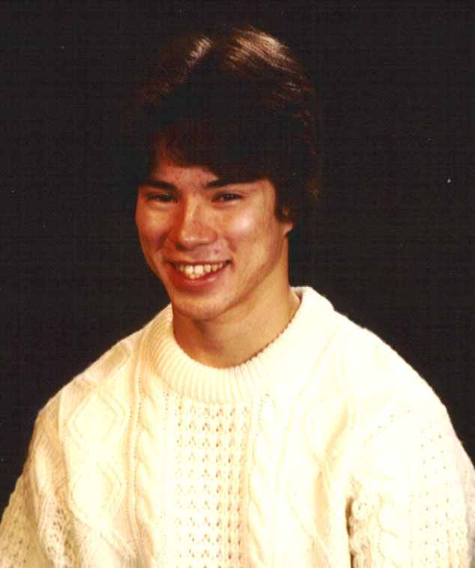
When we took our youth groups on retreats we had some fast rules one of them was if you kill an animal you eat it. We had some kids that were bound to go hunting out of season. We were at a ranch with our young life group and some of the boys killed a porcupine. Mal made them skin it like you do a catfish by nailing it to a board and taking the skin off. No way were they going to eat it and we said we would see. The end of that school year we had a progressive dinner and it ended up at our house for spaghetti and you guessed it, it was made with the porcupine meat. We told them after they ate it and there was lots of groans but they liked it. It tastes just like pork and is very good. There are many stories but I will leave that for another time.
Our nephew Paul Kitamura came to live with us when he was twelve years old. His parents lived in Tokyo Japan. His mom is Mal’s sister and Paul needed to have an education in an English speaking school. The original plan was to have him live with his grandfather Dr. Winter in a retirement facility but it was not set up for the energy of youth. Paul moved over to our home and lived with us until he graduated from High School. He and Susan were close to the same age so at times there was a bit of competition going on but all in all we enjoyed our time with Paul. He was state gymnastic champion which was fun to watch but at times scary.
Paul Kitamura

Chapter 8
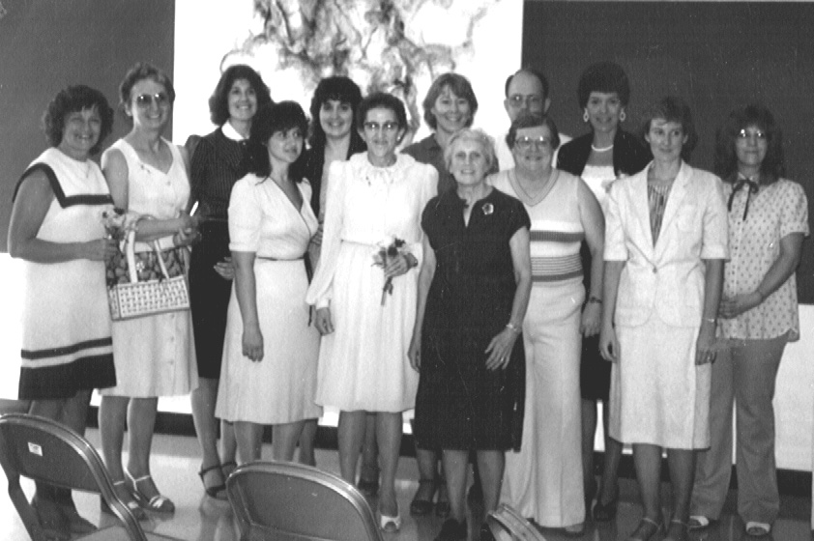
When Paul and Susan were sophomores in High School I decided to get my bachelors of science in nursing. Montana State was offering a satellite program in Miles City. There were ten of us taking the course. We had an instructor come from the university once a month and she would give us lectures and homework to last for a month of classes. The ten of us would get together and do our homework and basically pace ourselves so we didn’t leave it all until the last. It was hard work but real rewarding and Mal, Sue and Paul cheered me on and supported me in every way. We all passed and graduated in the top twelve percent of the university. I had to be in the top 12% because both Malcolm and Bruce graduated from MSU in with this honor. I decided to go back to work to make use of my degree. I worked med – surg on a swing shift for a few years and then was asked to start the Same Day Surgery department. There were three of us and we organized the whole department. This was a great learning experience and they still follow our protocol but have stream lined it according to needs. I then worked in OB and nursery and would go to ICU if they needed help. All in all I enjoyed my nursing and was able to set my own hours, which was nice. I worked for about 20 years and retired the end of 1998.
MSU nursing class with instructors
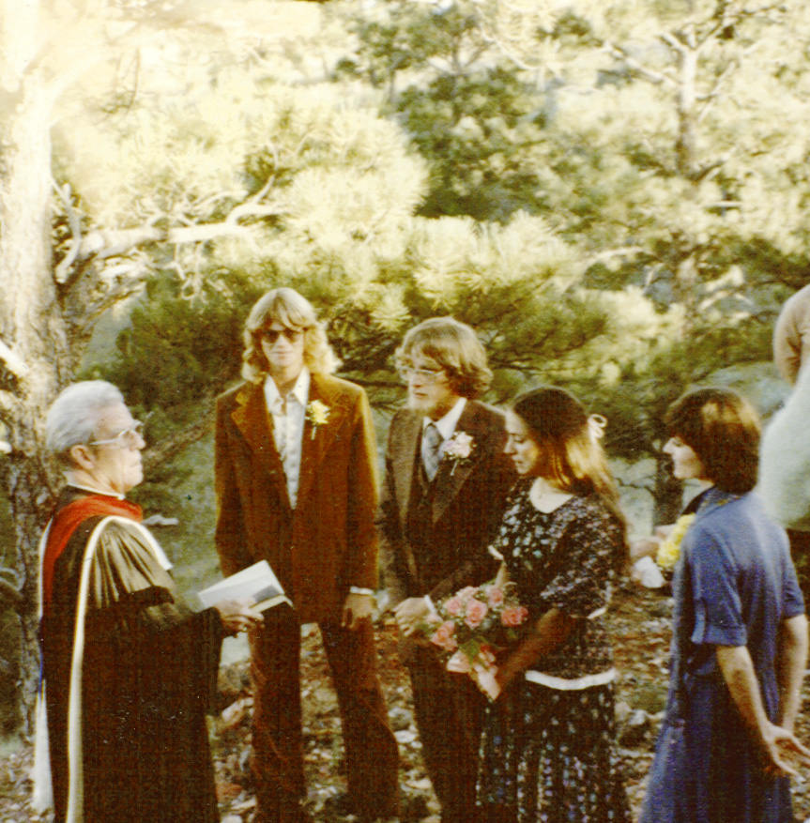
I also was involved with the state correctional system. My first job was an appointment to the Juvenal Justice board. I enjoyed working as an advocate for our youth. I saw a need for early intervention but some other members of the board did not see it the same and the next governor removed me from the board. The governor placed me on the board of oral examiners for the Law Enforcement Academy. This intelled oral interviews with new candidates for the academy. I really enjoyed this and was able to work with the university system setting up guidelines so the students could get college credit.
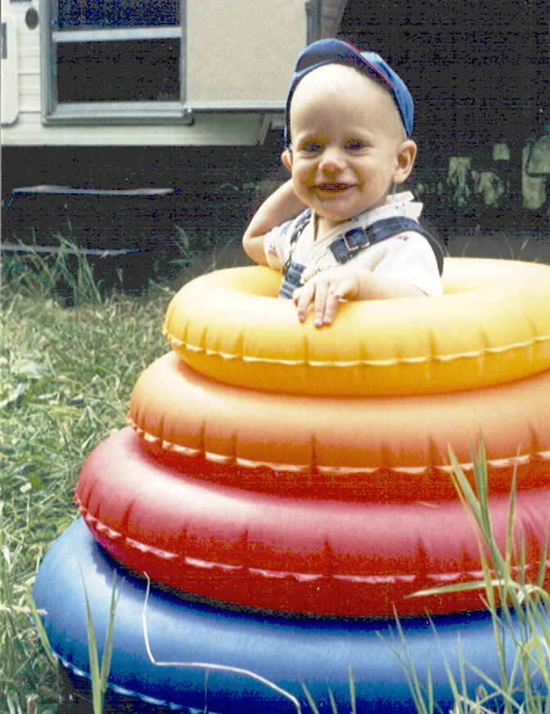
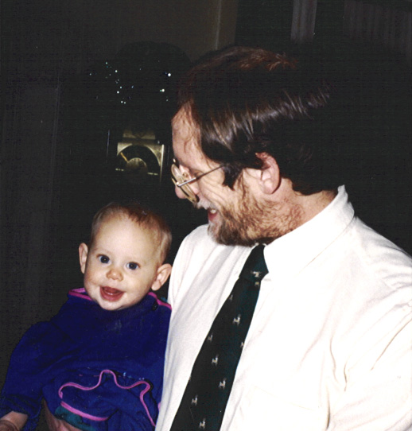
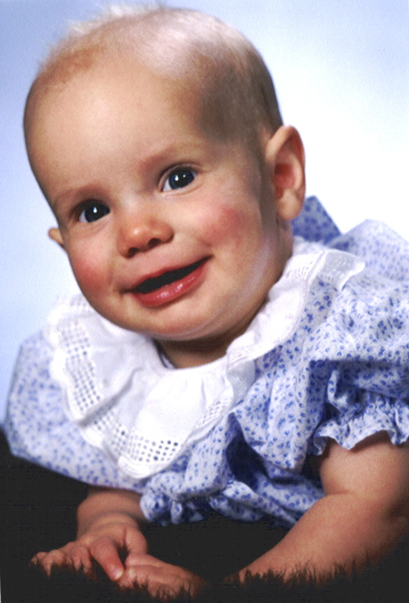
Life style changes as your family dynamics change. I would like to share our children’s lives. Malcolm attended Montana State University preparing for medicine. It was difficult to see your first child leave home. You are excited about their future but you also realize your home will never be the same. Malcolm entered the WAMI [Washington, Alaska, Montana, Idaho] medical school program. The states united so they could offer a medical school to their students. During his college days Malcolm met Kim Henninfent who was to be our daughter in law. Kim has been a wonderful support system for Malcolm and they were married the year he entered Medical School at the University of Washington. They moved to Rochester MN. to continue their residence in Internal Medicine. Malcolm was the first third generation to enter Internal Medicine. His father and his grandfather preceded him. Kim worked in research at University of Washington and also at Mayo’s. Our first grandchild arrived while they were at Mayo’s and Luke has been a real joy for us. He is a kind sensitive young man. Malcolm and Kim came and covered Mal’s practice while we went for an extended trip around the periphery of United States.
Grandpa Tate, Scott, Malcolm, Kim, Mary
Cassie & Malcolm
Figure 2Luke Winter
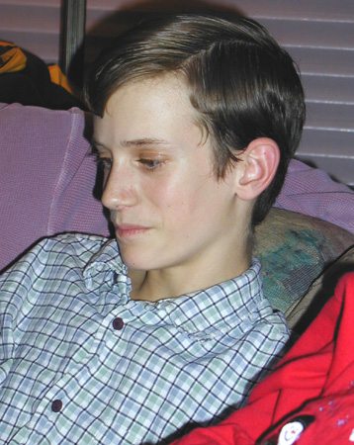
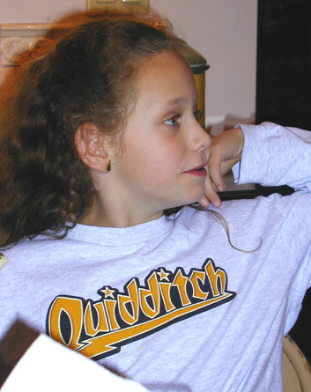
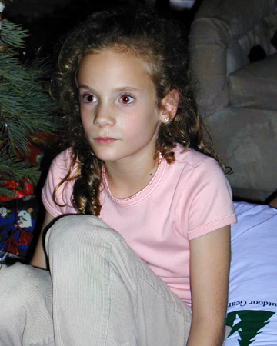
After coverings for us, Malcolm and Kim moved to Lewiston ID. and set up a very good practice with another physician. Malcolm’s specialty is Oncology and Hematology. Our first granddaughter arrived, a beautiful blond with blue eyes and curly hair. Cassie continues to charm her way through life. There is not a task Cassie won’t try and she will try to be the best or win. A few years later our McKenzie arrive with beautiful blue eyes and blond hair. She had a clubfoot, which meant the poor baby had to go through surgery shortly after birth and had to have it repeated as she grew but it has not stopped her from moving ahead. She will try anything and work hard to conquer the task. She is a delight and full of fun as well as a beautiful girl. I say she skips through life you would never know she has a problem and she sure doesn’t dwell on it. As you can see I am a very proud grandma and I love to be with our children and grandchildren.
McKenzie
McKenzie
Luke
Cassie
Luke
Our next son Scott was not the student his brothers were but he is very sociable and full of life. He is excellent mechanic and always has cars, trucks, snowmobiles and trailer. He is about the only
Cassie
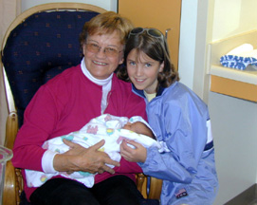
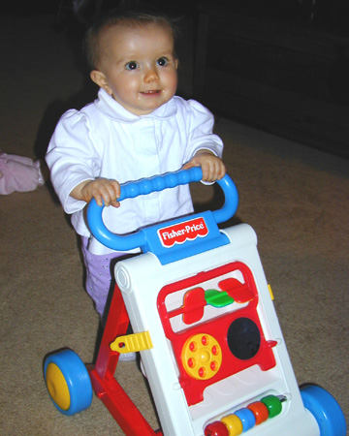
one I know who can pull and park a trailer as good as his dad. Scott worked at many jobs until he went to chef school at Missoula MT. at the University of Montana. He met Darcy Skates in Miles City and she soon followed him to Bozeman and the two of them were married and Darcy went to school in Missoula also and became a surgical tech. They have settled back in the Bozeman area and Darcy is a dental tech. And Scott was a chef at a restaurant but has since moved to a hardware business where he works in plumbing and electric. They are expecting their first baby in fact it is coming at any point today we are all waiting to get the news by phone. The date is April 6th 2000 and that is when she was born!
Maddisons' birth, Beth, Abbey
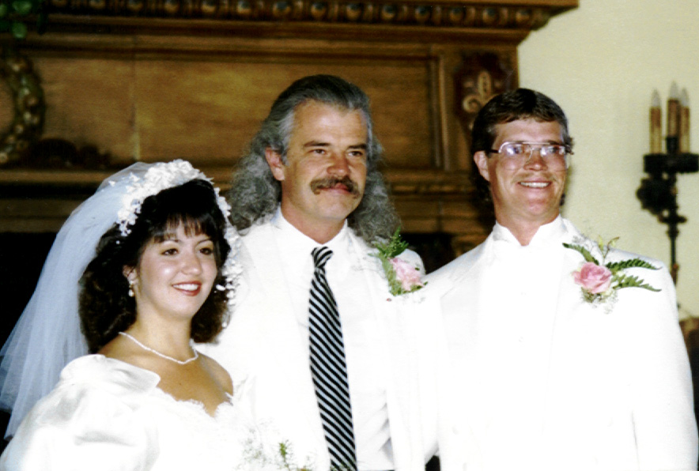
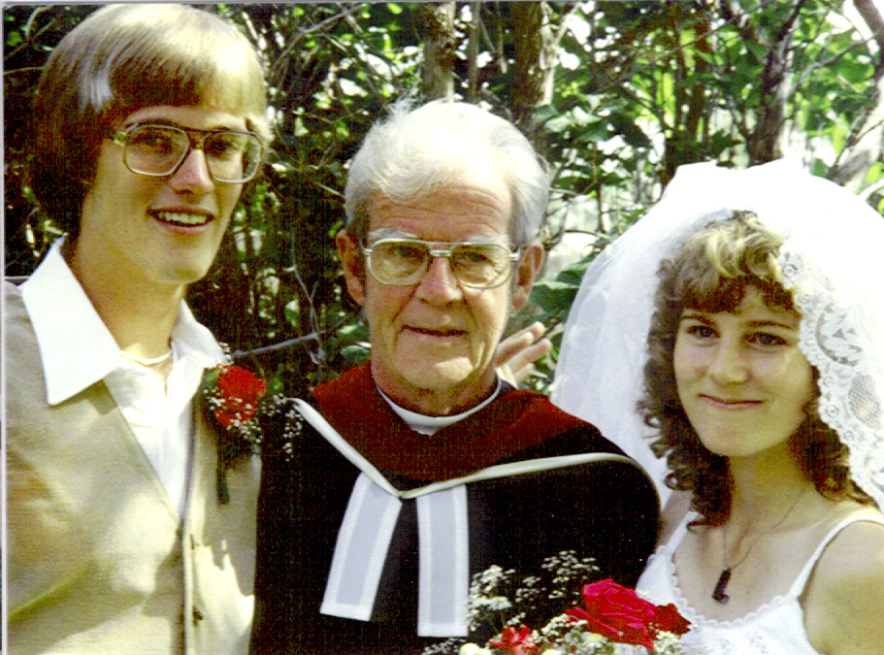
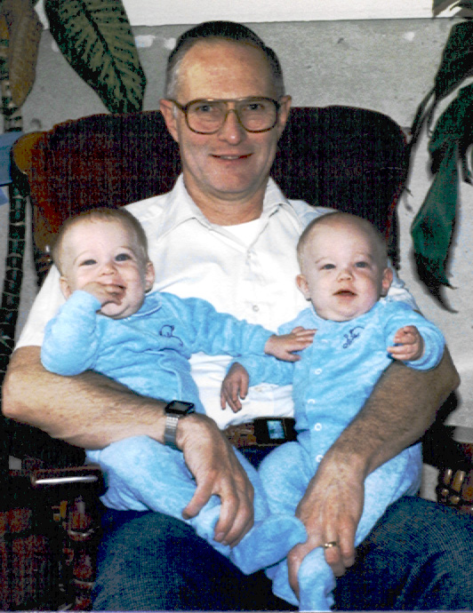
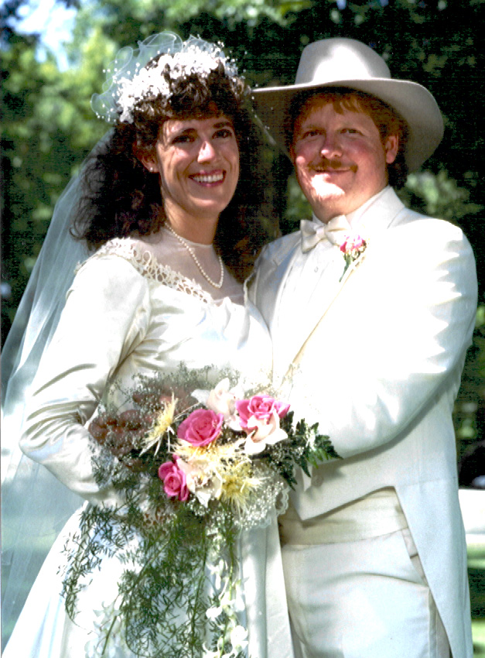
Son three is Bruce and he attended Montana State University in the school of engineering. When he was a teenager he built an automatic device for an aerial photo camera. His invention would allow the camera to continuously shoot pictures even if it was unmanned. This inventive mind followed him to college and he continues to discover ways to make computer chips work faster and smaller for IBM. He met his wife Laurie at college and she was an English major. They were married after graduation and Bruce went on to graduate school on a full scholarship at Madison WI. When he went job hunting he visited his brother in Rochester MN. And got the engineer job at IBM. He continues to do we helping other engineers solve their problems. They have twin boys who are very unlike each other. When they were toddlers they were always rolling around together you never knew who was who. They have very different personalities. Nick is a computer expert and very intelligent. I make the mistake of playing games with him such as chess and loose all the time. He enjoys sports once you get him away from the computer. Zack is more the social person and has many friends as you can tell by the phone ringing when he gets home. He has to work harder for his grades but enjoys school. He is a very good snow boarder, which he practices at in their back yard where they have built a ramp for him to use for jumps. Bruce brings the boys to Montana to go backpacking in the summer, which they enjoy once they get on the trail. When they were small and we were in the mountains hiking Bruce would take one boy and carry him up the trail and then he would run back and and get the other boy and run him up the trail. It was amazing to the rest of us who were struggling up the mountain. Laurie is a very successful writer she has had many works published and she has received many awards and honors. She has started to paint with oil and is developing a beautiful flowing art form. Needless to say when you are in their home there is always something happening.
Darcy & Scott wedding ,Tim Tate officiating
Madison at 9 months
Zack, Grandpa Mal, Nick
Bruce & Laurie's wedding, Grandpa Tate officiating
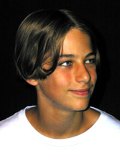
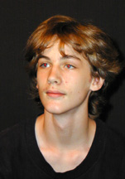
Our last child is our daughter Susan and what a joy she has been to us. After raising three boys she was a whole learning experience. When the boys had fight they physically fought and then they would be friends again. Once I intervened when Malcolm and Bruce were going at it on the floor. Malcolm stood up and said “mother how are we going to become friends if you always get in the middle!!” Wow I stepped back and said OK if no blood is drawn. Now Susan was a different story she would come slamming in the house and scream “I will never talk to ----again in all of my life” and with that announcement she would go in her room and slam the door. We all know that didn’t last but boys and girls handle problems differently. Susan hung out around home with her brothers friends and they all enjoyed her and included her which I am sure was the envy of her friends. When she finished High School she went to college in Sioux Falls South Dakota. She also attended Augistana and got training as an "educator", a teacher who treats the whole child not just academia. She took her psychology training at Sioux Falls College. During her second year at college, she didn’t come home for the summer because she had a job there. In the middle of the summer I got a call where she asked me if I could come she was having a tough time. It had to do with her roommates acting like high school snobs and it was getting to her. My girlfriend Susan was home for the summer and was just getting back the night before I left. I left a note on her parent’s door saying I was leaving and six the next morning and could she come with me. I drove by her home and there she was packed and waiting, true friend, especially when she got in the car and said, “Where are we going.” When we got there Sue’s roomies didn’t know what hit them. We came in and took over having all sorts of fun. We took them out to eat and made fools of ourselves to their embarrassment. We took them dancing after a nice meal where we almost got kicked out of because we were laughing so hard. Anyway we went to this popular dance place and it was packed so Susan and I wandered through until we found a table. We didn’t know the place was self imposed segregated and we had landed in the black section. Here we are with four very attractive young blond girls and loads of black men. They danced all night and had a ball of course Sue and I staid and chaperoned. By the time we left Sioux Falls her roommates thought we were a blast and Susan was accepted.
Susan and Brad's Wedding
Nick
Nick
Zack
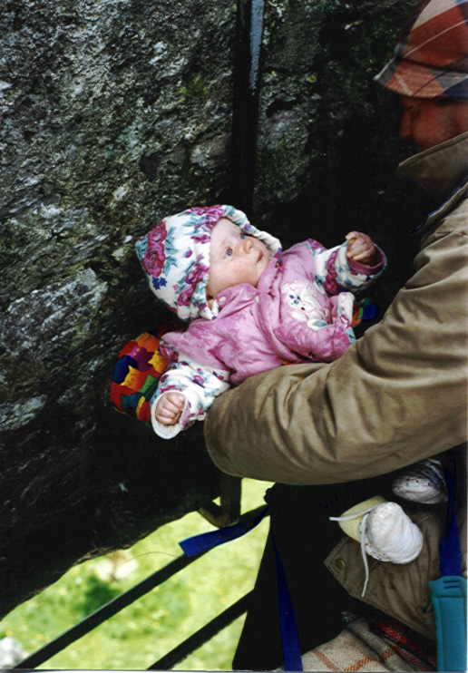
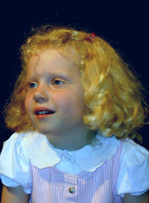
Susan worked in a home for disturbed kids in Helena after she graduated. This became stressful related to the schedule for work. They expected their staff to work all three shifts every week. She accepted a job as park ranger at Estes Park in CO. She and another ranger friend decided to hitch hike around Hawaii, New Zealand and Australia. While they were on Maui they met two men from Australia and they were given the invitation to stay at one of their parents home when they
Mikaylie kissing the blarney stone in Ireland
Mikaylie 4years
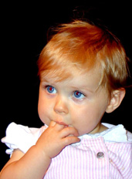
got to Sydney Australia. They did that and Susan and Brad, whose home they were staying at, fell in love and now our
Susan lives in a little town forty miles north of Sydney. They have two darling girls Mikaylie was the first to be born followed by Shianna three years later. We see each other every year either we go their or they come here. Susan works with street kids along the coast offering them alternatives in life outside of the school system. Brad is a fireman in Sydney.

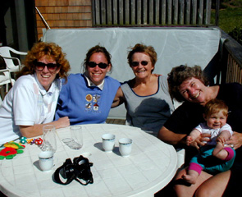
Shianna 20months
Susan, Katrina, Beth, Annie, Shianna 9months

Chapter 9

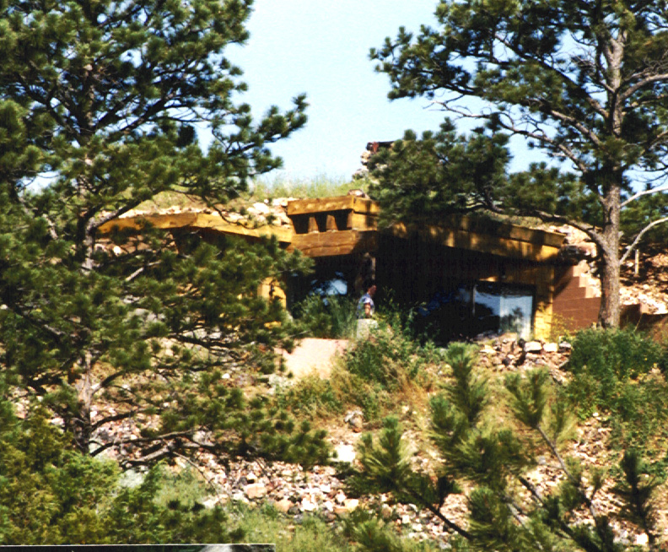
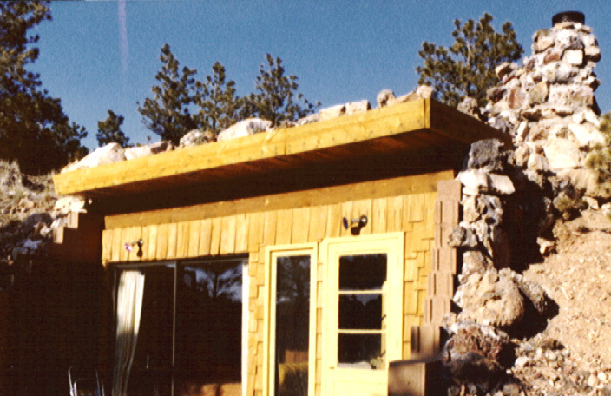
The “Cave” deserves a tale all of it’s own. Twelve miles out of town we have a ridge of hills, called the Pine Hills. Their elevation is about 800 feet higher than Miles City. They are covered with ponderosa pine trees. When we first moved to Miles City we liked to go out there for picnics and sledding. There was a particular area that I liked which overlooked reservoir. There is a great rock formation up on a cliff with the pond below. I would go out there just to sit and rest. About thirty years ago that ranch was sold and the new owners subdivided and made 40 acre plots to be sold. The plots allowed you to build on ten acres and the rest is common. We were at a barbeque at a friends place in the Ranchettes, which is the name for the area, and one of their boys asked me to go for a dirt bike ride with him. He drove over to my favorite spot but he had no idea it was my favorite spot. He was in his early teens and he asked me if I liked this area and of course I told him it was my favorite. He then told me his dad had bought it for him and would I like to buy it. I had just been given some money from the estate of Duncan McKenzie and I said I would love to. It turned out the kids wanted to buy a horse and the only way they could do it was to sell the land. This was on a Sunday so I said I would meet them at the courthouse on Monday for the transfer. The dad was a very unhappy camper because he had it in their name as a tax dodge not as a gift for them. The sale was perfectly legal and the dad’s statement to me was to ask me if I would pay for half of the road into it and I agreed. I had not planned to do anything with it except to sit on my hill and have picnics. That summer our oldest son told me he would help build a cabin if he didn’t stay in Minneapolis. He was home so we started to make plans. It was the time when birm homes were beginning to be thought about. There were no plans and know one to help us but we wanted to put it into the cliff and make it like a cave to use the ground as insulations. Our idea was to dig out a trough in the cliff and then pour a cement foundation and build the walls with cement blocks.
Cave east view
West view Cave
The fourth of July 1977 we went out with shovels to start to dig and with the first attempt we realized we were in trouble. The whole area is made up of cinder rock from old coal burns. It is like volcanic rock only the heat was caused by coal. We sat on the rocks trying to think what to do when up over the hill comes a great big yellow caterpillar dirt moving machine. We could hardly believe our eyes and as he came up to us he bladed a road. It was our neighbor in the Ranchettes and he said he would dig us a trench but we would have to promise him we would pour the walls cement because he would be dislodging the dirt and it would not be safe to use block. As he pushed the dirt out he made a wider base at both ends so we could have large patio area both front and
back. The whole construction was a miracle and all of Miles City was involved in fact you could hear cement trucks and loaders all stating on their CB radios that they were on their way to the cave and everyone in town knew what they were talking about. Our cement people got the forms up but the problem was the trucks were set up to pour down into the forms and these forms were above ground walls. We then had to bring out a big piece of equipment that had a bucket and they would put the cement into the bucket and the man operating it would remotely move the bucket to the wall and the cement people told him when to stop and dump. We had a friend visiting us from Germany and she was a beautiful blond and was wearing very short shorts. About the time she showed up the bucket was on its way to the wall but the operator was looking at the blond and the bucket went past and dumped on the hill. The poor guy was kidded and he was red faced. There is a lot of detail but I won’t go into it except for some of the most wonderful things and as I call it miracles.
The cave has a wonderful calming influence on any one who goes there. It seems like it is a sacred spot, which is what I believe. The way I obtained the land and the way everything was provided. One example is the ceiling beams. We had know idea how to build a under ground home and there were no examples at the time we built. We had a civil engineer friend and he came out and did some math to see what kind of support we needed to hold rock and dirt on the roof. Our lumberyard friends had a mill in South Dakota that they get their rough lumber from and they asked the man if he had any beams. When they told him what we were trying to do he was excited because that was his dream. He had been aging around twenty solid pine rough hewed beams straight and perfect. He had grown to old to build so he gave us the lumber! Our lumber company brought them back to Miles City on top of their cement blocks and the only cost to us was transport from the mill to the cement block place in Rapid City SD. Our lumber Co. owner put them on one of his trucks and left the keys in the ignition and called me and said I won’t mind if you steal the truck for a day. The company was not supposed to deliver out of the city limits. Son Malcolm and I picked it up and Malcolm drove it out. He backed it up our narrow road with a cliff on one side and a drop off on the other. I don’t know how he did it. We had some strong men to help us unload which was important because each beam was equivalent to a tree. Once they got the first one across the roof then they could place the rest of them across the one and then roll them down the roofline until it was in place. When it was done there were four very very tiered men. I fed them lunch and we were drinking pop from a can and I did not notice some wasps had gone inside my can. When I drank I was stung twice in the mouth and once in the esophagus. I instructed Malcolm how to do a traciotomy if my windpipe was closed off and then we waited. Out side of being very sore and swelling I was fine. I then got behind the wheel and drove the truck back to town. It was two trailer long and going down one gully and up another I stalled it with half the truck going up and the other half going down. The truck had eighteen gears so I had to double clutch and shift at the same time plus give it gas. I don’t know how I did it but it made it. By the time I was to the highway I was pulling the chain for the horn and having a ball. When I called Mal to give me a lift from the lumberyard I started to cry when I heard his voice. So much for being big and brave. I was sore for about five days but know other problems and you can believe I will not let anyone drink from open cans.
Grandpa Tate was very involved with the building of the cave and it was fun to have his enthusiasm. He would check out what we were doing and then he would go for long walks. He performed the weddings of both son Malcolm and Kim and brother Tim and wife Susan. They were very special times and I have a glider swing in the area of the weddings which allows a beautiful view as you sit a swing. Through the years the trees have grown to block the view but we are cutting them for our Christmas trees. We thought we had just one but there were three hiding behind it.
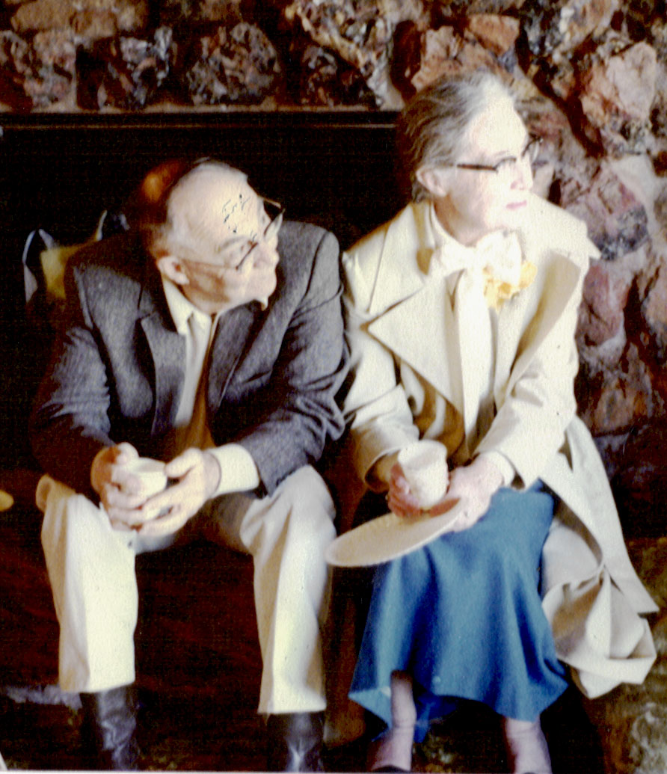
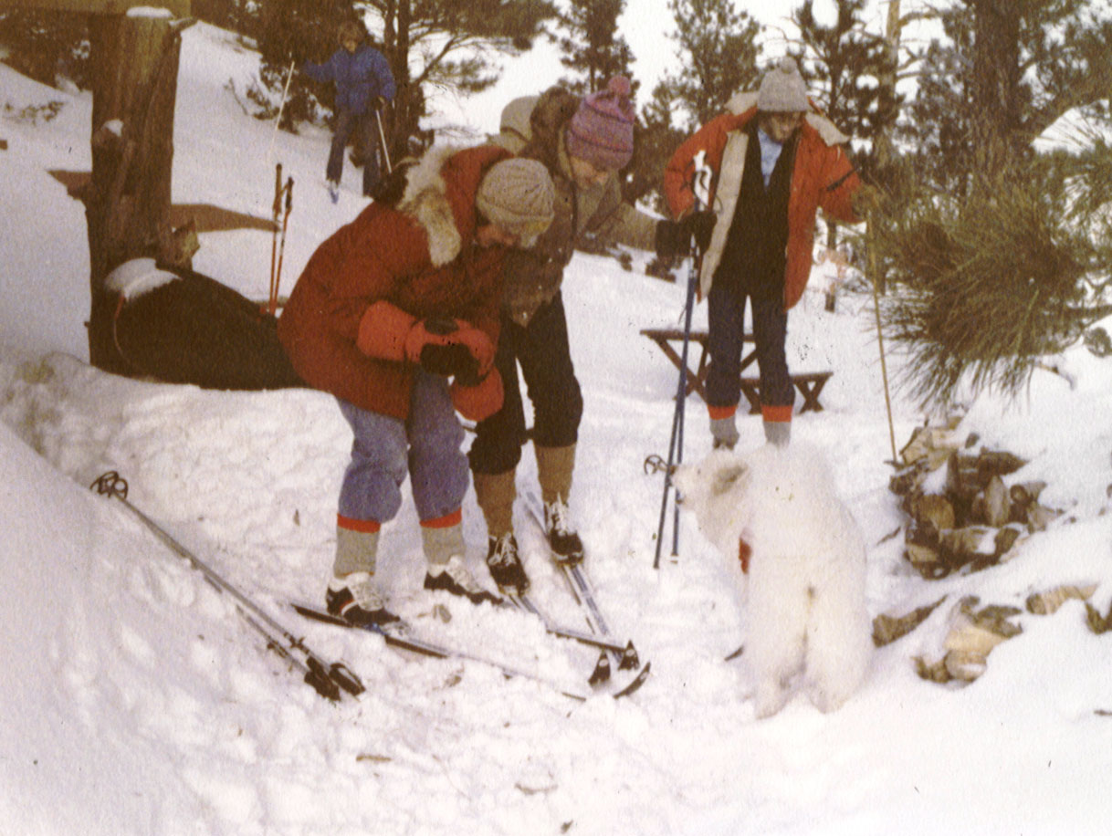
The cave has also been an emotional healing spot for us and also for some dear friends. It is hard to explain but if you are there to heal or get away from the rush of life it will do it for you. We also have had honeymoons there for three of our children. Malcolm and Kim stayed out after the wedding and woke up to snow the next morning. Tim and Susan had their pet cat climb a tree and it had to be rescued. Son Bruce and Laurie were married in Absorkee but came to the cave after and had a second reception in Miles City the next day. Daughter Susan and Brad were married in Miles City and stayed at the cave that night and then the next day joined the family for opening presents. Our Chillian adopted daughter and her husband Tab Fleming also spent their wedding night at the cave. Very special people have shared our cave and one couple in particular. They are gone now but Bill and Helen Wookcock took us under their arm when we moved to Miles City and taught us the beauty of the area. They taught us about Indian artifacts, floating the Yellowstone River. Looking for agates, wiled flowers, animals and birds. Our whole family has felt their influence.
Bill & Helen Woodcock
Beth, Kim, Malcolm & dog Tasha at Cave
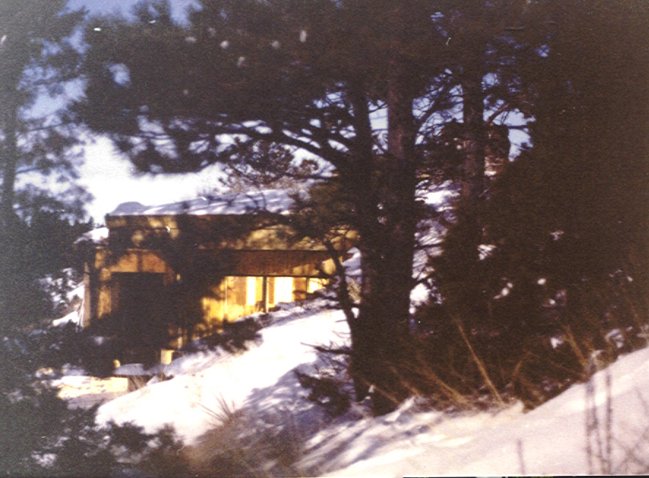
We have had winters at the cave where the snow has been so deep you had to ski in and dig down to get in. The kids had a wonderful toboggan run but at the bottom you had to abandon the ride but hold onto the sled otherwise you would go over a cliff. I could stand up on the hill and watch as I drank hot chocolate. We have had many youth retreats there and church picnics. Most of all it has been a wonderful place for family gatherings and a quiet place for friends. What has been interesting is that we have not had anyone just drop in when we are there. It is as if there is a protective cloack around it.
One night I awoke to a crash into the sliding glass door by our bed. It glass did not break but there was a very stunned coyote on the other side of the glass. He looked at me very disgusted, as much as to say where did you come from you were not there the last time I came by. Another night we were sound asleep and then we woke up to loud rumbling on the roof. At first I thought it was an earthquake and then we heard chomping and it turned out to be six horses eating the grass on our roof.
Cave in Moonlight
One day I was studying for my final exam in anatomy for my bachelor degree in nursing. I was sitting out on the picnic table looking west over a gully. Two bald eagles were flying up the gully. One was higher and ahead and the other followed lower and behind. As they came closer the first one pulled in its wings and for fuss balls started to fall. Three started to flap their wings and began to fly but the fourth one kept falling. The eagle in the back swooped under and caught it and headed back west to their nest on the Yellowstone River. I was in awe and could hardly wait to get home to talk to my neighbor who works for fish and game. When I told him he said very few ever see that and the eagle that was returned is the one most people get pictures of as the fly off the edge of the nest. Just another cave miracle.
I mentioned Duncan McKenzie earlier, the person who left me some money. He and his wife Bella lived on a ranch north of Miles City in an area called Cohagen near Jordan MT., Bella used to live with the Winter family when Mal was young and took care of the house and helped with Mal and sister Peggy. She met a married Duncan and they bought the ranch. Duncan obtained most of his land during the depression when he would buy piece by piece from people unable to hold on. He had a very large ranch and Mal spent most of his summers on the ranch. He became a very good horse rider, which is more that I can say for me. Once Mal took me riding on the ranch and we did not know there was a rivalry between the two horses. Mal started to gallop and of course my horse followed I had absolutely know control except to hang on to the horn. Mal looked back and thought Beth is riding great she is keeping up with me, Yeh Right!! We finally got to the ranch and that was the end of my riding. I am sure I had a few choice words but I don’t seem to remember them. Another time when we were at the ranch when we first moved to Miles City we got stuck in gumbo. When it rains the dirt becomes like slick clay it is almost impossible to to stand up on it and it collects and sticks like glue to your shoes and tires. I am eight months pregnant and Mal is trying to put chains on and then rock the car and I am trying to push. We finally get out and stop in Cohagen at the grocery store to see if we can clean up. The owner takes us out back and gets a pitcher of water and pours while we try to rub the gumbo off. There was no running water and it was cold and rainy but we managed to clean up enough to drive home. What we didn’t know was most of the people in that area didn’t like me. Mal was their boy and he should have picked a nice girl from around there not a city slicker from Chicago. After the grocery store owner helped us clean up he passed the word along that Beth was OK she could laugh at gumbo so I was accepted.
Bella became very ill with a stroke and we brought Duncan and she to Miles City. Bella died and Duncan never left our home. We finally had to take him out to the ranch and close it down and get some furniture for him. We also brought in their freezer, which was the first Montgomery Ward big freezer. We still are using it and the only repair we had to do was replace the gasket in the lid. We have to think about a fast transfer of food if it should go out but so far so good. When our family started to get bigger and want rooms of their own we had to move Duncan to a retirement home. He was beginning to need more care, which was hard for me with four children. He did very well we told him he could come back in six weeks if he didn’t like it but he fit in very well.

Chapter 10

Another fascinating nature story I have to tell is about rattlesnakes. One day in the spring I had a schoolteacher friend who wanted to skip school and go on a picnic. She was from California and was Salvadorian. I wanted to show her where I had gotten our large pieces of petrified rock. It is only ten miles north of Miles City. We parked the Jimmy on the cliff and then we scrambled down to the valley. On the floor of the valley there are big sage plants, which have not been knocked down by cattle because they are covering petrified tree stumps. We were beginning to walk to some of them when I noticed the ground moving. Once more I thought earthquake but I looked down on my hiking boots and rattlesnakes covered them. The next thing I knew my friend was piggyback which of course had to stop. She stood right behind me and I remember Mal telling me rattlesnakes are very shy and timid. I slowly raised my foot and the snakes scattered and then I raised the next foot and slowly we progressed to the cliff where the Jimmy was. The ground as far as we could see was covered with snakes. As we approached the cliff I thought all those snakes are going to the cliff also.
There was know other way out but to climb the cliff. I took loose rocks and put them in my pocket and through ahead of me up the cliff. Slowly we progressed up and finally got to the top. There were snakes there also but we got to the car and got in shaking like a leaf. When we finally calmed down I said there was a hot springs ten miles down the road lets have our picnic there. It was a cool overcast day so we moved on. When we got there I looked on the ground before we got out and sure enough there were snakes there also. We gave up and ate in the car and I said I better go talk to my neighbor, which I did. He said they have camped trying to catch that phenomena and have not been able to document it. They know that is what they do when they unravel themselves from the ball and it always happens on a cool overcast spring day. He also told me the next time I go out on an excursion he was coming along.
Another interesting experience we had in our home happened one Sunday morning on our way home from church. Susan, Mal and I were in the car coming up our drive. Susan’s friend Joslyn was waiting for Susan in her car in our drive they had planned to go out for lunch. As we drove up our drive we saw this lady in our front door. She had long straw colored hair and was wearing a long white dress, which Mal called dirty clean. It was during the time of the hippies so it looked natural. None of us recognized her so we drove into the garage and came into the house through the kitchen. When we got into the area there was no one there. By this time Joslyn had followed us and she said she had walked up the sidewalk to the door before we came home but she could only go part way and then she couldn’t go any further. There was nothing blocking her except she was looking at the lady. Joslyn turned around and went back to her car and then we came. We looked all over the house and I went downstairs to Scott’s room where he was sleeping after his night job. I woke the poor kid up and asked where she was and he asked me what I was talking about. Joslyn said she watched her except for one second when we got out of the car and when she looked back she was gone. Our only explanation was a guardian angle and for some reason we needed one at that time very comforting. At this point I will bring my story to a close but I am sure there will be some more to follow either from a memory or a new experience.

Chapter 11

There are many more stories to tell and wonderful people to talk about but I will close for now with some added pictures of my family and fun activities. May you enjoy this time of sharing my life with me.
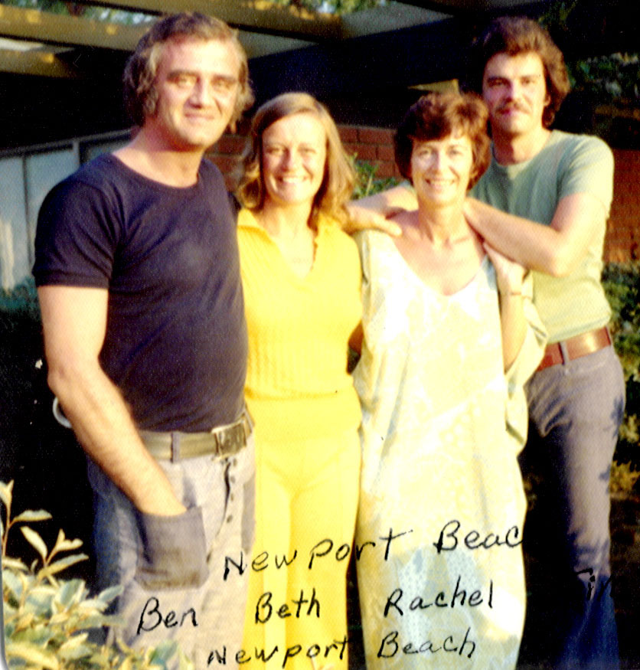
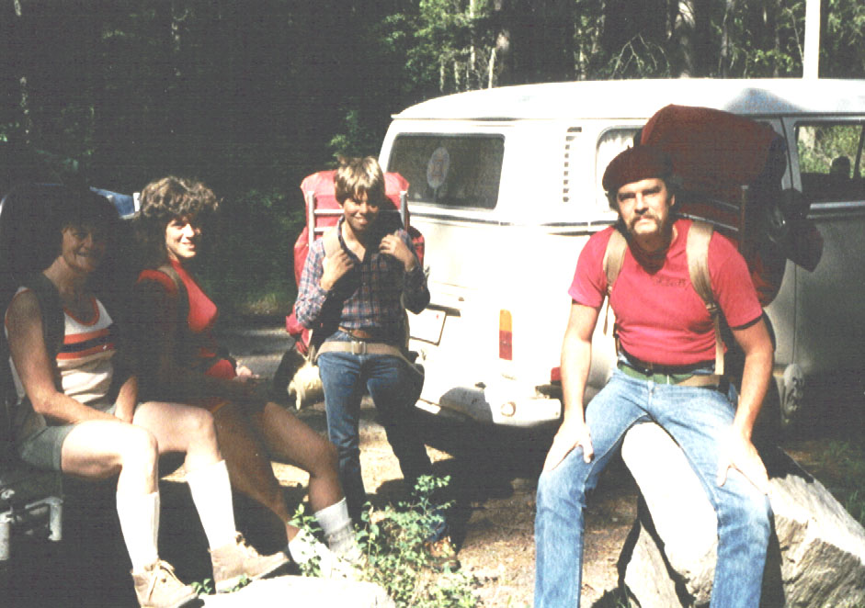
Beth,Susan,Brian,Tim at Pine Creek Lake

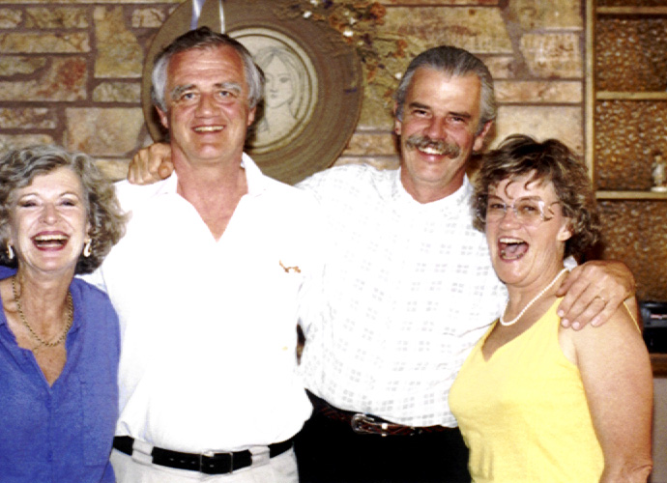

Ben,Beth,Tim,Rachel at Ceilo1986
Ben,Beth,Rachel,Tim at Newport Beach

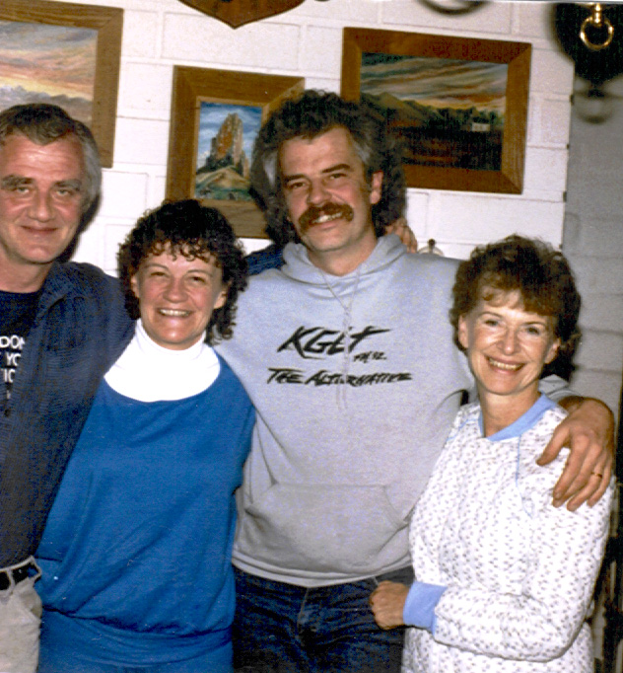
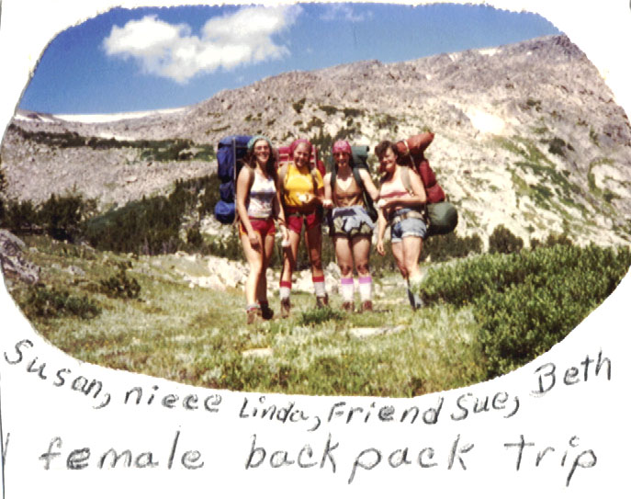

Rachel,Ben,Tim,Beth at Miles City 1990

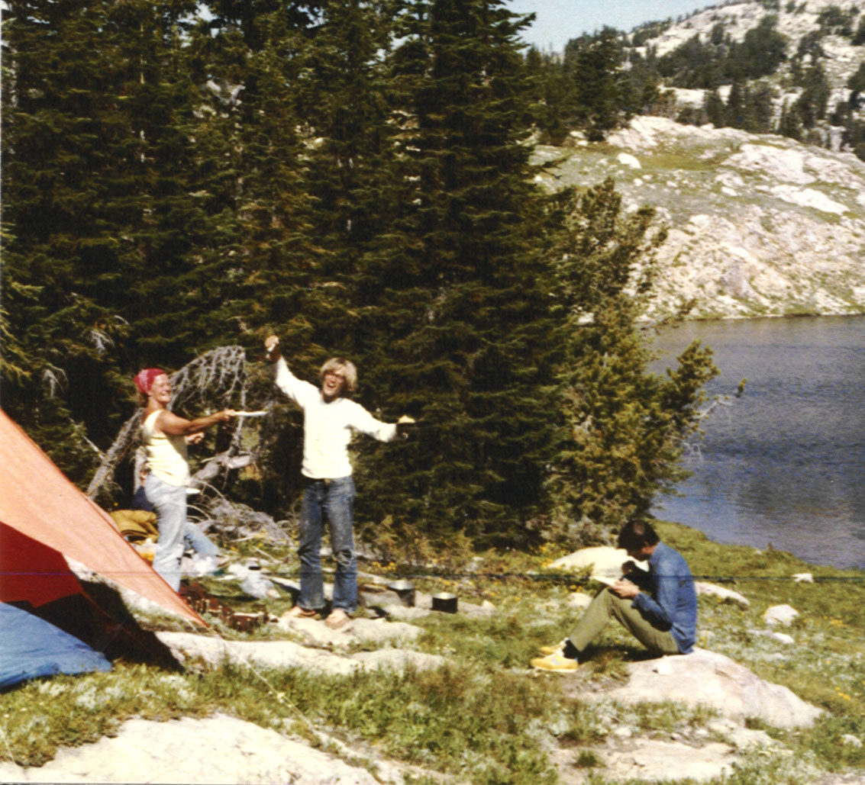

Beth, Bruce, cooking breakfast, Tom eating

